ECAP (EDUCATION CERTIFICATION AUTOMATED PROCESSING) SYSTEM ADMINISTRATOR GUIDE

1. Purpose. This training guide provides information on ECAP (Education Certification Automated Processing) for SAs (Systems Administrators). Since the original ECAP Administrator Guide was written, ECAP was converted from a personal computer based program to a server supported application. This guide includes information on other programs used in conjunction with ECAP. Security is used to create update files for schools using the Windows version of VACERT and to maintain the ECAP schools file. ETHOST is used to receive transmission files from schools using VACERT and to upload the transmission files to the ECAP server. DBView is used to check file structures and to view the actual data in the files. VA System Administrator Manager is used to generate statistical information. Appendix A contains instructions on the Pending Issue Man program used to establish chapter 1606 pending issues.

2. Rescissions. ECAP Version 307.0 Installation Instructions, dated February 12, 1998, and ECAP Version 307.0 Administrator’s Guide, updated June 24, 1998.

Celia P. Dollarhide
Director, Education Service

Distribution: Per VA Form 3-7225
SS (224B)

DEPARTMENT OF VETERANS AFFAIRS

ECAP

(EDUCATION CERTIFICATION

AUTOMATED PROCESSING)

SYSTEMS ADMINISTRATOR GUIDE

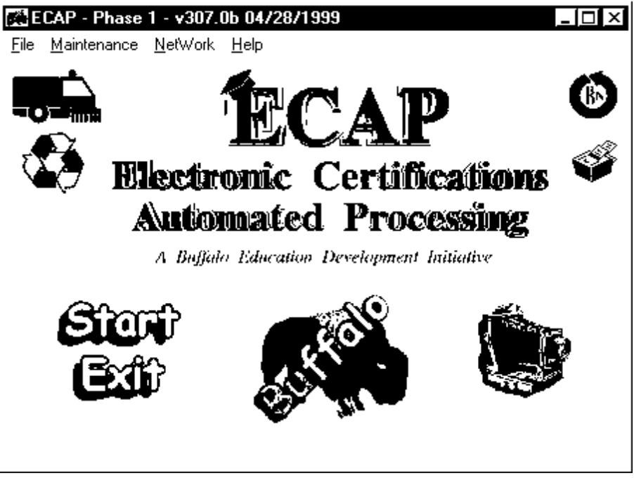

Training Guide 22-99-4 Veterans Benefits Administration
Education Service
December 8, 1999 Washington, DC

TABLE OF CONTENTS

CHAPTER SUBJECT PAGE

1. GENERAL

1.01 Introduction... 1-1
1.02 Overview... 1-1
1.03 Installation, Backups, Updates, and Future Changes 1-2
1.04 Configuration 1-2

2. ETHOST

2.01 General 2-1
2.02 Setup 2-2
2.03 Waiting for a Call 2-5
2.04 Automated Processing 2-6
2.05 Manual Processing 2-7
2.06 Reports 2-8

3. DAILY OPERATIONS

3.01 Uploading Transmission Files 3-1
3.02 Starting ECAP Server Processing 3-1
3.03 ECAP Personal Computer Processing 3-3
3.04 Continuing ECAP Server Processing 3-8
3.05 Pending Issue Man Processing 3-10

4. SECURITY

4.01 General 4-1
4.02 Maintaining School Records 4-2
4.03 Special Situations 4-6
4.04 Creating Update Files 4-7
4.05 Synchronizing School Records 4-10
4.06 Generating Statistics 4-12

5. DBVIEW

5.01 Starting 5-1
5.02 Displaying File Structure and Data 5-2
5.03 Searching 5-4
5.04 Special Feature 5-5

TABLE OF CONTENTS (Continued)

CHAPTER SUBJECT PAGE

6. VA SYSTEM ADMINISTRATOR MANAGER

6.01 Starting 6-1
6.02 Cleaning School Records 6-1
6.03 Generating Reports 6-2

7. TROUBLE SHOOTING

7.01 ETHOST Problems 7-1
7.02 ECAP Problems 7-2

APPENDIX SUBJECT PAGE

A. Pending Issue Man A-1

FIGURE PAGE

2.01 ETHOST Main Menu 2-1
2.02 Comm Port Setup Screen 2-3
2.03 Modem Selections/Settings Screen 2-3
2.04 Modem Strings Screen 2-4
2.05 Set Up Options Screen 2-4
2.06 Time Set Screen 2-5
2.07 Modem Download Screen 2-5
2.08 Unsuccessful Transmission Report 2-6
2.09 ETHOST Pre-Processor Screen 2-7
2.10 ETHOST Daily Log 2-8
2.11 ETHOST Daily Summary 2-8
2.12 Et321La Log 2-9
2.13 ETHOST Daily Pro Log 2-9

3.01 ECAP Server File Utility Screen 3-3
3.02 ECAP Processing Screen 3-4
3.03 ECAP Work in Progress Has Been Stopped Screen 3-5
3.04 ECAP Daily Processing Report 3-6
3.05 ECAP ProError Report 3-7
3.06 ECAP ProError Screen 3-8
3.07 Pending Issue Man Setup Screen 3-11
3.08 Pending Issue Man Main Menu 3-11

TABLE OF CONTENTS (Continued)

FIGURE PAGE

4.01 Security Main Menu 4-1
4.02 VACERT Security Screen 4-2
4.03 VACERT Data Management Screen 4-3
4.04 ECAP Add–Edit–Delete Schools Screen 4-5
4.05 Multiple Facility Codes Screen 4-6
4.06 VACERT Security Zapper Screen 4-7
4.07 Security Update Screen 4-7
4.08 Pop Up Screen 4-8
4.09 Add Screen 4-8
4.10 WinZip – Update.zip Screen 4-9
4.11 WinZip Self-Extractor Personal Edition Screen 4-10
4.12 Synchronization Screen 4-11
4.13 Print Options Screen 4-11
4.14 Statistics Screen 4-12

5.01 DBView Main Screen 5-1
5.02 DBView Driver and Folders 5-1
5.03 DBView Folder Contents 5-2
5.04 DBView List Box 5-3
5.05 DBView List Box Information – Structure 5-4
5.06 DBView List Box Information – Data 5-4
5.07 DBView Index Management Screen 5-5
5.08 TransFileViewer Quick Search Screen 5-5
5.09 Schools Clean Up Screen 5-5
5.10 Count Clean Up Log File 5-6
5.11 Zero Count Schools Log File 5-6

6.01 VA System Administrator Manager Main Menu 6-1
6.02 VA System Administrator Manager Printer Options Screen 6-2
6.03 Zero Transmissions Report 6-2
6.04 Individual Report 6-3
6.05 RPO Totals Report 6-3
6.06 Suspect Facility Codes Report 6-3

7.01 Illegal Operation Message 7-2
7.02 ECAP Continue Processing Screen 7-2

CHAPTER 1. GENERAL

1.01 INTRODUCTION

This training guide provides ECAP (Education Certification Automated Processing) SAs (Systems Administrators) with information on ECAP and the programs used in conjunction with it. Copies of this guide should be provided to the VACERT SAs at RPOs (Regional Processing Offices) where staffing allows for different employees to perform the functions of the ECAP and VACERT SAs.

1.02 OVERVIEW

a. Schools. Schools use the DOS and Windows versions of VACERT, the electronic education certification program, to create enrollment certifications and notices of change in student status. Schools use ETCERT, VACERT’s companion communication program, that comes with the DOS version of VACERT, or the 16 or 32 bit Windows versions, modems, and telephone lines to send transmission files to the RPOs.

b. ETHOST. RPOs use ETHOST on PCs with modems, printers, and telephone lines to receive transmission files from schools. At least once each working day, transmission files should be uploaded to the ECAP server via the RPO’s LAN (Local Area Network).

c. ECAP. ECAP consists of 2 processes, the ECAP server and the ECAP PCs.

(1) The ECAP server manages the flow of files between the ETHOST PC(s) and the ECAP PCs. It maintains the central files containing enrollment certifications and notices of change in student status before, during, and after processing by ECAP. It stores the log files used to generate reports and to trouble shoot ECAP if a problem occurs.

(2) Dedicated PCs run ECAP. Enrollment certifications and notices of change in student status are processed the same way that Veterans Claims Examiners do when working them from preprinted forms or TIMS (The Image Management System) images.

d. Security. RPO employees use Security to create update files for schools using the Windows version of VACERT and to enter the additional information about participating schools required by ECAP for processing.

e. DBView. DBView provides RPO employees with the capability to view and print data structures and the actual data in files.

f. VA System Administrator Manager. VA System Administrator Manager allows RPO employees to clean up the school records and to generate reports about schools using VACERT.

g. Help. ETHOST, Security, and ECAP programs have help files with additional information about the applications.

1.03 INSTALLATION, BACKUPS, UPDATES, AND FUTURE CHANGES

a. Installation. ECAP was installed on the RPO’s ECAP server. It was also installed on the dedicated PCs. If there is a crash, follow the standard restoration procedures.

b. Backups. Maintain ECAP backup files according to standard VBA backup procedures.

c. Updates

(1) The Education Service will notify the ECAP SAs when an ECAP update file is avail- able. The SAs are responsible for installing the update files on the ECAP server and PCs.

(2) Changes may be made to ETHOST, Security, DBView, and VA System Administrator Manager. If changes are made, the ECAP SAs will be notified by e-mail that an update file is available for downloading from a specified web site. Immediately download the update files and run them.

1.04 CONFIGURATION

a. Hardware. ECAP runs on designated PCs at each RPO. The PCs should be Deskpro EP Model 6266X/3200 with 15” monitors and the workstation enhancement packages. Printing is done on an Optra S 1255 Laser Printer, 12 pages per minute, 20 MB RAM, 350 Sheet Input, NetMark S 10BaseT/10Base2 Internal Network Adapter with a 500 sheet second drawer. The PCs and printer are connected to a Compaq Proliant 3000 Model 6/300 server with 64 MB RAM, 10/100 network card, a 14” monitor, 128 MB Buffered EDO DIMM memory kit, 9.1 gigabyte pluggable Wide-Ultra SCSI-3 10,000 RPM drive, external 15/30 GB DLT drive, and backup executable for Windows NT server, single server edition.

b. ECAP Server. The ECAP server receives incoming enrollment certifications and notices of change in student status contained in the ETCERT sub directory on the ETHOST PC(s) via the RPO’s LAN. The server program creates backup copies and distributes the certifications to the ECAP PCs for processing.

c. ECAP PCs. The number of PCs provided to each RPO was based on the workload data available when the equipment was ordered. If RPOs find that additional PCs are necessary to handle the workload, they may add additional PCs. (See chapter 3 for additional information.)

d. ETHOST PCs. ETHOST should be installed on at least 2 PCs at each RPO. The PCs should be connected to high speed modems and telephone lines to receive incoming telephone calls from school officials. The PCs should also be connected to the RPO’s LAN to facilitate the movement of files from the PCs to the ECAP server. By installing ETHOST on 2 PCs, incoming calls can be moved to the second PC without interruption if a problem is encountered with one PC. (See chapter 2 for additional information.)
CHAPTER 2. ETHOST

2.01 GENERAL

a. Starting ETHOST. Select Start, Programs, and ETHOST5 or click the ETHOST icon to start. The ETHOST Main Menu in figure 2.01 appears. The box at the top of the screen shows the status.

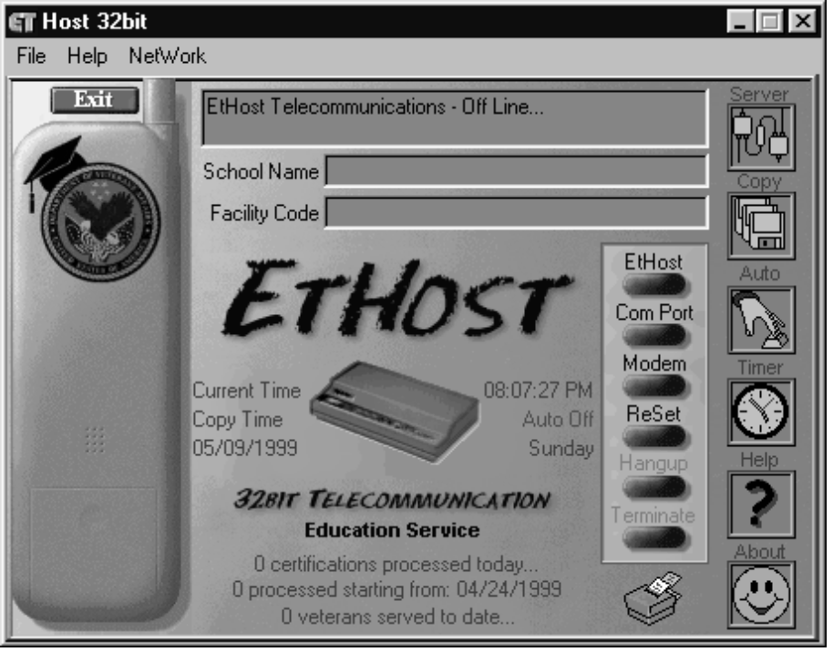

Figure 2.01. ETHOST Main Menu

b. Functions. There are 12 functions under File on the drop down menu. You can start some functions by clicking the buttons on the right side of the screen.

(1) ETHOST (Waiting For Call) is the host mode. See par. 2.03.

(2) Basic Setup provides access to the setup routine. See par. 2.02d.

(3) Comm Port Setup provides access to the PC’s communications ports. See par. 2.02a.

(4) Modem Setup provides access to the modem selection routine. See par. 2.02b.

(5) Reset Modem allows for resetting the modem without shutting down ETHOST.

(6) Hangup terminates the host mode.

(7) Terminate Session manually terminates an unsuccessful transfer.

(8) Pre-Processor checks transmission files for duplicate enrollment certifications and notices of change in student status. See par. 3.01d.

(9) Print generates daily and historical logs. See par. 2.06.

(10) Transmission Timing sets the elapsed time between the initial log on by a school and the start of the file transfer.

(11) Check for Dial Tone determines if the modem can get a dial tone.

(12) Exit closes ETHOST.

c. Network. ETHOST has 4 functions under Network on the drop down menu.

(1) Manually Processing starts the manual processing mode. See par. 2.05.

(2) Full Auto Processing manually starts the automated processing mode. See par. 2.04.

(3) Attach to Server connects the ETHOST PC to the ECAP server.

(4) Disconnect from Server disconnects the ETHOST PC from the ECAP server.

d. Help. ETHOST comes with a Help file with additional information.

2.02 SETUP

a. Communications Port. Select File and Comm Port Setup or click “Comm” on the right side of the Main Menu to check the communications ports. The Comm Port Setup screen in figure 2.02 appears. Select the desired communications port and the baud rate and click “OK.” We recommend leaving the default settings for data bits, parity, and stop bits.

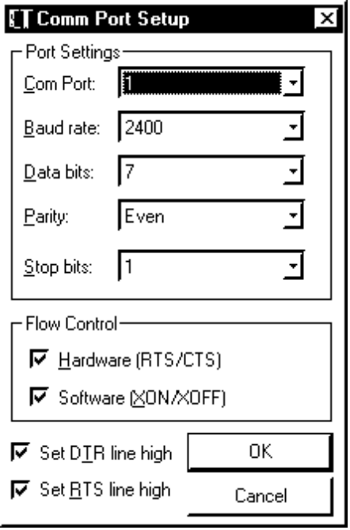

Figure 2.02. Comm Port Setup Screen

b. Modem Selection. Select File and Modem Setup or click “Modem” on the right side of the Main Menu to select a modem. The Modems Selections/Settings screen in figure 2.03 appears. Select the make and model and click “OK.”

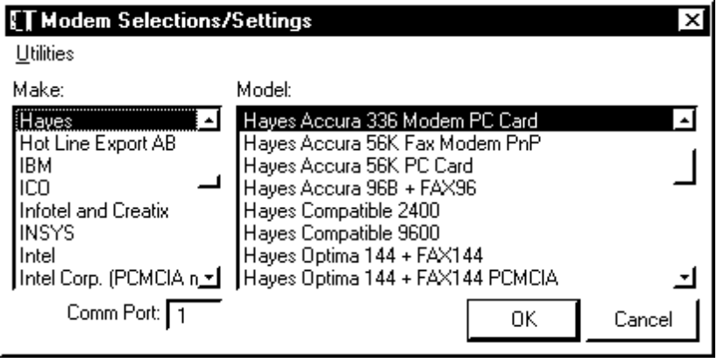

Figure 2.03. Modem Selections/Settings Screen

c. Utilities. Click Utilities and Edit Settings on the Modem Selections/Setting screen to edit the modem settings. The Modem Strings screen in figure 2.04 appears. Make the changes and click “OK.”

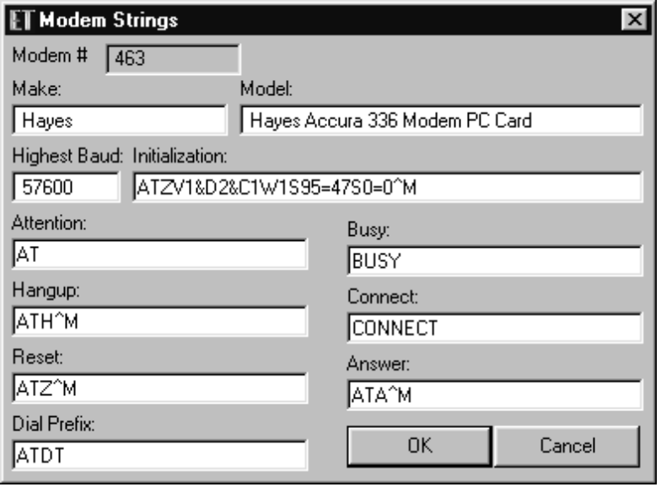

Figure 2.04. Modem Strings Screen

d. Basic Processing Selections. Select File and Basic Setup to set up the ProError log printing and the duplication checker. The Set Up Options screen in figure 2.05 appears. Click the box to the left of “Always Print the Error Log” to always print the error log. We strongly recommend printing the logs for future reference. Click the box to the left of “Always Run Duplication Remover” to run the Pre-Processor when using the automatic processing mode. Click “Save” to save the selections. Click “Exit” to go back to the Main Menu.

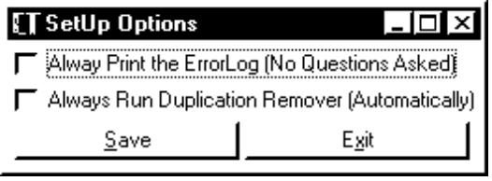

Figure 2.05. Set Up Options Screen

e. Turning on Automated Processing. ETHOST offers the option of fully or partially automated or manual processing. There are 2 steps to use the automated processing mode.

(1) Click the clock on the right side of the Main Menu. The Time Set screen in figure 2.06 appears. Enter the time for processing to begin. On the same line as the hour, minute, and second fields, click on “PM” to change it to “AM” or click on “AM” to change it to “PM.”

(2) Enter a check in the box to the left of “Automatically Process” and click “Exit.” The Main Menu shows the time selected below the current time.

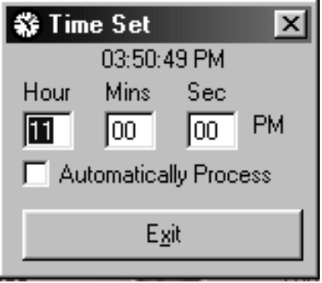

Figure 2.06. Time Set Screen

f. Turning off Automated Processing. Click the clock on the right side of the Main Menu. The Time Set screen appears. Delete the check in the box to the left of “Automatically Process.” Click “Exit.” The Main Menu appears with “Auto Off” in red below the current time.

2.03 WAITING FOR A CALL

a. Initial Processing. ETHOST checks for a dial tone. If it finds one, it goes into its “Waiting for a Call” mode.

b. Incoming Calls. The Modem Download screen in figure 2.07 appears when ETHOST receives a call. The screen shows the transmission file name, the protocol, a progress indicator, the file size, the elapsed time since the transfer started, and an estimate of the remaining time. If the file transfer hangs up (the progress indicator stops moving), click “Cancel.”

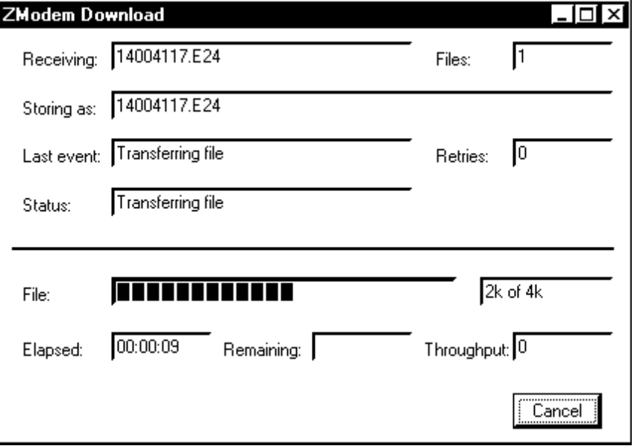

Figure 2.07. Modem Download Screen

c. Transmission Status

(1) After a successful transmission, the Main Menu appears. The transmission file name, school name, facility code, number of records sent, and transfer speed appear.

(2) If a transmission was unsuccessful, ETHOST prints all available data. See figure 2.08 for an example of an unsuccessful transmission. The data on the report may vary. The trans- mission file name should always appears. Use OLAF (On-Line Approval File) to search by facility code for the school name, its telephone number, and the name(s) of the certifying official(s). (See Training Guide 22-99-1, OLAF (On-Line Approval File) for Windows.) If enrollment certifications or notices of change of student status in the transmission file can be read, the school name, the telephone number, and the certifying official’s name may appear on the report. An RPO employee should call the school official to try to resolve the problem.

Unsuccessful Transmission File # 13000227.E59 Dated: 04/12/1999

School = UNIVERSITY OF NEBRASKA – KEARNEY

Phone # = Unknown

Official Unknown

Please call school and let them know that the file 13000227.E59 was not successfully received.

They may want to try again at a lower speed.

Figure 2.08. Unsuccessful Transmission Report

d. Subsequent Processing. ETHOST resumes its “Waiting for a Call” mode.

2.04 AUTOMATED PROCESSING

a. Steps. The automated processing mode:

(1) Deletes all transmission files in the current sub directory (C:\ETCERT\CURRENT) from the previous day;

(2) Copies all transmission files in the ETCERT sub directory (C:\ETCERT) to the Current sub directory (C:\ETCERT\CURRENT);

(3) Runs the Pre-Processor to check for duplicate enrollment certifications and notices of change in student status and removes the duplicates.

(4) Connects to the RPO’s LAN;

(5) Maps the next available drive to the ECAP SHARE on the ECAP server;

(6) Copies all files from the Current sub directory (C:\ETCERT\CURRENT) to the Net- Host sub directory ([n]:\ETHOST); and

(7) Disconnects from the ECAP server.

b. After Successful Transfer. ETHOST returns to “Waiting for a call” mode.

2.05 MANUAL PROCESSING

a. First Step. Click “Copy” on the right side of the Main Menu. The ETHOST Pre-Processor screen in figure 2.09 appears.

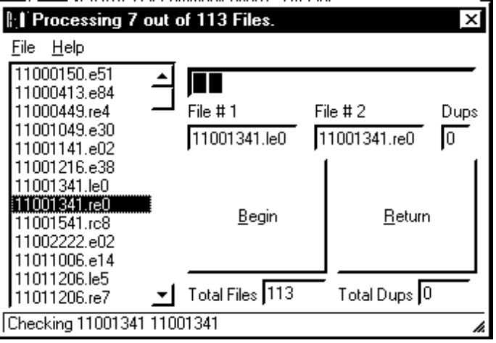

Figure 2.09. ETHOST Pre-Processor Screen

b. Second Step. Click “Begin” to start checking all transmission files for duplicate enroll- ment certifications and notices of change in student status. If you do not want the Pre-Processor to check for duplicates, click “Return” to go to the Main Menu.

c. Third Step. The Pre-Processor offers the option of removing the transmission files from the previous day from the Current sub directory (C:\ETCERT\CURRENT). If ECAP processed all the transmission files from the previous day, click “Yes.” If ECAP did not process all the transmission files from the previous day, click “No” to keep the transmission files from the previous day. Click “Cancel” to return to the Main Menu.

d. Fourth Step. After the Pre-Processor completes the duplication and copy functions, click “Return.” ETHOST resumes its “Waiting for a call” mode.

2.06 REPORTS

a. General. Besides the Unsuccessful Transmission report shown in figure 2.08 above, ETHOST automatically generates several reports during routine processing.

b. Daily Log. The Daily log shown in figure 2.10 shows the date and time of each trans- mission, the transmission file name, successful or unsuccessful, and the number of enrollment certifications or notices of change in student status received. If a school sends the same trans- mission file more than once, the Daily log shows all transmissions. However, the second and subsequent transmissions overlay the first one and only one transmission file is saved for processing. Use OLAF to search by facility code for the school’s name, telephone number, and the certifying official’s name. Call school official to determine why they sent the same trans- mission file more than once.

04261999.LOG

#1999-04-26 06:34:38#
“14917422.E08, FILE TRANSFERRED, 2 Certs Received.”
#1999-04-26 08:06:12#
“14806122.RE2, FILE TRANSFERRED, 2 Certs Received.”
#1999-04-26 08.37:01#
“11901114.E01, FILE TRANSFERRED, 9 Certs Received.”
#1999-04-26 10:03:42#
“11900126.E14, FILE TRANSFERRED, 2 Certs Received.”
#1999-04-26 11:22:13#
“11000413.E80, TRANSFER UNSUCCESSFUL, 1 Certs Received.”
#1999-04-26 11:30:42#
“11000413.E81, FILE TRANSFERRED, 28 Certs Received.”
#1999-04-26 12:28:43#
“14905416.E47, FILE TRANSFERRED, 26 Certs Received.”
#1999-04-26 13:44:27#
“31113125.C86, FILE TRANSFERRED, 19 Certs Received.”

Figure 2.10. ETHOST Daily Log

c. Daily Summary. The Daily Summary shown in figure 2.11 shows the date and time and the number of transmission files uploaded to the ECAP server via the RPO’s LAN.

04261999.LOG
04/26/1999 05:54:30 AM
88 Cert [s] Copied
04/26/1999 6:00:16 AM
The ETCERT subdirectory is Empty

Figure 2.11. ETHOST Daily Summary

d. Et321La Log. The Et321La log shown in figure 2.12 is printed when the schools file (SCHOOLS.DBF) used by ETHOST and ECAP has been updated.

***********************************
321LA.DBF RECEIVED ON 04/27/1999 6:00:26 AM
***********************************
21911106 DENVER TECHNICAL COLLEGE ADDED
21911506 DENVER TECHNICAL COLLEGE ADDED
31903423 NORTH CENTRAL UNIVERSITY UPDATED
31903523 NORTH CENTRAL UNIVERSITY UPDATED
***********************************
321LA.DBF PROCESS COMPLETED ON 04/27/1999 6:00:28 AM
***********************************

Figure 2.12. Et321La Log

e. Daily Pro Log. The Daily Pro log shown in figure 2.13 shows the dates and times of each upload to the ECAP server from the host PC via the RPO’s LAN.

DAILY PRO.LOG

1999-04-22 06:00:00 AM
04/22/1999 06:00:00 AM, PROCESSING STARTED
1999-04-22 06:00:22 AM
04/22/1999 06:00:22 AM, PROCESSING COMPLETED
1999-04-23 06:00:00 AM
04/23/1999 06:00:00 AM, PROCESSING STARTED
1999-04-23 06:00:15 AM
04/23/1999 06:00:15 AM, PROCESSING COMPLETED
1999-04-24 06:00:00 AM
04/24/1999 06:00:00 AM, WEEKEND, “NO” PROCESSING
1999-04-25 06:00:00 AM
04/25/1999 06:00:00 AM, WEEKEND, “NO” PROCESSING

Figure 2.13. ETHOST Daily Pro Log
CHAPTER 3. DAILY OPERATIONS

3.01 UPLOADING TRANSMISSION FILES

a. General. All transmission files received by ETHOST are routed to the ETCERT sub directory (C:\ETCERT).

b. Backup Files. ETHOST copies the transmission files in the ETCERT sub directory (C:\ETCERT) to the Current sub directory (C:\ETCERT\CURRENT) and to the Duplicate History sub directory (C:\ETCERT\CURRENT\DUPEHIST). The daily folders in the Duplicate History sub directory contain copies of all the transmission files received on that day.

c. ProError. The ETCERT sub directory has a ProError sub directory (C:\ETCERT\ PROERROR). ETHOST routes transmission files that do not contain enrollment certifications or notices of change in student status, corrupted files, or files not created by VACERT to the Pro- Error sub directory. RPO employees should check the sub directory every day to see if there are transmission files that need to be resent by school officials.

d. Pre-Processor. The transmission files in the Current sub directory are checked for duplicate enrollment certifications or notices of change in student status. If identical enrollment certifications or notices of change in student status are found, the duplicates are removed.

e. Manual Process. You have the option of manually starting the upload of transmission files to the ECAP server via the RPO’s LAN. After the transmission files are copied, a flag is set that tells the ECAP server to start processing. ETHOST resumes its “Waiting for a Call” mode.

f. Automated Process. You can select the automated option. Select the time for the host PCs to stop receiving transmission files and to upload the files to the ECAP server. After the transmission files are copied, a flag is set that tells the ECAP server to start processing. ETHOST resumes its “Waiting for a Call” mode.

3.02 STARTING ECAP SERVER PROCESSING

a. General. ECAP server processing is an automated process started by clicking the ECAP Server icon.

b. Copy Flag. The server checks the NetHost sub directory (E:\ECAP\NETHOST) for the NetHost flag (NETHOST.FLG) to determine if transmisison files are present and ready for processing. When the server finds the NetHost flag, it checks for a date. If the date is not found, the server stops and displays an error message.

NOTE: The NetHost flag contains the date the files were copied to the server. The date the files were copied is used as the date of receipt during subsequent processing.

c. Copying and Processing. The ECAP server performs the following functions:

(1) Copies the transmission files in the NetHost sub directory (E:\ECAP\NETHOST) to the Backup sub directory (E:\ECAP\BACKUP\SCHOOLS\[Date]).

(2) Empties the Temporary Working sub directory (E:\ECAP\WORKDIR).

(3) Moves the transmission files from the NetHost sub directory (E:\ECAP\NETHOST) to the Temporary Working sub directory (E:\ECAP\WORKDIR).

(4) Deletes the NetHost flag from the Temporary Working sub directory (e:\ECAP\WORK- DIR).

(5) Copies the Schools file (SCHOOLS.DBF) from the Cert sub directory (E:\ECAP\ SOFTWARE\CERT) to the Security sub directory (E:\ECAP\SECURITY).

(6) Opens the Schools file (SCHOOLS.DBF) and removes the total counts from the previous day.

(7) Moves the transmission files from the Temporary Working sub directory (E:\ECAP\ WORKDIR) to the Temporary Working sub directory (E:\ECAP\NETPROC\E[n]) for distribution to each ECAP PC.

NOTE: E[n] indicates the processor number. ECAP PCs should be numbered starting with E1.

(a) Copies the files to the Working sub directory for the first (E1) ECAP PC if there are less than 15 transmission files.

(b) Divides the files by size to the Working sub directories for the first (E1) and second (E2) ECAP PCs if there are 15 to 29 transmission files.

(c) Divides the files by size to the Working sub directories for all the ECAP PCs specified during the server setup if there are 30 or more transmission files.

(8) Copies the Schools file (SCHOOLS.DBF) from the Security sub directory (E:\ECAP\ SECURITY) to the Working sub directory (E:\ECAP\NETPROC\E[n]) for each ECAP PC.

(9) Creates a Backup sub directory (E:\ECAP\BACKUP\SCHOOLS\[Date]\E[n]) for each Working sub directory and copies the transmission files from the Working sub directory (E:\ECAP\ETPROC\E[n]) for each ECAP PC.

(10) Creates a Server flag (SERVER.FLG) with the ETHOST date of receipt and copies it to the Working sub directory (E:\ECAP\NETPROC\E[n]) for each ECAP PC.

(11) Empties the Temporary Working sub directory (E:\ECAP\WORKDIR).

(12) Polls the Working sub directories (E:\ECAP\NETPROC\E[n]) to determine when each sub directory is empty. When the Working sub directory is empty, the ECAP PC has down- loaded the assigned transmission files for processing.

3.03 ECAP PERSONAL COMPUTER PROCESSING

a. Start Processing. Click the ECAP Network Copy icon on each ECAP PC. The ECAP Server File Utility screen in figure 3.01 appears. Click “Go.”

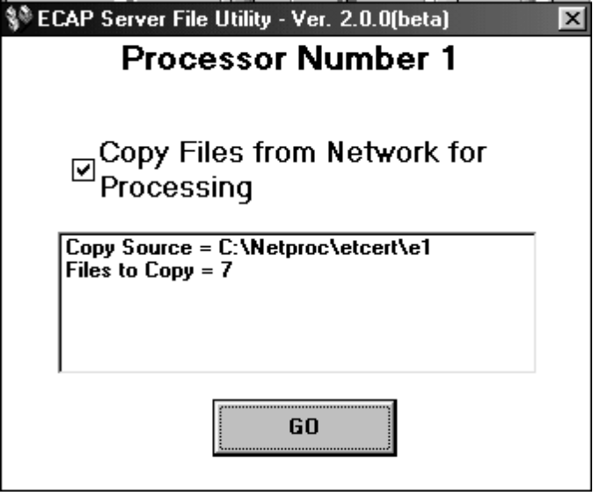

Figure 3.01. ECAP Server File Utility Screen

b. Copying from the ECAP Server. The first step is to copy all the necessary files from the ECAP server.

(1) Copies the transmission files in the PC’s NetProc sub directory (V:\NETPROC\ ETCERT\E[n]) to the PC.

(2) Copies the Server flag (SERVER.FLG) and Schools files (SCHOOLS.DBF) to the Cert sub directory (C:\CERT) and reindexes.

(3) Copies all other files to the ETCERT sub directory (C:\ETCERT).

c. Server Flag. ECAP enters the date of receipt in the Server flag file (SERVER.FLG) in a text file (GOING.TXT) for use during processing and deletes the Server flag file.

d. Copying on PC. ECAP copies the transmission files in the ETCERT sub directory (C:\ETCERT) to the Processing sub directory (C:\ETTODAY).

e. During Processing. The ECAP Processing screen in figure 3.02 appears with the BDN (Benefits Delivery Network) screens in the background.

(1) The Files to Process column shows the transmission files remaining to be processed. When processing is complete, the Files to Process column is blank.

(2) The File Identification box shows whether the transmission file being processed is a DOS or Windows file. When processing finishes, the File Identification box shows “Complete.”

(3) The Processing File box shows the transmission file currently being processed. When processing finishes, the Processing File boxes shows “Complete.”

(4) The box below the File Identification and Processing File boxes shows data about the file currently being processed, the number of files copied to the ProError sub directory, and the number of files processed.

(5) The 9 boxes in the lower right corner of the screen show statistical data on the current transmission file being processed and the totals following the completion of processing.

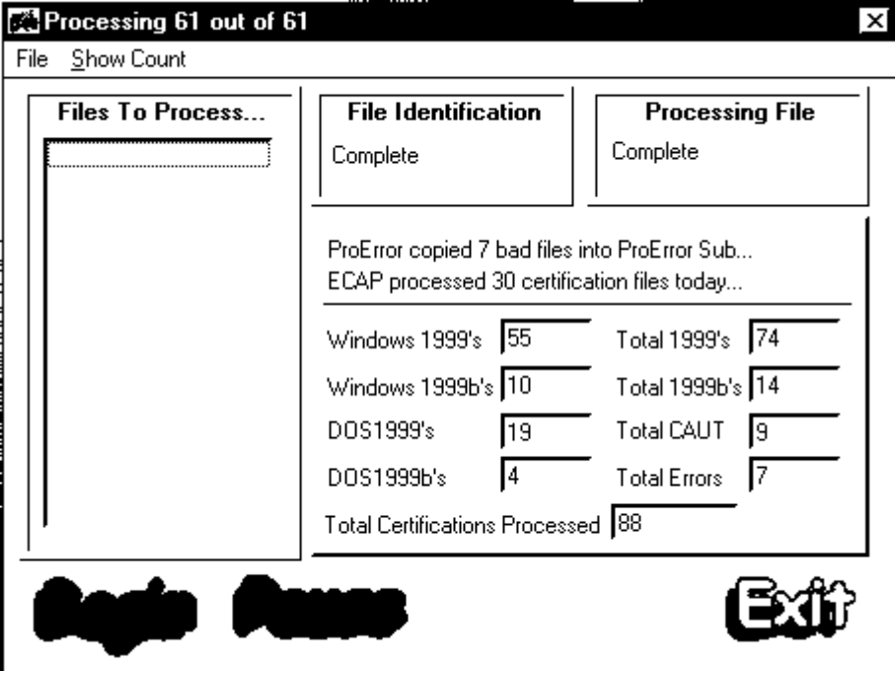

Figure 3.02. ECAP Processing Screen

f. Processing Cycle. ECAP processes the enrollment certifications and notices of change in student status as far as possible using the data in the student’s education master record.

g. Interruptions. If a PC stops processing, the ECAP Work in Progress Has Been Stopped screen in figure 3.03 appears. Do not do anything. ECAP attempts to resuming processing 3 times in 8 minutes. If ECAP cannot continue processing, click “Exit.” Click the ECAP Network Copy icon. The ECAP Server File Utility screen in figure 3.01 appears. The only difference is that the “Files to Copy” are zero. Click “Go” to resume processing. (See par. 3.02.)

Figure 3.03. ECAP Work in Progress Has Been Stopped Screen

h. Status File. The ECAP server maintains a status file for each ECAP PC. The file shows the total number of records in the current file being processed, the number of the current record being processed, the total number of files to be processed, the number of the current file being processed, and the current date and time. The file shows “Finished” after the last record in the last transmission file has been processed.

i. Completing Processing. Each PC performs the following steps after it completes processing:

(1) Copies the databases from the Cert sub directory (C:\CERT) to the Export sub directory (V:\NETPROC\EXPORT\[n]).

(2) Copies the spool files (*.spl) from the Image Copy sub directory (C:\IMAGECOP) to the Export sub directory (V:\NETPROC\EXPORT\E[n]\IMAGECOP) .

(3) Imports the log files (*.log) from the Cert sub directory (C:\CERT) to the Export sub directory (V:\NETPROC\EXPORT\E[n]).

(4) Creates and copies the ECAP flag (ECAP.FLG) to the Export sub directory (V:\NET- PROC\EXPORT\[n]).

j. Printing. ECAP prints enrollment certifications and notices of change in student status for chapter 32, 35, and 1606, and enrollment certifications or notices of change in student status that could not be identified. After completing processing, it prints the ECAP Daily Processing report shown in figure 3.04 and the authorized awards log.

ECAP Report – Processor 3
Friday, Jul 30 1999

Number of 1999s 103
Number of 1999bs 8
Total Cases Processed 111

Number of 30 Cases (Enroll) 73
Number of 30 Cases (Change) 6
Number of 35 Cases 8
Number of 32 Cases 0
Number of 1606 Cases 10
Number of 31 Cases 3
Total Cases Program IDed 100

Number of CH30 Pending Issues Set (Enroll) 26
Number of Ch30 Cases to GAD (Enroll) 9
Number of Ch30 Cases to GAD (Multiline Enroll) 6
Number of Ch30 Cases TAKEN to CAUT (Enroll) 21
Number of Ch30 Cases TAKEN to CAUT (Multiline Enroll) 14
Number of CH30 Pending Issues Set (Change) 5
Number of Ch30 Cases to GAD (Change) 0
Number of Ch30 Cases could CAUT (Change) 0
Number of Ch32 Pending Issues Set 0
Number of Ch35 Pending Issues Set 4

Number of Ch30 Cases STOPPED b/c Remarks 8
Number of Ch30 Cases STOPPED b/c Address 0
Number of Ch30 Cases Overlapping (Multi) 0
Number of Ch30 Cases Have Multiple Lines 35
Processing Time 1:53

Finished Processing on Friday, Jul 30 1999

Figure 3.04. ECAP Daily Processing Report

k. Imaging. ECAP copies the chapter 30 enrollment certifications, notices of change in student status, and 500 and 50B education award screens, to a spool file (C:\IMAGECOP\ CERT.SPL) to upload to the ECAP server.

l. Chapter 1606 Cases. Each PC creates a spool file (C:\IMAGECOP\PENDISSU.SPL) with the name and claim number of each chapter 1606 enrollment certification and notice of change in student status to upload to the server to input into Pending Issue Man.

m. File Management. ECAP deletes transmission files in the ETCERT sub directory (C:\ETCERT) after processing all enrollment certifications or notices of change in student status contained in the transmission files.

n. ProError Report. ECAP updates the ProError file (PROERROR.DBF) with the school name, facility code, number of enrollment certifications and notices of change in student status in each transmission file, and the number of enrollment certifications and notices of change in student status processed. See figure 3.05 for the ProError report. Check the total received and total processed figures at the bottom of the report. If the number of received and the number of processed do not match, look for records printed in bold with the status set to “False.”

ECAP ProError Log – Dated 04/26/1999 – Processor 1
Printed on – 04/26/1999

Name of School File Name In Out Success

UNIVERSITY OF WYOMING 11000150.E48 2 2 True
EASTERN ILLINOIS UNIVERSITY 11000213.E12 1 1 True
ILLINOIS STATE UNIVERSITY 11000413.E79 3 3 True
UNIVERSITY OF WISCONSIN - GREEN BAY 11001349.C09 2 2 True
UNIVERSITY OF WISCONSIN - GREEN BAY 11001349.E09 3 3 True
SAGINAW VALLEY STATE UNIVERSITY 11002222.E01 1 1 True
UNIVERSITY OF NEBRASKA 11801127.LC5 8 8 True
UNIVERSITY OF NEBRASKA 11801127.LE5 2 2 True
UNIVERSITY OF NEBRASKA 11801127.RC6 6 6 True
UNIVERSITY OF NEBRASKA 11801127.RE1 6 6 True
UNIVERSITY OF NEBRASKA - OMAHA 11801427.E69 14 14 True
BALL STATE UNIVERSITY 11811914.E18 1 1 True
SIU AT CARBONDALE 11821013.E47 16 16 True
MONTANA STATE UNIVERSITY - BOZEMAN 11900126.E13 4 4 True MINOT STATE UNIVERSITY 11901034.C26 2 2 True
METROPOLITAN STATE COLLEGE 11901306.RC6 6 6 True
METROPOLITAN STATE COLLEGE 11901306.RE2 6 6 True
METROPOLITAN COMMUNITY COLLEGE 14910427.RC1 10 10 True
METROPOLITAN COMMUNITY COLLEGE 11901306.RE1 13 13 True
WESTERN MICHIGAN UNIVERSITY 11918122.E08 29 29 True
WESTERN MICHIGAN UNIVERSITY 11918122.E09 32 32 True

LONGVIEW COMMUNITY COLLEGE 14935425.E14 14 14 True

ECAP Total Certifications Received 181

ECAP Total Certifications Processed 181

Page # 1

Figure 3.05. ECAP ProError Report

o. ProError Screen. If you selected manual processing, the ProError screen in figure 3.06 appears. Transmission files that could not be processed and files where the number of enrollment certifications or notices of change in student status received and the number processed by ECAP do not match are highlighted in red.

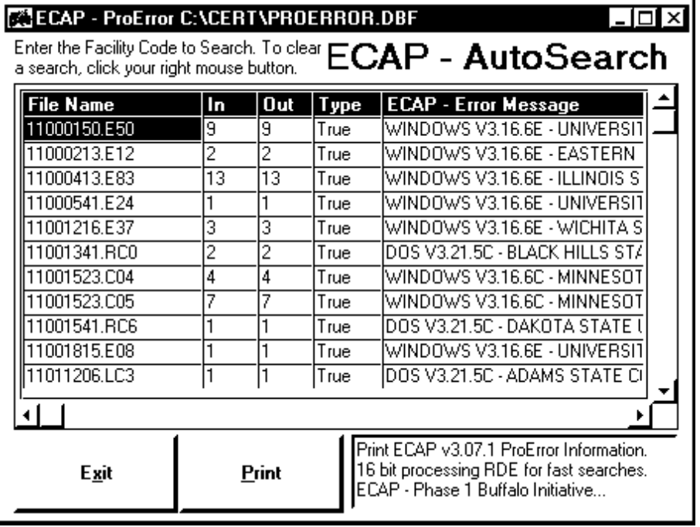

Figure 3.06. ECAP ProError Screen

p. Required Corrective Action. Review the ProError report or the screen for transmission files that could not be processed and files where the number received and the number processed do not match and the status is “False.” Determine why ECAP could not process the transmission file and take the necessary corrective action. (See chapter 3 for additional information.)

3.04 CONTINUING ECAP SERVER PROCESSING

a. During Processing. While the ECAP PCs are running, the server checks the Export sub directories (E:\ECAP\NETPROC\EXPORT\E[n]) on the ECAP PCs for the flag file (ECAP.FLG).

b. After the ECAP PCs Have Completed Processing. When the server finds the flag file for each PC, the following steps are repeated for all PCs:

(1) Copies the databases from the Export sub directories (E:\ECAP\NETPROC\EXPORT\ E[n]) to the Backup sub directories (E:\ECAP\BACKUP\SCHOOLS\[Date]\EXPORT\E[n]).

(2) Copies the spool files (*.spl) from the Export sub directories (E:\ECAP\NETPROC\ EXPORT\E[n]\IMAGECOP) to the Backup sub directories (E:\ECAP\BACKUP\SCHOOLS \[Date]\EXPORT\E[n]).

(3) Imports the log files (*.log) from the Export sub directories (E:\ECAP\NETPROC\ EXPORT\E[n]) to the Log Storage sub directory (E:\ECAP\LOGS\PROCESS).

(4) Checks the Imagecop sub directory and performs the following actions:

(a) Copies the spool files (*.spl) to the Backup sub directory (E:\ECAP\BACKUP\ SCHOOLS\[Date]\E[n]).

(b) Adds the Pending Issue spool files to the ECAP pending issue spool file (E:\ECAP\ NETPROC\SPOOL\PENDISSU.SPL).

(c) Adds the Cert spool files to the ECAP cert spool file (E:\ECAP\NETPROC\SPOOL\ CCERT.SPL).

(5) Copies the files in the ECAP ProError sub directory (E:\ECAP\NETPROC\EXPORT\ E[n]\PROERROR) to the server’s ProError sub directory (E:\ECAP\SOFTWARE\CERT\PRO- ERROR).

(6) Updates the totals in the Schools file (E:\ECAP\SOFTWARE\CERT\SCHOOLS.DBF) with the totals in the Schools file (E:\ECAP\NETPROC\EXPORT\E[n]\SCHOOLS.DBF) for each PC.

(7) Moves the records from the ECAP ProError Export file (E:\ECAP\NETPROC\ EXPORT\E[n]\PROERROR.DBF) to the ECAP ProError file (E:\ECAP\SOFTWARE\CERT\ PROERROR.DBF) and deletes the ECAP ProError Export file

(8) Moves the records from the ECAP Report Export file (E:\ECAP\NETPROC\EXPORT\ E[n]\REPORT.DBF) to the ECAP Report file (E:\ECAP\SOFTWARE\CERT\REPORT.DBF) and deletes the ECAP Report Export file.

(9) Moves processed certifications in the ECAP certification file (E:\ECAP\NETPROC\ EXPORT\E[n]\*.DBF) to the ECAP certification file (E:\ECAP\SOFTWARE\CERT\*.DBF).

c. Indexing. ECAP reindexes all files in the Cert sub directory (E:\ECAP\SOFTWARE\ CERT).

d. Printing. ECAP prints the combined Daily Processing, Authorization, and ProError reports. See figures 3.03 and 3.04 above for the ECAP Processing report and the ProError report. The only differences between the PC reports and the server reports is that the server reports combine all the PC reports to one report.

e. File Transfer Protocol (TIMS Stations ONLY). ECAP transfers chapter 30 enroll- ment certifications, notices of change in student status, and 500 and 50B education award screens, to the TIMS server for additional processing or drop filing. The 3 steps are:

(1) Count the number of documents in the ECAP spool file (E:\ECAP\NETPROC\SPOOL\ C*SPL) created in TIMS and save the data in the server log (E:\ECAP\LOGS\SERVER\Date] .LOG).

(2) Transfer the spool files (*.spl) in the server log (E:\ECAP\LOGS\SERVER) to the TIMS server.

(3) Delete the spool files (*.spl) in the server log (E:\ECAP\LOGS\SERVER) after a successful transfer.

NOTE: The above procedure was changd at the RPOs running the 32 bit version of TIMS. The TIMS server is rsponsibile for transferring the spool file from the ECAP server to the TIMS server. Therefore, if the transfer is unsuccessful or fails to occur, the problem should be referred to the TIMS system administrator.

f. After Completing Processing. The server resumes checking the NetHost sub directory (E:\ECAP\NETHOST) for the NetHost flag (NETHOST.FLG) to determine if transmission files are present and ready for processing. (See par. 3.02b above.)

3.05 PENDING ISSUE MAN PROCESSING

a. General. Pending Issue Man is not part of ECAP. It is used to establish pending issues for enrollment certifications and notices of change in student status positively identified as chapter 1606 claims. (See appendix A for additional information about Pending Issue Man.)

b. Setup. The PC used to run Pending Issue Man should be set up to look for the 1606 spool file (PENDISSU.SPL) in the ECAP spool sub directory (V:\NETPROC\SPOOL). The Pending Issue Man Setup screen in figure 3.07 appears. Enter the ECAP spool sub directory in the VACERT Source Directory field and click “OK.”

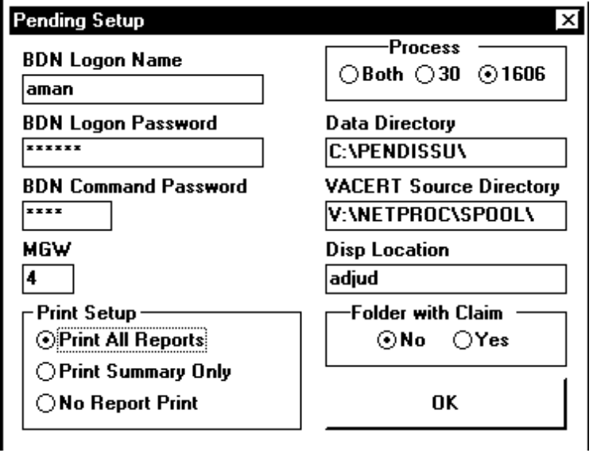

Figure 3.07. Pending Issue Man Setup Screen

c. Starting. Click the Pending Issue Man icon. The Pending Issue Man Main Menu in figure 3.08 appears. Click Go.

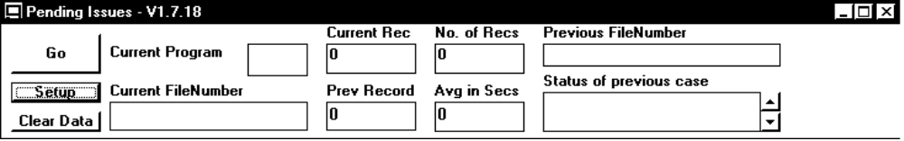

Figure 3.08. Pending Issue Man Main Menu

d. Processing. Pending Issue Man attempts to establish a chapter 1606 pending issue for enrollment certifications or notices of change in student status positively identified by ECAP as chapter 1606 claims. When Pending Issue Man finds the last record in the spool file, it automatically shuts down.
CHAPTER 4. SECURITY

4.01 GENERAL

a. Starting Security. Select Start, Programs, and Security or click the Security icon. The Security Main Menu in figure 4.01 appears.

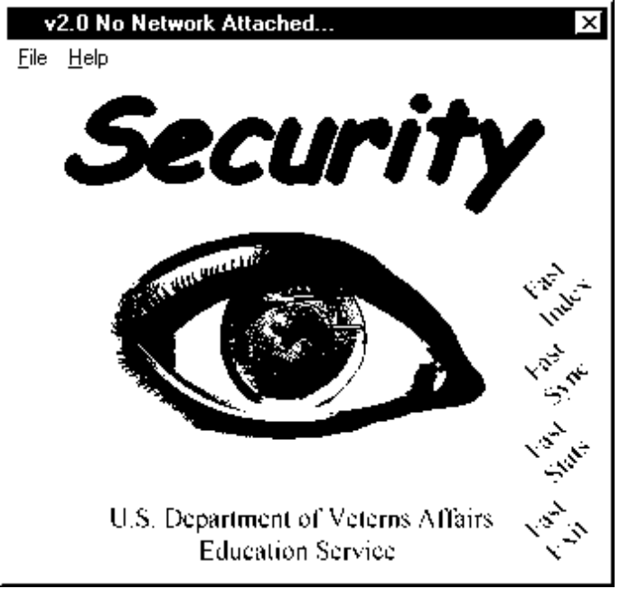

Figure 4.01. SECURITY Main Menu

b. Functions. Security has 6 functions.

(1) The Security program maintains the ECAP Schools file used to process enrollment certifications and notices of change in student status and to create the update files for schools using the Windows version.

(2) Reindex (or Fast Index) reindexes the schools file.

(3) Populate copies the data in the Cert (CERT.DBF) and Host files (HOST.DBF) to the Security files. (This step only needs to be done once.)

(4) Synchronize (or Fast Sync) identifies possible duplicate records and merges those that appear to be dual schools if the names are identical.

(5) Statistics (or Fast Stats) displays statistical data about the records.

(6) Exit (or Fast Exit) closes the Security program.

c. Help. Security comes with a Help file with additional information.

4.02 MAINTAINING SCHOOL RECORDS

a. General. Select File and Security or click anywhere on the Main Menu. The VACERT Security screen in figure 4.02 appears. The title bar shows the number of records. The screen shows the school name, IHL (Institution of Higher Learning) and/or NCD (Noncollege Degree) facility codes, and password. Records are in alphabetical order by school name.

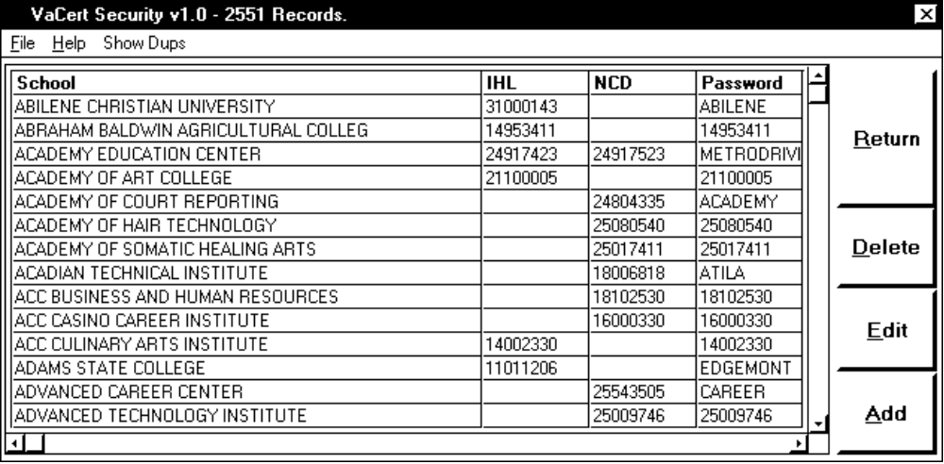

Figure 4.02. VACERT Security Screen

b. Add a Record. Select File and Add or click “Add” to add a new record. A blank VACERT Data Management screen in figure 4.03 appears. Click “Exit” to cancel the action and go back to the Main Menu.

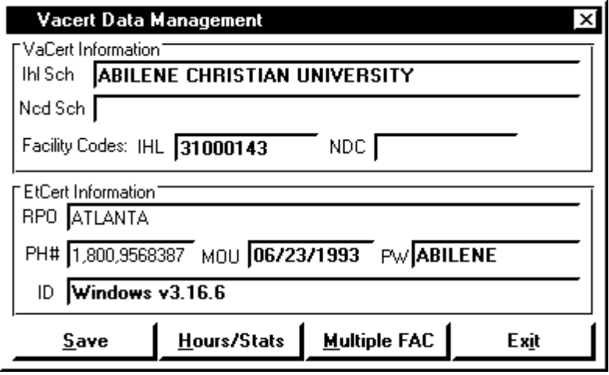

Figure 4.03. VACERT Data Management Screen

c. Screen Fields. The names and descriptions of the fields on the VACERT Data Management screen follow. Enter the necessary data in the fields and click Save.

NAME | DESCRIPTION
IHL Sch | Enter the school’s name if it is an IHL.
NCD Sch | Enter the school’s name if it is an NCD.
Facility Codes

IHL | Enter the school’s IHL facility code.
NCD | Enter the school’s NCD facility code.
NOTE: Schools may have IHL or NCD facility codes or both. If the third digit of the facility code is a “9,” the IHL and NCD codes cannot be identical. If the third digit is an “8,”, the IHL and NCD codes can be identical.

RPO | The RPO’s name appears.
PH # | The VACERT 800 number (1-800-956-8387) appears.
MOU | The current date appears. Enter the date the MOU was signed.

NAME | DESCRIPTION
PW | (Password) Not required. Security inserts the school’s facility code.
ID | (Identification) Not required. Security inserts “VACERT.”

d. Editing a Record. Highlight a record and select File and Edit or click “Edit” to change a record. A Vacert Data Management screen with the current data on the school appears.

e. Deleting a Record. Highlight a record and select File and Delete or click “Delete” to remove a record. A message appears asking if you want to delete the record. Click “Yes” to delete the record or “No” to cancel the action.

f. Making a Master File. Select File and Make Master to create a new 321LA.DBF file of all registered schools to copy to the ETHOST PC.

g. Checking for Duplicate Records. Click “Show Dups” to search for possible duplicate schools where the school names are not identical. If duplicate records are found, a screen shows the record number and facility code. Review the records to determine if they are duplicates.

h. Exiting. Select File and Exit or click “Return” to go back to the Main Menu.

i. ECAP Data. ECAP needs additional data to process enrollment certifications and notices of change in student status. Enter the basic data on the VACERT Data Management screen and clicking Save. Click Hours/Stats. The ECAP – Add-Edit-Delete Schools screen in figure 4.04 appears. The data necessary to complete the fields is in OLAF.

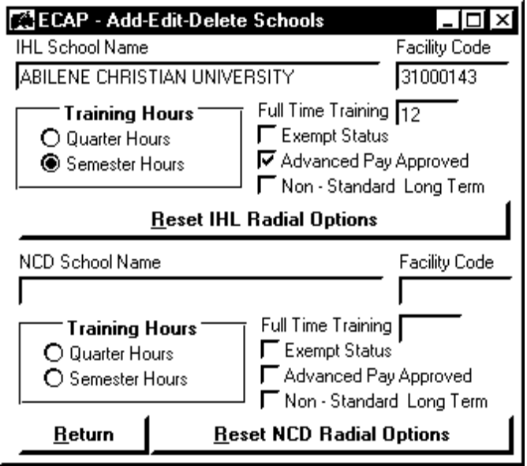

Figure 4.04. ECAP Add–Edit–Delete Schools Screen

j. Field Descriptions. The names and descriptions of the fields on the ECAP Add-Edit-Delete Schools screen follow.

NAME | DESCRIPTION
IHL School Name | The school’s name appears.
Facility Code | The school’s facility code appears.
Training Hours | Click Quarter or Semester.
Full Time Training | Enter the school’s full time undergraduate measurement, i.e., 12, 13, or  14 quarter or semester hours.
Exempt Status | Click this box.
Advance Pay Approved | Click this box if the school has agreed to accept advance payments.
Non-Standard Long Term | Click this box if the school has terms longer than 13 weeks for schools  that measure in quarter hours or 19 weeks for schools that measure in  semester hours.

k. Processing. Enter the required data and click “Return.” To erase the IHL Training Hours, Exempt Status, Advanced Pay Approved, or Non-Standard Long Term fields, click “Reset IHL Radial Options.” To erase the NCD Training Hours, Exempt Status, Advanced Pay Approved, or Non-Standard Long Term fields, click “Reset NCD Radial Options.”

CAUTION: Clicking the Reset button does not delete entries in the Full Time Training fields.

l. IHLs and NCDs. If the school is approved for both IHL and NCD programs, complete the fields on the lower half of the screen. The NCD School Name and Facility Code fields are completed with the data entered in the NCD SCH and NCD facility code fields on the VACERT Data Management screen. Enter the necessary data in the fields and click “Return.”

4.03 SPECIAL SITUATIONS

a. Multiple Facility Codes. Use the Multiple Facility Codes screen to create special update files for school officials who certify enrollments and changes for 2 or more IHL facility codes and/ or 2 or more NCD facility codes. If you encounter a school with this situation, contact the school official to determine if they want to be able to certify students under different facility codes with one copy of VACERT. If they want the capability, click “Multiple FAC” on the VACERT Data Management screen. The Multiple Facility Codes screen in figure 4.05 appears.

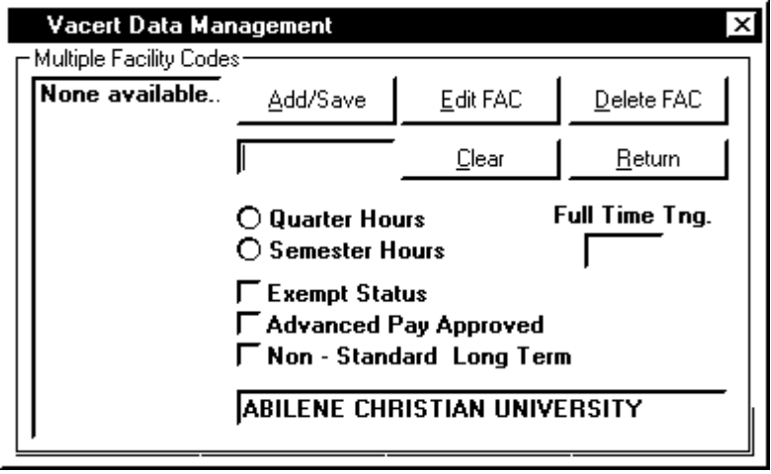

Figure 4.05. Multiple Facility Codes Screen

b. Screen Entries. Enter the additional IHL and/or NCD facility codes in the box under “Add/Save.” Enter the name of the location in the box at the bottom of the screen. Add as many facility codes as needed for the school. However, each facility code must have a unique school name. The remaining fields are identical to those on the ECAP Add-Edit-Delete screen in figure 4.04 above. Complete the fields for each facility code.

c. Processing

(1) To save the data, click “Add/Save.”

(2) To change the data , click “Edit FAC.”

(3) To delete the facility code, highlight the code and click “Delete FAC.”

(4) To erase the facility code(s) in the box below the Add/Save button, click “Clear.”

(5) Click “Return” to go back to the ECAP Add-Edit-Delete screen in figure 4.04 above. After adding a record, editing an existing record, or deleting a record, the system asks if you want to save your changes. Click “Yes” to save them or “No” to discard them.

4.04 CREATING UPDATE FILES

a. Creating the Update File

(1) After you complete the VACERT Data Management 4.02 and the ECAP Add-Edit-Delete Schools screens and click “Save,” the VACERT Security Zapper screen in figure 4.06 appears. Click “No.”
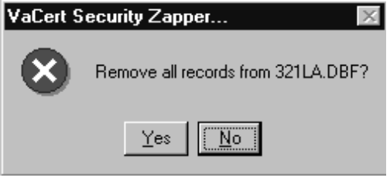

Figure 4.06. VACERT Security Zapper Screen

(2) The Security Update screen in figure 4.07 appears. Click “Yes.”
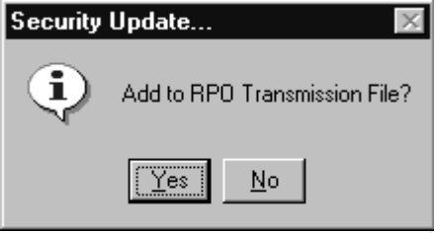

Figure 4.07. Security Update Screen

(3) Exit from Security. Select Start, Programs, and Windows Explorer. Find the sub directory containing Security. It should be V:\SOFTWARE\CERT\SECURITY. Find the Vapas file (VAPAS.DBF). Hold down the CTRL key and select the file. Click the right mouse button. The Pop Up screen in figure 4.08 appears. Select Add to Zip. (This launches WinZip.)

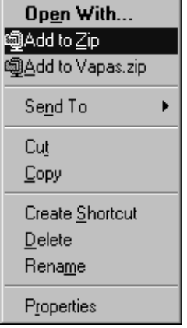

Figure 4.08. Pop Up Screen

(4) The Add screen in figure 4.09 appears.

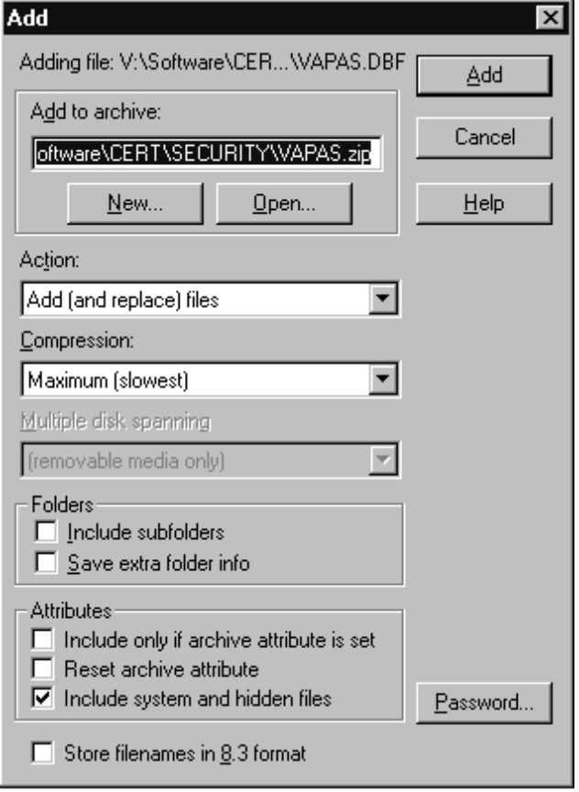

Figure 4.09. Add Screen

(5) In the Add To Archive box, change the file name to “UPDATE.ZIP.” Click “Password” in the lower right corner. Enter the password Security. (The password is case sensitive!) Click “OK.” Enter the password again and click “OK.” Click “Add.” The WinZip - Update.zip screen in figure 4.10 appears.

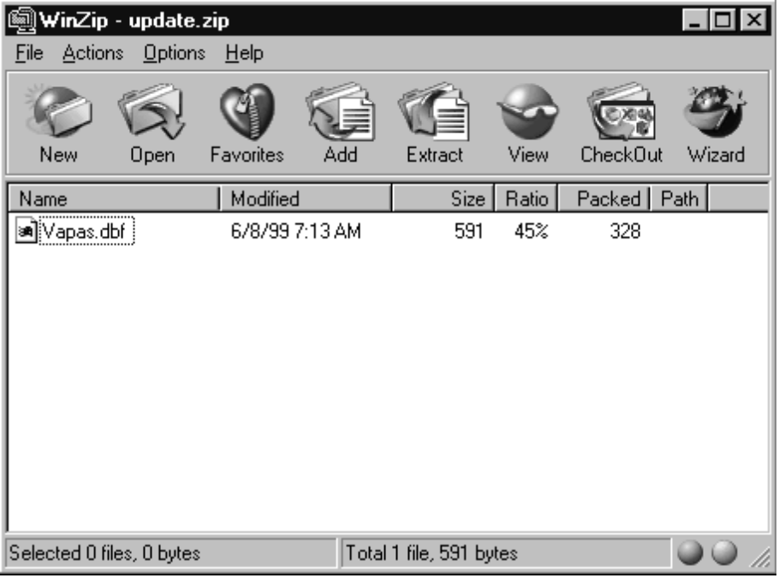

Figure 4.10. WinZip - Update.zip Screen

(6) Select Actions and Make .EXE File on the drop down menu. The WinZip Self-Extractor Personal Edition screen in figure 4.11 appears.

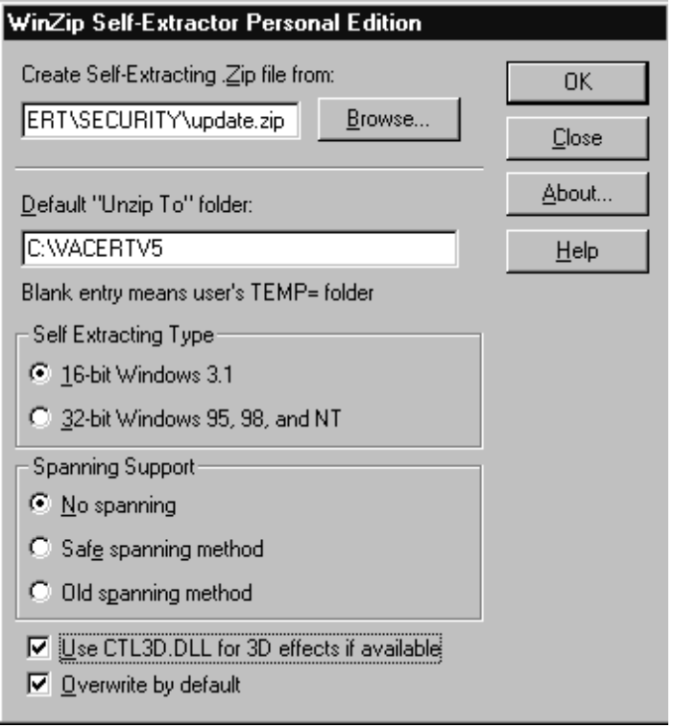
Figure 4.11. WinZip Self-Extractor Personal Edition Screen

(7) In the Default “Unzip To” folder box type in “c:\VACERTV5” under Self-Extracting Type, select the 16-bit Windows 3.1 option. Check the box next to Use CTL3D.DLL for 3D effects if available. Click “Make .EXE.” A message appears saying the file is password protected. Click “OK.” A message appears saying the file already exists and asks if you want to replace it. Click “Yes.” A message appears asking if you want to test it. Click “NO.” Close the WinZip Self-Extractor Window and the WinZip Program
b. E-mailing the Update File. The final step is to e-mail the update file (UPDATE.EXE) and the installation instructions to the school.

4.05 SYNCHRONIZING SCHOOL RECORDS

a. Starting. Select File and Synchronize or click “Fast Sync.” The Synchronization screen in figure 4.12 appears. Click “Begin.” The program checks all the records in the schools file. The results are displayed in the boxes. Click “Return” to go back to the Main Menu.

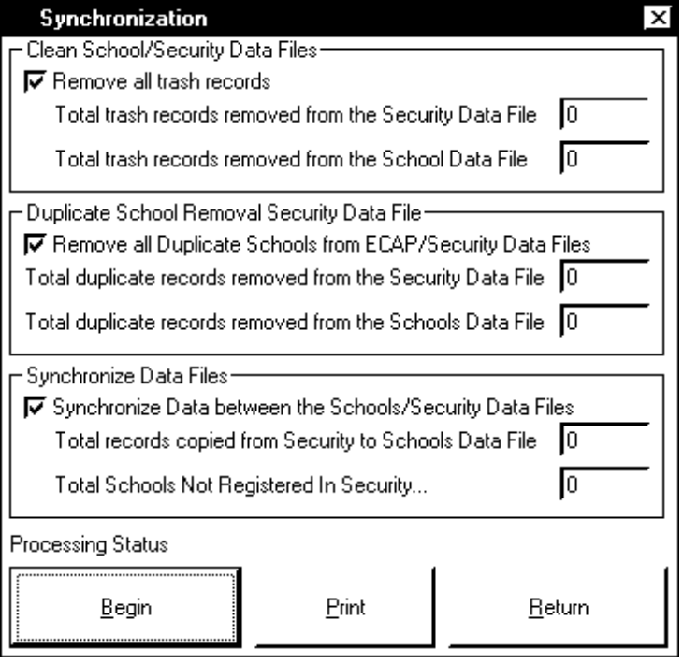

Figure 4.12. Synchronization Screen

b. Printing Reports. Click “Print.” The Print Options screen in figure 4.13 appears. The program can print reports for IHLs, NCDs, dual schools, all of the above, or all log files. Select alphabetical or numerical order. Click “Return” to go back to the Synchronization screen.

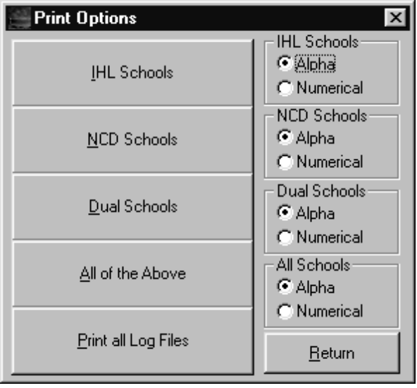

Figure 4.13. Print Options Screen

4.06 GENERATING STATISTICS

Select File and Statistics or click “Fast Stats.” The Statistics screen in figure 4.14 appears. Click “Begin.” The program checks all records in the schools file. The results appear in the boxes. Click “Return” to go back to the Main Menu.

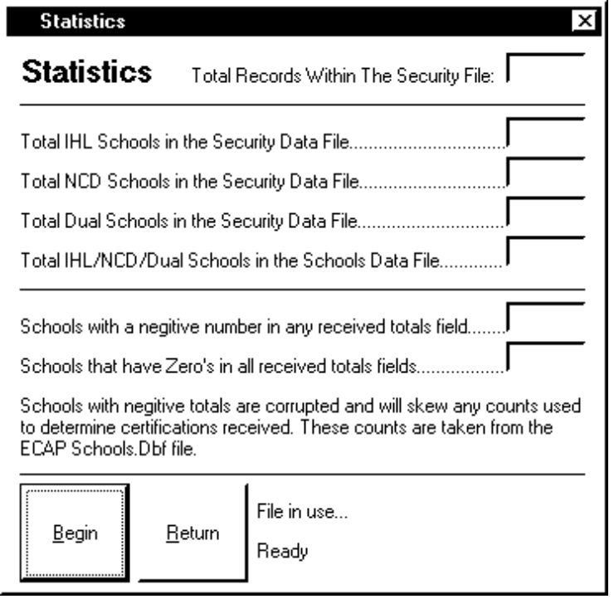

Figure 4.14. Statistics Screen

CHAPTER 5. DBVIEW

5.01 STARTING

a. Starting DBView. Select Start, Programs, and DBView or click the DBView icon to start. The DBView Main screen in figure 5.01 appears.

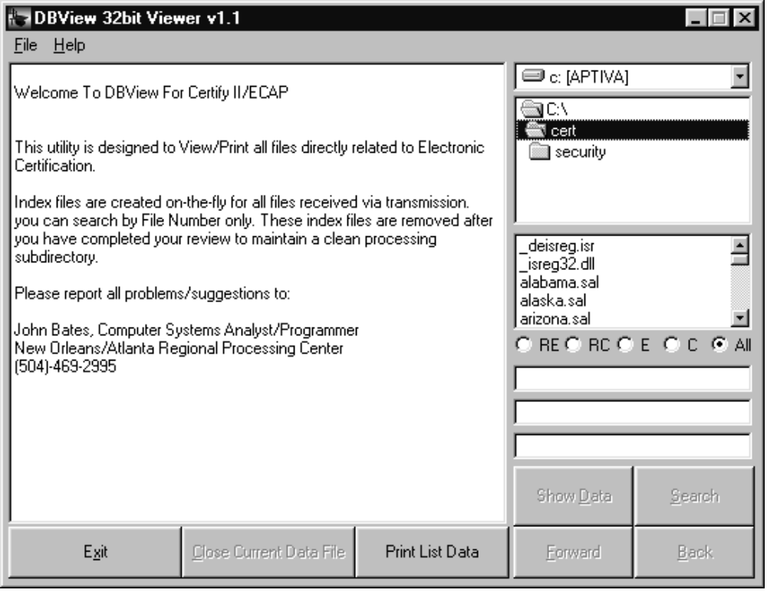

Figure 5.01. DBView Main Screen

b. Defaults. DBView defaults to the last drive and folder. The drive appears in the box in the upper right corner. See figure 5.02. To select another drive, click on the down arrow, high- light the drive, and double click. To select another folder, highlight the folder and double click.

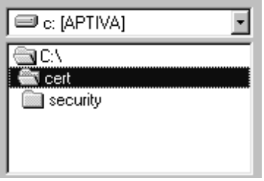

Figure 5.02. DBView Drive and Folders

c. Contents. The contents of the highlighted folder appear in the box below the folders. See figure 5.03. You can limit the display of the files in the highlighted folder with the Option Buttons.

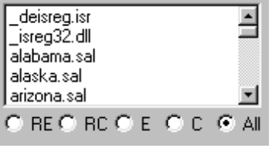

Figure 5.03. DBView Folder Contents

(1) Click “RE” to see transmission files containing enrollment certifications from schools using the DOS version of VACERT.

(2) Click “RC” to see transmission files containing notices of change in student status from schools using the DOS version of VACERT.

(3) Click “E” to see transmission files containing enrollment certifications from schools using the Windows version of VACERT.

(4) Click “C” to see transmission files containing notices of change in student status from schools using the Windows version of VACERT.

(5) Click “ALL” to see all files in the folder. This is the default setting.

d. Closing DBView. Select File and Exit or click “Exit” in the lower left corner of the screen to close DBView.

e. Help. DBView comes with a Help file with additional information.

5.02 DISPLAYING FILE STRUCTURE AND DATA

a. Selecting a File. Use the scroll bar or the up and down arrows to find the desired file. When the file is highlighted, double click it. The list box on the left side shows the file structure. The 3 boxes below the box with the files show the number of fields, number of records, and the record number. See figure 5.04.

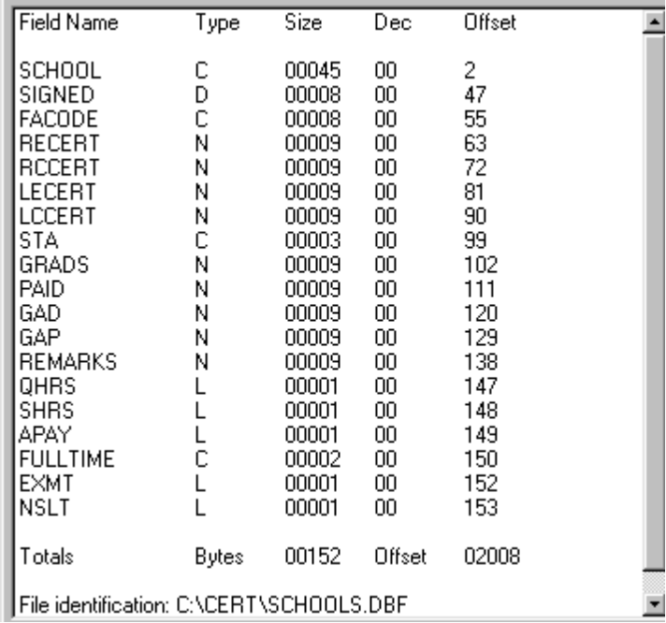

Figure 5.04. DBView List Box

b. File Structure. The list box shows field name, type (c - character, n - numeric, m - memo, d - date, or l - logical), size, number of decimal, and starting position. A total line shows the number of bytes in the file. The bottom line is the file identification. Some files include a brief description of the purpose of the file, file names, and key fields. The drive, folder, and file name are displayed on the title bar at the top of the screen.

c. Viewing the Data. You can view the data in a file. Click “Show Data” in the lower right corner of the screen. The list box shows the data in the fields in the selected record. You can scroll forward or backward through the records by clicking “Forward” and “Back” in the lower right corner of the screen. A message appears when you reach the first or last record in a file. Click “Show Structure” to the display of the file structure.

d. Printing. Click “Print List Data” on the bottom of the screen to print the data in the list box. Figure 5.05 shows a print of the data structure. Figure 5.06 shows the actual data.

(1) If the files in the list box are enrollment certifications or notices of change in student status, there are 2 print options. To print the data as it appears in the list box, click “Print List Data.” To print data in the VAF 22-1999-3, 22-1999-4, 22-1999b-2, or 22-1999b-3 formats, select File and Print Certification(s).

(2) A message appears asking if you want to print all records in the file, the displayed record, or to cancel the print request. Make the appropriate selection.

DBView Listbox Information

Field Name Type Size Dec Offset

SCHOOL C 00045 00 2
SIGNED D 00008 00 47
FACODE C 00008 00 55
LOGON C 00032 00 63
PASSWORD C 00016 00 95
DUMPIT C 00001 00 111

Totals Bytes 00110 Offset 00373

File Identification: c:\CERT\SECURITY\321LA.DBF

Figure 5.05 DBView List Box Information – Structure

DBView Listbox Information

SCHOOL XYZ COMMUNITY COLLEGE
SIGNED 05/11/1999
FACODE 14900420
LOGON VaCert
PASSWORD 14900420
DUMPIT

Figure 5.06 DBView List Box Information – Data

e. Closing File. Click “Close Current Data File” on the bottom of the screen to close a file.

5.03 SEARCHING

a. General. DBView can search a file for a particular record. The only prerequisite is that you must specify the field you want to use for the search.

b. Specifying the Field. Find the file you want to search. Double click it. Find the field in the list box you want to use for the search. Highlight the field and click the left mouse button. With the field highlighted, click the right mouse button. The DBView Index Management screen in figure 5.07 appears. If the field in the message is the one you want to use, click “Yes.” If it is not the desired field, click “No.” Go back to the list box and select the another field.

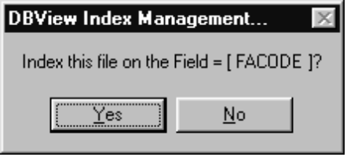

Figure 5.07 DBView Index Management Screen

c. Search Criteria. Click “Search.” The Trans File Viewer Quick Search screen in figure 5.08 appears. Enter the data. Click “OK” to start. If the search is unsuccessful, a message appears. The next record in the file appears. If the match is successful, the message appears saying that a partial or complete match was made. Click “OK.” The record appears.

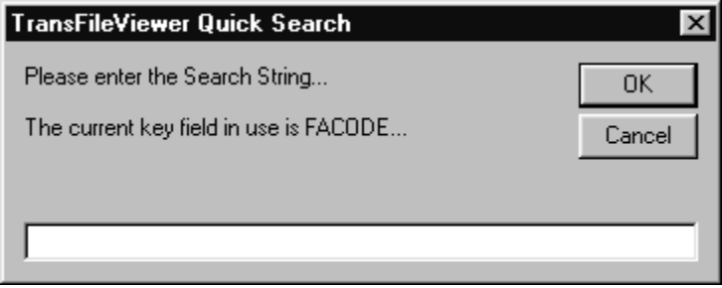

Figure 5.08 TransFileViewer Quick Search Screen

5.04 SPECIAL FEATURE

a. General. DBView has a feature to help maintain the Schools file used by ETHOST and ECAP. Double click on Schools.dbf. The School Clean Up screen in figure 5.09 appears. The number of schools in the file appears in the Record Count field. Checks appear next to Schools.Ntx, Station.Ntx, and Faccode.Ntx. If you do not want a file cleaned, remove the check. Click “Clean.” If you do not want to clean the files, click “Exit.” The data structure for the Schools.dbf file appears in the list box.

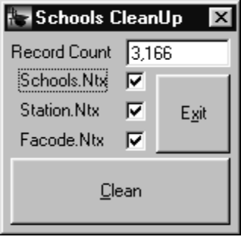

Figure 5.09 Schools Clean Up Screen

b. Cleaning. Click “Clean.” A caution message appears. Read the caution before continuing. Click “Yes.” After cleaning the files, the Clean Up screen appears with the Clean button grayed out. Click “Exit” and the Schools.dbf structure appears in the list box. Click “Cancel” and the Clean Up screen appears with the Clean button grayed out. Click “Exit” and the Schools.dbf structure appears in the list box.

“* * * * * * * * * * * * * * * * * * * * * * * * *”

“PALM BEACH COMMUNITY COLLEGE
RECOUNT – 29980
RECOUNT – 28589
LECOUNT – -11328
LCCOUNT – 10560”

“* * * * * * * * * * * * * * * * * * * * * * * * *”

Figure 5.10 Count Clean Up Log File

“* * * * * * * * * * * * * * * * * * * * * * * * *”
“HENDERSON STATE UNIVERSITY 11000204”
“* * * * * * * * * * * * * * * * * * * * * * * * *”

“* * * * * * * * * * * * * * * * * * * * * * * * *”
“JERSEY CITY STATE COLLEGE 11000230”
“* * * * * * * * * * * * * * * * * * * * * * * * *”

“* * * * * * * * * * * * * * * * * * * * * * * * *”
“KEAN COLLEGE 11000330”
“* * * * * * * * * * * * * * * * * * * * * * * * *”

Figure 5.11 Zero Count Schools Log File
CHAPTER 6. VA SYSTEM ADMINISTRATOR MANAGER

6.01 STARTING

a. Starting the VA System Administrator Manger. Select Start, Programs, and VaSaMgt or click the VA System Administrator Manager’s icon to start. The VA System Administrator Manager Main Menu in figure 6.01 appears.

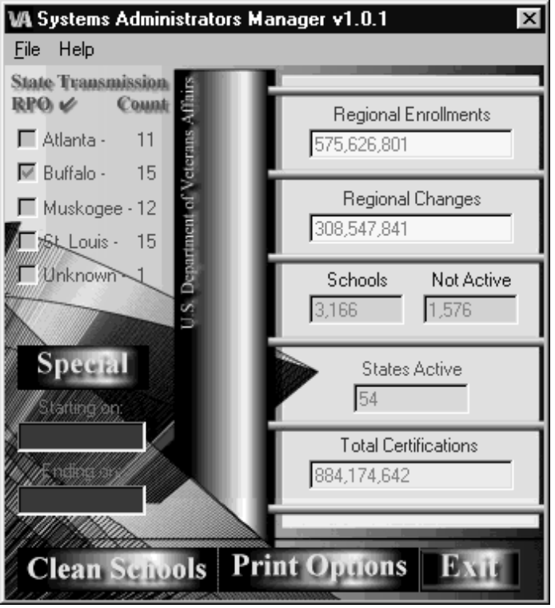

Figure 6.01. VA System Administrator Manager Main Menu

b. Initial Processing. The scroll bar at the bottom of the screen moves from left to right as VA System Administrator Manager compiles the data. When the scroll bar is finished, the bottom of the screen changes as shown in figure 6.01. The upper left corner of the screen shows a breakdown of participating schools by RPO. The fields on the right side of the screen show the number of enrollment certifications received, the number of notices of change in student status received, the number of schools in the Schools file, the number of schools that are not trans- mitting, the number of states with participating schools, and the total number of enrollments and changes received. The fields in the lower left corner of the screen are reserved for future use. “Clean Schools,” “Print Options,” and “Exit” buttons appear.

6.02 CLEANING SCHOOL RECORDS

To clean records, click “Clean Schools.” The VA System Administrator Manager checks each record in the Schools file. It looks for facility codes that are all one number (11111111), sequential numbers (12345678), and invalid characters (asterisks, hyphens, plus signs, under scores, etc.) in the codes (3-1-9001-20). It checks the date the MOU was signed. If the field is blank, it inserts the current date and reports it as an error. It checks for duplicated codes. If 2 records are found with the same IHL facility code, it removes one records. If errors are found, it generates a report specifying the nature of the problem. If “No” errors are found, a message screen appears.

6.03 GENERATING REPORTS

a. Print Options. Click ‘Print Options.’ The screen in Figure 6.02 appears. You have the option of requesting all reports or requesting the 4 individual reports. Click “Exit Report Options” to go back to the Main Menu.

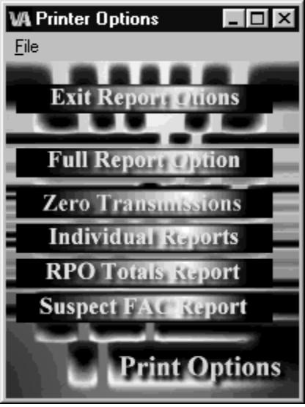

Figure 6.02. VA System Administrator Manager Printer Options Screen

b. Zero Transmissions Report. Click “Zero Transmissions” to generate the Zero Trans- missions report shown in figure 6.03. The report shows the facility code and name of the schools not transmitting to the RPO.

Schools with zero transmissions . . . Report Dated

“NO” TRANSMISSIONS FROM FACILITY CODE: 11007733 SOUTHERN ILLINOIS UNIVERSITY
“NO” TRANSMISSIONS FROM FACILITY CODE: 11018710 CENTRAL MICHIGAN UNIV NAS JAC
“NO” TRANSMISSIONS FROM FACILITY CODE: 11050410 SOUTHERN ILLINOIS UNIV AT NTC
“NO” TRANSMISSIONS FROM FACILITY CODE: 11901518 NORTHEAST LOUISIANA UNIVE.
“NO” TRANSMISSIONS FROM FACILITY CODE: 14821511 GEORGIA MILITARY COLLEGE

Figure 6.03. Zero Transmissions Report

c. Individual Reports. Click “Individual Reports” to generate the Individual Report shown in Figure 6.04. VA System Administrator Manager generates a separate report for each state in the RPO’s jurisdiction. The report shows the name and facility code of each registered school. If the school has transmitted, the right column shows Active. If the school has not trans- mitted, the right column shows Not Active.

State Listing for ALABAMA – Report Dated

UAB, SCHOOL OF PUBLIC AND ALLIED HEALTH 11011501 ACTIVE
JACKSONVILLE STATE UNIVERSITY 11505001 ACTIVE
TROY STATE UNIVERSITY PHENIX CITY 11800501 ACTIVE
UNIVERSITY OF ALABAMA – SCHOOL OF LAW 11906301 NOT ACTIVE
TROY STATE UNIVERSITY SCHOOL OF NURSING 11963201 ACTIVE
CENTRAL ALABAMA COM COL – ALEX CITY 14002301 ACTIVE
LURLEEN B WALLACE ST JUNIOR COLLEGE 14002701 NOT ACTIVE
CALHOUN COMMUNITY COLLEGE 14918401 ACTIVE
LAWSON STATE COMMUNITY COLLEGE, IHL 14922401 ACTIVE

Figure 6.04. Individual Report

d. RPO Totals Report. Click “RPO Totals Report” to generate the RPO Totals Report shown in Figure 6.05. The report shows the same data that appears on the VA System Administrator Manager’s Main Menu in figure 6.01.

RPO Totals – Report Dated

TOTAL SCHOOLS . . . . . .. . . . . . : 816
TOTAL ENROLLMENTS . . . . . . : 439,850
TOTAL CHANGES . . . . . .. .. . . . : 156,408
TOTAL CERTIFICATIONS. . . . . .: 596,258
SCHOOLS W/ZERO TRANS . . . . : 378
SCHOOLS TRANSMITTED . . . . .: 15

Figure 6.05. RPO Totals Report

e. Suspect Facility Codes Report. Click “Suspect FAC Report” to generate the Suspect Facility Codes report shown in Figure 6.06. VA System Administrator Manger checks the last 2 digits of the facility code. If the last 2 digits are between 51 and 62 or greater than 67, the report shows the facility code and name of the school. Use OLAF to check the school’s facility code.

Suspect Facility Codes – Report Dated

SUSPECT FACILITY CODE: 24922152 DRAUGHTONS JUNIOR COLLEGE – NCD

Figure 6.06. Suspect Facility Codes Report
CHAPTER 7. TROUBLE SHOOTING

7.01 ETHOST PROBLEMS

Should ETHOST stop working for any reason, shut down the program and reboot the PC. This should resolve most problems. If school officials call the RPO to report problems with the VACERT 800 number (1-800-956-vets) (1-800-956-8387), the person answering the telephone should obtain the name and telephone number of the person calling. Check the ETHOST PC to determine if it is currently waiting for a call, receiving a call, or is hung up. If the Modem Download screen in figure 2.07 above appears with the scroll bar not moving, click “Cancel.” If the ETHOST Main Menu in figure 2.01 above appears and the box at the top does not show “Waiting For a Call,” click “ReSet” on the right side of the screen. If possible, have the school official try to resend the file while you stay on the telephone and watch the ETHOST PC. If the problem continues, take the necessary action to have both the VACERT 800 number and the local telephone lines check to determine if they are in working order. Report problems with ETHOST to the programmer. Report problems with the VACERT 800 number to the Education Service Procedures Staff (224B). Please have the school’s telephone number and inquire whether the school has a new area code before you call in with an 800 number problem.

7.02 ECAP PROBLEMS

a. General. If an ECAP PC stops processing, a screen appears. The corrective action depends upon the message that appears.

(1) Problem: BDN Unavailable

Explanation: If one or more of the education chapters are not available, ECAP stops processing. ECAP attempts to resume processing 3 times in 8 minutes. A message box appears on the ECAP Main Menu saying that the BDN is unavailable.

Corrective Action: Contact the RPO’s STO (Supervisory Terminal Operator).

(2) Problem: Softerm Error

Explanation: If a Softerm error occurs, ECAP cannot continue processing.

Corrective Action: Reboot the ECAP PC.

(3) Problem: “This program has performed an illegal operation and should be shut down.”

Explanation: The message screen shows the name of the program that caused the general protection fault. Click Details for an explanation of the general protection fault and make a note of the program that caused the illegal operation. If Softerm caused the illegal operation, contact the RPO’s IRM staff for assistance.

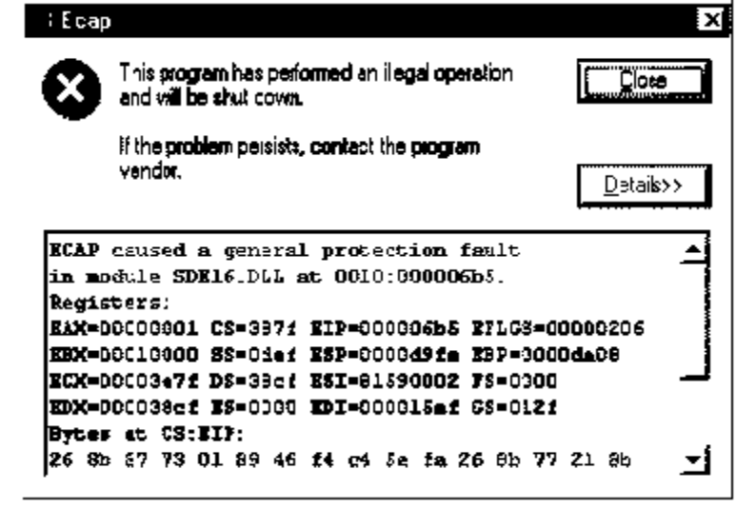

Figure 7.01. Illegal Operation Message

Corrective Action: Shut down all programs and reboot the ECAP PC.

(4) Problem: Run Time Error

Explanation: The run time error displays a number. Make a note of the number. Clicking on “OK” automatically shuts down ECAP.

Corrective Action: Restart ECAP.

(5) Problem: Recurring Run Time Error

Explanation: The run time error displays a number. If the error continues to appear, contact one of the ECAP technicians for assistance.

Corrective Action: Contact ECAP technician.

b. Restarting ECAP. If you try to restart ECAP, the Continue Processing screen in figure 7.02 appears. Click “Yes” to restart ECAP.

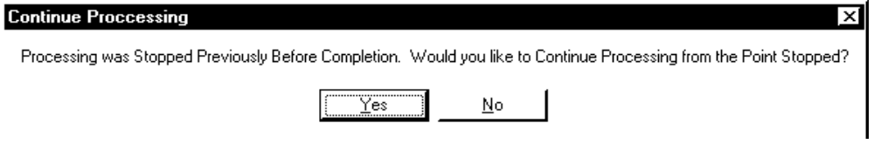

Figure 7.02. ECAP Continue Processing Screen

c. Failure to Copy Data to Server. If an ECAP PC fails to copy any of the necessary data to the server, the SA should execute “V:\Programs\Ecapnet.Exe End.”

APPENDIX A. PENDING ISSUE MAN

Pending Initialization File

The Pending Initialization file is located in the C:\Windows sub directory. It contains the initialization information that the program needs to execute successfully. The entries and their meanings are listed below. All entries are under the section [INIT].

Process – This indicates the program type to be processed. The only valid entry is:

106 – The program will only process and report on Chapter 1606. After all Chapter 1606 type records are processed, the file will be reset.

Auto – This allows the program to auto-start when you execute it or to wait for you to start it after execution begins. Valid entries are:

0 – When execution is started, the program waits for you to press GO before starting.

1 – When execution starts, processing starts automatically.

Source – This drive and sub directory contain the Pendissu.spl file.

Data – This drive and sub directory contain the Pending.MDB and New.MDB files.

Logon – This is the logon name for BDN access.

Pass – This is the logon password for BDN access.

Command – This is the 4 character command password for BDN.

MGW – This is the MGW number that is being used for BDN.

NOTE: This number should be the same number contained in the file MGW.INI.

Disp – Disp'ing 'location'

Folder – Folder with claim? (Y or N)

Other Files

Pending.Exe – This is the executable program.

Pending.Mdb – This file contains the data for Pending Issue Man.

New.Mdb – This is an empty file that is copied over the Pending.MDB to reset the file.

Mgw.Ini – Located in the C:\Windows sub directory, this contains the MGW (Migration Gate- Way) number to open the BDN window.

Targ-Ses.Exe – Located in the C:\Windows sub directory, this program starts a BDN session using the MGW number specified in the MGW.INI.

*.Ldb – Any file(s) of this type are created and used by Access. All files are Access 2.0.

Operations

Assumptions : – The PC is connected to the ECAP server.
– The data drive and sub directory for the *.MDB files are C:\Pending.
– The Pending Issue program was installed in C:\Pending.
– The AUTO setting in the Pending.ini is 1. (ON).

A chapter 1606 pending issue file is created by each ECAP PC during processing and uploaded to the ECAP server. The ECAP server combines the chapter 1606 pending issue files created by the PCs into a consolidated file (V:\NETPROC\SPOOL\PENDISSU.SPL).

Execute Pending.exe by double-clicking on the Pending Issue Man icon. This starts the program.

Once finished, close the BDN window. You will know when it finishes because the status window disappears.

Anytime during the process, click the STOP button in the Pending Issue Man window to end processing.

How It Works

Processing Input File – The Pendissu.spl is ONLY processed if the file has been reset. Resetting the file is done when the processing is complete. The file Pendissu.spl is read and records are created for each file number.

Starting BDN – A BDN window is started and logged on to by the program. The logon name and password are set in the Pending.Ini.

Processing Transactions Through BDN – Each record is processed in the following manner:

Pending Issue Man searches for a record with a 0 status. If it is not found, it goes to the reports section.

A Ready screen is requested from BDN. The status is changed to 1 for that record.

The data from the record is used to complete the Ready screen with a CEST command to establish an end product 280. (The command password is obtained from the Pending.Ini).

The program determines if any error is detected. If there is, it is recorded, the status is changed to 9, and processing continues.

NOTE: If the stub name is incorrect, it is retrieved from the error message on the Ready screen and processing starts over for that record. If a DOD screen is detected, the case is DISP’ed to ADJUD, and processing continues. This prevents the case from being locked in use.

The CEST screen is completed and executed using the current date and DISP’ed to ADJUD.

Pending Issue Man determines if any errors are detected. If there are, the errors are recorded and the status is changed to 9. If the processing was successful, the status is changed to 2.

During this process, each transaction is timed and the time is recorded. Any record that was not successfully processed has the status changed to 9 and the error information is recorded.

Reporting – After processing, Pending Issue Man generates 2 reports, a Processing Report and a Detail Report.

The Processing Report shows the total number of records and the status of the records.

The Detail Report shows the disposition of each record. The fields are listed below:

1. FILE “NO” – File number

2. STUB NAME – Stub name that was used

3. STAT – The status of the record.
a. 0 – Not processed yet
b. 1 – Stopped in middle of processing record
c. 2 – Processed Successfully
d. 9 – Processed with error

4. TIME – The number of seconds it took to process record

5. ERR – The error code if there was an error. See Error Codes for details.

6. ERROR MESSAGE – The message corresponding to the error code.

CLEANING UP - If all data has been processed, the file is reset and is ready for another PendIssu.Spl file.

Chapter 1606 Error Codes And Results

The codes listed below correspond to the ERR column on the Detail Report. If the code is more than 0, the program detected an error in processing that case and it was not processed.

0 – “No” Error – “No” error was detected.

1 – “No” Ready Screen Found – The BDN did not respond with a Ready screen after the F8 key was transmitted.

2 – Other Error on Ready Screen – After the Ready screen was completed and transmitted, the BDN responded with a message on the Ready screen that was not recognized by Pending Issue Man. The detail report contains the message.

3 – CEST Required – Not used.

4 – Duplicate 280 – A end product 280 already exists for this case. The BDN displayed an S02 screen when the Ready screen was completed and transmitted.

5 – Not 1606 – “No” Chapter 1606 master record was found when the case was MINQ’d.

6 – 8 Digit Claim Number (Not 1606) – The case had an 8 digit claim number that is set to automatically be skipped in processing 1606 cases.

7 – Unknown CEST Screen – After the Ready screen was completed and transmitted, the BDN displayed a screen that the program did not recognize.

8 – S02 Screen – After the Ready screen was completed and transmitted, the BDN displayed a S02 screen instead of a CEST screen.

9 – Other – Anything other than above errors.

System Administration

Pending Issue Man needs a BDN account with the CADJ-EDU, MINQ, CEST, and CADD commands.

Log on with this account to establish a logon password. Once established, enter the logon name, logon password, and command password in the Pending.Ini file.

BDN requires a change of the logon password every 30 days. Reset the BDN password every 3 weeks manually and make any necessary changes to the Pending.Ini file. If this is not done, the program will not be able to access BDN until it is. This program will NOT make the password changes on its own.

NOTE: After you reset the BDN logon password, immediately logon to BDN to establish the new password.

Problem Solving

Pending Issue Man was written to handle the errors it encountered. There are some problems that could arise from improper setting in the INI files.

Problem | Suggestions
Cannot login to BDN | • Make sure the settings in the PENDING.INI file are correct.
 | • Check the MGW.INI file to make sure that number equals the MGW setting in the PENDING.INI file.
The records are not being read into the file from the PENDISSU.SPL file | • The file reset did not occur. You can reset manually by copying the NEW.MDB to the PENDING.MDB.
Pending Issue Man cannot find a file | • Check the PENDING.INI file and make sure that the directories are correct

