 | Itemization of HUD-1 lines
“801, 802, & 803”
VA Case Number: | XX-XX-X-XXXXXXX (VA #)
Item: | 801 “Our Origination Charge”
1 | Origination Fee | $1,000
2 | Lender Paid Broker Compensation Fee | $1,700
3
4
 | Total | $2,700
Item: | 802 “Your credit or charge (points)”
1 | Discount Points | $1,200
2 | Lender Paid Broker Compensation Fee | $-1,700
3
4
 | Total | $-500
Item: | 803 “Your Adjusted Origination Charge”
1 | Line 801 | $2,700
2 | Line 802 | $-500
 | Total | $2,200
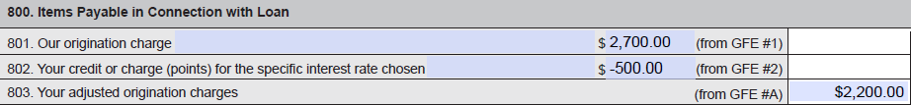

4

