Statutory Bar to Benefits and Character of Discharge (COD)

Overview

In this Section | This section contains the following topics:  Topic Topic Name See Page  5 Character of Discharge (COD) Determinations 1-B-2  6 Statutory Bar to Benefits 1-B-13  7 Discharges Considered to be Issued Under Other Than Honorable (OTH) Conditions 1-B-16  8 COD Determinations and Healthcare 1-B-18  9 Conditional Discharges and Uncharacterized Discharges 1-B-21  10 Clemency, Upgraded, and Discharge Review Board (DRB) Discharges 1-B-30  11 Processing DRB Decisions 1-B-35

5. Character of Discharge (COD) Determinations

Introduction | This topic contains general information on character of discharge determinations, including  - character of discharge (COD) requirement for benefit eligibility  - when COD is binding on VA  - formal findings required for other than honorable discharges  - when it is not necessary to make a COD determination  - responsibility for development of evidence  - responsibility for COD determinations  - overview of COD determination process  - requesting facts and circumstances  - sufficient facts and circumstances for a COD determination  - insufficient facts and circumstances for a COD determination, and  - COD determination template.

Change Date | August 21, 2014
Continued on next page
5. Character of Discharge (COD) Determinations, Continued

a. COD Requirement for Benefit Eligibility | A Veteran’s character of discharge (COD) must be under other than dishonorable conditions to establish eligibility for Department of Veterans Affairs (VA) benefits based on that individual’s military service.  A dishonorable discharge or a statutory bar deprives a claimant of all VA benefits.  Exception: A dishonorable discharge or statutory bar is not binding on VA if it is determined that the individual was insane when committing the acts which resulted in the discharge.  Note: A COD under other than honorable (OTH) conditions is not the same as dishonorable and does not deprive the claimant of all benefits.  References: For more information on  - conditions of discharge and eligibility for VA benefits, see  - 38 CFR 3.12, and  - 38 CFR 3.13, and  - insanity, see  - M21-1MR, Part III, Subpart v, 1.E, or  - 38 CFR 3.354 (b)  - statutory bar, see M21-1MR, Part III, Subpart v, 1.B.6  - the definition of the term Veteran, see  - 38 CFR 3.1(d), or  - 38 U.S.C. 101(2).
Continued on next page
5. Character of Discharge (COD) Determinations, Continued

b. When COD is Binding on VA | An individual is entitled to full rights and benefits of programs administered by VA, unless there is a bar to benefits under 38 U.S.C. 5303(a). Normally, the military’s characterization of service is binding on VA if the discharge is  - honorable  - under honorable conditions (UHC), or  - general.  Note: The characters of service listed above are binding on VA, irrespective of the separation reason. For example, if the separation reason is “drug use,” but the characterization of service is under honorable conditions, the character is service is still binding on the VA and no COD determination should be made.  Exception: Records added to BIRLS from the Veterans Assistance Discharge System (VADS) after October 16, 1975, include the reason for separation. Further development of circumstances of discharge is required, even if there is indication that character of discharge was honorable or general, if the reason code shown in the corporate record is  - T38 (possible Title 38 bar to VA benefits)  - 953 (clemency discharge)  - BEO (by executive order), or  - DRO (discharge review under other than honorable conditions).
Continued on next page

5. Character of Discharge (COD) Determinations, Continued

c. Formal Findings Required for OTH Discharges | A formal COD determination is required when the Veteran’s discharge is one of the following:  - an undesirable discharge  - an OTH discharge, or  - a bad conduct discharge.  Important: Review the issue of “Veteran status” prior to making a COD determination. Determinations of status as a Veteran must be supported by a preponderance of the evidence. See 38 CFR 3.1(b) for the definition of Veteran.  The reasonable doubt rule of 38 CFR 3.102 does not apply in determinations of status. In Laruan v West, No. 96-179, the Court of Appeals for Veterans Claims (CAVC) discussed a claimant’s need to establish Veteran status before he or she can enjoy the more favorable evidentiary criteria under the reasonable doubt rule.
Continued on next page
5. Character of Discharge (COD) Determinations, Continued

d. When it is Not Necessary to Make a COD Determination | It is not necessary to make a COD determination for VA claim purposes  - before the claimant applies to the Veterans Benefits Administration (VBA) and places the matter at issue, or  - if there is a separate period of honorable service, which qualifies the person for the benefits claimed  Exception: A COD determination may be made prior to a claimant’s application for VBA benefits, as noted in M21-1MR, Part III, Subpart v, 1.B.5.f  Note: If there is any question regarding which period of service would qualify the person for the benefits claimed, a COD determination must be made before a rating decision can be completed.

e. Responsibility for Development of Evidence | The Veterans Service Representative (VSR) has the responsibility for development of all necessary evidence and preparation of administrative decisions for issues discussed in this chapter.  Reference: For more information on the actions required before and after a COD determination, see M21-1MR, Part III, Subpart v, 1.A.4.

f. Responsibility for COD Determinations | The VSR is responsible for determining if an OTH discharge was granted under honorable conditions for VA purposes (HVA) for eligibility to all VA benefits.  Note: Upon request, the VSR makes these determinations for other entities, such as the  - Department of Veterans Affairs Health Administration (VHA),  - U.S. Department of Labor  - U.S. Railroad Retirement Board, and  - State agencies.  References:  - For information on requests to, or from, other Federal and State agencies, see M21-1-MR, Part III, Subpart iii, 4.  - For information on responsibilities of the VSR, see M21-1MR, Part III, Subpart i, 1.4.f.
Continued on next page

5. Character of Discharge (COD) Determinations, Continued

g. Overview of COD Determination Process | Follow the steps in the table below when a COD determination is needed.  Important: Strictly observe the due process provisions listed in 38 CFR 3.103 and M21-1MR, Part I, Chapter 2.

Step | Action
1 | If the discharge at issue is not specifically honorable, under honorable conditions, or general, send a request to the service department for the complete summary of the facts and circumstances and proceedings pertaining to the discharge.  References: For more information on requesting facts and circumstances see M21-1MR, Part III, Subpart v, 1.B.5.h
2 | Make a formal determination.  Important:  - In any COD determination, there must be, minimally, a finding that the issue of the Veteran’s sanity is not involved.  - If the Veteran had more than one period of consecutive service, include information covering the periods of satisfactory as well as unsatisfactory service in the determination.  Note: Vietnam Era Special Upgraded Discharges require special consideration before a formal determination.  References: For more information on  - Vietnam Era Special Upgraded Discharges, see M21-1MR, Part III, Subpart v, 1.B.11.  - insanity, see  - M21-1MR, Part III, Subpart v, 1.E, or  - 38 CFR 3.354 (b).
3 | Prepare the formal determination for the approval of the Veterans Service Center Manager (VSCM) or designee not lower than a coach.  Reference: For more information on preparation of a formal administrative decision, see M21-1MR, Part III, Subpart v, 1.A.
Continued on next page
5. Character of Discharge (COD) Determinations, Continued

h. Requesting Facts and Circumstances | It is always necessary to request the facts and circumstances surrounding the claimant’s discharge prior to making a formal decision.  Request facts and circumstances using Personnel Information Exchange System (PIES) or Defense Personnel Records Information Retrieval System (DPRIS), as appropriate.

i. Sufficient Facts and Circumstances for a COD Determination | The service department generally provides sufficient facts and circumstances to make an administrative decision when discharge or dismissal is due to any of the following reasons:  - the person was a conscientious objector who refused to perform military duties, wear the uniform, or otherwise comply with lawful orders of competent military authorities  - sentence issued by a General Court Martial (GCM)  - resignation of an officer for the good of the service  - the reason for discharge was desertion  - the discharge was for alienage, or  - an unauthorized absence (UA) or absence without leave (AWOL) for a continuous period of 180 days or more.  Exception: If insanity becomes an issue, full and complete development of information pertaining to the discharge, including but not limited to Service Treatment Records (STRs) and the complete military personnel file, is needed.  References: For more information on  - insanity, see  - M21-1MR, Part III, Subpart v, 1.E, and  - 38 CFR 3.354 (b)  - cases in which discharge was for alienage, see M21-1MR, Part III, Subpart v, 1.B.6.c, and  - cases of UA or AWOL, see M21-1MR, Part III, Subpart v, 1.B.6.d, and  - developing for facts and circumstances, see M21-MR, Part III, Subpart v, 1.B.5.h
Continued on next page
5. Character of Discharge (COD) Determinations, Continued

j. Insufficient Facts and Circumstances for a COD Determination | Occasionally the service department will provide only limited facts and circumstances. Make a determination using all the evidence in VA’s possession.

k. COD Determination Template, Segment 1 | Displayed in this and the remaining blocks of Topic 5 is a template for COD determinations. It contains all possible paragraphs and language that may be included in the determination depending on the facts of the particular case.  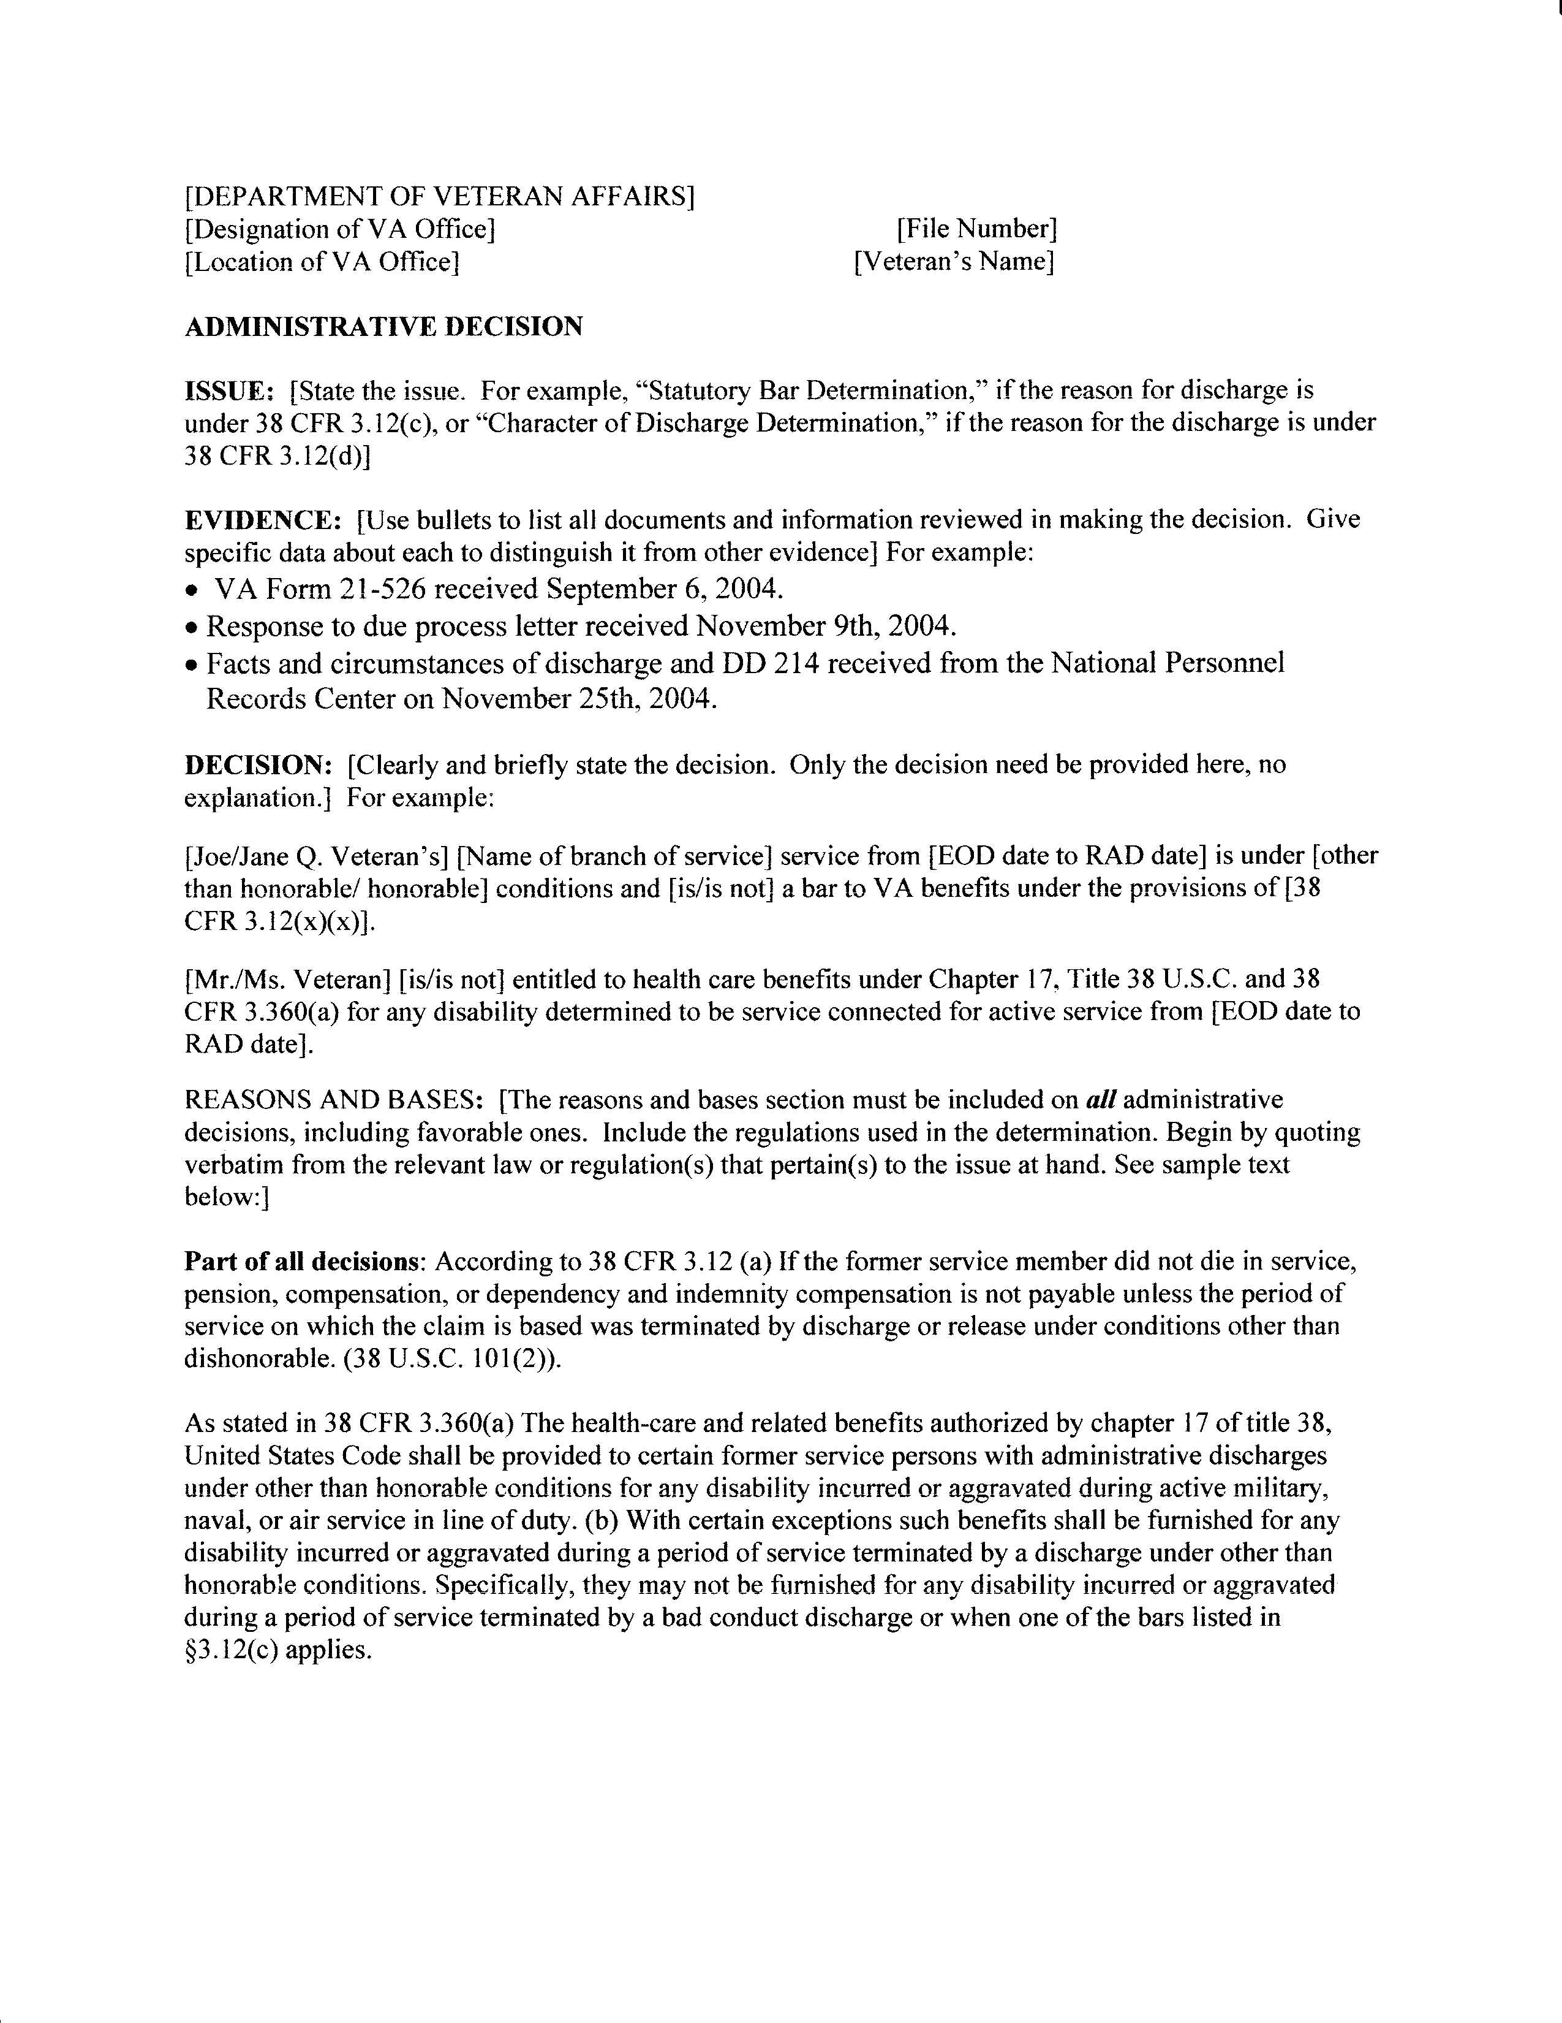
Continued on next page

5. Character of Discharge (COD) Determinations, Continued

l. COD Determination Template, Segment 2 | Below is an image representing Segment 2 of the template for COD determinations.  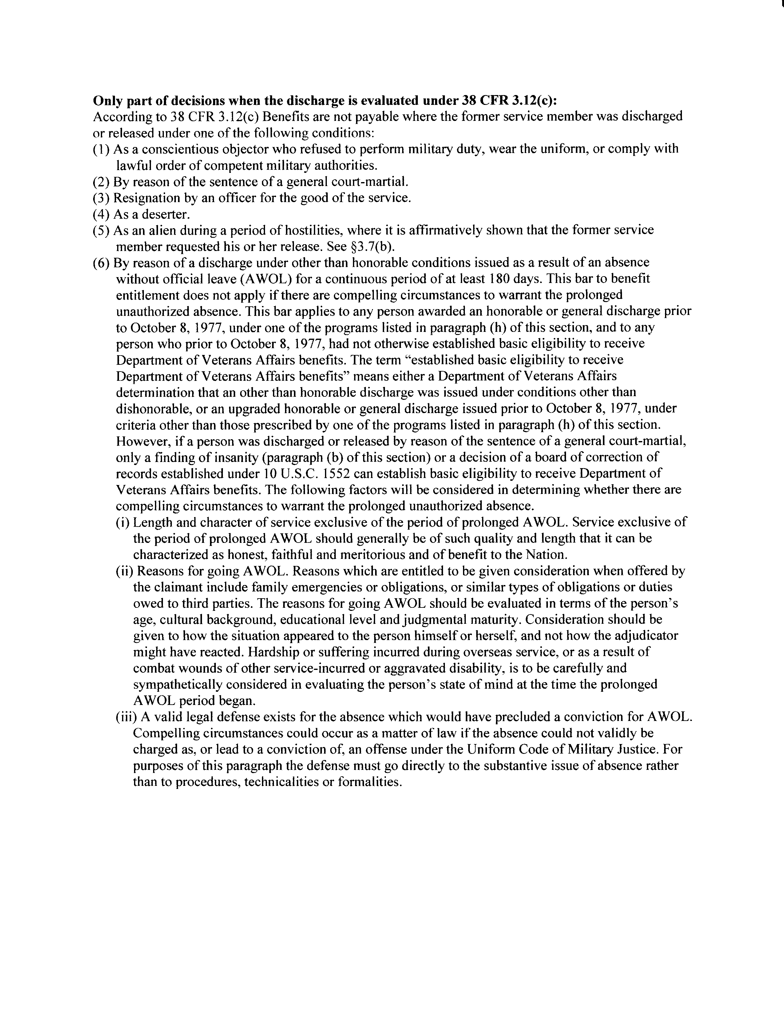
Continued on next page

5. Character of Discharge (COD) Determinations, Continued

m. COD Determination Template, Segment 3 | Below is an image representing Segment 3 of the template for COD determinations.  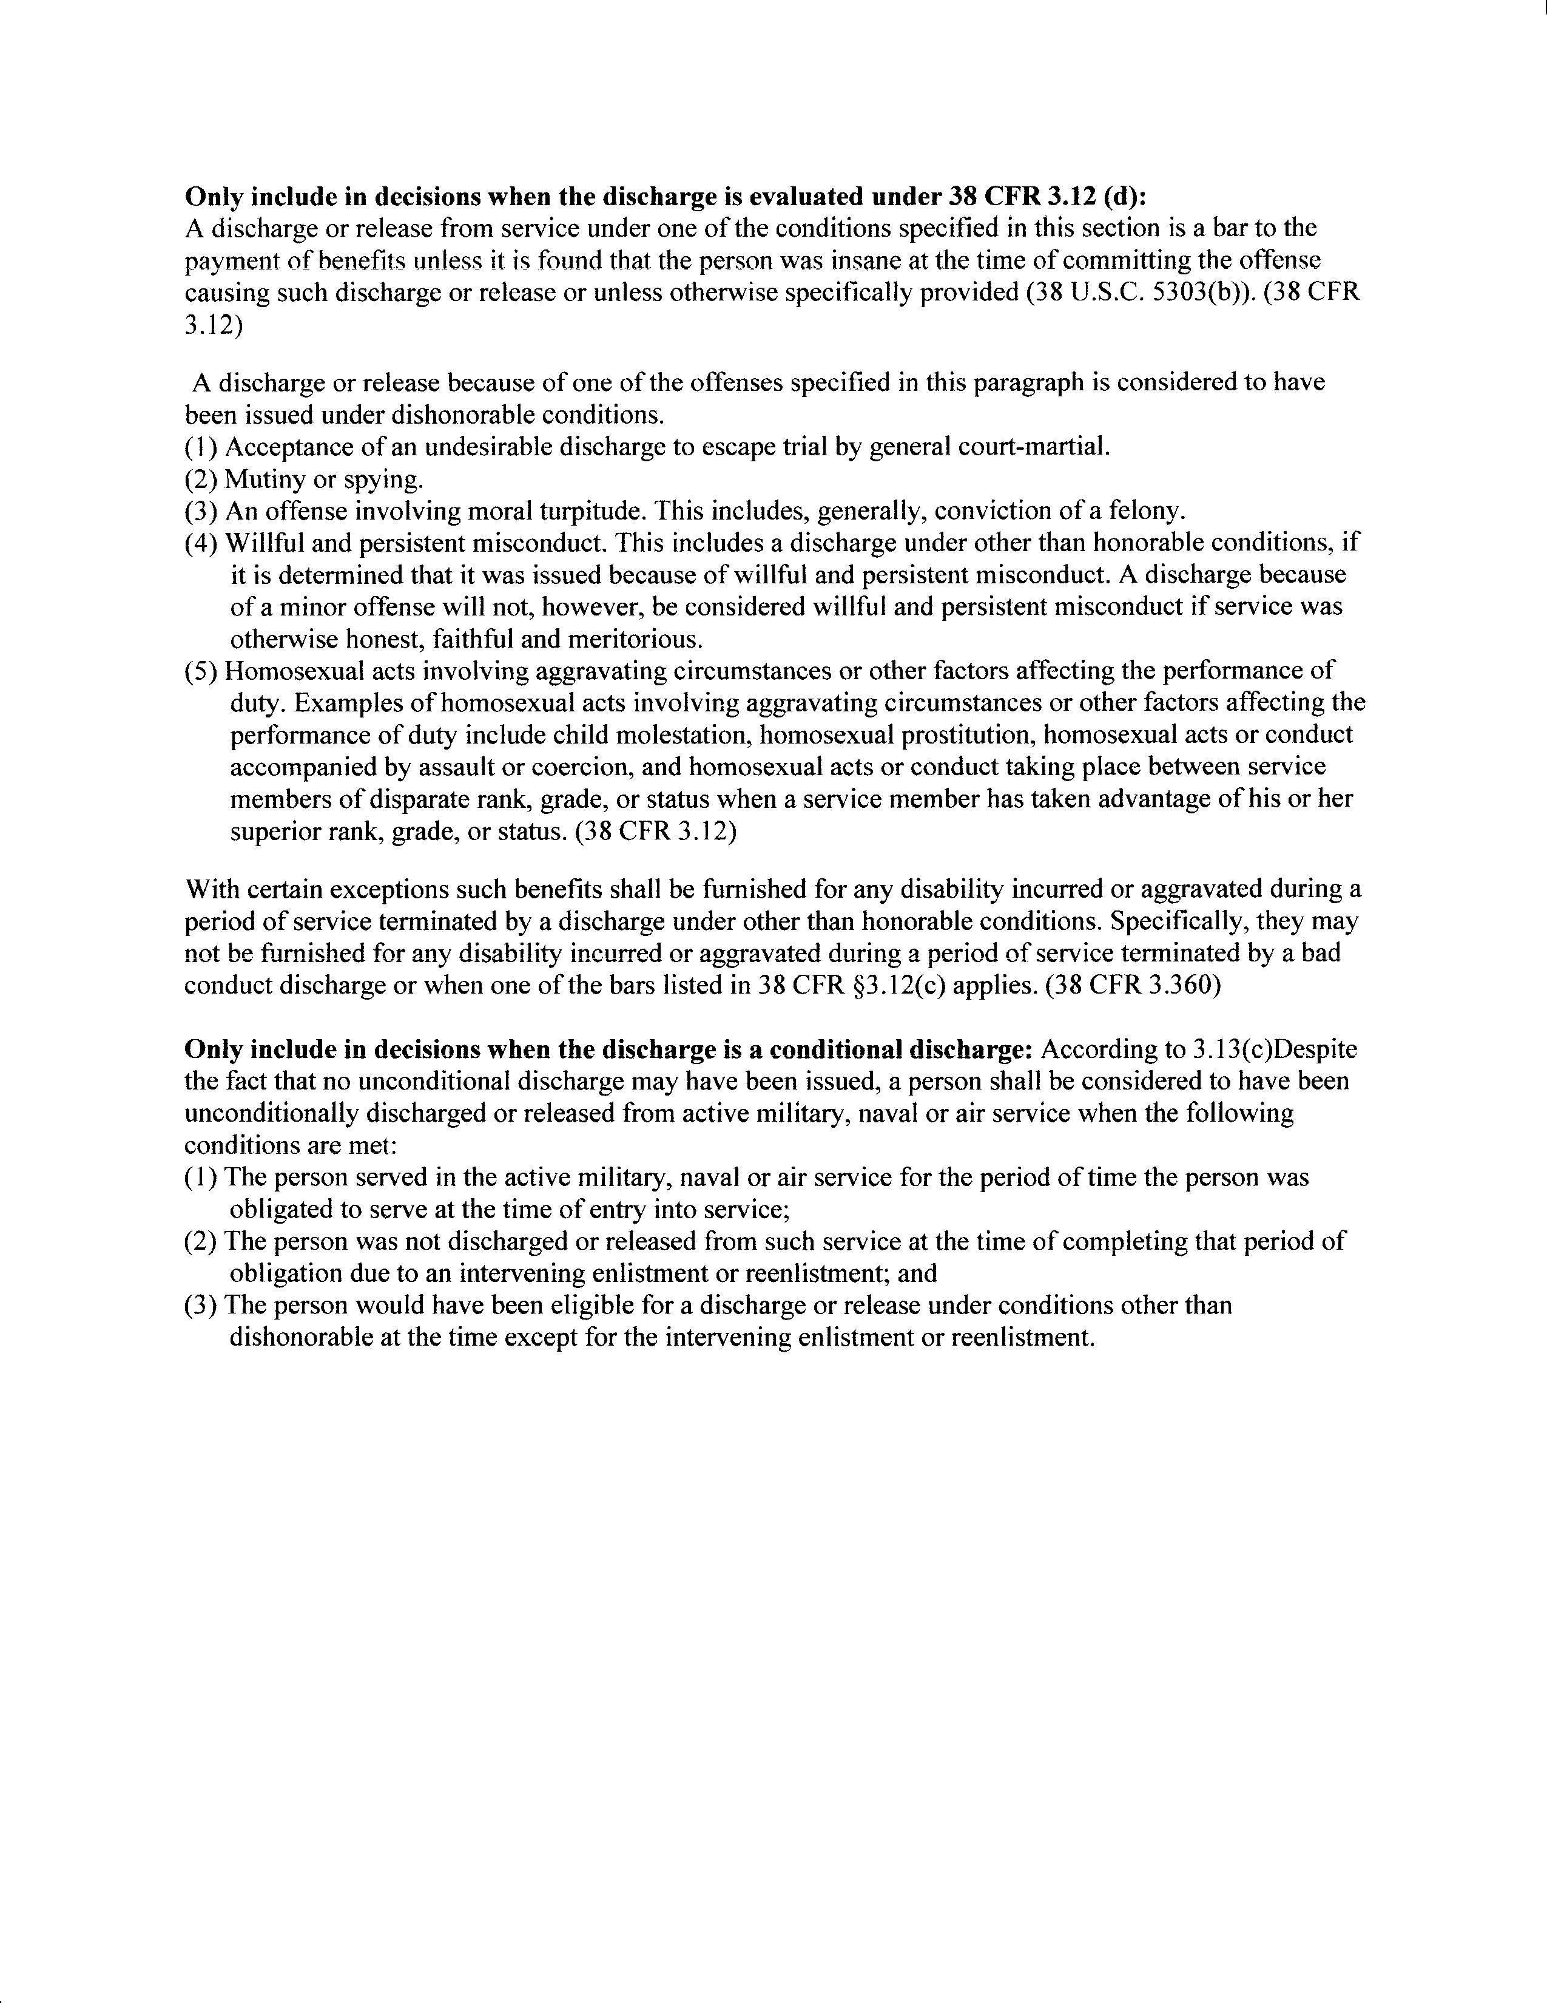
Continued on next page

5. Character of Discharge (COD) Determinations, Continued

n. COD Determination Template, Segment 4 | Below is an image representing Segment 4 of the template for COD determinations.  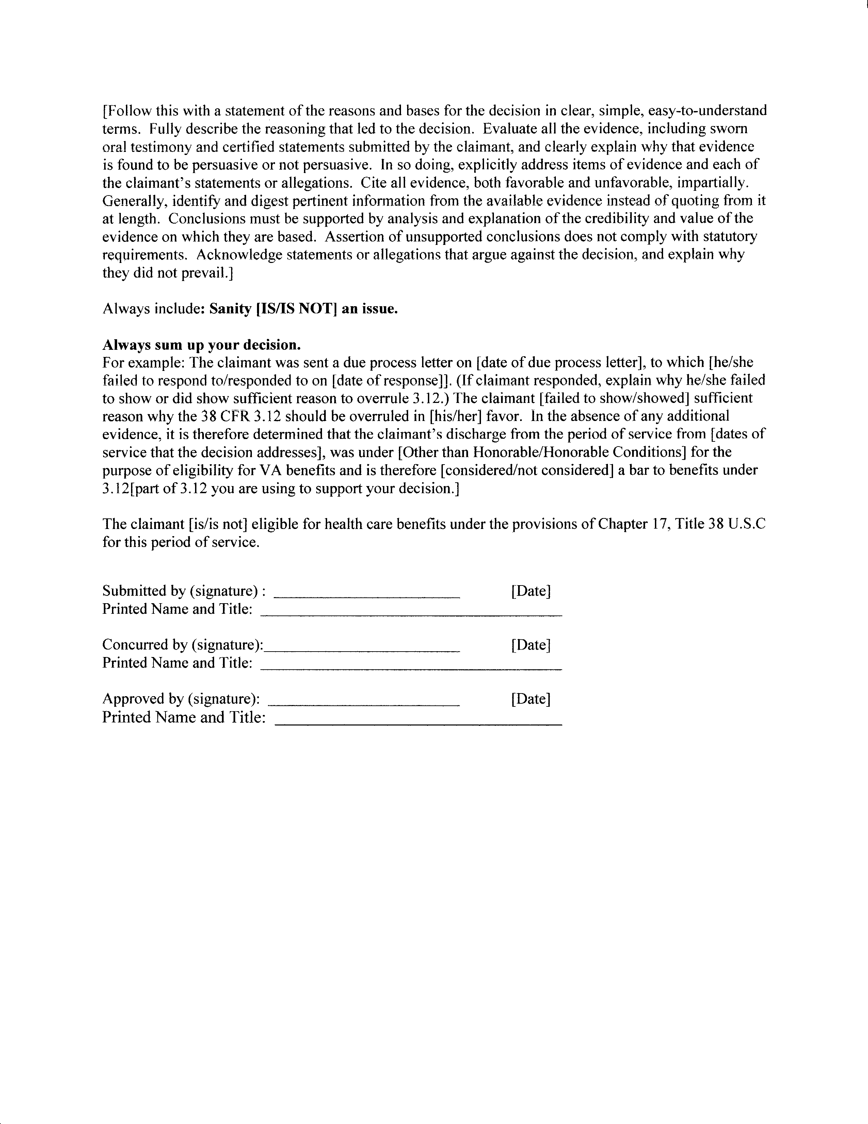

6. Statutory Bar to Benefits

Introduction | This topic contains information on the statutory bar to benefits, including  - bars established by 38 CFR 3.12(c)  - additional information on discharge  - by the sentence of a General Court-Martial (GCM),  - for alienage, and  - for unauthorized absence (UA) or absence without official leave (AWOL).

Change Date | August 21, 2014

a. Bars Established by 38 CFR 3.12(c) | A statutory bar to benefits is established any time a COD determination finds that the reason the discharge or release was under any of the conditions listed in 38 CFR 3.12 (c) Some examples of discharges under 38 CFR 3.12 (c) include  - as a conscientious objector  - sentence of a General Court-Martial (GCM)  - resignation by an officer for the good of the service,  - an alien during a period of hostilities,  - absence without official leave (AWOL) for continuous period of at least 180 days, and  - as a deserter.

b. Additional information on Discharge by the Sentence of a General Court-Martial | Cases in which the facts indicate the service member was sentenced by a GCM are considered to be a statutory bar to benefits.  Note: The evidence, including facts and circumstances, must show that the service member was sentenced by a general court-martial, not a summary court-martial or a special court-martial.
Continued on next page

6. Statutory Bar to Benefits, Continued

c. Additional Information on Discharge for Alienage | If there was a discharge during a period of hostilities that was not changed to honorable prior to January 7, 1957, determine if the records show that the Veteran requested the discharge. If the record  - shows that the Veteran requested the discharge, it is a bar,  - does not show that the Veteran requested the discharge, make a specific request to the service department for this information.  Note: The absence of affirmative evidence in the service department’s reply or in the claims folder showing that the Veteran requested the release is a sufficient basis for a favorable decision.  Reference: For more information on discharge for alienage, see 38 CFR 3.7(b).

d. Additional information on Discharge for UA or AWOL | Follow the steps in the table below to determine the action to take if a discharge was issued under OTH conditions, and there was a continuous period of 180 or more days of either an unauthorized absence (UA) or AWOL.

Step | Action
1 | As with all COD determinations, send the claimant a due process letter and request facts and circumstances via PIES or DPRIS, as appropriate.  Reference: For more information on due process letters, see M21-1MR Part I, chapter 2.
2 | Review the information collected via facts and circumstances to confirm that it includes the exact dates and nature of the lost time.  Reference: For more information on UA or AWOL, see 38 CFR 3.12(c)(6).
Continued on next page

6. Statutory Bar to Benefits, Continued

d. Additional information on Discharge for UA or AWOL (continued)

Step | Action
3 | If the service department confirms a continuous period of 180 or more days of UA or AWOL (exclusive of periods  of imprisonment or confinement) which led to the OTH discharge, and the claimant didn’t provide compelling reasons for the absence, then deny benefits.  Note: “Time Lost” as listed on the DD Form 214, Certificate of Release or Discharge from Active Duty, is not sufficient to determine the number of days of UA or AWOL, because it does not reflect periods of imprisonment or confinement and does not typically indicate if the days absent were continuous.
4 | If the claimant provided compelling reasons for the absence but our decision is ultimately unfavorable, make the issue in the formal decision “Statutory Bar Under 38 U.S.C. 5303(a)” rather than “Character of Discharge,” and use the following as the Conclusion: “The discharge for the period [date] to [date] is a bar to VA benefits under the provisions of 38 CFR 3.12(c)(6) and 38 U.S.C. 5303(a).”  Important: Do not make a separate decision concerning character of discharge since 38 CFR 3.12(a) is not an issue.

Reference: For more information on identifying upgraded discharges, see M21-1MR, Part III, Subpart v, 1.B.10.c.

7. Discharges Considered to be OTH

Introduction | This topic contains information on the discharges considered to be OTH, including  - bars established by 38 CFR 3.12(d)  - additional information on  - undesirable discharge to escape trial by General Court Martial  - discharge for moral turpitude, and  - discharge for willful and persistent misconduct.

Change Date | February 27, 2012

a. Bars Established by 38 CFR 3.12(d) | A bar to benefits is established any time a COD determination finds that the reason the discharge or release was under any of the conditions listed in 38 CFR 3.12 (d) . Some examples of discharges under 38 CFR 3.12 (d) include  - mutiny or spying  - undesirable discharge to escape trial by General Court Martial (GMC), and  - homosexual acts involving aggravating circumstances.

b. Additional Information on Undesirable Discharge to Escape Trial by General Court Martial | Cases in which the facts indicate the service member agreed to accept an undesirable discharge (often seen on the DD Form 214 as OTH) in order to escape trial by GCM, are a bar to benefits.  Note: The evidence must show that the service member accepted the undesirable discharge to escape a general court-martial, not a summary court-martial or a special court-martial.
Continued on next page

7. Discharges Considered to be OTH, Continued

c. Additional Information on Discharge for Moral Turpitude | Cases in which the facts indicated the discharge was for moral turpitude, generally including conviction of a felony, are a bar to benefits.  General Council Precedent Opinion 6-87 defined moral turpitude by saying, in part, that it is a willful act committed without justification or legal excuse. This act violates accepted moral standards and would likely cause harm or loss of a person or property.  Moral turpitude does not have to be a felony conviction; it can be a single incident or a series of events.  Reference: For more information on willful and persistent misconduct, see General Council Precedent Opinion 6-87.

d. Additional Information on Discharge for Willful and Persistent Misconduct | Cases in which the facts indicated the service member’s behavior constituted willful and persistent misconduct are a bar to benefits.  Note: The evidence must show both willful and persistent misconduct. A one-time offense or a technical violation of police regulations or ordinances does not necessarily constitute willful and persistent misconduct.  Reference: For more information on willful and persistent misconduct, see 38 CFR 3.12 (d) (4).

8. COD Determinations and Healthcare

Introduction | This topic contains information on the healthcare benefits available with different types of discharges, including  - health care benefits for former military personnel with certain OTH discharges, and  - statutory bar or bad conduct discharges (BCDs).

Change Date | February 27, 2012

a. Health Care Benefits for Former Military Personnel With Certain OTH Discharges | Effective October 8, 1977, under Public Law (PL) 95-126, eligibility to health care benefits for any disability incurred or aggravated in the line of duty during active service is extended to any former military personnel with an OTH discharge, regardless of the date of that discharge. Even service members who are determined to have been discharged under the bars described in 38 CFR 3.12(d), are eligible for health care.  Eligibility for health care is not extended to persons discharged  - by reason of a bad conduct discharge (BCD), or  - under one of the statutory bars described in 38 CFR 3.12(c).  Consider any claim which requires review of a statutory bar or preparation of a COD determination as a claim for health care benefits.  Note: Even if a BCD is determined to be honorable for VA purposes (HVA), the service member is not eligible for health care. This is the only circumstance in which a service member may be found to have service connected disabilities but not be eligible for health care.  References: For more information on  - eligibility for the health care benefits based on an OTH discharge, see 38 CFR 3.360, and  - treatment for service-connected disabilities, see Chapter 17, 38 U.S.C. 1710.
Continued on next page
8. COD Determinations and Healthcare, Continued

b. Statutory Bar or BCD | Use the table below to determine action to take for health care benefits when a COD is the result of a statutory bar or is a BCD.

If the claimant has an other-than-honorable discharge and there is… | Then …
a determination that the discharge was  - due to a statutory bar under 38 CFR 3.12 (c), or  - a BCD | - in the conclusion of the administrative decision include the following eligibility statement: “The individual is not entitled to health care under Chapter 17 of Title 38, U.S.C. for any disabilities incurred in service.”  - notify the claimant that entitlement to health care is not established  References: For more information on  the notification procedures in character of discharge cases, see M21-1MR, Part III, Subpart v, 1.A.3
Continued on next page

8. COD Determinations and Healthcare, Continued

b. Statutory Bar or BCD (continued)

If the claimant has an other-than-honorable discharge and there is… | Then …
A determination that discharge was due to a condition listed in 38 CFR 3.12 (d), but not due to a  - statutory bar, or  - BCD | - in the conclusion of the administrative decision include the following eligibility statement: “The individual is entitled to health care under Chapter 17 of Title 38, U.S.C. for any disabilities incurred in service.”  - notify the claimant entitlement to health care is established, and  - explain that, although conditions surrounding his/her discharge generally preclude payment of VA benefits, there may be eligibility to VA medical care for any disabilities incurred or aggravated during active service, and that he or she should apply for VA medical care at the nearest VA Medical Center.  References: For more information on  notification procedures in character of discharge cases, see M21-1MR, Part III, Subpart v, 1.A.3.

Note: If a routine review of a living Veteran’s claim folder reveals a COD determination without either of these statements, determine eligibility to health care benefits and make a written annotation on the existing paper copy of the determination with the appropriate eligibility statement. It is not necessary to send a due process letter in these cases.

9. Conditional Discharges and Uncharacterized Discharges

Introduction | This topic contains information on conditional discharges and uncharacterized separations, including  - provisions of 38 U.S.C. 101(18), for reenlistment prior to discharge  - when to develop for a possible conditional discharge  - how to develop for possible conditional discharge  - identifying the need for a conditional discharge COD determination  - determining the dates of service for a conditional discharge  - example 1:  - scenario for determining dates of service for a conditional discharge  - method for determining dates of service for a conditional discharge  - alternative method for determining dates of service for a conditional discharge  - sample language for a conditional discharge COD determination  - assigning effective dates for claims based on a conditional discharge  - uncharacterized separations, and  - action to take for uncharacterized separations.

Change Date | August 21, 2014

a. Provisions of 38 U.S.C. 101(18), for Reenlistment Prior to Discharge | 38 U.S.C. 101(18) provides that an individual who enlisted or reenlisted before completion of a period of active service can establish eligibility to VA benefits if he/she satisfactorily completed the period of active service for which he/she was obligated at the time of entry. The satisfactory completion of one contracted period of enlistment while serving on a subsequent contracted period of service under a new enlistment is considered a conditional discharge.  The provisions of 38 U.S.C. 101(18) apply even if  - the subsequent discharge was under dishonorable or other than honorable conditions, or  - a statutory bar exists for entitlement to benefits for the later period of service.  Note: VA has the authority to determine the character of discharge for any type of discharge that is not binding on it; therefore, VA has the authority to determine the character of discharge for all periods of service identified in a conditional discharge.
Continued on next page
9. Conditional Discharges and Uncharacterized Discharges, Continued

b. When to develop for a Possible Conditional Discharge | A DD Form 214 may show that an individual served one continuous period of service. However, enlistment contracts generally range from three to six years. Therefore development for a conditional discharge must be undertaken, if  - the service was over three years, especially if the discharge dates do not line up to an exact number of years or months, or  - if there is any question about how many periods of service the Veteran enlisted for, or  - the DD Form 214 shows that prior active service exists  Example: Claimant served from February 5, 1969 to May 26, 1972. Though this service was only for 3 years and approximately 4 months, the actual periods of enlistment were as follows:  - First enlisted on February 5, 1969 for 3 years,  - Discharged November 14, 1970 for immediate reenlistment for 3 years, and  - Discharged on July 26, 1971 for immediate reenlistment for 3 years

c. How to Develop for a Possible Conditional Discharge | To develop for a possible conditional discharge  - request facts and circumstances as with all COD determinations, and  - request complete eligibility for separation information from the applicable service department using PIES or DPRIS, as appropriate. This request will provide information regarding  - whether the Veteran was eligible for complete separation prior to the date of dishonorable or OTH discharge, and  - the date(s) on which this claimant completed the period(s) of active service for which he or she was obligated at the time(s) of induction or reenlistment.
Continued on next page
9. Conditional Discharges and Uncharacterized Discharges, Continued

d. Identifying the need for a Conditional Discharge COD Determination | Once development is complete and evidence is received, use the table below to identify the need for a conditional discharge COD determination.

If….. | Then…
development discloses a prior and separate period of honorable service which would qualify the claimant for the benefit requested  Note: A complete and separate period of service is defined as a break in service greater than one day.  Example: The individual was discharged on September 3, 1975. His next period of service began on September 5, 1975. | - adjudicate the claim on that basis, if the claimed conditions fall under the good period of service, or  - complete a COD determination if the claimed conditions fall under the questionable period of service.  Note: If it is unclear which period of service the claimed conditions fall under, complete a COD determination.
development does not disclose a prior and separate period of honorable service which would qualify the claimant for the benefit requested | - proceed with a COD determination,  - consider whether the former service member had faithful and meritorious service through the period of active duty for which he/she was obligated at the time of induction or enlistment, and  - discuss the issue of conditional discharge in the decision.
Continued on next page

9. Conditional Discharges and Uncharacterized Discharges, Continued

e. Determining the Dates of Service for a Conditional Discharge | When determining the dates of service for a conditional discharge it is necessary to know the length of each enlistment contract the claimant signed. Dates of faithful and meritorious service are calculated by  - adding the full length of the first enlistment contract to the claimant’s entry into service date, thus calculating the date the individual would have completed his first period of obligation and would have been discharged, then  - adding the full length of the next enlistment contract to the date determined above, thus calculating the next date that the individual would have completed his period of obligation and would have been discharged, then  - continuing to add the full length of the each enlistment contract to the date determined above, until no more enlistment contract periods remain.

f. Example 1: Scenario for Determining Dates of Service for a Conditional Discharge | Scenario:  A claimant has one DD Form 214 showing dates of service as December 29, 1980, to December 23, 1991, nearly 11 years of service. Because enlistment contracts generally range from three to six years, conditional discharge may be at issue and we must request information regarding his eligibility for complete separation.  The evidence, such as enlistment contracts, shows that the claimant actually had three periods of service. He entered active duty on December 29, 1980, for four years, reenlisted for six years on April 4, 1984, and reenlisted for another six years on October 31, 1988. He began a period of 243 days AWOL on February 14, 1991.
Continued on next page

9. Conditional Discharges and Uncharacterized Discharges, Continued

g. Example 1: Method for Determining Dates of Service for a Conditional Discharge | The table below shows how dates of service would be determined for the scenario described in M21-1MR, Part III, Subpart v, 1.B.9.f:

Dates | Facts | Remarks
Entered Duty on12/29/80 | Initial enlistment for 4 years | Based on enlistment date, the obligated period of service is considered complete on 12/28/84
Obligated period of service would have ended on 12/28/84 | Reenlisted for 6 years on 04/04/84 | Based on reenlistment contract, the obligated period of service is considered complete on 12/27/90  Note: The 6 year enlistment is added to the completion date determined above (12/28/84).
Obligated period of service would have ended on12/27/90 | Reenlisted for 6 years on 10/31/88 | Based on reenlistment contract, the obligated period of service is considered complete on 12/26/96  Note: The 6-year enlistment is added to the completion date determined above (12/27/90).
Continued on next page

9. Conditional Discharges and Uncharacterized Discharges, Continued

h. Example 1: Alternative Method for Determining Dates of Service for a Conditional Discharge | The table below shows an alternative method for determining dates of service for the scenario described in M21-1MR, Part III, Subpart v, 1.B.9.f, using only entry, obligation, and release from active duty (RAD) dates:  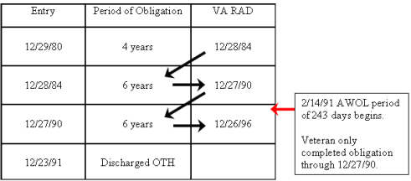  Since the claimant did not begin his period of AWOL until February 14, 1991, he completed his initial enlistment and one reenlistment period, ending December 27, 1990, faithfully and meritoriously. The time from December 28, 1990, to December 23, 1991—the date of discharge—cannot be considered good service due to the AWOL period of over 180 consecutive days.

i. Sample Language for a Conditional Discharge Determination | The “Decision” section of a conditional discharge determination should state how many periods of obligation were honorably completed, the COD for the periods and health care benefit eligibility.  Example from above case: The claimant's service from December 29, 1980, to December 27, 1990, his first two periods of obligation, was under honorable conditions, and he is entitled to receive VA benefits and health care benefits under Chapter 17, Title 38 U.S.C based upon this period of service.  The claimant's service from December 28, 1990, to December 23, 1991, was under other than honorable conditions, and he is not entitled to receive VA benefits or health care benefits under Chapter 17, Title 38 U.S.C. based upon this period of service.  Note: The “Reasons and Basis” section of a conditional discharge determination should explain how the dates of service are determined.
Continued on next page
9. Conditional Discharges and Uncharacterized Discharges, Continued

i. Sample Language for a Conditional Discharge Determination (continued) | Example: A review of facts and circumstances shows the claimant originally enlisted on December 29, 1980, for four years with an obligated period of service until December 28, 1984. On April 4, 1984, he extended his enlistment for another six years with a new obligated period of service until December 27, 1990. On October 31, 1988, he extended his enlistment again for another six years, with a new obligated period of service until December 26, 1996. He was discharged on December 23, 1991, with an OTH character of discharge.

j. Assigning Effective Dates for Claims Based on a Conditional Discharge | Use the table below to determine the effective dates for claims based on a conditional discharge.

Determining the date for | Procedure
a Presumptive Period | - Treat the conditional discharge date as  - certified by the service department, and  - authorized by the character of discharge determination as if the Veteran were actually given a complete and honorable separation, and  - measure all presumptive periods and any other issue that relates to date of discharge or release from the conditional discharge date.
Payment | If a conditional discharge is established, apply the provisions of 38 CFR 3.114(a) to determine the effective date.  Note: The effective date may not be earlier than October 8, 1977.
Continued on next page

9. Conditional Discharges and Uncharacterized Discharges, Continued

k. Uncharacterized Separations | In cases in which enlisted personnel are administratively separated from service on the basis of proceedings initiated on or after October 1, 1982, the separation may be classified as one of following three categories of administrative separation:  - entry level separation  - void enlistment or induction, and  - dropped from the rolls.  Note: Entry level separation can include separation reasons such as:  - failure to meet procurement medical fitness standards  - failure to meet retention standards due to a preexisting medical condition  - completion of a period of Active Duty for Training (ADT)  - hardship discharge  - dependency discharge  Important: The service department does not need to provide a characterization of service for the aforementioned three categories of separation.  Reference: For more information on uncharacterized separations, see 38 CFR 3.12(k).
Continued on next page

9. Conditional Discharges and Uncharacterized Discharges, Continued

l. Action to Take for Uncharacterized Separations | Use the table below for the action to take for the three categories of uncharacterized administrative separations.

Type of Separation | Action
Entry Level Separation | - Consider uncharacterized separations of this type to be under conditions other than dishonorable.  - No administrative decision is required.  Reference: For information on the effect of an entry-level separation based upon fraudulent enlistment on the status as a Veteran, see VAOPGCPREC 16-99.
Void Enlistment or Induction | - Review uncharacterized separations of this type based on facts and circumstances surrounding separation, with reference to the provisions of 38 CFR 3.14 to determine whether separation was under conditions other than dishonorable.  - Prepare an administrative decision.
Dropped from the Rolls | - Review uncharacterized administrative separations of this type based on facts and circumstances surrounding separation to determine whether separation was under conditions other than dishonorable.  - Prepare an administrative decision.

10. Clemency, Upgraded, and Discharge Review Board (DRB) Discharges

Introduction | This topic contains information on Clemency, Upgraded, and DRB second reviews, including  - identifying a clemency discharge  - making a clemency discharge determination  - elements that assist in identifying upgraded discharges,  - decisions made through a board for correction of records or a DRB  - recognizing an honorable or general discharge issued by a DRB intended to set aside a bar  - effect of a change in character of discharge  - the guidelines of PL 95-126, and  - cases exempt from PL 95-126.

Change Date | August 21, 2014

a. Identifying a Clemency Discharge | All copies of a DD Form 214, Certificate of Release or Discharge From Active Duty, granting clemency issued to military absentees under Presidential Proclamation no. 4313 contain the following statement in the Remarks section: “Subject member has agreed to serve months alternate service pursuant to Presidential Proclamation No. 4313.”  In addition, the VA copy of the DD Form 214, which goes to the Austin Data Processing Center (DPC) (but not to the discharged individual), gives the reason for separation as “Separation for the good of the service by reason of a willful and persistent unauthorized absence, pursuant to Presidential Proclamation No. 4313.”  The service department also issued a special type of discharge, Clemency Discharge, DD Form 1953, which was a substitute for the previously awarded undesirable discharge.  Note: These clemency discharges were offered to certain individuals who incurred other than honorable discharges for unauthorized absence, or failed to report for ordered military service between August 4, 1964, and March 28, 1973.
Continued on next page

10. Clemency, Upgraded, and Discharge Review Board (DRB) Discharges, Continued

b. Making a Clemency Discharge Determination | A clemency discharge does not necessarily entitle or reinstate entitlement to benefits administered by VA, and VA must make a decision on the COD.  Prior to making a determination on service that resulted in a clemency discharge furnish notification in accordance with M21-1MR, Part III, Subpart v, 1.A.3.

c. Elements That Assist in Identifying Upgraded Discharges | Use the table below for descriptions of elements that assist in identifying upgraded discharges.

Type of Upgrade | Element | Description
All | 9A on DD Form 214 | Contains “Discharge.”
 | 9F on DD Form 214 | Contains “Certificate Issued.”
 | 13 on DD Form 214 | (Reserve Obligation) contains “NA.”
 | 21 and 27 of DD Form 214 | Shows 30 days or more time lost.
 | 29 on DD Form 214 | Contains no signature of person separated.
Issued as a result of the Presidential Proclamation of January 19, 1977 | Item 27 on copy 3 (VA copy) of corrected DD Form 214 | Contains a statement to the effect that the discharge was upgraded to “under honorable conditions” by the January 19, 1977, extension of Presidential Proclamation 4313 by virtue of being wounded in combat or decorated for valor in Vietnam.
 | The BIRLS record | Was established, or updated to show  - the type of discharge as HONORABLE, and  - the separation reason as BEO (By Executive Order).
Continued on next page

10. Clemency, Upgraded, and Discharge Review Board (DRB) Discharges, Continued

c. Elements That Assist in Identifying Upgraded Discharges (continued)

Type of Upgrade | Element | Description
Issued as a result of the DoD Special Discharge Review Program | The VA copy (copy 3) of the corrected DD Form 214 | Contains the narrative reason for separation as “Upgraded under the DoD Discharge Review Program (Special)” and also indicates  - the date the individual first applied for discharge upgrade  - the date the discharge was upgraded, and  - the character of service (discharge) prior to upgrade.
 | The BIRLS record | Established or updated to show  - the type of discharge as HONORABLE, and  - the separation reason as  - DRO (Discharge Review—prior discharge “Under Conditions Other Than Honorable)”, or  - DRG (Discharge Review—prior discharge “Under Honorable Conditions,” commonly called general).
Continued on next page

10. Clemency, Upgraded, and Discharge Review Board (DRB) Discharges, Continued

d. Decision Made Through a Board for Correction of Records or a DRB | A decision by a service department acting through a Board for Correction of Records is final and binding on VA. This applies  - even if VA previously made a formal determination concerning a statutory bar under 38 CFR 3.12, and/or  - a service department, acting through a Discharge Review Board (DRB), changed the character of discharge prior to enactment of PL 95-126 on October 8, 1977.  Exception: A change in character of discharge from a service department through a DRB is not final and binding on VA when there is a bar because the discharge was due to the sentence of a GCM per 38 CFR 3.12(c)(6) and 38 CFR 3.12(f).

e. Recognizing an Honorable or General Discharge Issued by a DRB Intended to Set Aside a Bar | VA does not recognize an honorable or general discharge issued by a DRB intended to set aside a bar under 38 CFR 3.12(c), on or after enactment of PL 95-126, October 8, 1977 (38 CFR 3.12(g)). If such an upgraded discharge is received, examine the claim for the existence of a statutory bar.  Exception: Only favorable action by a Board for Correction of Military Records will overcome a bar under 38 CFR 3.12(c).  Note: This provision also applies to those discharges issued prior to October 8, 1977, under the special review program (38 CFR 3.12(h)), even if a later review by a DRB confirms that the upgrading was warranted under the uniform published review criteria.

f. Effect of a Change in Character of Discharge | Do not make a formal determination to void the earlier determination. Write an annotation on the prior determination to show that it has been superseded by a later “corrected” discharge.  Make a formal determination if the corrected character of discharge is  OTH, therefore requiring reconsideration and redetermination.  Determine the effective date of the determination per 38 CFR 3.400(g).
Continued on next page

10. Clemency, Upgraded, and Discharge Review Board (DRB) Discharges, Continued

g. Guidelines of PL 95-126 | In addition to a requirement that the Department of Defense (DoD) establish a set of uniform procedures and standards for use by DRBs, PL 95-126 also prohibits payment of VA benefits based solely on a discharge upgraded under  - the Presidential Proclamation of January 19, 1977, or  - the DoD Special Discharge Review Program.  The DRB had to review an upgraded discharge to determine if it could be upheld under the new uniform criteria established by PL 95-126. After the DRB has completed their second review and made a decision, the responsibility for determining eligibility to VA benefits exists solely with VA.

h. Cases Exempt From PL 95-126 | Veterans are exempt from the procedures applicable to special upgraded discharges if they had  - general or under honorable conditions discharges upgraded by the special review program, or  - filed a claim for VA benefits based on an other than honorable discharge and had received a favorable character of discharge determination prior to enactment of PL 95-126, effective October 8, 1977.

11. Processing DRB Second Review Decisions

Introduction | This topic contains information on adjudication procedures, including handling  - eligibility for DRB second review  - responsibility for determining eligibility to benefits after a DRB second review  - narrative of decision on DD Form 215  - favorable DRB determinations  - favorable DRB determinations when 38 CFR 3.12(c) is a possible factor  - unfavorable DRB decisions, and  - effective dates for compensation and pension benefits based on DRB second review.

Change Date | February 27, 2012

a. Eligibility for DRB Second Review | A Veteran may request that the DRB perform a second review of a character of discharge determination.  Note: The second review was done automatically for all Veterans whose discharges were upgraded under one of the special programs.  To be eligible for the DRB second review, the Veteran must have  - served between August 4, 1964, and March 28, 1973  - been released with an “other than honorable” (formerly known as “undesirable”) discharge, and  - been issued an upgraded discharge on or after January 19, 1977, under the provisions of the  - Presidential Proclamation of January 19, 1977, or  - the DoD Special Discharge Review Program.
Continued on next page

11. Processing DRB Second Review Decisions, Continued

b. Responsibility for Determining Eligibility to Benefits After a DRB Second Review | VA has final responsibility for determining eligibility to VA benefits.  If the DRB review was favorable, and the Veteran’s upgraded discharge was, VA can still deny eligibility to VA benefits if a statutory bar under 38 CFR 3.12(c) exists.  If the DRB review was unfavorable and the Veteran’s upgraded discharge was not upheld, VA will decide eligibility to VA benefits using the original discharge and facts and circumstances to complete a COD determination.

c. Narrative of Decision on DD Form 215 | The narrative summary of the decision of the DRB’s second review should be released on DD Form 215. VA must have a copy of this paperwork in order to make a decision. The following table shows the commonly used language for favorable and unfavorable decisions.

Criteria | Narrative Decision on DD Form 215
USN/USMC favorable second review | Discharge review under PL 95-126 and a determination has been made that characterization of service is warranted by DOD Directive 1332.28.
USN/USMC unfavorable second review | Discharge review under PL 95-126 and a determination has been made that characterization of service is warranted by DOD SDRP 4 Apr 77.
USA/USAF favorable second review | Discharge review under PL 95-126 and a determination has been made that a change in characterization of service is warranted by DOD Directive 1332.28.
USA/USAF unfavorable second review | Discharge review under PL 95-126 and a determination has been made that characterization of service was warranted by DOD SDRP 4 Apr 77.

d. Favorable DRB Determinations | Carefully review the full service records and determine if the former service member was discharged or released under one of the following conditions listed in 38 CFR 3.12(c).  - If so, follow the instructions in M21-1MR, Part III, Subpart v, 1.B.11.e  - If not, the favorable DRB determination is used as the basis for eligibility to VA benefits.  Reference: For more information on aliens, see 38 CFR 3.7(b).
Continued on next page

11. Processing DRB Second Review Decisions, Continued

e. Favorable DRB Determinations When 38 CFR 3.12(c) Is a Factor | If 38 CFR 3.12(c) is a factor, VA can still deny eligibility to benefits, even though the DRB review was favorable.  If a previous administrative decision held that the character of discharge was other than honorable, and 38 CFR 3.12(c) is a factor, annotate that decision to show the date of the  - application for discharge review  - initial DRB upgrade, and  - VA affirmed previous decision.

f. Unfavorable DRB Determinations | If the DRB decision is unfavorable, eligibility to VA benefits rests on the merits of the original “other than honorable” discharge and corresponding facts and circumstances.  Follow the steps in the table below to process an unfavorable DRB decision, even if the claims folder contains an unfavorable administrative decision made prior to the issuance of the adverse DRB decision.

Step | Action
1 | Provide the claimant with a due process notice prior to making an administrative decision.
2 | Following receipt of any evidence from the claimant or the expiration of 60 days, whichever is earlier  - review the case and prepare an administrative decision  - cite 38 CFR 3.12(h) in the administrative decision as the authority for reexamining a DRB decision.
Continued on next page

11. Processing DRB Second Review Decisions, Continued

f. Unfavorable DRB Determinations (continued)

Step | Action
3 | If the individual’s discharge was issued under conditions that prevent payment of VA benefits, discuss and resolve the issues of  - a possible conditional discharge, and  - entitlement to 38 U.S.C. Chapter 17 medical benefits in the same administrative decision.  References: For more information on eligibility requests for health care benefits under 38 U.S.C. Chapter 17, see  - M21-1MR, Part III, Subpart v, 1.B.8, and  - conditional discharge, see M21-1MR, Part III, Subpart v, 1.B.9.

Notes:
- Unless a valid conditional discharge for a separate period of service is established, eligibility to health care benefits under 38 U.S.C. Chapter 17 must be denied if a statutory bar exists.
- A Special Upgraded Discharge that is affirmed by a DRB under PL 95-126 is an honorable discharge for purposes of entitlement to unemployment compensation under 5 U.S.C. 85. This is true even if a statutory bar exists under 38 CFR 3.12(c)(6).
Continued on next page

11. Processing DRB Second Review Decisions, Continued

g. Effective Dates for Compensation and Pension Benefits Based on DRB Second Review | Authorize payments from the date  - an application for review of discharge was filed with the service department, or  - the claim was filed with VA, whichever is later.  Important:  - January 19, 1977, is considered the date of application for all discharges upgraded under the Presidential Memorandum of January 19, 1977.  - Use the date the original application was filed with the service department for DoD Special Review Board cases.  - If a previously disallowed claim is reopened based on a change in  the character of discharge, authorize payments from the latest of the following dates:  - one year prior to receipt of the reopened claim  - the date on which the application for review of discharge was filed with the service department, or  - the date of receipt of the previously disallowed claim.  Reference: For information on the provisions that should be applied when authorizing payments, see  - 38 CFR 3.400(b), and  - 38 CFR 3.400 (g).

