Section C. Beneficiary Identification and Records Locator Subsystem (BIRLS), Records Management Center (RMC), and the Service Treatment Record (STR) Folder

Overview

In This Section | This section contains the following topics:

Topic | Topic Name
1 (old 19) | BIRLS FOLDER LOCATION Screens
2 (old 20) | Other BIRLS Information

1. BIRLS FOLDER LOCATION Screens

Introduction | This topic contains information on the BIRLS FOLDER locATION screen as it pertains to STR folder establishment, including  - important background information about STRs and the Department of Veterans Affairs’ (VA’s) RMC  - description of BIRLS and how to access it  - establishment of an STR folder in BIRLS  - snapshot of the FOLDER LOCATION screen showing the establishment of an STR folder when no claims folder exists  - STRs received at RMC when a BIRLS record and claims folder exist  - snapshot of the FOLDER LOCATION screen showing receipt of STRs by the RMC when a BIRLS record and claims folder exist  - actions regional offices (ROs) previously took upon receipt of original STRs from the RMC, and  - snapshot of the FOLDER LOCATION screen showing consolidation of an STR folder with the claims folder.

Change Date | May 28, 2015

a. Important Background Information About STRs and VA’s RMC | For many years, the Department of Veterans Affairs (VA) referred to the medical records created during a Veteran’s period of service as “service medical records” (SMRs). During the same period of time, the Department of Defense (DoD) referred to these records as “health treatment records.” In the interest of consistency, and to avoid confusion, both departments now refer to these records as “service treatment records” (STRs).  Prior to January 1, 2014, individual service departments sent the STRs of Veterans with active-duty service to VA shortly after the Veteran separated from service. VA stored STRs at the Service Medical Records Center (SMRC) (375) until October 1, 1995, when it replaced the SMRC and VA Records Processing Center (RPC) with the Records Management Center (RMC).  The SMRC/RMC retained STRs in storage unless a corresponding claims folder existed at a regional office (RO), in which case the SMRC/RMC transferred the STRs to that RO. Whenever an RO established a claims folder, the SMRC/RMC also transferred any corresponding STRs in its custody to that RO for association with the claims folder.  Starting with Veterans who were separated from service on or after January 1, 2014, service departments (except the Coast Guard, Public Health Service (PHS), and National Oceanic and Atmospheric Administration (NOAA)) now scan (convert to an electronic image) STRs and upload them into DoD’s Healthcare Artifacts and Images Management Solution (HAIMS). Only the Coast Guard, PHS, and NOAA currently send STRs to the RMC for storage.  The process for transferring STRs from the RMC to ROs also changed as ROs began processing claims in a paperless environment. Now, instead of shipping STRs to ROs, the RMC sends them to a scanning vendor. Once scanning is complete, the vendor uploads electronic copies of the STRs into the appropriate Veteran’s eFolder.  If an RO needs STRs that exist in HAIMS only, the RO obtains electronic copies through an interface between the Veterans Benefits Management System (VBMS) and HAIMS.  Reference: For more information about  - HAIMS, see M21-1, Part III, Subpart iii, 2.B.2 and 3, or  - STRs the RMC currently houses, see M21-1, Part III, Subpart iii, 2.A.4.a.

b. Description of BIRLS and How to Access It | VA’s Beneficiary Identification and Records Locator Subsystem (BIRLS) is a computer application that displays data about individual Veterans, to include their profile and the location of their VA records.  Exception: Although VA records might include STRs (which, technically, belong to DoD), the location of a Veteran’s STRs is not displayed in BIRLS if an RO obtained them through the VBMS/HAIMs interface instead of obtaining them from the RMC.  Users access BIRLS through Share.  Reference: For more information about  - the VBMS/HAIMS interface, see M21-1, Part III, Subpart iii, 2.B.3, or  - using BIRLS and Share, see the Share User’s Guide.

c. Establishment of an STR Folder in BIRLS | Prior to January 1, 2014, the RMC recorded receipt of a Veteran’s STRs from a service department by establishing an STR folder in BIRLS. This action triggered the updates described in the table below to the BIRLS FOLDER LOCATION screen.

The entry in the field labeled … | Was updated with the entry …
TYPE | SMR
SMR | Y

Notes:
- All service departments, except the Coast Guard, PHS, and NOAA, stopped sending STRs to the RMC on January 1, 2014. The RMC still takes the action described in the above paragraph upon receipt of STRs from one of these organizations.
- Other possible entries in the SMR field are
- C (STR consolidated with the claim or notice of death (NOD) folder), or
- O (RO received STR from a source other than the RMC).
- The absence of an entry in the SMR field indicates that no STR folder exists.

Reference:
- For an explanation as to why SMR is used on the FOLDER LOCATION screen instead of STR, see M21-1, Part III, Subpart iii, 2.C.1.a.
- For a snapshot of a FOLDER LOCATION screen indicating establishment of an STR folder when no claims folder exists, see M21-1, Part III, Subpart iii, 2.C.1.d.

d. Snapshot of a FOLDER LOCATION Screen Showing the Establishment of an STR Folder When No Claims Folder Exists | Below is a snapshot of a BIRLS folder location screen showing establishment of an STR folder when no claims folder exists.

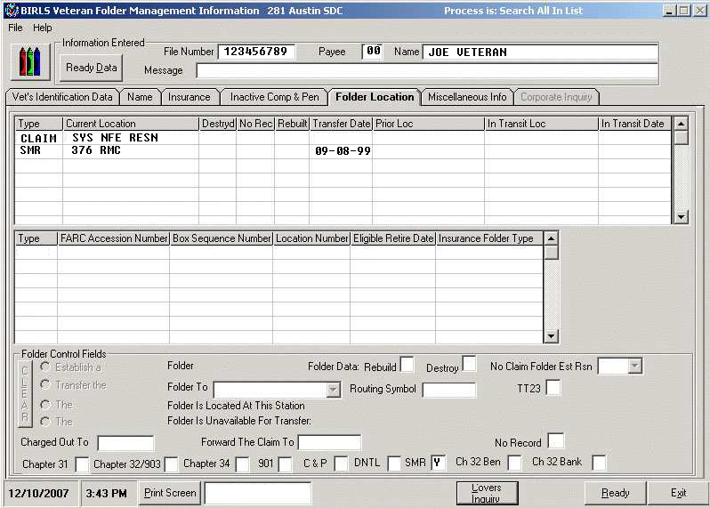

Reference: See M21-1, Part III, Subpart iii, 2.C.1.a for an explanation as to why
- 375 SMRC, instead of 376 RMC, might occasionally appear in the CURRENT LOCATION field, and
- SMR is used on the FOLDER LOCATION screen instead of STR.

e. STRs Received at RMC When a BIRLS Record and Claims Folder Exist | As explained in M21-1, Part III, Subpart iii, 2.C.1.a, only the Coast Guard, PHS, and NOAA now send STRs to the RMC for storage. The table below describes the process that is initiated when the RMC receives STRs from one of these organizations and a claims folder already exists. (All fields referenced in this block appear on the BIRLS FOLDER LOCATION screen.)  Exception: The process described in the table below is not initiated if the entry in the CURRENT LOCATION field for the claims folder is one of the following:  - RMC, or  - Federal Records Center (FRC).

Stage | Description
1 | Upon establishment of the STR folder in BIRLS (by the RMC),  - the entry in the IN TRANSIT LOC field for the STR folder is automatically set to match the entry in the CURRENT LOCATION field for the claims folder, and  - the entries in the TRANSFER DATE and IN TRANSIT DATE fields for the STR folder are automatically set to the current processing date.
2 | The system generates a request for the RMC to transfer the STR folder to the RO named in the CURRENT LOCATION field for the claims folder.
3 | The RMC  - removes all entries in the IN TRANSIT LOC and IN TRANSIT DATE fields, and  - sends the STRs to a scanning vendor.
4 | Once scanning is complete, the vendor uploads electronic copies of the STRs into the appropriate Veteran’s eFolder.

Note: The process described in the table above is similar to the process that occurs when the RMC receives STRs from the Coast Guard, PHS, or NOAA concurrent with a request from an RO for transfer of the corresponding claims folder which, at the time, is in the RMC’s custody.

References:
- For a snapshot of the FOLDER LOCATION screen showing an STR folder established when a claims folder already exists, see M21-1, Part III, Subpart iii, 2.C.1.f.
- For information on processing STR folders when the FOLDER LOCATION screen shows the claims folder is at the RMC or FRC, see M21-1, Part III, Subpart iii, 2.C.2.d.

f. Snapshot of the FOLDER LOCATION Screen Showing Receipt of STRs by the RMC When a BIRLS Record and Claims Folder Exist | Below is a snapshot of a BIRLS Folder location screen showing receipt of a Veteran’s STRs by the RMC when a BIRLS record and claims folder exist.

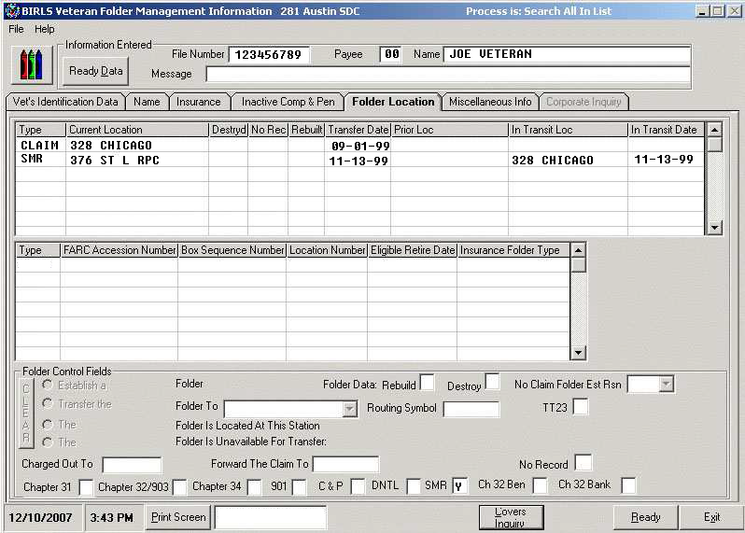

Reference: See M21-1, Part III, Subpart iii, 2.C.1.a for an explanation as to why
- 375 SMRC, instead of 376 RMC, might occasionally appear in the CURRENT LOCATION field, and
- SMR is used on the FOLDER LOCATION screen instead of STR.

g. Actions ROs Previously Took Upon Receipt of Original STRs From the RMC | Before the RMC began sending STRs to a scanning vendor, ROs had to take the following actions upon receipt of a Veteran’s original STRs from the RMC  - update the BIRLS FOLDER LOCATION screen to reflect The STR folder is located at this station,  - change the entry in the SMR field on the BIRLS FOLDER LOCATION SCREEN from Y to C, and  - associate the STR folder with the corresponding claims folder.  When the update was processed (by clicking on the READY or EXIT button), the row containing information about the STR folder (current location, transfer date, etc.) disappeared.  When an RO receives original STRs from a source other than the RMC, and the SMR field on the BIRLS FOLDER LOCATION screen is blank, the RO must enter O in the smr field.  References:  - For more information about possible entries in the SMR field, see M21-1, Part III, Subpart iii, 2.C.1.c.  - For a snapshot of a FOLDER LOCATION screen showing consolidation of an STR folder with the corresponding claims folder, see M21-1, Part III, Subpart iii, 2.C.1.h.

h. Snapshot of the FOLDER LOCATION Screen Showing Consolidation of an STR Folder With the Claims Folder | Below is a snapshot of a BIRLS FOLDER LOCATION screen showing consolidation of an STR folder with the corresponding claims folder.

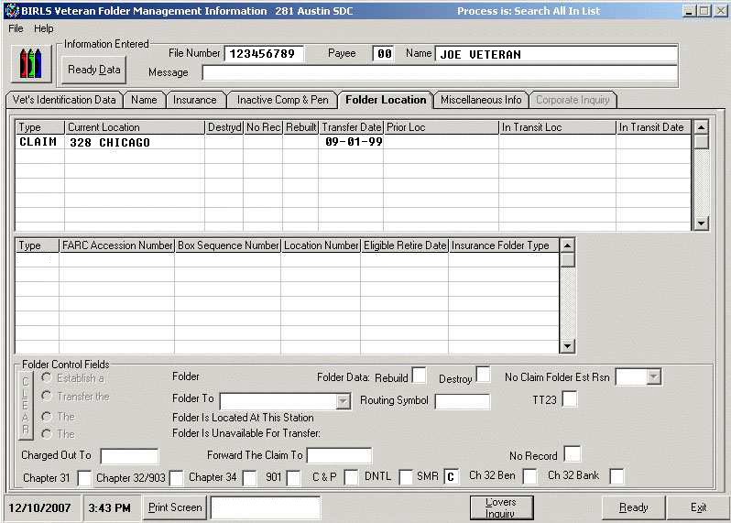

Reference: See M21-1, Part III, Subpart iii, 2.C.1.a for an explanation as to why
- 375 SMRC, instead of 376 RMC, might occasionally appear in the CURRENT LOCATION field, and
- SMR is used on the FOLDER LOCATION screen instead of STR.

2. Other BIRLS Information

Introduction | This topic contains other information on BIRLS processing, including  - handling the receipt of additional STRs  - RO action if two BIRLS records exist for the same Veteran and VA has custody of the Veteran’s original STRs  - obtaining STRs for association with a NOD folder  - STRs that require association with claims folders located at the RMC or FRC  - requesting the transfer of separate STR and claims folders in the RMC’s custody  - informational message that appears when an RO establishes a claims folder and VA has custody of the corresponding STRs, and  - message that appears when an RO attempts to establishing a claim when no BIRLS record exists.

Change Date | May 28, 2015

a. Handling the Receipt of Additional STRs | The RMC might receive additional STRs from the Coast Guard, PHS, or NOAA for a Veteran whose STRs have already been forwarded to an RO and consolidated with a claims folder. When this occurs  - the system  - repopulates the row containing information about the STR folder (current location, transfer date, etc.) that was automatically deleted when STRs were originally consolidated with the claims folder  - resets the entry in the SMR field to Y, and  - generates a request for the RMC to transfer the additional STRs to the RO that has custody of the claims folder, and  - the RMC sends the STRs to a scanning vendor without updating BIRLS.

b. RO Action If Two BIRLS Records Exist for the Same Veteran and VA Has Custody of the Veteran’s Original STRs | If two BIRLS records exist for the same Veteran, and the Veteran’s STRs are in VA custody, follow the instructions for duplicate claim (DUPC) processing in M21-1, Part III, Subpart ii, 4.E.2.

c. Obtaining STRs for Association With a NOD Folder | When an RO creates a NOD folder, the RO cannot use BIRLS to request transfer of the corresponding STRs. If the RO requires the STRs from RMC and the STRs are not shown as “in-transit” in BIRLS upon claim establishment, it must e-mail a request to VAVBASTL/RMC/RCD.  Important: BIRLS can only generate a request for STRs for a claims folder.

d. STRs That Require Association With Claims Folders Located at the RMC or FRC | The table below describes the actions the RMC takes upon receipt of an STR folder from the Coast Guard, PHS, or NOAA.

If BIRLS indicates the corresponding claims folder is located at the ... | Then the RMC ...
RMC | associates the STRs with the claims folder.
FRC | removes all entries in the IN TRANSIT LOC and IN TRANSIT DATE fields.  Note: The BIRLS FOLDER LOCATION screen will contain one row showing the disposition of the claims folder and a separate row showing the disposition of the STR folder.

Note: Normally, STR folders are maintained by Social Security number (SSN). However, beginning early in 1998, if the claims folder at the RMC is under a number other than the SSN, the STR folder is associated with the claims folder under the claim number.

e. Requesting the Transfer of Separate STR and Claims Folders in the RMC’s Custody | If an RO needs a Veteran’s claims folder and STRs, the claims folder and STRs are both located at the RMC, and the BIRLS FOLDER LOCATION screen contains separate rows for the claims folder and STR folder, then the RO may obtain both the STRs and claims folder from the RMC by submitting a request for the claims folder through the Control of Veterans Records System (COVERS).  Note: Current programming prohibits claims establishment actions from generating an automatic STR request because the claims folder is also at the RMC at the time of claims establishment.  Reference: For detailed instructions for using COVERS, see the COVERS User Guide.

f. Informational Message That Appears When an RO Establishes a Claims Folder and VA Has Custody of the Corresponding STRs | When an RO establishes a claims folder, and the BIRLS FOLDER LOCATION screen shows the RMC has custody of the corresponding STR folder,  - a request for the RMC to transfer the STR folder to the RO is automatically generated, and  - the message SMRC SENDING SERVICE MEDICAL RECORDS is displayed for the user’s information.  Reference: See M21-1, Part III, Subpart iii, 2.C.1.a for an explanation as to why SMRC still appears in system messages instead of RMC.

g. Message That Appears If an RO Attempts to Establish a Claim When No BIRLS Record Exists | If no BIRLS record exists when an RO attempts to establish a claim, Share displays the following message to the user: No BIRLS record exists. You cannot create a claim until a BIRLS record is established for the Veteran via the BIRLS Add process.  As the message indicates, the user must create a corresponding BIRLS record before the system will allow him/her to establish a claim.  Note: Upon receipt of a Veteran’s STRs, the RMC creates a corresponding BIRLS record (if one does not already exist). Therefore, if no BIRLS record exists for a Veteran, users may assume VA does not have custody of his/her STRs.  Reference: For more information about creating a BIRLS record, see the Share User’s Guide.

