Section B. Decision Notices

Overview

In This Section | This section contains the following topics:

Topic | Topic Name
1 | Notification Requirements
2 | Special Requirements for Visually Impaired Veterans
3 | Decision Notices Containing Federal Tax Information (FTI)
4 | Decision Notices Prepared Using the Automated Decision Letter (ADL) Process
5 | Exhibit 1: Sample Decision Notice –Grant of Entitlement to Veterans Pension
6 | Exhibit 2: Sample Decision Notice – Denial of Entitlement to Veterans Pension

1. Notification Requirements

Introduction | This topic contains information on notification requirements, including  - notifying a claimant or beneficiary of a potentially adverse decision  - notifying a claimant of a decision to grant and/or deny entitlement to benefits  - requirement to use a single decision notice  - guidelines for preparing a decision notice  - when to provide a summary of evidence in a decision notice  - guidelines for summarizing evidence in a decision notice  - when to explain in a decision notice the reason(s) for a decision  - notifying claimants of potential entitlement to additional benefits  - other decision-related issues to consider  - steps to follow after preparing a decision notice  - requirement to send a copy of correspondence to the power of attorney (POA) and/or fiduciary  - erroneous notification for service connection, and  - restrictions placed on the disclosure of draft rating decisions.

Change Date | December 11, 2015

a. Notifying a Claimant or Beneficiary of a Potentially Adverse Decision | In most cases, the Department of Veterans Affairs (VA) must give a claimant or beneficiary advance notice of a decision that might adversely affect him/her. The legal term for this is “due process.” Decisions that may require advance notice include, but are not limited to, those involving the  - character of a former service member’s discharge  - competency of a claimant or beneficiary to manage his/her financial affairs, and  - reduction or discontinuation of a VA benefit.  Follow the guidelines in M21-1, Part I, 2.B.1 and Part I, 2.D.1.a, to determine whether VA  - must issue notice before taking an adverse action, or  - may issue notice at the same time it takes the adverse action (also known as “contemporaneous notice”).  Reference: For more information about due process, see M21-1, Part I, 2.A.1.

b. Notifying a Claimant of a Decision to Grant and/or Deny Entitlement to Benefits | After making a decision on a claim, VA must notify the claimant of  - the decision VA made, and  - the claimant’s  - appellate rights, and  - right to  - procedural due process  - a hearing, and  - representation.  The table below shows additional information VA must include in its decision notice.

If VA ... | Then VA must ...
grants entitlement to a benefit | notify the claimant of  - the monthly rate of payment  - the effective dates of entitlement and payment  - the amount of any benefits VA is withholding and the reason for the withholding, and  - information about any additional benefits to which the claimant may be entitled.
denies entitlement to a benefit | provide the claimant with  - the reason(s) for the decision, and  - a summary of the evidence it considered in determining entitlement does not exist.

Important: As a result of Clarke v. Nicholson, 21 Vet.App. 130, 133 (2007), if VA decides a claim but fails to notify the claimant of the decision, the claim remains open, legally, regardless of whether or not the regional office (RO) clears the corresponding end product (EP). Under such circumstances, if VA denied entitlement to a benefit, failed to notify the claimant of the denial, and then granted entitlement to the same benefit years later, the claimant might be entitled to benefits retroactive to the initial date of claim, because the decision on the initial claim never became final.

Note: The current version of VA Form 21-0958, Notice of Disagreement, is September 2015. When generating a decision notice for compensation claims in the Automated Decision Letter (ADL) and/or Personal Computer Generated Letters (PCGL), you must ensure that the current version of VA Form 21-0958 is attached. After printing the decision notice, remove the January 2015 version of VA Form 21-0958 and replace it with the current, September 2015, version of the form. There is no expectation that the copy of the decision notice contained within the claimant’s claim folder contains the current version of the form. Letter generation systems will be updated shortly.

References:
- To view sample decision notices, see M21-1, Part III, Subpart v, 2.B.5 and 6.
- For more information on
- summarizing the evidence VA considered, see M21-1, Part III, Subpart v, 2.B.1.e and f
- explaining the reason(s) for a decision, see M21-1, Part III, Subpart v, 2.B.1.g, and
- notifying the claimant of potential entitlement to additional benefits, see M21-1, Part III, Subpart v, 2.B.1.h.

c. Requirement to Use a Single Decision Notice | Use a single decision notice to notify a claimant of a VA decision, even if the decision involves both an award and a denial of benefits.  Important: All decision notices must meet the requirements of M21-1, Part III, Subpart v, 2.B.1.b.  Examples: The following illustrate decisions that involve both an award and a denial of benefits:  - VA awards service connection (SC) for one disability but denies SC for another.  - VA awards entitlement to pension but denies entitlement to special monthly pension (SMP).

d. Guidelines for Preparing a Decision Notice | When preparing a decision notice  - use  - clear and concise wording  - Reader-Focused Writing (RFW) principles, and  - a customer-friendly and compassionate tone  - provide complete and accurate information concerning the issue(s) addressed, and  - avoid using VA jargon, to include  - abbreviations with no accompanying definition, and  - phrases such as  - service connection not found  - disability not due to service, or  - wanton and reckless disregard of the probable consequences.  References: For more information on using RFW principles, see the Reader-Focused Writing Manual.

e. When to Provide a Summary of Evidence in a Decision Notice | Only when VA is denying entitlement to a benefit does 38 CFR 3.103 require VA to summarize in the corresponding decision notice the evidence it considered in reaching its conclusion that entitlement does not exist.  Notes:  - If a decision notice was preceded by notice of proposed adverse action, as described in M21-1, Part III, Subpart v, 2.B.1.a, there is no need to re-summarize in the final decision notice any evidence referenced in the advance notice.  - Rating decisions contain a summary of the evidence VA considered when deciding any rating-related issues. As long as the claimant will receive a copy of the rating decision, there is no need to summarize this same evidence in the decision notice.  Important: ADL includes all evidence listed in the rating decision. However, award decision evidence may need to be entered by the user through the Veterans Benefits Management System-Awards (VBMS-A).

f. Guidelines for Summarizing Evidence in a Decision Notice | When summarizing in a decision notice the evidence VA considered, use descriptive identifiers of the evidence, such as  - date(s) of treatment  - name(s) of doctor(s) and/or hospital(s) that provided treatment, and  - form names.  Avoid using  - form numbers without also providing the title of the form, and  - general references to an area of the body when more than one disability exists in that area.  Example: A general reference to a back disorder would not be appropriate if the claimant suffers from  - a pinched nerve in the cervical spine  - arthritis in the lower spine, and  - shell fragment damage to vertebrae in the thoracic spine.

g. When to Explain in a Decision Notice the Reason(s) for a Decision | Explain in a decision notice the reason(s) for a decision if VA is denying entitlement to a benefit and  - the issue does not require resolution by rating decision (such as entitlement to additional benefits for a dependent), or  - the issue requires resolution by rating decision, but  - the claimant will not receive a copy of the rating decision, or  - rating activity used the ADL format described in M21-1, Part III, Subpart v, 2.B.4 to prepare the corresponding rating decision.  Notes:  - The explanation contained in the decision narrative is generated by the Rating Veterans Service Representative (RVSR) within Veterans Benefits Management System-Rating (VBMS-R).  - When explaining the reason(s) for a decision, provide sufficient detail regarding the rationale used in reaching the decision to ensure the claimant will understand its basis. This may include restating applicable regulation(s) in laymen’s terms.  - When a Veterans Service Representative (VSR) processes a rating decision using the ADL format described in M21-1, Part III, Subpart v, 2.B.4, the decision notice contains the explanation of the reason(s) for the decision.

h. Notifying Claimants of Potential Entitlement to Additional Benefits | When preparing a decision notice, notify the claimant of any additional benefit(s) to which potential entitlement exists and, if applicable, the form or web site available for applying for the benefit(s).  The table below lists  - additional benefits to which a claimant may be entitled  - the form for applying for each benefit, and  - references to additional information about these benefits.

Benefit | Form | Reference
Veterans’ Group Life Insurance (VGLI) | VA Form 29-4364, Application for Service-Disabled Veterans Insurance | M21-1, Part III, Subpart vi, 8.6.b
vocational rehabilitation | - VA Form 28-1900, Disabled Veterans Application for Vocational Rehabilitation, and  - VA Form 28-8890, Important Information About Rehabilitation Benefits | M21-1, Part IX, Subpart i, 1.A.2.c
health care for service-connected disabilities | VA Form 10-10EZ, Application for Health Benefits | M21-1, Part III, Subpart v, 7.A.1.c
automobile or adaptive equipment | VA Form 21-4502, Application for Automobile or Other Conveyance and Adaptive Equipment | M21-1, Part IX, Subpart i, 2.4.a
special adaptive housing | VA Form 26-4555, Application in Acquiring Specially Adapted Housing or Special Home Adaption Grant | M21-1, Part IX, Subpart i, 3.1.a
clothing allowance | VA Form 10-8678, Application for Annual Clothing Allowance | M21-1, Part IX, Subpart i, 7.1.d
Dependent’s Educational Assistance (DEA) | VA Form 22-5490, Dependents’ Application for VA Education Benefits | M21-1, Part III, Subpart iii, 6.C.1.b
SMP | VA Form 21-2680, Examination for Housebound Status or Permanent Need for Regular Aid and Attendance | M21-1, Part V, Subpart iii, 2.A.1
additional benefits for a spouse/children | Form 21-686c, Declaration of Status of Dependents  Important:  - In addition to decision notices processed through ADL, PCGL decision notices do not need to include dependency solicitation language when a dependency decision or dependency development is at issue in the decision notice.  - The ADL dependency development language should never be used with a 130 EP as any required development should happen up front.  Note: Dependency solicitation language is not required in decision notices when a dependency decision or dependency development is at issue as part of the decision notice. | M21-1, Part III, Subpart iii, 5.A.1.c
increased pension based on unreimbursed medical expenses | VA Form 21-8416, Medical Expense Report | M21-1, Part V, Subpart iii, 1.G.2

Note: ADLs provide the Veteran additional benefits information by notifying the Veteran of any applicable forms, and referring the Veteran to the web site or phone number where they can receive additional information.

i. Other Decision-Related Issues to Consider | The table below lists  - issues VSRs commonly face when  - processing an award or denial of benefits, and  - preparing a decision notice, and  - references to additional information about the issues.

Issue | Reference
- elections between benefits  - waivers of VA benefits  - recoupment of separation pay, and  - adjustments based on receipt of military retired pay. | M21-1, Part III, Subpart v, 4.A.4
apportionments | M21-1, Part III, Subpart v, 3.A.1.b
awards to incompetent beneficiaries through a fiduciary or guardian | M21-1, Part III, Subpart v, 9
adjustments or reductions due to hospitalization | M21-1, Part III, Subpart v, 6.B.1.a
adjustments based on incarceration | M21-1, Part III, Subpart v, 8.A.1.a
reduction of pension based on residence in a Medicaid-covered nursing home | M21-1, Part V, Subpart iii, 3.1.a
effect of income and net worth on pension entitlement | M21-1, Part V, Subpart i, 3.A.1
entitlement to DEA for a severely injured current active service member | M21-1, Part IX, Subpart ii, 2.1.a

j. Steps to Follow After Preparing a Decision Notice | After preparing a decision notice  - review it for completeness and accuracy  - ensure the notice date reflects the expected date of mailing  - add a copy in the claims folder, and  - mail the original to the claimant.

k. Requirement to Send a Copy of Correspondence to the POA and/or Fiduciary | Send a copy of all correspondence with a claimant or beneficiary to his/her  - power of attorney (POA), if he/she has selected one, and/or  - fiduciary, if VA has appointed one.  Note: Most Veterans Service Organizations (VSOs) receive an electronic indicator when new documents are added to the Veteran’s electronic claims folder (eFolder). If the VSO has access to the eFolder, and an electronic indicator is received, there is no need to send an additional paper copy to the VSO. VSO access to the eFolder can be verified under the POWER OF ATTORNEY tab on the VETERAN PROFILE screen in VBMS.  Reference: For more information about POAs, see M21-1, Part I, 3.

l. Erroneous Notification for Service Connection | If a claimant is erroneously notified of an SC decision and is subsequently notified of the correct decision, then the appeal period begins when the claimant is notified of the correct decision.  Important:  The Supreme Court held (OPM v. Richmond) that  “payments of money from the Federal Treasury are limited to those authorized by statue, and erroneous advice given by a Government employee to a benefit claimant cannot stop the Government from denying benefits not otherwise permitted by law.”  Notes: Since the rating decision is not in question, the  - authority to sever SC is absent  - error was not in the decision but in the communication of that decision, and  - claimant did not meet the statutory requirements for this benefit to begin with.

m. Restrictions Placed on the Disclosure of Draft Rating Decisions | Draft rating decisions and notices are not intended to be final and binding on VA and should not be shared or transmitted by VSOs to their clients (beneficiaries).  Important: ROs should exert sufficient diligence to ensure that decisions and notices that have not yet been finalized are not provided to claimants.  References: For more information on  - finality of decisions, see 38 CFR 3.104, and  - VSO review of new rating decisions, see M21-1, Part I, 3.B.3.

2. Special Requirements for Visually Impaired Veterans
Change Date | June 1, 2015

a. Preparing Decision Notices for Visually Impaired Veterans | Use 14-point font when preparing a decision notice for a Veteran with visual impairment that is at least 70 percent disabling. After the notice is mailed, a member of the Public Contact Team must make a minimum of three attempts to contact the Veteran by telephone to explain the substance of the decision.  The Public Contact Team must  - allow sufficient time for the decision notice to reach the Veteran before attempting to contact him/her, and  - document  - successful telephone contact on VA Form 27-0820, Report of General Information, or  - unsuccessful attempts to contact the Veteran as a contact note in Modern Awards Processing - Development (MAP-D) or VBMS.  Important: In order to readily identify the claims folder and corporate record of a visually impaired Veteran, ROs must  - reverse file VA Form 21-0178, Visually Impaired Veteran, in the center section of the Veteran’s paper claims folder, if one exists, and  - add the Blind Veteran flash to the Veteran’s record in Share.  Reference: For information about adding a flash to a Veteran’s record, see the Share User Guide.

3. Decision Notices Containing FTI

Introduction | This topic contains information about decision notices containing FTI, including  - protecting FTI, and  - procedures for decision notices containing FTI.

Change Date | October 5, 2015

a. Protecting FTI | Agencies or agents that legally receive Federal Tax Information (FTI) directly from the Internal Revenue Service (IRS), or secondary sources such as the Social Security Administration (SSA), must have adequate programs in place to protect the data received.  Reference: For more information on safeguarding FTI, see M21-1, X.9.B.

b. Procedures for Decision Notices Containing FTI | If a letter contains FTI, the procedures in the table below must be followed.

Stage | Who Is Responsible | Action
1 | VSR | After preparing the decision notice for the claimant  - ensure the letter contains a header in bold font on every page with the text CONTAINS FTI  - print one copy of the letter but do not scan the barcode  - deliver the letter directly to a Senior Veterans Service Representative (SVSR) for the usual and customary review process, and  - update the corresponding log to reflect the movement of the letter, once the letter is either delivered to the SVSR or stored securely.  Note: If the letter cannot be delivered directly to a designated secure drop off point, ensure it is stored securely until it can be delivered, for a time no longer than is necessary and not to exceed the end of the business day the letter was created and printed.  References: For more information on using PCGL with Veterans Service Network (VETSNET) Awards, see the Letter Generation section of the VETSNET Awards Handbook.
2 | SVSR | Use the table below to determine the appropriate actions.  Note:  - Letters deemed not appropriate for release to the claimant can be destroyed immediately. There is no minimum waiting period for destruction.  - If the letter cannot be delivered directly to a designated secure drop off point, ensure it is stored securely until it can be delivered, for a time no longer than is necessary and not to exceed the end of the business day the letter was created and printed.
  If the … | Then …
  - letter is appropriate for release to the claimant, and  - claimant has a valid POA of record (executed within the past five years) | - print another copy of the letter for the POA  - ensure the  - delivery address is correct for the  - claimant, and  - POA, and  - envelope is sealed, unless local procedures state otherwise  - deliver the envelopes directly to the designated mail drop off point (secure environment) for pickup by a mailroom employee  - print an additional copy of the letter and place it in a secure environment for pickup by an imaging employee, and  - update the log attached to the secure environment whenever a letter is deposited or delivered directly to a mailroom or imaging employee.
  - letter is appropriate for release to the claimant, and  - claimant does not have a valid POA of record (executed within the past five years) | - ensure the  - delivery address is correct for the claimant, and  - envelope is sealed, unless local procedures state otherwise  - deliver the envelope directly to the designated mail drop off point (secure environment) for pickup by a mailroom employee  - print an additional copy of the letter and place it in a secure environment for pickup by an imaging employee, and  - update the log attached to the secure environment whenever a letter is deposited or delivered directly to a mailroom or imaging employee.
  letter is not appropriate for release to the claimant | - place all paper copies of the rejected letter(s) in a secure environment for destruction, and  - update the log attached to the secure environment.
3 | Imaging Employee | For letters that contain FTI  - scan the letter(s) into Virtual VA (VVA) using a cover sheet with the bar code that inserts the letters to the secure folder within VVA  - store the letter(s) in a secure environment until destruction, and  - update the log attached to the secure environment to reflect the status of the document(s) and the scheduled date for destruction.  Note: Veterans Benefits Administration (VBA) policy requires a minimum period of 90 days to pass before an imaged document can be destroyed.
4 | Mailroom Employee | For letters that contain FTI  - deliver the sealed envelopes containing the letter(s) to the U.S. Postal Service, or  - store the sealed envelopes containing the letter(s) in a secure environment until delivery to the U.S. Postal Service.  Note: If the letter cannot be delivered directly to a designated secure drop off point, ensure it is stored securely until it can be delivered, for a time no longer than is necessary and not to exceed the end of the business day the letter was created and printed.

4. Decision Notices Prepared Using the ADL Process

Introduction | This topic contains information on decision notices generated using ADL, including  - overview of ADL,  - types of cases that are eligible for ADL processing  - sections of the ADL  - using ADL to prepare a decision notice in VBMS-A  - dependency development functionality within ADL  - entering dependency development information within ADL  - soliciting claims within ADL  - adding award-specific evidence within ADL, and  - adding free text within ADL.

Change Date | July 29, 2015

a. Overview of ADL | The ADL process within VBMS-A functionality provides for automation of the rating and award decision notice through utilization of system generated rating and award language. This system-generated language is driven by rules-based logic that inserts the appropriate decision notice language based the specific rating and award decisions at issue.  The use of the system-generated language based on rating and award decisions allows for standardization of decision notice processing, while streamlining the process for the end-user.  Important: ADL requires the generation of an award for all cases. This includes cases that have traditionally been processed without an award, to include confirmed and continued decisions and denials on non-original claims.

b. Types of Cases That Are Eligible for ADL Processing | The following types of cases are currently eligible for processing under ADL:  - most EP  - 110s  - 010s  - 130s  - 310s  - 320s  - 687  - 689  - 690s  - 930s, and  - 020s, and  - pension administrative denials based on military service, to include  - no active duty service  - no wartime service  - less than 90 days of service, and  - minimum requirements not met (24 months of service, after September 7, 1980).

c. Sections of the ADL | The various sections of the ADL are generated based on the specific rating and award decisions/considerations at issue as part of the given decision.  The table below describes the sections of the letter.

Section | Description
Introduction | - Informs claimants that we have made a decision regarding their entitlement to VA benefits.  - Includes information about what type of information is presented in the ADL decision notice.
Payment Summary (if applicable) | - Displays a payment table describing the monthly entitlement amounts, to include  - total VA benefit  - amount withheld (if applicable)  - amount paid (if applicable)  - payment start date, and  - award line reason.  - Includes a statement describing whether the payment is based on a single Veteran status or a Veteran with dependent(s).
You Can Expect Payment (if applicable) | Describes  - when payments generally occur, and  - Electronic Funds Transfer (EFT) or Direct Express® Debit MasterCard® requirements mandated by the Department of Treasury.
We Have Withheld Benefits (if applicable) | Describes any withholdings that are part of the current award.
Concurrent Receipt of VA Compensation and Military Retired Pay (if applicable) | Describes that eligibility to full or partial concurrent receipt of VA compensation and military retired pay under the Combat-Related Special Compensation (CRSC) and/or Concurrent Retired and Disability Pay (CRDP) programs, may exist as determined by the retired pay center (RPC).
What We Decided | Describes the specific decisions associated with the decision notice.
Dependents | - Describes dependency decisions, and  - dependency development associated with the decision notice.
Are You Entitled To Additional Benefits (if applicable) | Describes the various additional benefits that the beneficiary may be eligible to receive.  Note: These paragraphs are generated using rules-based logic specific to the rating and award decisions data associated with that particular decision notice.
Conditions That Affect Your Right To Payments (if applicable) | Describes additional considerations that could result in future adjustments to benefits.
Evidence Considered | Lists the evidence entered by the user in  - VBMS-R, and  - the AWARD LETTER INTERVIEW screen.
What You Should Do If You Disagree With Our Decision | Describes the appellate rights for the decisions being made.
What is eBenefits | Describes the various self-service features associated with an eBenefits account.
If You Have Questions or Need Assistance | - Describes how to contact VA  - where to send written correspondence, and  - includes applicable representation language.
Enclosure(s) | Lists the various enclosures included with the decision notice.

d. Using ADL to Prepare a Decision Notice in VBMS-A | The table below describes the steps for preparing a decision notice for a rating decision that an RVSR prepared using the ADL format.

Step | Action
1 | Verify that the award has been generated in VBMS-A.
2 | Using ADL, Select the GEN LETTER button.
3 | If additional award/authorization specific actions are needed, utilize the following fields to insert the appropriate information into the ADL  - DEPENDENCY DEVELOPMENT  - SOLICITING CLAIMS  - EVIDENCE LIST (specific to awards evidence as evidence entered in VBMS-R will automatically insert into the ADL), and  - FREE TEXT.
4 | Preview ADL to ensure the decision notice is complete and accurate.
5 | Route the claim to the authorization activity.

e. Dependency Development Functionality Within ADL | The dependency development feature within ADL will allow the user to request  - completion of a VA Form 21-686c, Declaration of Status of Dependents  - marriage certificate(s)  - divorce certificate(s)  - birth certificate(s)  - Social Security number(s)  - information regarding school attendance, and  - information regarding step child relationship(s).  For each dependency development action, the user should select the ADD button.  Reference: For more information regarding processing dependency-related issues, see M21-1, Part III, Subpart iii, 5. A-L.

f. Entering Dependency Development Information Within ADL | To enter dependency development content into ADL, follow the steps below for each dependent requiring development.

Step | Action
1 | Select the DEPENDENCY DEVELOPMENT tab within the AWARD LETTER INTERVIEW screen.
2 | Select the ADD button.
3 | Enter the first and last name of the dependent.
4 | Click the checkbox for the specific issue(s) pertinent to the development.
5 | Enter information into the ADDITIONAL REASON free text field (if applicable).
6 | Select ACCEPT.

g. Soliciting Claims Within ADL | To solicit a claim within ADL, follow the steps below.

Step | Action
1 | Select the SOLICITING CLAIMS tab within the AWARD LETTER INTERVIEW screen.
2 | Select the ADD button.
3 | Enter the name of the claim(s) you need to solicit within the SOLICITING CLAIMS field.
4 | Select ACCEPT.

Reference: For more information regarding soliciting claims for chronic unclaimed disabilities, see M21-1, Part IV, Subpart ii, 2.A.1.f.

h. Adding Award-Specific Evidence Within ADL | To add award-specific evidence in ADL, follow the steps below for each specific piece of evidence.

Step | Action
1 | Select the EVIDENCE LIST tab within the AWARD LETTER INTERVIEW screen.
2 | Select the ADD button.
3 | Type the name of the specific piece of evidence within the EVIDENCE FREE TEXT field exactly as you would like it to appear in the decision notice.
4 | Select ACCEPT.

i. Adding Free Text Within ADL | To add free text within ADL, follow the steps below.  Important: Free text should only be used when it is required by regulatory or procedural guidance. In every instance where free text is used, the user should simultaneously submit a trouble ticket to the National Service Desk so that future automation can account for the insertion of the needed language, in order to prevent additional work for the end-user.

Step | Action
1 | Select the FREE TEXT button within the AWARD LETTER INTERVIEW screen.
2 | Select the specific section of the letter where you would like the free text to appear.
3 | Enter your free text into the FREE TEXT field associated with the particular section you chose.
4 | Select SAVE.
5 | Select RETURN TO LETTER INTERVIEW.

5. Exhibit 1: Sample Decision Notice – Grant of Entitlement to Veterans Pension

Introduction | This exhibit contains a sample decision notice regarding a claim for Veterans Pension, including  - paragraphs announcing entitlement to Veterans Pension  - paragraphs containing details of the decision  - paragraphs explaining the Veteran’s responsibilities and information regarding direct deposit  - paragraphs about additional benefits, the appeal process, and eBenefits, and  - closing paragraphs of the decision notice.

Change Date | June 1, 2015

a. Paragraphs Announcing Entitlement to Veterans Pension | The page below contains the opening paragraphs of a sample decision notice that inform the Veteran  - VA granted entitlement to Veterans Pension  - of the amount of pension he/she will receive monthly, and  - when the Veteran may expect to receive his/her payment.

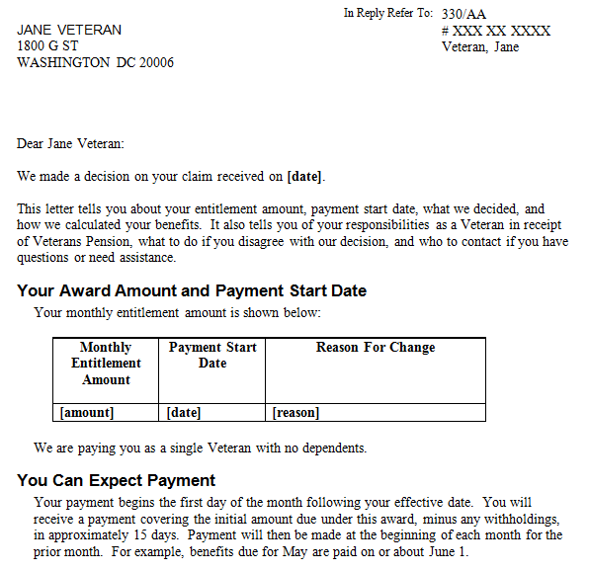

b. Paragraphs Containing Details of the Decision | The page below contains paragraphs that explain  - the decision VA made  - the effective date of the decision  - what income and expenses VA counted in determining entitlement, and  - how VA calculated his/her income for VA purposes (IVAP).

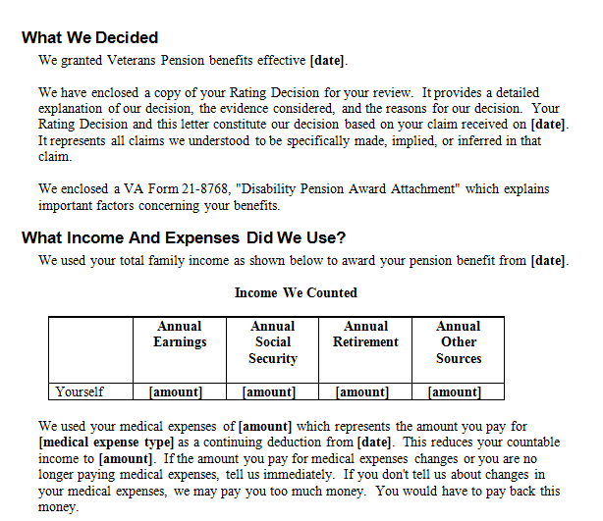

c. Paragraphs Explaining the Veteran’s Responsibilities and Information Regarding Direct Deposit | The page below contains paragraphs that instruct the Veteran  - to notify VA if  - he/she loses or gains a dependent, or  - there is a change in  - his/her income or the income of his/her dependent(s)  - net worth  - medical expenses, or  - his/her address or telephone number, and  - how to set up direct deposit.

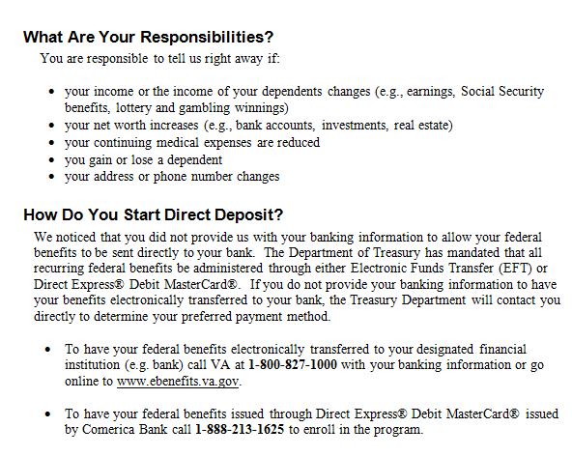

d. Paragraphs About Additional Benefits, the Appeal Process, and eBenefits | The page below contains paragraphs that inform the Veteran  - about additional benefits  - how to appeal VA’s decision, and  - about eBenefits.

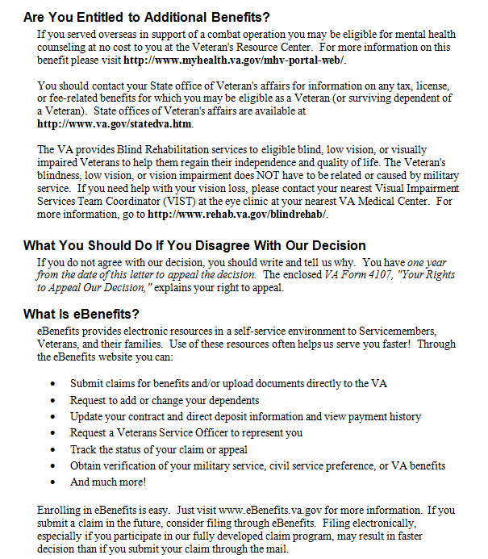

e. Closing Paragraphs of the Decision Notice | The page below represents the last page of the sample decision notice, which  - informs the Veteran how to contact VA  - informs the Veteran that VA has no record he/she selected a representative (if applicable), and  - lists the enclosures that accompany the decision notice.

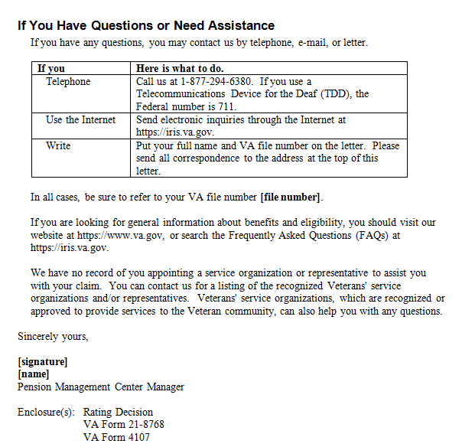

6. Exhibit 2: Sample Decision Notice – Denial of Entitlement to Veterans Pension

Introduction | This exhibit contains a sample decision notice regarding a denied claim for Veterans Pension, including  - paragraphs explaining what VA decided and additional actions the Veteran may take  - paragraphs explaining eBenefits, and  - closing paragraphs of the decision notice.

Change Date | June 1, 2015

a. Paragraphs Explaining What VA Decided and Additional Actions the Veteran May Take | The page below contains the opening paragraphs of a sample decision notice, including paragraphs that explain  - what VA decided  - how to reapply for benefits, and  - appeal rights.

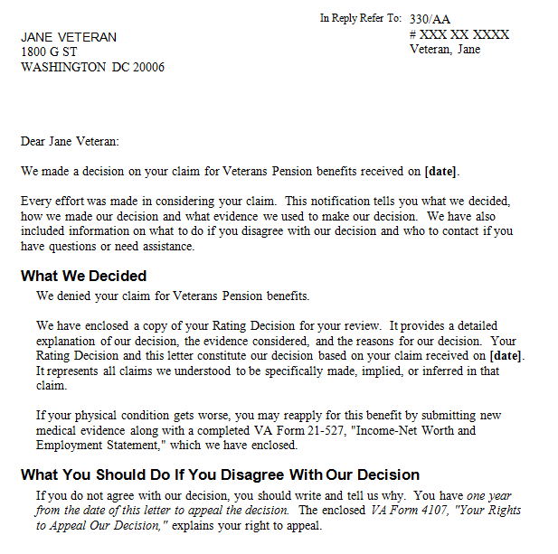

b. Paragraphs Explaining eBenefits | The page below contains paragraphs explaining eBenefits.

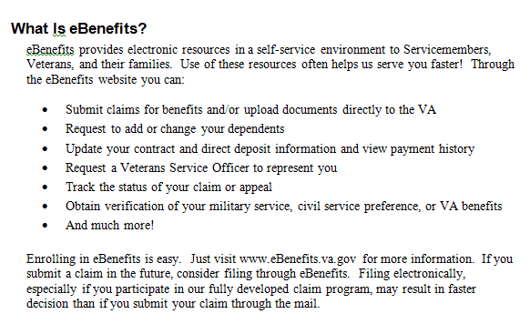

c. Closing Paragraphs of the Decision Notice | The page below represents the last page of the sample decision notice, which  - informs the Veteran how to contact VA  - informs the Veteran that VA has no record he/she selected a representative (if applicable), and  - lists the enclosures that accompany the decision notice.



