Chapter 5: Determining VA Estate Value

39. Overview

a. Introduction | Your review of accountings and various other estate administration duties will require knowledge of the value of the beneficiary’s VA-derived estate. You will need this information to determine the amount of  - surety bond to be required,  - funds to be placed under a restricted withdrawal agreement, and  - the beneficiary’s estate potentially subject to escheat.

This chapter is devoted to providing you with procedures that will standardize the manner in which we determine the value of the beneficiary’s VA-derived estate. You will

- achieve a basic understanding of how we determine value of a beneficiary’s VA estate, and
- be introduced to the Estate Breakdown Tool (BreakdownVAEstate.xls) that automatically performs the basic computations with minimal user entry.

References: For more information on the requirement to breakdown assets to identify VA-source funds, see the Fiduciary Program Manual.

b. Contents | This chapter contains the following topics.

Topic | Topic Name | See Page
 | Overview | 5-1
 | Preliminary Concepts | 5-2
 | Presumption as to Use | 5-3
 | Formula for Determining the Value of a Beneficiary’s VA-Derived Estate | 5-4
 | The Estate Breakdown Tool | 5-8
 | Documenting VA Estate Value | 5-21
 | [Reserved] | 5-23

40. Preliminary Concepts

a. Objectives | To understand the standardized method of separating VA derived assets from assets derived from other sources of income, you must understand a few basic concepts. In this section, we will discuss the various principals that you will follow to determine VA estate values.

b. What funds should you consider when attempting to identify VA funds? | When identifying VA assets, consider only those funds that were actually paid to a third party in a fiduciary capacity. Although accumulated assets may have originated from payment of VA benefits, they are not considered to be VA derived funds if  - paid directly to the beneficiary prior to appointment of a fiduciary, or  - originally paid to another individual by VA and later inherited by the beneficiary.

c. Are there situations when VA estate value is a matter of fact? | When VA funds are the only source of income, or when the fiduciary maintains a separate account for VA benefits, identification of VA assets is a matter of fact. It is only when VA funds are co-mingled with other income that it becomes necessary to have a standardized method of identifying VA derived funds.

d. How do you treat interest income? | When the beneficiary’s estate consists of both VA and other source funds, you must consider a proportionate share of any interest income to have been derived from VA benefits.

e. How do you treat administrative expenses? | You must treat administrative expenses differently for court-appointed fiduciaries than for federal fiduciaries. Refer to the following chart to determine how to treat these expenses.

If the fiduciary is … | Charge administrative expenses …
court-appointed, | proportionately between VA and other source funds.
a federal fiduciary, | to other source funds unless properly authorized by VA.

41. Presumption as to Use

a. What is a “presumption as to use?” | Congress intended that VA benefits be used for the care and maintenance of the beneficiary and any dependents. We therefore exercise a “presumption” that VA funds are used before income from other sources to meet the beneficiary’s needs and the needs of his or her dependents.

b. How do you determine what funds are used to meet expenses? | Current income should always be used first to meet the beneficiary’s ordinary expenses. It is only when expenses exceed income that reductions in accumulated funds (corpus of the estate) are appropriate. Simply stated, expenses are deducted as follows  - first, from VA income (not to exceed the dollar amount of VA benefits received),  - secondly, from other source (OS) income (not to exceed the dollar amount of other OS income received), and  - lastly, from any accumulated VA funds.

c. Can VA benefits be used to manage non-VA funds? | The presumption as to use does not apply to expenses paid for management of non-VA funds. When a court-appointed fiduciary is managing both VA and non-VA funds, presume the expenses of administering the funds to have been paid proportionately from each fund.

d. What if the fiduciary expends funds for a purpose specifically denied by VA? | The presumption as to use does not apply to expenditures specifically denied by VA. Consider the following example. The fiduciary requests authority to spend $10,000 for purchase for an automobile for the beneficiary’s sister, VA denies the request, and the fiduciary continues with the purchase. We would consider the automobile purchase to have been made from the beneficiary’s other source income or accumulated funds.

e. Are there instances when a presumption as to use is not permissible? | The presumption that VA funds were used first will not be made if it will preclude or limit VA intervention in cases of fiduciary misconduct or when excessive fees are claimed (unless the excessive fees pertained only to non-VA funds and the matter has been referred to the court for resolution).

42. Formula for Determining the Value of a Beneficiary’s VA Derived Estate

a. Basic concepts | Remember the following basic concepts for establishing VA estate value.  - When the only income managed by the fiduciary is the VA benefit, VA estate is a matter of fact.  - Only income paid to the fiduciary, in a fiduciary capacity, may be considered VA-derived.  - Interest income is applied proportionately to VA and other source income.  - Income is always spent first, before any reduction to the accumulated funds.  - Administrative expenses are charged proportionately between VA and other source funds.  - We generally presume that VA income is spent before other source income.  - Expenses specifically denied by VA must be charged to other source income or accumulated funds.  - A presumption as to use is not made if it will preclude or limit VA intervention in cases of fiduciary misconduct or when excessive fees are claimed.
Continued on next page
42. Formula for Determining the Value of a Beneficiary’s VA Derived Estate, Continued

b. Basic Computations – Current VA Estate Known | The following chart illustrates the basic computation you will use to determine the value of VA-derived funds when you have previously identified VA funds in the existing estate:

 | A | B | C
 |  | VA | Other Source (OS)
1 | Receipts this period (excluding interest income) | $ | $
2 | (-) Expenditures this period (excluding administrative costs, i.e. fiduciary or attorney fees) | (Cannot exceed amount of VA income)  $ | (Additional expenses, over and above VA benefits paid, but not more than other income)  $
3 | Increase to VA/OS Estate | $ | $
4 | (+) Estate balance from last accounting | $ | $
5 | Net Estate | $ | $
6 | Adjustment to estate balance when expenses exceed income (see example) | $ | $
7 | Net Estate - VA/OS breakdown | $ | $
8 | % Of VA/Other to total estate | % of estate | % of estate
9 | (+) Proportionate share of interest income | $ | $
10 | (-) Proportionate share of administrative expenses (Note that for legal custodian cases, the admin expenses must be broken down to reflect those authorized by VA and other expenses. Only those specifically authorized by VA may be used to reduce the VA estate.) | $ | $
11 | Ending Balance | $ | $
Continued on next page
42. Formula for Determining the Value of a Beneficiary’s VA Derived Estate, Continued

c. Basic Computations – Current VA Estate Unknown | If expenses are less than total income, but exceed VA income, there will be no increase to VA estate. If you have not previously done so, however, you will still need to breakdown the beginning estate balance. Use the following guidelines.

- Is beneficiary’s situation such that expenses have consistently exceeded income over the past several accounting periods?
- If so, there is likely no VA estate, unless accumulated funds were derived from VA retroactive benefits.
- It will be necessary for you to estimate VA estate based solely on your review of the file. The templates will be of no value to you in these cases.

- Look at the current accounting under review. Did expenses exceed income only because of a large, one-time expenditure such as $10,000 for purchase of a car? If so, complete the worksheet as usual except, deduct the one-time expense from the total expenditures and complete your computations as usual.
- If VA authorized the one-time expenditure (or if prior authorization was not requested but it would have been approved upon request), deduct it from the ending VA estate balance.
- If, however, VA specifically denied a request for the expenditure, deduct it from the “other” estate balance.
Continued on next page
42. Formula for Determining the Value of a Beneficiary’s VA Derived Estate, Continued

c. Basic Computations – Current VA Estate Unknown (continued) | The following chart illustrates the basic computation you will use to determine the value of VA-derived funds when you have not historically broken down funds to identify the beneficiary’s VA-derived estate.

Note: The following formula will not work if expenses exceed income. In cases where expenses exceed income, please see the guidelines following this table.
 |  | VA | Other Source (OS)
1 | Receipts this period (excluding interest income) | $ | $
2 | (-) Expenditures this period (excluding administrative costs, i.e. fiduciary or attorney fees) | (Cannot exceed amount of VA income)  $ | (Additional expenses, over and above VA benefits paid, but not more than other income)  $
3 | Sub-total | $ | $
4 | % of increase this reporting period | % of increase | % of increase
5 | Proportionate share of beginning balance based on above percentages | $ | $
6 | Sub-total (from lines 3 and 5 above) | $ | $
7 | Add back lump sum payment if applicable | $ | $
8 | Sub-total | $ | $
9 | (+) Proportionate share of interest income | $ | $
10 | (-) Proportionate share of administrative expenses (Note that for legal custodian cases, the admin expenses must be broken down to reflect those authorized by VA and other expenses. Only those specifically authorized by VA may be used to reduce the VA estate.) | $ | $
11 | Ending Balances | $ | $

43. The Estate Breakdown Tool

a. What is the Estate Breakdown Tool? | The Estate Breakdown Tool is an Excel workbook containing 4 worksheets as follows:  - Court - Example  - Court - Template  - Legal Cust - Example  - Legal Cust - Template

A tab at the bottom of the workbook identifies the various examples and templates.

Example documents illustrate what a completed computation will look like. Template documents contain embedded formulae that will perform the required computations when you input case-specific data.

Each worksheet is divided into two (2) parts. The top half is a worksheet for use when VA assets have been previously identified.

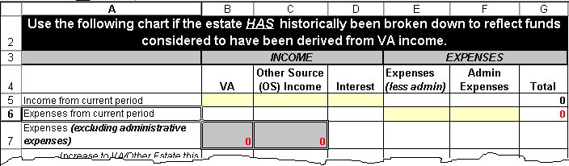

The bottom half is a worksheet for use when VA assets have not been previously identified.

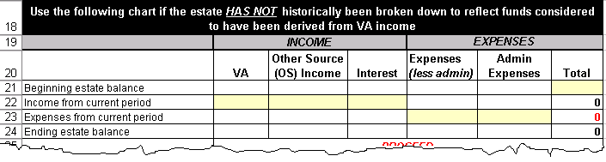
Continued on next page
43. The Estate Breakdown Tool, Continued

a. What is the Estate Breakdown Tool? (continued) | Following is an illustration of a template for a court-appointed estate computation:

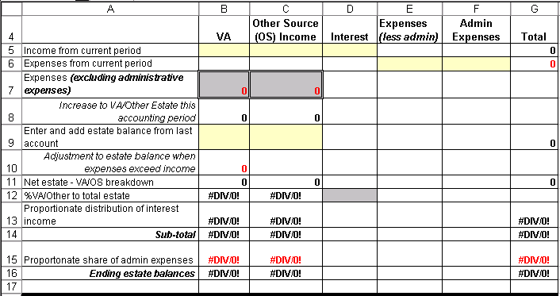

Each template contains seven (7) yellow-highlighted cells for entry of

- VA income (Cell 5B)
- Other Source Income (Cell 5C)
- Interest Income (Cell 5D)
- Expenses (less Administrative) (Cell 6E)
- Administrative Expenses (Cell 6D)
- Beginning VA Estate (Cell 9B)
- Beginning Other Source Estate (Cell 9C)

By completing only the yellow-highlighted cells, computations are automatic.

Two (2) gray cells are unprotected to allow adjustments for an expenditure that was specifically disallowed by VA.

- Expenses (excluding administrative expenses) – VA (Cell 7B), and
- Expenses (excluding administrative expenses) – Other Source (Cell 7C)
Continued on next page
43. The Estate Breakdown Tool, Continued

a. What is the Estate Breakdown Tool? (continued) | Make entries in these cells only if this situation exists. If no such adjustments are necessary, computations are automatic.

A word of caution: If you make changes to these cells, your changes will override the cell formulas. Should you then decide you don’t want to make the adjustment, the formulas will have been deleted. Just close the file and answer “NO” to the question “Do you want to save changes?” You can then reopen the file and begin again.

b. Save a Shortcut to your Desktop | By saving a shortcut to the Estate Breakdown Tool to your desktop, you can easily access it with each account analysis and complete the appropriate worksheet to arrive at the necessary estate breakdown. (If you are not familiar with this process, your IRM staff can assist you.)

c. Examples | Following are examples of various scenarios with completed templates to illustrate how this tool works.

- Examples 1A through 1C illustrate computations to determine the increase to a VA estate when you have previously determined the value of the VA-derived estate.
- Examples 2A through 2D illustrate computations to determine the value of the VA estate, as well as any increase in VA funds, when you have not determined the value of the VA-derived estate.
- Example 3 illustrates the computation to determine VA estate value in a federal fiduciary case.

You are encouraged to access the Estate Breakdown Tool and perform the computations as you review the exercises to familiarize yourself with this job aid.

You can access the Estate Breakdown Tool from the Fiduciary Program Homepage at: http://vbaw.vba.va.gov/bl/21/fiduciary/Tools.htm. Select Training Tools, then Breakdown VA Estate.xls.
Continued on next page
43. The Estate Breakdown Tool, Continued

d. Example 1A: Income Exceeds Expenses | The beneficiary’s beginning estate balance is $80,000.  You have historically broken down estate funds and know that the estate consists of $50,000 VA funds and $30,000 other source funds.

The fiduciary is court-appointed and the current accounting reflects income and expenses as follows:

Income | Expenses
$25,000 VA | $30,000 Expenses (less administrative)
$10,000 OS | $ 2,000 Administrative Expenses
$ 4,000 Interest
$39,000 Total Income | $32,000 Total Expenses

Here is what your worksheet will look like:

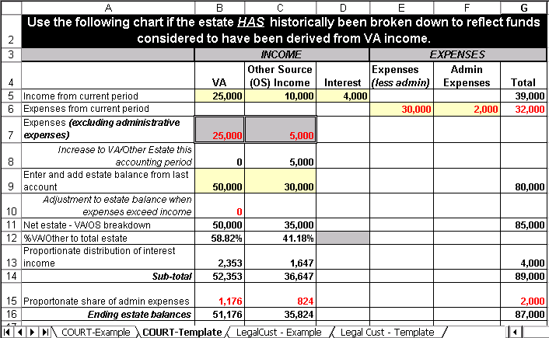

In this example the user entered only seven numbers, filling the yellow-highlighted cells. Embedded formulae made the resulting computations.

As expenditures exceeded VA income, all VA income was applied toward expenses with the remaining $5,000 taken from other source income.
Continued on next page
43. The Estate Breakdown Tool, Continued

e Example 1B: Expenses Exceed Income | The beneficiary’s beginning estate balance is $80,000.  You have historically broken down estate funds and know that the estate consists of $50,000 VA funds and $30,000 other source funds.

The fiduciary is court-appointed and the current accounting reflects income and expenses as follows:

Income | Expenses
$25,000 VA | $40,000 Expenses (less administrative)
$10,000 Other Source | $ 2,000 Administrative Expenses
$ 4,000 Interest
$39,000 Total Income | $42,000 Total Expenses

Here is what your worksheet will look like:

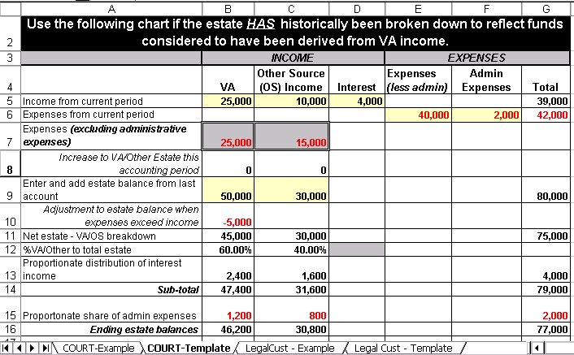

Again, the user entered only seven numbers, filling the yellow-highlighted cells. Embedded formulae made the resulting computations.

As expenditures in this example exceeded all income, all VA (Cell 7B) and OS (Cell 7C) income was applied toward expenses first with the remaining $5,000 taken from the VA estate (Cell 10B).
Continued on next page
43. The Estate Breakdown Tool, Continued

f. Example 1C: Expenditure Specifically denied by VA | As in Examples 1A and 1C, the beneficiary’s beginning estate balance is $80,000 and because you have historically broken down estate funds, you know that the estate consists of $50,000 VA funds and $30,000 OS funds.

The fiduciary is court-appointed and the current accounting reflects income and expenses as follows:

Income | Expenses
$25,000 VA | $22,000 Expenses (less administrative)
$10,000 Other Source | $ 2,000 Administrative Expenses
$ 4,000 Interest
$39,000 Total Income | $24,000 Total Expenses

In this example, expenditures reported include a $4,000 down payment on an automobile for the beneficiary’s sister. VA specifically denied this expense.

Here is what your worksheet will look like:

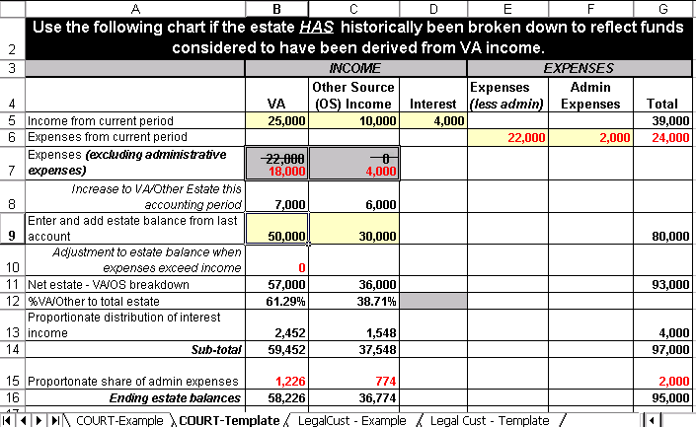
Continued on next page
43. The Estate Breakdown Tool, Continued

f. Example 1C: Expenditure Specifically denied by VA (continued) | Because VA income exceeds all expenses (less administrative) the template automatically charged all expenses ($22,000) to VA income. Remember, however, that VA specifically denied the $4,000 down payment on the sister’s automobile. This is where the gray cells come in. As these cells are unprotected, you are able to manually adjust these figures by subtracting the $4,000 from the VA expenses (Cell 7B) and adding them to the OS expenses (Cell 7C). Embedded formulae will then recomputed the breakdown based on this adjustment.

Be sure to print your worksheet, annotate the basis for this adjustment on back, and file it in the PGF.
Continued on next page
43. The Estate Breakdown Tool, Continued

g. Example 2A: VA assets not previously identified and expenses exceed VA benefit | The beneficiary’s beginning estate balance is $60,000. You have not historically broken down assets. The fiduciary is court-appointed and the current accounting reflects income and expenses as follows:

Income | Expenses
$25,000 VA | $32,000 Expenses (less administrative)
$10,000 Other Source | $ 2,000 Administrative Expenses
$ 4,000 Interest
$39,000 Total Income | $34,000 Total Expenses

Here is what your worksheet will look like:

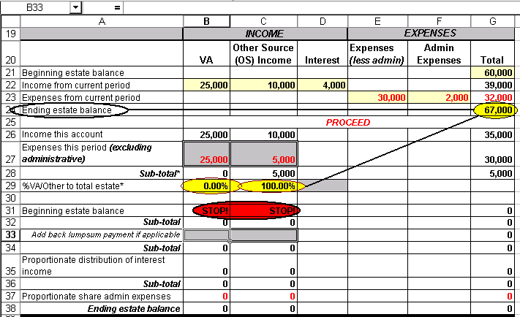

In this example, you will note that the ending balance is $67,000. Expenses exceeded VA income and your preliminary review of the PGF found no evidence of lump sum VA payments made to the fiduciary.

As the resulting computation reveals VA assets comprise 0.00% of the remaining estate, formulae embedded within the spreadsheet tell you to “STOP.” Your computations are complete. The estate consists entirely of other source funds.
Continued on next page
43. The Estate Breakdown Tool, Continued

h. Example 2B: VA assets not previously identified and VA benefit exceeds expenses | The beneficiary’s beginning estate balance is $150,000 and you have not historically broken down estate funds. The fiduciary is court-appointed and the current accounting reflects income and expenses as follows:

Income | Expenses
$37,500 VA | $30,000 Expenses (less administrative)
$20,000 Other Source | $ 3,750 Administrative Expenses
$ 6,750 Interest
$64,250 Total Income | $33,750 Total Expenses

In this example, VA income exceeds expenses. Your preliminary review of the PGF found no evidence of lump sum VA payments made to the fiduciary.

Here is what your worksheet will look like:

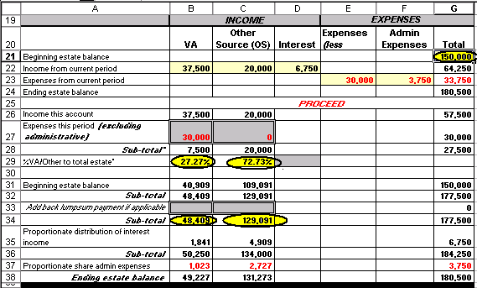

Note that, in this example, all expenses (except administrative) were deducted from VA income. After expenses, VA benefits represented 27.27% of the surplus income. When this percentage is applied to the beginning balance, we find that $48,409 of those funds ($150,000 x 27.27%) are VA-derived.
Continued on next page
43. The Estate Breakdown Tool, Continued

i. Example 2C: VA assets not previously identified and expenses include VA-approved one-time purchase | The beneficiary’s beginning estate balance is $60,000 and you have not historically broken down estate funds. The fiduciary is court-appointed and the current accounting reflects income and expenses as follows:
 |  | Income | Expenses
 |  | $25,000 VA | $30,000 Expenses (less administrative)
 |  | $10,000 Other Source | $ 2,000 Administrative Expenses
 |  | $ 4,000 Interest
 |  | $39,000 Total Income | $32,000 Total Expenses

In this example, expenses exceed VA income and include a one-time, VA-approved expenditure of $10,000 for purchase of an automobile. Your preliminary review of the PGF found no evidence of lump sum VA payments made to the fiduciary. If we allow the formulae alone to compute the VA estate value, we will be left with no VA estate as reflected below.

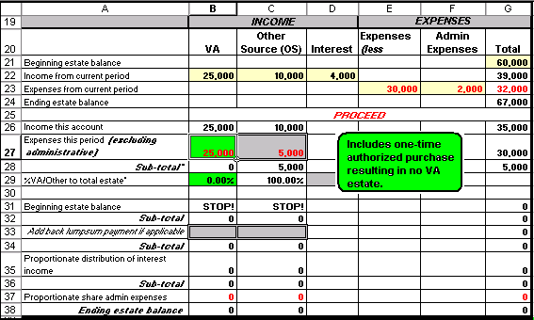
Continued on next page
43. The Estate Breakdown Tool, Continued

i. Example 2C: VA assets not previously identified and expenses include VA-approved one-time purchase (continued) | When we attempt to identify VA funds in an existing estate, we base our breakdown on the amount of increase to accumulated VA funds during the current accounting period. We presume VA income is spent first to meet day-to-day needs. Lump sum expenses such as the $10,000 automobile purchase generally require expenditure from accumulated funds. It is, therefore, appropriate to adjust the VA expenditures by this amount to get a fair picture of the percentage of income, surplus to day-to-day needs, that is VA-derived. This is the percentage that we apply to the beginning estate balance to arrive at the beginning VA estate.

Once we have made this determination, we can then reduce the resulting VA estate by the amount of the authorized expenditure. The below graphic illustrates the appearance of your spreadsheet after you have made the required adjustments.

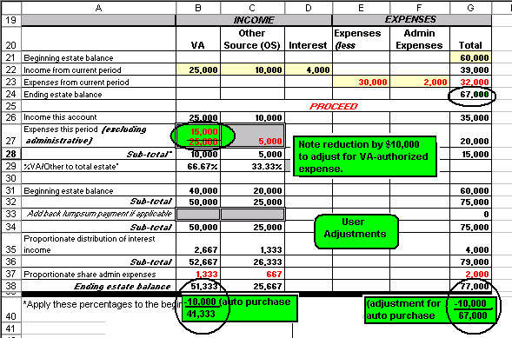
Continued on next page
43. The Estate Breakdown Tool, Continued

j. Example 2D: VA assets not previously identified and expenses include disallowed one-time purchase | For this example, the facts are identical to Example 2C except that the $10,000 automobile purchase was for a sibling and VA specifically disallowed the purchase. Accordingly, the expenditure must come from other source funds.  The following graphic illustrates the completed worksheet with user adjustments and annotations:

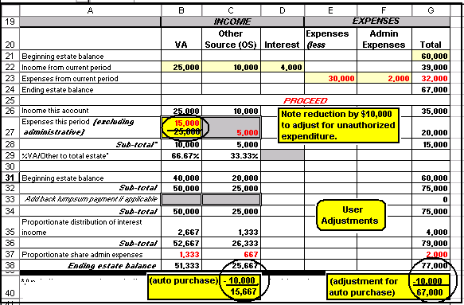

k. Example 3: Federal Fiduciary Computation with Approved Commission | Computations for federal fiduciary cases are identical to the computations in court-appointed cases except for the manner in which you must treat administrative expenses. For purposes of this example, the beneficiary’s beginning estate balance is $60,000 and you have not historically broken down estate funds. The fiduciary is a legal custodian and the current accounting reflects income and expenses as follows:

Income | Expenses
$25,000 VA | $32,000 Expenses (less administrative)
$10,000 Other Source | $ 1,500 Federal Fiduciary Commission
$ 4,000 Interest
$39,000 Total Income | $34,000 Total Expenses
Continued on next page
43. The Estate Breakdown Tool, Continued

k. Example 3: Federal Fiduciary Computation with Approved Commission (continued) | In this example, the fiduciary reported commissions that exceed the maximum statutory commission allowable for a federal fiduciary.  Here is what your worksheet will look like:

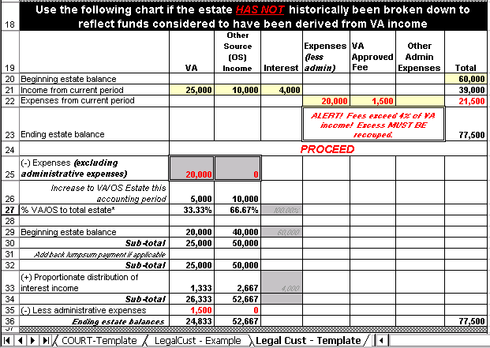
Note ALERT informing you that excess fees must be recouped.

44. Documenting VA Estate Value

a. Document Support Your Computation of VA Estate Value | It is not sufficient to merely annotate the VA estate value in the PGF. As with all decisions you make as an LIE, you must document the basis for your determination of the VA estate value. Always be sure that you  - print your Estate Breakdown worksheet,  - document the basis for any necessary adjustments to computations on the reverse side,  - file the worksheet in the PGF, and  - remember to respond “NO” to the question “Do you want to save changes to the document?” when closing the file.

b. Document VA Estate Value | As we have learned, knowledge of the beneficiary’s VA estate value is needed for various facets of estate administration. This information will facilitate determinations regarding  - accounting requirements,  - estate protection, and  - the type of fiduciary arrangement most suitable to the beneficiary’s situation.

Additionally, accurate estate values must be recorded in all cases to ensure accurate data for Fiduciary Program administration.

The following blocks will discuss the various documentation requirements for this information.

c. VA Form 21-4707, Estate Summary | Section 11a of VA Form 21-4707, Estate Summary, requires entry of the beneficiary’s personal estate data. Post the value of the beneficiary’s net VA and OS estate in the designated blocks.
Continued on next page
44. Documenting VA Estate Value, Continued

d. FBS: VetBene Record | The FBS VetBene record contains 3 estate data fields. The following table identifies the specific fields by field “name” and provides a description of data required for each field:

Field Name | Required Data
EstateValue | Enter the gross value of the beneficiary’s estate (VA + OS funds)
HomeValue | Enter the value of the beneficiary’s home.
ValueDate | Enter the date the value was last reviewed and updated.  - In accounting cases, this will be the ending date of the last accounting.  - In non-accounting cases, this will be the date last verified by the field examiner.

e. FBS: WorkStatus Record | You will enter the beneficiary’s estate value into the work status record whenever you complete an accounting work product (WPC 560 or 565). The following table identifies the specific fields by field “name” and provides a description of data required for each field:

Field Name | Required Data
Receipts | Enter the amount of benefits paid and income derived from VA benefits. This will include VA benefits paid plus any interest income earned on VA-derived funds.
Investments | Enter the total value of investments derived from VA benefits.
Cash | Enter the amount of the beneficiary’s VA estate that is in cash at the end of the accounting period.

45. [Reserved]

