Section B. Onsite Review Protocol

Overview

In this Section | This section contains the following topics:

Topic | Topic Name | See Page
4 | Onsite Review Notification | 6-B-2
5 | Records to Be Reviewed and Sample Size | 6-B-3
6 | Beneficiary or Other Third Party Interviews | 6-B-5
7 | Misuse Identified As a Part of Onsite Review | 6-B-6
8 | Actions Resulting From Noncompliance | 6-B-7
9 | Exit Interview | 6-B-8
10 | Exhibit 1: Onsite Review Notification Letter | 6-B-9
11 | Exhibit 2: Onsite Review Worksheet | 6-B-10

4. Onsite Review Notification

Introduction | This topic contains information on notification requirements for all reviews.

Change Date | July 13, 2005

a. Notification Requirements | The fiduciary will be notified by the Fiduciary Activity of the onsite review at least 30 days in advance of the scheduled review date. This notification will be in writing and will inform the fiduciary that 38 U.S.C. 5508 requires VA to perform onsite visits. The identification of individual cases to be reviewed will not be released in advance of the onsite visit. The notification will also explain that the onsite review may include  - examination of case files  - bank statements  - ledgers  - check registers  - receipts, and  - bills.

Note: The notification will also advise the fiduciary that VA will review their fiduciary operation for VA beneficiaries and help with any VA fiduciary-related issues they may have. The notice will indicate that VA personnel will review records to verify how benefits were used, as well as verify existing funds on deposit.

Reference: For a sample onsite review notification letter, see M21-1MR, Part XI, 6.B.10.

5. Records to Be Reviewed and Sample Size

Introduction | In this topic we will discuss records to be reviewed and sample size.

Change Date | July 13, 2005

a. Records to Be Reviewed | Determine records to be reviewed based upon the type of fiduciary involved. The review will include records of income and expenditures.  - If the fiduciary is a state facility, the review may be limited to review of case files and account ledgers to ensure that the fiduciary can account for all income, justify expenditures, and can accurately identify funds belonging to the beneficiary.  - If the fiduciary is an individual, the review may include case files, bank statements, ledgers, check registers, receipts to support purchases, and actual bills.

Reference: For a sample onsite review worksheet, see M21-1MR, Part XI, 6.B.11.

b. Additional Records for Review | Pursue any leads that indicate irregularities. This may include interviewing the beneficiary, his or her caregiver, etc. These contacts will generally be by telephone; however, personal interviews may be conducted at the discretion of the reviewer.
Continued on next page
5. Records to Be Reviewed and Sample Size, Continued

c. Sample Size | For each fiduciary meeting the criteria for mandatory onsite reviews, the station must review 25 percent of cases managed by that fiduciary, not to exceed 25 cases unless circumstances dictate an expanded review. The review sample may be expanded if trends are identified.

d. Case Selection | Case selection will be at the discretion of the reviewer. Use the following guidelines to determine actual cases to be reviewed:  - If the fiduciary has accountings that are delinquent, all delinquent accounting cases should be considered for review.  - If the fiduciary has cases involving disallowed accountings that cannot be resolved, each such case should be considered for review.  - If a beneficiary or other interested party has made repeated complaints about a fiduciary, that individual’s case should be considered for review.  - If none of the above situations are identified, select a random sampling of cases. The method used to obtain a random sample must be described in the report; i.e. every third case, odd terminal digits, even terminal digits, etc.  - If discrepancies are found in a significant proportion of the cases, expand the initial sample until sufficient cases have been reviewed to reach a conclusion as to the fiduciaries suitability.

6. Beneficiary or Other Third Party Interviews

Introduction | In this topic we will discuss issues relating to beneficiary or other third party interviews as a part of the onsite review.

Change Date | July 13, 2005

a. Decision to Interview Beneficiary or Other Third Party | It will not always be necessary to interview beneficiaries or other third parties. The review of selected PGFs in advance of the onsite visit as well as review of the fiduciary’s records will determine if additional interviews are warranted.  Example: If the review identifies unusual or questionable purchases, the reviewer may contact the beneficiary or their caregiver to corroborate the purchase.

7. Misuse Identified As a Part of Onsite Review

Introduction | This topic will include information on required actions when misuse is identified during the course of an onsite review.

Change Date | July 13, 2005

a. When Misuse is Identified | Where indications of misuse are discovered during an onsite review, referral must be made to the VSCM for a decision regarding need for a misuse investigation.  A separate referral will be made for each case of potential misuse identified.

Reference: For more information on requirements for handling misuse issues, see M21-1MR, Part XI, 5.A.

b. Discovery Date | The date of the onsite review will be the date of discovery of potential misuse.

8. Actions Resulting From Noncompliance

Introduction | This topic contains information on handling issues of fiduciary noncompliance with fiduciary duties and responsibilities.

Change Date | July 13, 2005

a. Basis for Noncompliance | If a fiduciary’s performance is questionable, the Fiduciary Activity must make a determination as to the severity of the noncompliance.

b. Noncompliance Based on Lack of Understanding of Duties | If the noncompliance resulted from a lack of understanding of requirements, the fiduciary will be properly instructed and a follow-up review scheduled at an appropriate time to ensure compliance.  Ensure any follow up review is scheduled at a time that will provide the fiduciary adequate time to comply, however, not so long as to allow the situation to continue indefinitely if the fiduciary does not comply.

c. Noncompliance Severe | If non-compliance is determined to be severe, immediate action must be taken to replace the fiduciary.  In all cases, non-compliance may be considered severe in nature in circumstances such as  - a fiduciary who refuses to cooperate with an onsite review  - a fiduciary who is found to have misappropriated funds belonging to a beneficiary, or  - a fiduciary who is unable to maintain appropriate records to support his or her actions.

9. Exit Interview

Introduction | In this topic, we will discuss the purpose and elements of the exit interview to be conducted with the fiduciary at the termination of the onsite review.

Change Date | July 13, 2005

a. Purpose | The reviewer will conduct an exit interview to communicate preliminary findings to the fiduciary.

b. Elements of the Exit Interview | The reviewer will  - communicate preliminary findings, both positive and negative  - inform the fiduciary of any practices that need to be changed or improved as well as other recommendations, and  - advise the fiduciary that a summary of findings will follow.

10. Exhibit 1: Onsite Review Notification Letter

Introduction | This topic contains a sample of a suggested onsite review notification letter.

Change Date | July 13, 2005

a. Notification Letter | A sample of a suggested Onsite Review Notification letter is below.

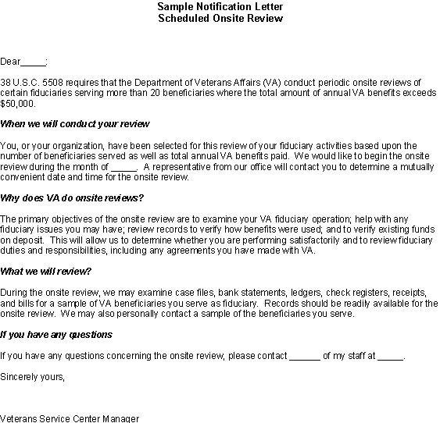

11. Exhibit 2: Onsite Review Worksheet

Introduction | This topic contains a sample of a suggested onsite review worksheet.

Change Date | July 13, 2005

a. Review Worksheet, page one | A sample of a suggested onsite review worksheet, page one is below. Complete one worksheet for each beneficiary record reviewed

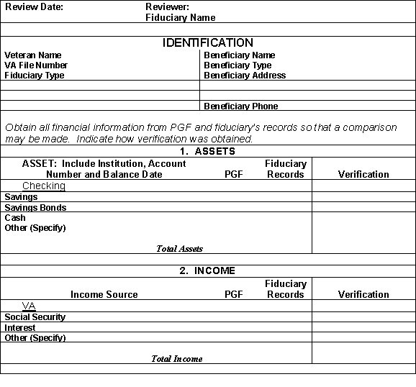
Continued on next page
11. Exhibit 2: Onsite Review Worksheet, Continued

b. Review Worksheet, page two | A sample of a suggested onsite review worksheet, page two is below.

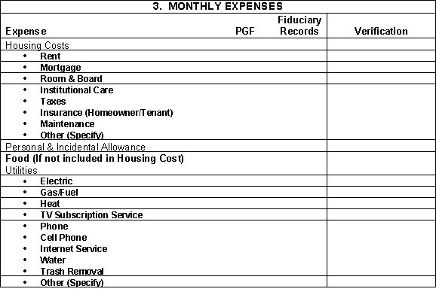
Continued on next page
11. Exhibit 2: Onsite Review Worksheet, Continued

c. Review Worksheet, page three | A sample of a suggested onsite review worksheet, page three is below.

