Section J. Exhibits

Overview

In This Section | This section contains the following exhibits:

Topic | Topic Name
1 (old 34) | Label for the Front of a Paper Claims Folder
2 (old 35) | BVA Label for the Paper Claims Folder Flaps
3 (old 36) | Label for the Center of the Paper Folder
4 (old 37) | Certification of Record Integrity

1. Label for the Front of a Paper Claims Folder

Introduction | This topic contains information about labels for pending appeal cases, including  - explanation of the Board of Veteran Appeals (BVA) label for potential Court of Appeals for Veterans Claims (CAVC) appeals, and  - example of the label for CAVC review.

Change Date | December 16, 2010

a. Explanation of the BVA Label Potential CAVC Appeals | This label is used for a paper claims folder that the Board of Veterans’ Appeals (BVA) has determined meets the criteria for review by the Court of Appeals for Veterans Claims (CAVC). BVA places the label on the outside of the paper claims folder.  Note: Regional offices (ROs) do not stock this label.

b. Example of the Label for CAVC Review | ATTENTION  THE BOARD OF VETERANS APPEALS HAS MADE A DECISION ON THIS APPEAL WHICH IS SUBJECT TO REVIEW BY  THE UNITED STATES COURT OF APPEALS FOR VETERANS CLAIMS  SPECIAL PROCEDURES TO PROTECT THE INTEGRITY OF THE  FOLDER  MUST BE FOLLOWED

2. BVA Label for the Paper Claims Folder Flaps

Introduction | This exhibit contains information about BVA folder labels, including  - an explanation of the BVA labels for the paper claims folder, and  - an example of the label for the flaps.

Change Date | December 16, 2010

a. Explanation of the BVA Labels for the Paper Claims Folder | This label is used for a paper claims folder that the BVA has determined meets the criteria for review by the CAVC. BVA places the label in each volume of the paper claims folder.  Note: ROs do not stock this label.

b. Example of the Label for the Flaps | 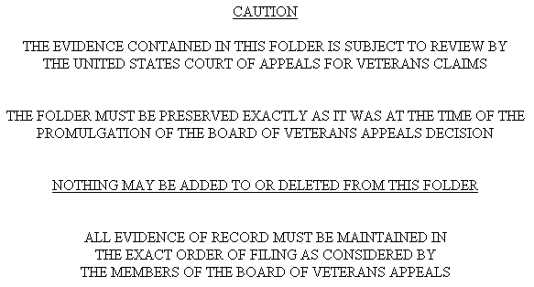

3. Label for the Center of the Paper Folder

Introduction | This topic contains information about placement of BVA labels, including  - an explanation of the BVA label used on the center folder flap, and  - an example of a label for the center flap of a claims folder.

Change Date | December 16, 2010

a. An Explanation of the BVA Label Used on the Center Folder Flap | This label is used for paper claims folders that the BVA has determined to meet the criteria for review by the CAVC. BVA places the label over the records in the center of the paper claims folder.  Note: ROs do not stock this label.

b. An Example of a Label for the Center Flap of a Paper Claims Folder | 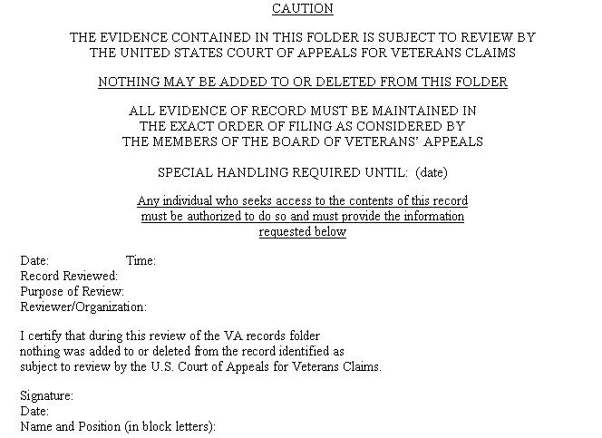

4. Certification of Record Integrity

Introduction | This exhibit contains an example of the Certification of Record Integrity.

Change Date | December 16, 2010

Example of Certification of Record Integrity | “I certify that this VA records folder was maintained in a secured area at the VA Regional Office ___________ and that to the best of my knowledge and belief nothing was added to or deleted from the record identified as subject to review by the United States Court of Appeals for Veterans Claims.”  ______________  Date  _____________________________  Signature and Title of Certifying Official

