Department of Veterans Affairs M21-1, Part III, Subpart iii
Veterans Benefits Administration January 26, 2016
Washington, DC 20420

Key Changes

Changes Included in This Revision | The table below describes the changes included in this revision of Veterans Benefits Manual M21-1, Part III, “General Claims Process,” Subpart iii, “General Development and Dependency Issues.”  Note: Minor editorial changes have also been made to bring the document into conformance with M21-1 standards.

Reason for the Change | Citation
To update examples to clarify that only one contention is required for dependency claims. | M21-1, Part III, Subpart iii, Chapter 1, Section D, Topic 2, Block a (III.iii.1.D.2.a)

Rescissions | None

Authority | By Direction of the Under Secretary for Benefits

Signature | Thomas J. Murphy, Director  Compensation Service

Distribution | LOCAL REPRODUCTION AUTHORIZED

Section D. Record Maintenance During Development Process

Overview

In This Section | This section contains the following topics:

Topic | Topic Name
1 | Routine Review of Electronic Claims Folder (eFolder) Documents and Claimant Flashes
2 | Utilizing Contentions and Special Issue Indicators Associated With the Claimed Issues
3 | Utilizing Tracked Items to Document Development
4 | Updating Claim Status

1. Routine Review of Electronic Claims Folder (eFolder) Documents and Claimant Flashes

Introduction | This topic contains information on the review of eFolder documents and adding flashes to a claimant record, including  - routine review of eFolder documents, and  - claimant flashes.

Change Date | October 30, 2015

a. Routine Review of eFolder Documents | During routine review of the electronic claims folder (eFolder) all claims processors must conduct eFolder maintenance to ensure  - end product (EP) controls are consistent with claims document, including use of a correct  - date of claim  - EP series, and  - claim label  - information regarding the Veteran’s service dates and character of discharge in VA systems are consistent with the evidence in the eFolder, including  - the Veterans Benefits Management System (VBMS)  - Benefits Identification and Records Locator Subsystem (BIRLS), and  - Participant Profile  - the claims folder contains proper documentation of claimant representation, including system updates of  - Share, and  - VBMS  - any documents identified as duplicate upon review are managed in accordance with M21-1, Part III, Subpart ii, 4.G.2.q  - any documents reviewed are indexed properly in accordance with M21-1, Part III, Subpart ii, 4.G.2.r  - any misfiled document(s) are removed and transferred to the proper claims folder(s) following the procedures outline in M21-1, Part III, Subpart ii, 4.G.2.c, and  - all pertinent evidence is properly noted, bookmarked, and/or annotated following the respective guidance found in  - M21-1, Part III, Subpart ii, 4.G.2.s  - M21-1, Part III, Subpart ii, 4.G.2.n, and  - M21-1, Part III, Subpart ii, 4.G.2.o.  Note: To manage the documents associated with the Veteran’s eFolder in VBMS, click the DOCUMENT link on the VETERAN PROFILE screen.  References: For more information on  - viewing eFolder documents, see the VBMS User Guide  - EP series, see M21-4, Appendix B  - date of claim, see M21-4, Appendix B, Section I, Block c  - Veteran’s service dates and character, see M21-1, Part III, Subpart ii, 6  - updating military service information, see M21-1, Part III, Subpart ii, 3.C.7, and  - power of attorney (POA) appointments, see M21-1, Part III, Subpart ii, 3.C.4.

b. Claimant Flashes | Claimant flashes are claimant-specific indicators that represent an attribute, fact, or status that may occasionally change (e.g. Former Prisoner of War (FPOW), blind Veteran, homeless, etc.). Regional offices (ROs) are responsible for  - identifying claimant’s records that require flashes  - inputting the flashes when required, and  - promptly removing the flash when it no longer applies.  Claimant flashes must be entered in the corporate record once the need is identified. Most flashes are added by the end user, but some are generated by the system. Flashes will exist on a claimant’s record until the flash is manually removed.  Once the scenario no longer applies, the flash will be removed by any authorized end user. ROs are responsible for identifying and updating flashes when applicable.  Examples:  - The Foreign Claim flash should be applied when the claimant resides in a foreign country and removed when the scenario changes.  - The Homeless flash should be applied when the case involves a homeless Veteran and removed when the scenario changes.  Claimant flashes may be reviewed on the VBMS profile screen.  Illustration:  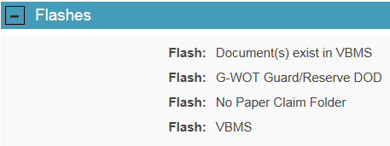  Note: Claimant flashes must be added using Share. Currently, VBMS only contains functionality to view claims folder flashes.  Reference: For more information on adding claims folder flashes in Share, see the Share User’s Guide.

2. Utilizing Contentions and Special Issue Indicators Associated With the Claimed Issues

Introduction | This topic contains information on utilizing contentions and special issue indicators associated with claimed issues, including  - identifying contentions  - verifying contentions  - classifying contentions  - associating claim types to contentions  - entering a claim-specific special issue, and  - properly applying special issues.

Change Date | January 26, 2016

a. Identifying Contentions | All claimed issues must be entered as contentions as they are claimed. Each claimed issue, including non-rating issues, must be entered as a separate contention. Non-rating contentions should relate to the specific benefit being sought.  Use of contentions for each claim is mandatory and should be entered as soon as they are identified.  Important: This information will be made available via eBenefits and should be easy to understand and in the claimant’s own words, as appropriate.  Examples:  - A Veteran submits a claim for ringing in the ears. The contention should be entered as ringing in the ears.  - A Veteran submits a claim to add a spouse and a child to a running award. Only one contention should be entered as Dependency.

b. Verifying Contentions | All contentions must be verified in order for them to be available via eBenefits.  Contentions automatically entered by the system will not be verified until an employee reviews the contention and checks the verified box. All employees reviewing a claim are responsible for ensuring all contentions are correct and verified.

c. Classifying Contentions | The CLASSIFICATION field is a required component when entering a contention. When selecting a classification, use appropriate medical verbiage that corresponds to the claimed medical condition, instead of the claimant’s original language.  Note: Classifying a contention is required if the MEDICAL field is set to Yes. If the MEDICAL field is set to No, adding a classification is optional.  Exception: Unemployability is a classification that must be applied to an individual unemployability contention in order to complete necessary specific development actions in VBMS.

d. Associating Claims Types to Contentions | Each contention must have the correct claim type associated with it. The contention claim types are  - New  - Increase  - Secondary, and  - Reopen.  Example: A Veteran claims an increase in her service-connected (SC) peripheral neuropathy of the left lower extremity. The condition was previously granted on a secondary basis associated with the Veteran’s SC diabetes mellitus, type II. Although the condition was originally granted on a secondary basis, the current claim is for an increased evaluation. Therefore, the correct contention claim type is Increase.

e. Entering a Claim-Specific Special Issue | The RO has a responsibility to identify any contention that may have a special issue associated to it. Once the RO identifies the contention as having a special issue, the RO must enter a claim-specific special issue indicator that provides additional details about the contention and claim.  Use of special issues is mandatory with every claim. ROs are responsible for identifying and inputting special issues where required. If a special issue exists and applies to the claim, it is required.  Example: The claimant files a claim for diabetes mellitus due to Agent Orange exposure while serving in Vietnam. Since Agent Orange is identified as a special issue, the diabetes mellitus contention must contain an Agent Orange-Vietnam special issue flash.  Special issues may need to be updated throughout the life of a claim. It is important that field users are vigilant in identifying when the circumstances of the claim result in addition, removal, or editing of special issue indicators.  Example: The claimant submits a Fully Developed Claim (FDC), and the user properly applies the FDC special issue indicator to one of the contentions associated with the claim. The claim is later excluded from the FDC Program based on evidence received after claims establishment, so the user edits FDC special issue from Fully Developed Claim to FDC Excluded – Evidence Received After FDC CEST.  Follow the steps in the table shown below when entering a claim-specific special issue flash to a contention in VBMS.

Step | Action
1 | Under the CONTENTION tab, select the SPECIAL ISSUES down arrow.  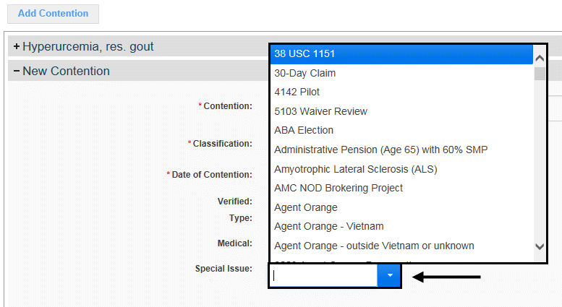
2 | Select the appropriate special issue to be associated to the contention.  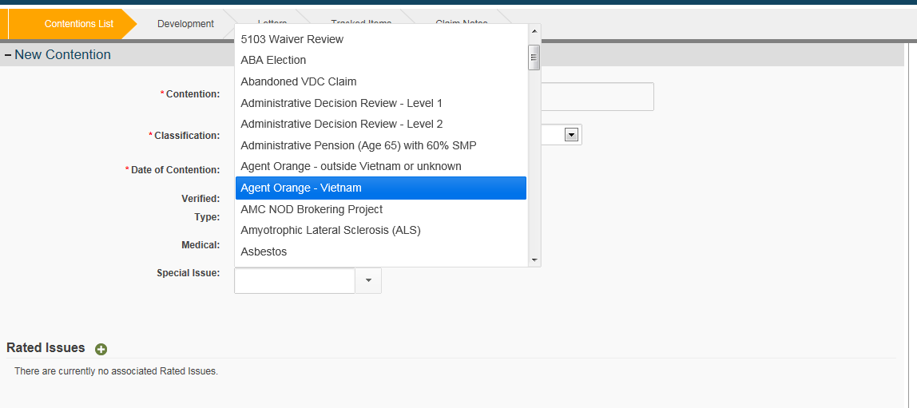
3 | Select the SAVE button to save the special issue or the CANCEL button to discard the changes.  Note: If you finish adding special issues and want to add another contention select the SAVE and ADD button.

Note: To delete a special issue flash from a contention, click on the CLAIM DETAILS screen and then select the TRASH CAN icon next to the special issue to be deleted.

Reference: For more information on how to apply a special issues flash to a contention in VBMS, see the VBMS Job Aid – Adding Special Issues in VBMS.

f. Properly Applying Special Issues | Special issues must be applied or updated once they are identified. Use the table below to determine how special issues should be applied to contentions.

If the special issue applies to ... | Then apply the special issue to ...
the claim | one contention.  Examples:  - Special Ops Claim  - Fully Developed Claim  - FDC Excluded – Needs Non-Fed Evidence Development
a contention | each applicable contention.  Examples:  - Agent Orange – Vietnam  - Asbestos  - Burn Pit Exposure

References: For more information about inputting special issues into
- VBMS, see the VBMS User Guide, and
- Modern Award Processing-Development (MAP-D), see the MAP-D User Guide.

3. Utilizing Tracked Items to Document Development

Introduction | This topic contains general information on utilizing tracked items to document development, including  - purpose of tracked items  - creation of tracked items  - tracked item dispositions  - tracked item automation  - accuracy of tracked items, and  - determining that a claim is ready for a decision.

Change Date | October 30, 2015

a. Purpose of Tracked Items | The purpose of tracked items is to control receipt or non-receipt of information requested from the claimant, beneficiary, or other information provider. Status of individual tracked items will be visible through eBenefits.

b. Creation of Tracked Items | Tracked items are established automatically for corresponding development actions when creating and finalizing development letters in VBMS or MAP-D. Custom tracked items can also be established manually by the claims processor.  References: For more information on creating tracked items in  - VBMS, see the VBMS User Guide, and  - MAP-D, see the MAP-D User Guide.

c. Tracked Item Dispositions | Tracked items must be updated with the appropriate date and disposition to reflect the status of the corresponding request or development action. Use the table below to determine the appropriate date and disposition to use when updating tracked items.

Tracked Item Disposition | Description
Received | Use this when evidence requested is received or a negative response from the information provider is received. For a negative response, create a system note to communicate this information.
Closed | Use this to administratively close a tracked item for non-receipt. Generally, the earliest date an item can be closed is upon review that the suspense date has expired and the timeframe given for a response has elapsed. This includes any necessary follow-ups.  Note: If a tracked item is closed due to non-receipt but the evidence is received later, while the claim is still pending, the new “received” date will supersede the prior “closed” date.
In Error | Use this to administratively close tracked items that were erroneously created or evidence that was requested in error.
Follow Up 1 or Follow Up | Use this to track the date evidence was requested for a second time.
Follow Up 2 or 2ndFlwUp | Use this to track the date evidence was requested for a third time.

References: For more information on
- managing tracked item dispositions in
- VBMS, see the VBMS User Guide, and
- MAP-D, see the MAP-D User Guide, and
- processing solicited and unsolicited mail, see M21-1, Part III, Subpart ii, 1.E.5.d.

d. Tracked Item Automation | If the suspense date for an open, non-actionable tracked item has expired, and no response, either positive or negative, was received in reply to the request, VBMS will automatically close the tracked item by entering the suspense date into the Closed disposition. A tracked item is considered non-actionable if no action is required at the expiration of the suspense date.  If the last remaining tracked item is manually updated by adding a date in the Closed, Received, or In Error disposition, VBMS automatically sets the status and claim level suspense reason to  - Ready for Decision for rating claims, and  - Ready to Work for non-rating claims.

e. Accuracy of Tracked Items | It is the responsibility of the claims processor reviewing or taking action on a claim to ensure that  - the necessary tracked items have been generated  - all suspense dates are accurate, and  - the dispositions of all tracked items have been accurately managed, to include any automated tracked item actions.  Important: Accuracy of the claim level suspense reason and date is dependent on properly generated and managed tracked items.

f. Determining That a Claim Is Ready for a Decision | The receipt or closing of all tracked items does not necessarily mean that the claim is ready for a decision. This determination must be based on an analysis of the evidence of record. A claim is considered ready for a decision after all the requested evidence has been received or otherwise accounted for, ensuring VA’s obligations to assist the claimant have been met.

4. Updating Claim Status

Introduction | This topic contains information on updating the status of a claim, including  - claim status, and  - claim level suspense.

Change Date | October 30, 2015

a. Claim Status | Claim status is used to determine immediate actions and provide more accurate customer service. Claim status should be properly updated to indicate the approximate stage of processing.  Use the table below to determine the appropriate claim status.

Claim Status | Definition
Open | Default status for claims not in any other status. Typically stays in this status during claims development.
Ready for Decision (RFD) | Signifies that the claim is ready for a rating decision.
Ready for Work | Signifies that the claim is ready for a non-rating decision.
Rating Decision Complete (RDC) | Signifies that a rating decision has been completed and is awaiting promulgation.
Rating Correction | Signifies that a rating decision correction is needed.
Rating Incomplete | Signifies that a rating decision was returned to corporate from the work pending column.
Closed | The claim is complete with no further action possible.
Cancelled | The claim is cancelled with no further action possible.

References: For more information on updating the claim status in
- VBMS, see the VBMS User Guide, and
- MAP-D, see the MAP-D User Guide.

b. Claim Level Suspense | The claim level suspense reason and date will automatically update based on tracked items when a claim is in Open status.  Each tracked item will automatically map to a claim level suspense reason.  When the claim status is a status other than Open and a tracked item is added or an existing tracked item is opened, the system will automatically set the claim status to Open and update the claim level suspense reason and date based on the opened tracked item(s).  The claim level suspense reason and date will be updated by the claim status when the claim status is anything other than Open.

