Section E. Processing an Appellate Claim

In This Section | This section contains the following topics:

Topic | Topic Name
1 | Establishing and Tracking a Notice of Disagreement (NOD)
2 | Controlling a Perfected Appeal

1. Establishing and Tracking an NOD

Introduction | This topic contains information about establishing and tracking an NOD, including  - determining if an NOD is timely  - determining if an appeal is duplicative  - establishing an NOD in the Veterans Appeals Control Locator System (VACOLS)  - establishing an NOD in the Veterans Benefits Management System (VBMS), and  - jurisdiction for control of an appellate record.

Change Date | July 29, 2015

a. Determining if an NOD Is Timely | A notice of disagreement (NOD) must be filed within one year of the date the Department of Veterans Affairs (VA) decision notice was sent to the claimant.  Follow these steps to determine if an NOD is timely.

Stage | Description
1 | Access the claimant’s electronic claims folder (eFolder) in the Veterans Benefits Management System (VBMS).
2 | In the DOCUMENTS tab, locate the decision notice and the rating decision associated with the issues on the claimant’s NOD.  Note: Ensure the NOD is valid in accordance with M21-1, Part I, 5.B.1.
3 | Use the table below for guidance on NOD timeliness.  If the NOD is … Then ...  received within one year of the decision notice - it is considered timely, and - determine if the appeal or claim is duplicative using the guidance in M21-1, Part III.ii.3.E.1.b.  not received within one year of the decision notice - the NOD is not considered timely, and - proceed to step 4.  Reference: For more information on computing the one-year NOD time limit, see M21-1, Part I.5.B.2.b.
4 | For all appeals found not timely  - send the claimant the NOD Not Timely letter under the APPEALS tab in the Letter Creator, and  - include a copy of the VA Form 4107, Your Rights to Appeal our Decision with the letter.

Exceptions:
- A contested claim, including an apportionment claim, must be filed within 60 days of the decision notice to be considered timely.
- Pension Management Centers (PMCs) send locally generated letters for appeals.

References: For more information on
- using the Letter Creator, see the Letter Creator User Guide
- time limits for filing an NOD, see M21-1, Part I, 5.B.2
- contested claims, see M21-1, Part III, Subpart VI, 6.A.1
- apportionment claims, see M21-1, Part III, Subpart V, 3.A.1, and
- NOD timeliness, see
- M21-1, Part I, 5.B.2.a
- M21-1, Part I, 5.B.3.f
- 38 CFR 20.302
- 38 CFR 20.501, and
- 38 U.S.C. 7105.

b. Determining if an Appeal Is Duplicative | Before taking action to establish an NOD, verify it is not a duplication of a pending appeal.  Use the table below to determine if it is duplicative of a pending appeal.

If the correspondence ... | Then ...
does not contain any of the same issue(s) as the pending appeal, or | - follow the guidance in  - M21-1, Part III, Subpart ii, 3.E.1.c to establish the NOD in VACOLS, and  - M21-1, Part III, Subpart ii, 3.E.1.d to establish the NOD in VBMS, and  - send the claimant the Appeals Process Explanation letter under the Appeals tab in the Letter Creator.
contains only the same issue(s) as the pending appeal | - print a copy of the VA Form 21-0958, Notice of Disagreement  - send the claimant the Duplicate Documents letter available under the APPEALS tab in the Letter Creator, and  - no further action is necessary.
contains both new and issues already pending appeal | - add the new issues to the pending VACOLS record, and  - add the new issue as a contention to the pending appeals end product (EP) in VBMS.

Exception: PMCs send locally generated letters for appeals.

References: For more information on
- screening subsequent claims for pending appeals, see M21-1, Part III, Subpart ii, 1.A.3, and
- using the Letter Creator, see the Letter Creator User Guide.

c. Establishing an NOD in VACOLS | Follow the steps in the table below to establish a claimant’s NOD in VACOLS.

Stage | Description
1 | - From the VACOLS main screen, select ADD NEW APPEAL.  - Enter the claims folder number or Social Security number (SSN).  - Reenter the claimant’s information to confirm.
2 | On the ADD APPEAL screen, input the following information in the designated fields, including  - NAME OF VETERAN  - ADDRESS  - PHONE NUMBER  - NAME OF APPELLANT (when applicable),  - VETERANS SERVICE ORGANIZATION (VSO),  - SSN (if not previously indicated as the claims folder number), and  - DATES fields, including  - NOTIFICATION (enter the date from the decision notice shown in VBMS)  - NOD (enter the date the NOD was received by VA), and  - DRO Elect (when applicable).  Example:  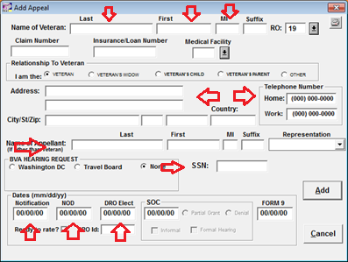
3 | On the SPECIAL INTEREST screen, identify special contentions or indicate no special contentions.  Example:  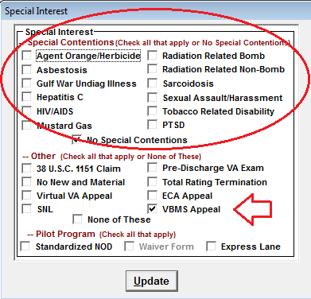
4 | On the ADD ISSUE screen, add claimed contentions and relevant details by populating fields, including  - PROGRAM AREA  - ISSUE  - SUBSIDIARY QUESTIONS OR OTHER TRACKING IDENTIFIERS, and  - NOTES.  Example:  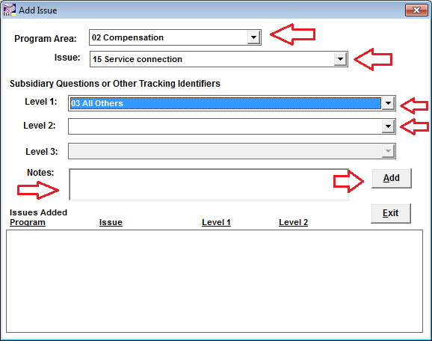  Note: Select ADD for each contention until all have been added, then select EXIT.
5 | On the VACOLS main screen, enter the claimant’s identification (ID) number and select the DIARY tab to ADD the information listed below on the DIARY DETAIL screen.  - ASSIGNED TO (VSR)  - DIARY CODE (NOD received)  - DAYS (in compliance with local guidance).  Example:  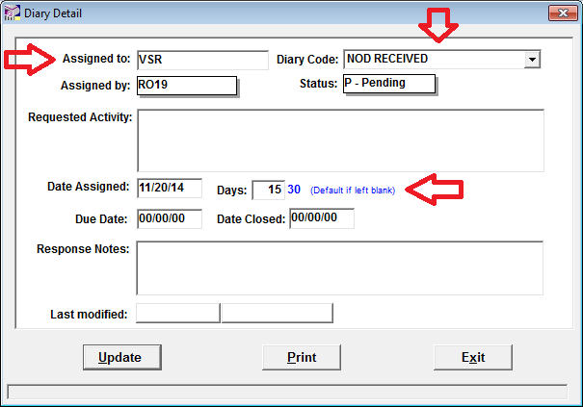
6 | Select UPDATE to save the information.

Notes:
- VACOLS allows the tracking of fiduciary appeals. The following are the user names for the Fiduciary Hubs
- Columbia Fiduciary Hub RO64
- Indianapolis Fiduciary Hub RO65
- Lincoln Fiduciary Hub RO66
- Louisville Fiduciary Hub RO67
- Milwaukee Fiduciary Hub RO68
- Western Area Fiduciary Hub RO69, and
- The Manila Regional Office (RO) fiduciary activity will continue to use the RO's user name.
- VACOLS allows the tracking of pension related appeals. The following are the user names for the PMCs
- Philadelphia PMC RO81
- Milwaukee PMC 082, and
- St. Paul RO83.

References: For more information on
- Fiduciary Hub jurisdictions, see M21-1 III.ii.1.E.6.c, and
- jurisdiction over fiduciary appeals, see M21-1, I.5.D.1.c.

d. Establishing an NOD in VBMS | Follow the steps in the table below to establish a claimant’s NOD in VBMS.

Step | Action
1 | Open the claimant’s profile and select NEW CLAIM from the ACTIONS drop down menu.
2 | Review and update the following fields, including  - ADDRESS  - TELEPHONE NUMBER, and  - POWER OF ATTORNEY (POA).
3 | Select 170NOD – NOTICE OF DISAGREEMENT in the EP & CLAIM LABEL field. The EP 170 will be shown as the default EP in the MODIFIER field.
4 | Enter the date of receipt of the NOD in the DATE OF CLAIM.
5 | Assign the EP 170 to Appeals (National) in the SEGMENTED LANE field.  Example:  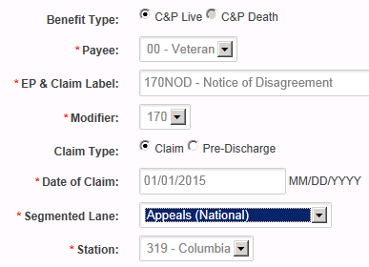
6 | Select SUBMIT to save the information.
7 | From the CONTENTIONS tab, add each contention specified by the claimant.
8 | From the PROFILE screen, select MANAGE EVIDENCE from the ACTIONS drop down menu.  - Select ADD UNSOLICITED and populate the following fields  - RECEIPT DATE  - DOCUMENT TYPE, and  - EVIDENCE NAME.  Example:  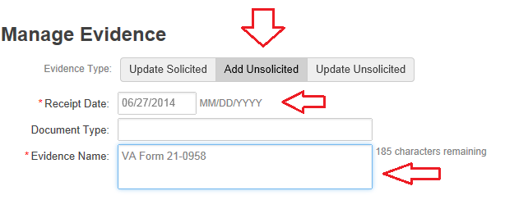  - Select COMPLETE on the right panel of the screen to update and save the information.

Exception: Establish non-Veteran appeals in Share.

References: For more information on establishing claims in
- VBMS, see M21-1, Part III, Subpart ii, 3.D.2.c, and
- Share, see M21-1, Part III, Subpart ii, 3.D.2.e.

e. Jurisdiction for Control of an Appellate Record | The following divisions will establish the appeal record for their respective NODs.  - Veterans Service Center (VSC)  - PMC  - Fiduciary Hub  - Education Division  - Philadelphia Insurance Center  - Vocational Rehabilitation and Employment (VR&E) Division, and  - Veterans Health Administration (VHA)  Program Offices other than those listed above will refer an NOD to the VSC to establish and maintain the appeal record in VACOLS. The VSC is entitled to EP credit for those appeals tracked for other program offices.  Note: Effective April 1, 2002, VHA’s Administration Service assumed responsibility for establishing appeal records in VACOLS and managing the VHA appellate workload.

2. Controlling a Perfected Appeal

Introduction | This topic contains information pertaining to controlling an appellate claim perfected by the submission of a VA Form 9, Appeal to Board of Veterans’ Appeals, including  - controlling a perfected appeal in VBMS, and  - updating VACOLS for tracking of a perfected appeal.

Change Date | July 29, 2015

a. Controlling a Perfected Appeal in VBMS | After receiving a decision on an NOD, the claimant may choose to submit a VA Form 9, Appeal to Board of Veterans’ Appeals to show his/her disagreement with the NOD decision and certify an appeal to the Board of Veterans’ Appeals (BVA).  Follow the steps below to establish control of a perfected appeal.

Step | Action
1 | Open the appellant’s VBMS profile and select NEW CLAIM.
2 | Review the following information and update fields as necessary  - ADDRESS  - TELEPHONE NUMBER, and  - POWER OF ATTORNEY (POA).
3 | Enter 170FRM9 – FORM 9 in the EP & CLAIM LEVEL field.
4 | Enter the date the VA received the VA Form 9 in the DATE OF CLAIM field.
5 | Assign the 170FRM9 to APPEALS (NATIONAL) as the SEGMENTED LANE  Example:  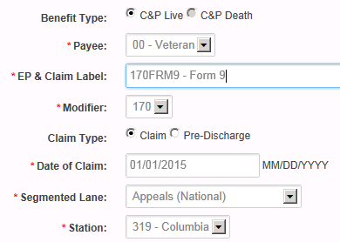
6 | Select SUBMIT to save the information.
7 | Return to the claimant’s PROFILE screen and select MANAGE EVIDENCE from the ACTIONS drop down menu.  - Select ADD UNSOLICITED and populate the following fields.  - RECEIPT DATE  - DOCUMENT TYPE, and  - EVIDENCE NAME.  Example:  - Select COMPLETE on the right panel of the screen to update and save the information.

Exception: Establish non-Veteran appeals in Share.

References: For more information on
- establishing claims in VBMS, see M21-1, Part III, Subpart ii, 3.D.2.c
- establishing claims in Share, see M21-1, Part III, Subpart ii, 3.D.2.e, and
- managing evidence in VBMS, see the VBMS Job Instruction Sheet Manage Evidence.

b. Updating VACOLS for Tracking of a Perfected Appeal | In addition to establishing an EP 170 in VBMS for a perfected appeal, VACOLS must also be updated for tracking purposes.  Follow the steps in the table below to update VACOLS for perfected appeals.

Step | Action
1 | On the VACOLS main screen, enter the claimant’s ID number and select the DIARY tab to ADD the following information on the DIARY DETAIL screen.  - ASSIGNED TO (in compliance with local guidance)  - DIARY CODE (VA Form 9 RECEIVED)  - DAYS (in compliance with local guidance).  Note: Refer to local Regional Office (RO) guidance regarding assignment of a perfected appeal. In many cases, a Decision Review Officer (DRO), the appeals rating activity, or other designee will be assigned the perfected appeal in order to expeditiously certify it to BVA.
2 | Select UPDATE to save the information.

