Section C. System Updates

Overview

In This Section | This section contains the following:

Topic | Topic Name
1 | Change of Address and Direct Deposit Processing
2 | Change of Name Processing
3 | Processing Third Party Information Requests
4 | Handling Power of Attorney (POA) Appointments
5 | Updating Electronic Systems for POA
6 | POA Codes

1. Change of Address and Direct Deposit Processing

Introduction | This topic covers information on changing claimant’s address or direct deposit information in Share or the Veterans Benefits Management System (VBMS), including  - receiving notice of change of address or direct deposit  - updating the address in VBMS  - updating the address and/or direct deposit information in Share, and  - homeless Veteran address resources.

Change Date | July 11, 2015

a. Receiving Notice of a Change of Address or Direct Deposit | Change of address/direct deposit notification may come in multiple formats including  - a signed statement from the claimant  - undeliverable mail with the United States Post Office (USPS) forwarding address sticker affixed to the envelope  - VA Form 20-572, Request for Change of Address/Cancellation of Direct Deposit, and  - other Department of Veterans Affairs (VA) forms that contain the information.  Important:  - For any claimant assigned a fiduciary do not  - change the address  - establish a direct deposit account, or  - change a direct deposit account.  - An address change request is to be sent to the Fiduciary Hub of jurisdiction via Veterans Assistance Inquiry (VAI).  Notes:  - Update addresses in Veterans Benefits Management System (VBMS) or Share. VBMS release 8.0 added functionality to automatically update the corporate record in Share.  - Update direct deposit information only in Share.  - An appointed Veterans Service Organization (VSO), agent, or attorney has the legal authority to change a claimant’s address in person, by telephone, or by letter when annotated in  - block 14 of the VA Form 21-22, Appointment of Veterans Service Organization as Claimant's Representative, or  - block 11 on the VA Form 21-22a, Appointment of Individual as Claimant's Representative.  References: For more information on  - changing addresses by power of attorneys (POAs) or by fiduciaries (for incompetent Veterans), see M27-1, Part I, 7.5  - undeliverable mail procedures, see M21-1 Part III, Subpart ii, 1.B.3, and  - change of address and direct deposit request procedures, see M27-1, Part 1, 3.12.

b. Updating the Address in VBMS | Follow the steps in the table below to update the address in VBMS.

Step | Action
1 | Open VBMS and enter the claimant’s claims folder number in the search box.
2 | Select OPEN PROFILE.
3 | Select EDIT VETERAN from the ACTIONS drop down menu.  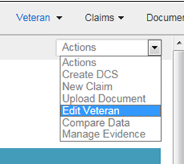
4 | Update address and contact information on the UPDATE VETERAN PROFILE screen.  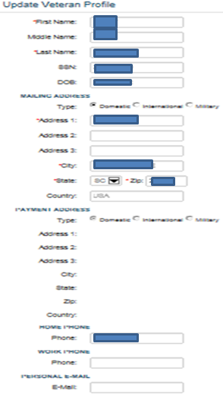
5 | Once updates are complete select SUBMIT to save the information.

Note: Direct deposit cannot be updated in VBMS.

c. Updating the Address and/or Direct Deposit Information in Share | Follow the steps in the below table to  - update the address, and/or  - direct deposit information in Share.

Step | Action
1 | Open Share
2 | - Select the CORPORATE INQUIRIES command  - enter the claimant’s information in the FILE NUMBER OR SSN field, and  - select SUBMIT.  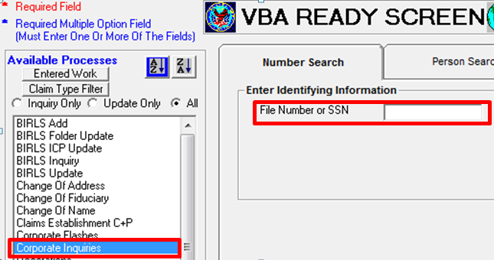
3 | - Select the AWARDS/RATINGS tab, and  - select the line containing Mailing under the ADDRESS TYPE column.  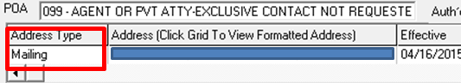
4 | Compare the address in the system to the address on the change request or USPS forwarding address sticker. Is the address different?  - If yes, proceed to Step 6.  - If no, proceed to the next step.
5 | Does direct deposit need to be updated?  - If yes, proceed to Step 8.  - If no, upload documents to VBMS and proceed Step 10.
6 | - Select the READY button on the lower right of the screen  - select CHANGE OF ADDRESS command  - choose Live CPL (or applicable) in the BENEFIT TYPE field  - choose 00 – Veteran (or applicable) in the PAYEE NUMBER field, and  - select SUBMIT.  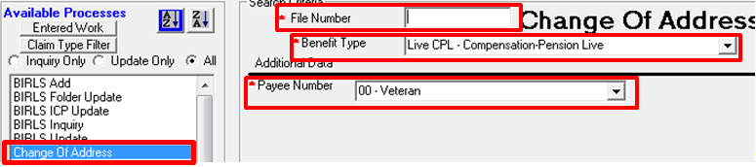
7 | When entering or editing the new address  - enter the street address  - enter city  - enter zip code (if the zip code doesn’t match the city, then Share will prompt you to change the city), and  - enter or edit phone numbers.  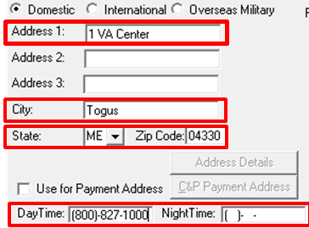  Note: If the address has an apartment or unit number, enter it in the ADDRESS 1 box, then enter the street address in the next box.
8 | For entering or editing direct deposit  - enter or edit information in the DIRECT DEPOSIT fields  - if the claimant does not have direct deposit ensure the USE FOR PAYMENT ADDRESS radio button is checked, and  - if the claimant has direct deposit ensure the USE FOR PAYMENT ADDRESS radio button is not checked.  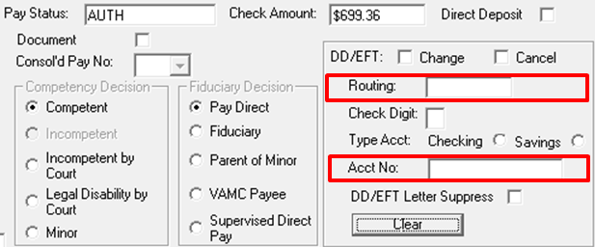
9 | Select UPDATE.
10 | Update the evidence tab in VBMS for returned mail or address/direct deposit change by  - entering the claims folder number in the search box  - selecting the OPEN PROFILE button  - selecting MANAGE EVIDENCE from the ACTIONS drop down menu  - selecting UPDATE UNSOLICITED  - entering the date of receipt as the earliest stamp date on the mail  - typing Returned mail, Address change, or Direct deposit change (as applicable) in the DOCUMENT TYPE  - selecting ADD EVIDENCE, and  - selecting COMPLETE.

d. Homeless Veteran Address Resources | Use the following resources when researching a homeless Veteran’s address.  - Homeless Shelter Directory  - Regional Office Homeless Coordinator Directory  - HUD Exchange  Reference: For more information on processing claims for homeless Veterans, see  - M21-1, Part III, Subpart ii, 1.D.2, and  - M27-1, Part II, 3.

2. Change of Name Processing

Introduction | This topic contains information on changing a claimant’s name in the systems, including  - evidence required for name changes, and  - processing name changes.

Change Date | July 11, 2015

a. Evidence Required for Name Changes | Before changing the claimant’s name in the systems, the claimant must have submitted a signed request and sufficient evidence of the legal name change.  Reference: For more information on evidence requirements for name changes, see M21-1, Part III, Subpart iii, 8.1.a.

b. Processing Name Changes | Once adequate evidence has been received to change the Veteran or claimants name, follow the steps in the below table to process the change.

Step | Action
1 | Open Share
2 | Select the BIRLS UPDATE command.  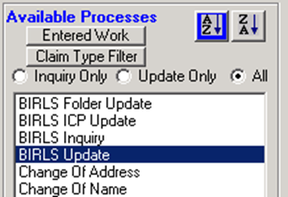
3 | On the BIRLS UPDATE screen, select the second tab labeled NAME.  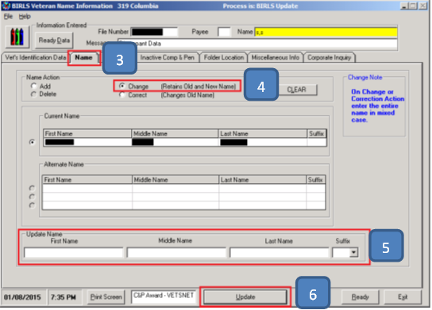
4 | Select the CHANGE (RETAINS OLD AND NEW NAME) radio button.
5 | Enter the new name in the UPDATE NAME fields at the bottom of the screen.
6 | Select UPDATE.
7 | Upload the document to VBMS and add a permanent VBMS note.

Note: Until the Pension Management Centers (PMCs) fully transition to VBMS, substitute uploading documents to Virtual VA (VVA) and adding notes to Modern Awards Processing Development (MAP-D).

3. Processing Third Party Information Requests

Introduction | This topic contains information on determining if a third party information request is substantially complete and how to update systems to indicate a valid request, including  - use of VA Form 21-0845, Authorization to Disclose Personal Information to a Third Party  - VA Form 21-0845 required criteria checklist, and  - updating systems for third party disclosure.

Change Date | July 11, 2015

a. Use of VA Form 21-0845 | VA Form 21-0845, Authorization to Disclose Personal Information to a Third Party, allows the National Call Centers (NCCs) and regional offices (ROs) to release specified information normally protected under privacy provisions to family members or other designated persons who are not POAs, agents, or fiduciaries.  Note: A Veteran may only designate one person or one organization on the form. In addition, only one form may be valid at a time.  Reference: For more information on third party release of information, see the M27, Part I, Chapter 7.6

b. VA Form 21-0845 Required Criteria Checklist | To be valid, the VA Form 21-0845 must contain or meet the following criteria to be considered substantially complete  - the signature of Veteran/claimant and date  - the name and claims folder number of the Veteran/claimant  - the contact information (address, daytime or cell phone number, or e-mail address)  - the type of information authorized for release  - the length of time authorization is valid, if applicable  - a security question and answer  - the form date stamped by the VA  - the form designates only one person or organization, and  - if the Veteran has a fiduciary, the signature of the fiduciary.  Important: The signature cannot be someone other than Veteran/claimant except in cases where the Veteran/claimant is incompetent. When the Veteran/claimant is found incompetent, the VA Form 21-0845 must be signed by a VA appointed fiduciary.  Note: If the form does not contain substantially complete information required to authorize access  - return it with a letter explaining  - the reason for the return, and  - the block(s) that must be completed, and  - add a VBMS or MAP-D note stating VA Form 21-0845 returned on MM/DD/YY for completion.

c. Updating Systems for Third Party Disclosure | Once the VA Form 21-0845 is deemed acceptable, follow the steps in the table to below to update systems for third party information disclosure.

Step | Action
1 | Open Share.
2 | - Select the CORPORATE FLASHES command on the left side of the screen  - enter the claimant’s claims folder number in the FILE NUMBER OR SSN field, and  - select SUBMIT.
3 | Verify that Third Party Release flash is not shown in the top right field labeled SELECT RO FLASHES.  Note: If the flash is already present  - select CANCEL, and  - proceed no further.
4 | - Scroll down on the left top box labeled AVAILABLE RO FLASHES and highlight THIRD PARTY RELEASE  - select the right arrow between the two upper boxes to move the flash to the right  - select submit to save the flash and Share will display Update Complete, and  - Select OK to return to the READY screen.  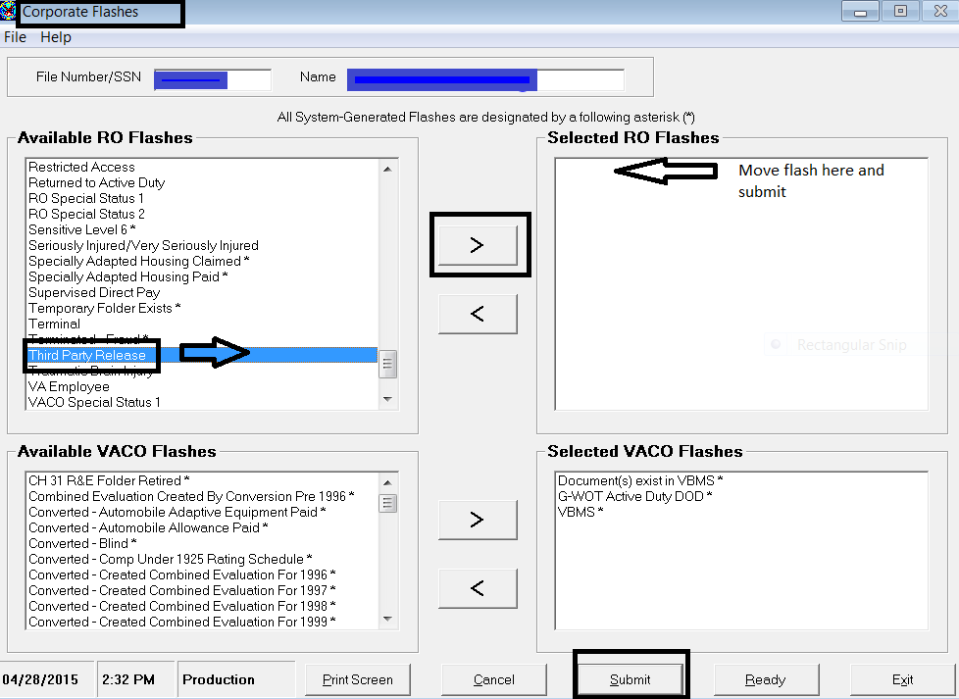
5 | Add the following VBMS or MAP-D note  VA Form 21-0845, Authorization to Disclose Personal Information to a Third Party, received and of record in favor of:  [type whoever is named in block 10 here]  If the claimant selected a limited time frame for the authorization, also note  VA Form 21-0845 expires on [MM/DD/YYYY].

Reference: For more information on third party release of information, see the M27, Part I, Chapter 7.6

4. Handling Power of Attorney (POA) Appointments

Introduction | This topic contains information on handling representative appointment forms including  - when to process POA appointment forms  - endorsing a POA appointment form as limited  - acceptable versions of VA Form 21-22 and VA Form 21-22a  - reviewing a submitted VA Form 21-22 or VA Form 21-22a  - requests to revoke or change POA  - handling an outdated VA Form 21-22 or VA Form 21-22a  - handling an incomplete VA Form 21-22 or VA Form 21-22a  - processing copies of VA Form 21-22 or VA Form 21-22a with paper claims folders  - processing copies of VA Form 21-22 or VA Form 21-22a with eFolders  - unclear declaration  - handling appointment forms/letters when there is no record of a claims folder, and  - validating claims without appointment forms/letters.

Change Date | July 11, 2015

a. When to Process POA Appointment Forms | Process representative appointment forms as soon as they are received from the claimant.

b. Endorsing a POA Appointment Form as Limited | If a claimant other than the Veteran appoints a representative, the appointment is considered limited. Using the table below to clearly identify limited appointments to avoid erroneous referral of the Veteran’s claims folder to the claimant’s representative.

If processing the POA appointment in a ... | Then ...
paper format | endorse the form as limited.
electronic format | add a permanent note in VBMS indicating the limited appointment of representation.  Notes:  - In addition to the permanent note, the word Limited can be added to the subject line of the POA appointment in the eFolder, once upload has occurred.  - Until the PMCs fully transition to VBMS, substitute adding notes to MAP-D.  Reference: For more information on changing the subject line of a document in an eFolder, see the VBMS Job Aid – Editing Document Properties.

c. Acceptable Versions of VA Form 21-22 and VA Form 21-22a | VA can accept older versions of VA Form 21-22 until depletion of existing stock. However, forms prior to the February 2012 version are not compliant with the provisions of 38 U.S.C. 7332, regarding authorization for disclosure of protected records. Do not establish or change a Veteran’s POA, unless the form is complete and compliant with the provisions of 38 U.S.C. 7332.  Only the most current version of the VA Form 21-22a dated June 2009 is compliant with the provisions of 38 U.S.C. 7332. No earlier versions of this form are acceptable.  Note: Always accept older versions of forms submitted via the Stakeholder Enterprise Portal (SEP) and Veterans Online Application (VONAPP) Direct Connect (VDC). The form versions included in Veterans Benefits Administration (VBA) applications for electronic submittal may significantly lag behind the release of new form versions.  Reference: For more information on submission of VA Form 21-22 via SEP/VDC, see M21-1, Part III, Subpart i, 4.B.2.

d. Reviewing a Submitted VA Form 21-22 or VA Form 21-22a | When reviewing a VA Form 21-22 or VA Form 21-22a  - check that the version of the form is compliant with the provisions of 38 U.S.C. 7332, regarding authorization for disclosure of protected records  - check that the form is complete, to include  - completion of all blocks (unless labeled optional), and  - signatures of both the representative and claimant  - process each copy of the properly completed and current form, and  - update electronic systems to reflect the appointment.  Important: Due to a technical issue, VA Forms 21-22 submitted through SEP/VDC between March 22, 2015, and May 3, 2015, do not show an electronic signature from the Veteran. The forms without an electronic signature from this period remain valid for VA purposes.  Notes:  - A VA Form 21-22 received as part of an Integrated Disability Evaluation System (IDES) claim must have the word Veteran replaced with Service Member in Block 1.  - If a VA Form 21-22a is received without an attorney fee agreement, see M21-1, Part I, 3.C.  References: For more information on  - receiving a VA Form 21-22 from an IDES participant, see M21-1, Part III, Subpart i, 2.D.4, and  - updating POA in VA systems, see M21-1, Part III, Subpart ii, 3.C.5.

e. Requests to Revoke or Change POA | When a request to revoke POA is received or a new POA is appointed, update all systems as appropriate.  Use the table below to annotate a revoked appointment of a claimant’s representative, when  - a new appointment form is received, or  - a request for revocation of POA is received without a new appointment.

If revocation is being processed in a(n) ... | Then ...
paper format | annotate the revoked form with the  - reason for revocation, and  - date the revocation is processed.
electronic format | add a permanent note in VBMS indicating the revocation of the appointment of representation.  Notes:  - In addition to the permanent note, the word Revoked can be added to the subject line of the POA appointment form in the eFolder, if available.  - Until the PMCs fully transition to VBMS, substitute adding notes to MAP-D.  Reference: For more information on changing the subject line of a document in an eFolder, see the VBMS Job Aid – Editing Document Properties.

Reference: For more information on updating POA in VA systems, see M21-1, Part III, Subpart ii, 3.C.5.

f. Handling an Outdated VA Form 21-22 or VA Form 21-22a | If a claimant submits an outdated version of VA Form 21-22 or VA Form 21-22a, send a development letter requesting completion of the current version of the VA Form 21-22 or VA Form 21-22a. With the letter  - provide the current version of the form for completion, and  - return the outdated form.  Important: If the form is being processed electronically in the centralized mail (CM) portal, print the form so it can be returned to the POA or claimant and upload to VBMS.

g. Handling an Incomplete VA Form 21-22 or VA Form 21-22a | Use the procedure below if VA Form 21-22 or VA Form 21-22a is incomplete.

If the VSO is ... | Then ...
located in the same building as the RO | - forward the form to the VSO for completion, and  - check all necessary incomplete items on the form.
- not located in the same building as the RO, and  - there is an end product (EP) pending | - return the form to the claimant with a letter, and  - check all necessary incomplete items on the form in red ink.
- not located in the same building as the RO, and  - there is no EP pending | - establish an EP 400 Correspondence  - return the form to the claimant with a letter  - check all necessary incomplete items on the form in red ink, and  - clear the EP 400.

Important: If the form is being processed electronically in the CM portal, print the form so it can be returned to the POA or claimant and upload to VBMS.

Note: The VBMS development action Form incomplete - Items checked in red needed,” can be found under the category GENERAL.

Reference: For more information about VBMS development actions, see the VBMS User Guide.

h. Processing Copies of VA Form 21-22 or VA Form 21-22a With Paper Claims Folders | The current versions of VA Form 21-22 or VA Form 21-22a no longer have multiple copies to be acknowledged and sent to the POA or representative.  To process these forms with paper claims folders use the below table.

If the form is a … | Then ...
paper VA Form 21-22 | - enter in the Acknowledged block  - the current date  - your initials, and  - as applicable, complete the Sent to block.
paper VA Form 21-22a | annotate with  - the current date, and  - Acknowledged.
an electronic VA Form 21-22 or VA Form 21-22a | - upload to VBMS.  Note: Users may view the form electronically in VBMS.
paper original of either VA Form 21-22 or VA Form 21-22a | reverse file the form on the right flap of the claims folder.

i. Processing Copies of VA Form 21-22 or VA Form 21-22a With eFolders | The current versions of VA Form 21-22 or VA Form 21-22a no longer have multiple copies to be acknowledged and sent to the POA or representative.  To process these forms with eFolders, upload the form the CM portal to VBMS.  Notes:  - The claims folder copy is shown in VBMS or Virtual VA.  - The service organization is able to view the electronic claims folder for Veterans or claimants they represent.  - If a paper folder exists for VR&E, Education, Insurance, or Loan Guaranty, those business lines have access to VBMS and are able to print the form.

j. Unclear Declaration | If a private attorney’s declaration of representation is unclear whether it is limited to a certain claim/appeal or unlimited, write to the attorney and ask for clarification. Reverse-file any such clarification in the claims folder, or upload to the eFolder, whichever is applicable.

k. Handling Appointment Forms/Letters When There Is No Record of a Claims Folder | Use the table below to handle the receipt of VA Form 21-22, VA Form 21-22a, or the appointment letter when there is no record of a claims folder or a pending claim.

If … | Then …
the form/letter indicates a claim for disability insurance only | forward the form/letter to the appropriate insurance center.
there is no record of a claim for disability insurance | return the form/letter to the VSO, agent, non-licensed individual, or attorney with an explanation for the return.  Important: Before returning the document, check the BIRLS LOC screen for the existence of a Chapter 30 or NOD folder since the appointment could relate to a Chapter 30 claim or NOD claim.

Note: If the form is being processed electronically in the CM portal, print the form and upload to VBMS.

l. Validating Claims Without Appointment Forms/Letters | Some cases require validation of an informal claim filed by an accredited representative of a VSO, agent, non-licensed individual, or attorney before the necessary VA Form 21-22, VA Form 21-22a, or appointment letter is received.  In the absence of evidence to the contrary, presume the existence of a valid appointment in favor of the accredited representative or a VSO, agent, non-licensed individual, or attorney intending to file a claim as of the date the claim was received.  References: For information about  - applications for disability compensation and/or pension, see M21-1, Part III, Subpart ii, 2.B.1, and  - informal claims and intent to file (ITF), see M21-1, Part III, Subpart ii, 2.D.1.

5. Updating Electronic Systems for POA

Introduction | This topic contains information on  - updating the POA in Share and VBMS  - handling preexisting representative relationships, and  - updating Share to reflect POA authorized access to sensitive information.

Change Date | July 11, 2015

a. Updating the POA in Share and VBMS | Once current and complete VA Form 21-22 or VA Form 21-22a has been received, follow the steps in the table below to update Share for the appointment of a representative.

Step | Action
1 | Open Share
2 | To verify that the POA has not already been updated  - select the BIRLS INQUIRY command  - enter the claimant’s claims folder number in the FILE NUMBER OR SSN field, and  - select SUBMIT.
3 | Review the POWER OF ATTORNEY field.  Does the POA need to be updated?  - If yes, go to the next step.  - If no, go to Step 7.
4 | To update the BIRLS record in Share  - select the BIRLS UPDATE command  - enter the claimant’s first and last name, and  - select SUBMIT.
5 | Under the POWER OF ATTORNEY SEARCH command, use the LOCATE field to look up the POA  Was the POA found using the LOCATE field?  - If yes, select UPDATE and go to Step 7.  - If no, go to the next step.
6 | Perform an accreditation of VSOs search using the Office of General Counsel (OGC) Accreditation Search.  Was the POA found in the OGC Accreditation Search?  - If yes,  - follow the procedure in M21-1, Part III, Subpart ii, 3.C.6 to have the POA added to the corporate database  - add a note to VBMS or MAP-D  - select the POWER OF ATTORNEY SEARCH command  - use the code 099 as the POA in the LOCATE field  - select UPDATE, and  - go to the next step.  - If no,  - add a note to VBMS or MAP-D explaining why the POA could not be updated, and  - forward the information to the Agent and Attorney Fee Coordinator (AAFC) for follow up with the POA.  References: For more information on AAFC’s responsibilities in handling non-accredited POA submissions, see  - M21-1, Part I, Subpart i, 3.C.1.d  - M21-1, Part I, Subpart i, 3.C.6, and  - M21-1, Part I, Subpart i, 3.C.7.
7 | Is there an EP pending?  - If yes, go to the next step.  - If no, go to Step 9.
8 | To update the pending issue in Share  - select the PIF INQUIRY command  - make note of the specific EP and claim label, and  - select READY  - select the PIF CHANGE command and enter the  - BENEFIT TYPE (CPL, etc.)  - PAYEE NUMBER (00 for a Veteran, etc.), and  - CLAIM TYPE (020, etc.)  - if required, update the POA using the POWER OF ATTORNEY SEARCH command (the BIRLS UPDATE should have updated POA)  - if block 12 on the form is checked, select Yes in the AUTH’D POA ACCESS drop down menu  - if block 14 on the form is checked, click on the CADD AUTH’D radio button, and  - select UPDATE.
9 | To verify and update POA access to documents in VBMS  - open VBMS and enter the claims folder number in the search box  - select OPEN PROFILE  - select the POA from the VETERAN dropdown options  - verify that the POA is correct  - if the POA needs to be updated, establish an EP 400 and update the POA during the establishment process, and  - if block 12 was checked on the form, click on the ALLOW POA ACCESS TO DOCUMENTS radio button allowing POA access to the electronic claims folder.  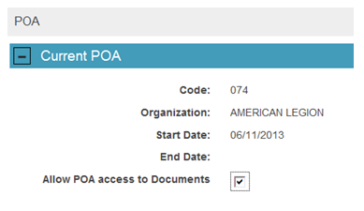
10 | If the claimant has a pending appeal, update the POA in VACOLS.

Important: Do not check the ALLOW POA ACCESS TO DOCUMENTS field, if the claimant’s chosen representative is not found when conducting a OGC Accreditation Search.

Note: If the Board of Veterans’ Appeals (BVA) has jurisdiction over the claims folder, the representative must obtain permission from BVA to revoke or terminate his/her representation.

References: For more information on
- POA codes, see M21-1, Part III, Subpart ii, 3.C.6
- accreditation of VSOs, go to OGC Accreditation Search
- updating POA in Share, see the Share User Guide
- updating POA in VBMS, see the VBMS User Guide, and
- updating POA in VACOLS, see the VACOLS User Guide.

b. Handling Preexisting Representative Relationships | If an attorney files a limited declaration of representation with respect to a particular claim or claims, it is possible that a preexisting representative relationship with a VSO, agent, or other licensed attorney remains in effect with respect to all other claims.  However, even if the attorney’s limited declaration of representation does not completely revoke all preexisting representative relationships, change the POA code to 099.  Notes:  - If the claimant was previously represented by a VSO, changing POA code to 099 blocks the VSO’s access to corporate records concerning the claimant. Therefore, access to the claimant’s record under the preexisting representative relationship will be limited to a review of the claims folder.  - Update VBMS to reflect the limited representation by adding a VBMS note listing the particular claim or claims that the attorney indicates in his or her declaration of representation.

c. Updating Share to Reflect POA Authorized Access to Sensitive Information | Update Share and VBMS as indicated in the table below to reflect whether the claimant has authorized disclosure to an appointed representative of records protected by 38 U.S.C. 7332 (relating to drug abuse, alcoholism or alcohol abuse, or infection with human immunodeficiency virus (HIV) or sickle cell anemia).

If a claimant ... | Then claims personnel establishing a claim in...
authorizes a representative’s access with no limitations to records protected by 38 U.S.C. 7332 by  - checking block 12 and not checking block 13 of VA From 21-22, or  - checking block 9 and leaving block 10 blank of VA Form 21-22a | - Share, select the name of the representative and select Y in the Auth’d POA Access box, or  - VBMS, check the box Allow POA access to Documents on the POA screen.
indicates any limitation to or does not authorize a representative’s access to records protected by 38 U.S.C. 7332 by  - checking block 13 of VA From 21-22, or  - not checking block 9 and/or listing limitations in block 10 of VA Form 21-22a | - Share, select the name of the representative and select Y in the Auth’d POA Access box, or  - VBMS, ensure the box Allow POA access to Documents on the POA screen is not checked.

Important: A PIF CHANGE is necessary to update disclosure of records when
- there is a pending claim, and
- representation is changed via BIRLS.

Note: Details regarding POA access are viewable on the Share
- ALL RELATIONSHIP tab of CORPORATE INQUIRY, and
- GENERAL INFORMATION screen under AWARDS/RATINGS.

Reference: For more information on PIF CHANGE, see M21-1, Part III, Subpart ii, 3.C.5.a.

6. POA Codes

Introduction | This topic contains information on the POA codes, including  - notes on POA codes  - adding POA codes to corporate  - National organization POA codes listed alphabetically  - National organization POA codes listed numerically  - State organization POA codes listed alphabetically, and  - State organization POA codes listed numerically.

Change Date | July 11, 2015

a. Notes on POA Codes | - POA codes are shown by the corporate record as either alphanumeric codes or by the name of the organization. BIRLS shows the codes prefixed by a zero.  - State VSO codes are based on the last two digits of the RO number. Only one number is used when there is more than one RO to a state.  - States not listed have no recognized VSO.  - Private attorneys or agents submitting requests to represent a VA claimant must be verified as accredited by the Office of General Counsel (OGC), per 38 CFR 14.629.  Reference: For a list of accredited VSOs, attorneys, and agents, see the OGC Accreditation Search.

b. Adding POA Codes to Corporate | When a POA is not located in corporate but is found in the OGC Accreditation Search, follow the procedures in the table below to have the POA added to corporate.

Stage | Description
1 | To initiate adding a VSO to the corporate database, contact the Information Security Officer (ISO) assigned to the local RO and provide the  - POA code  - name of agent, attorney, or representative  - role, such as  - claims agent  - an attorney, or  - VSO representative, and  - POA’s contact information (address, phone, fax, and email).  Note: The local ISO contacts the Network Information Security Officer to update the POA in the corporate database.
2 | Update the claimant’s profile to include POA code 099 as a placeholder until the corporate database is updated.  Note: Once the POA code is updated in the corporate database, the ISO contacts the local AAFC to properly update the code in all VBA systems.  Reference: For more information on updating POA in Share, see M21-1, Part III, Subpart ii, 3.C.5.a.
4 | Upon notification of a newly established POA code, the AAFC will  - contact the individual attorney or agent to identify any other Veterans or claimants they represent  - verify the validity of the other clients VA Form 21-22a, and  - update all records as necessary.  Note: Historically, these individuals may have been assigned a 099 (no exclusive contact) or 066 (exclusive contact) code and will not automatically be displayed for the specific attorney in Share, VBMS, or the Stakeholder Enterprise Portal (SEP).

c. National Organization POA Codes Listed Alphabetically | The table below lists the POA codes for National VSOs alphabetically.

National Organization Name | POA Code
African American PTSD Association | 091
American Ex-Prisoners of War, Inc. | 065
American GI Forum, National Veterans Outreach Program | 068
American Legion | 074
American Red Cross | 075
American Veterans/AMVETS | 077
Armed Forces Services Corporation | 078
Army and Navy Union, USA | 079
Associates of Vietnam Veterans of America | 011
Blinded Veterans Association | 080
Catholic War Veterans of the U.S.A. | 081
Disabled American Veterans | 083
Fleet Reserve Association | 085
Gold Star Wives of America, Inc. | 012
Italian American War Veterans of the United States, Inc. | 095
Jewish War Veterans of the United States | 086
Legion of Valor of the United States of America, Inc. | 087
Marine Corps League | 088
Military Officers Association of America | A21
Military Order of the Purple Heart | 089
National Amputation Foundation, Inc. | 024
National Association for Black Veterans, Inc. | 084
National Association of County Veterans Service Officers | 064
National Veterans Legal Services Program | 082
National Veterans Organization of America | 094
Navy Mutual Aid Association | 093
Non Commissioned Officers Association of the U.S.A. | 062
Paralyzed Veterans of America, Inc. | 071
Polish Legion of American Veterans, U.S.A. | 003
Swords to Plowshares, Veterans Rights Organization, Inc. | 043
The Retired Enlisted Association | 007
The Veterans Assistance Foundation, Inc. | 063
The Veterans of the Vietnam War, Inc. & The Veterans Coalition | 092
United Spanish War Veterans of the United States | 096
United Spinal Association, Inc. | 090
Veterans of Foreign Wars of the United States | 097
Veterans of World War I of the U.S.A., Inc. | 098
Vietnam Era Veterans Association | 029
Vietnam Veterans of America | 070
The Wounded Warrior Project | 00V

d. National Organization POA Codes Listed Numerically | The table below lists the POA codes for National organizations numerically.

POA Code | National Organization Name
A21 | Military Officers Association of America
00V | The Wounded Warrior Project
007 | The Retired Enlisted Association
011 | Associates of Vietnam Veterans of America
012 | Gold Star Wives of America, Inc.
024 | National Amputation Foundation, Inc.
029 | Vietnam Era Veterans Association
043 | Swords to Plowshares, Veterans Rights Organization, Inc.
062 | Non-commissioned Officers Association of the U.S.A.
064 | National Association of County Veterans Service Officers
065 | American Ex-Prisoners of War, Inc.
068 | American GI Forum, National Veterans Outreach Program
070 | Vietnam Veterans of America
071 | Paralyzed Veterans of America, Inc.
074 | American Legion
075 | American Red Cross
077 | American Veterans/AMVETS
078 | Armed Forces Services Corporation
079 | Army and Navy Union, USA
080 | Blinded Veterans Association
081 | Catholic War Veterans of the U.S.A.
082 | National Veterans Legal Services Program
083 | Disabled American Veterans
084 | National Association for Black Veterans, Inc.
085 | Fleet Reserve Association
086 | Jewish War Veterans of the United States
087 | Legion of Valor of the United States of America, Inc.
088 | Marine Corps League
089 | Military Order of the Purple Heart
090 | United Spinal Association, Inc.
091 | African American PTSD Association
092 | The Veterans of the Vietnam War, Inc. & The Veterans Coalition
093 | Navy Mutual Aid Association
094 | National Veterans Organization of America
095 | Italian American War Veterans of the United States, Inc.
096 | United Spanish War Veterans of the United States
097 | Veterans of Foreign Wars of the United States
098 | Veterans of World War I of the U.S.A., Inc.

e. State Organization POA Codes Listed Alphabetically | The table below lists the POA codes for State organizations alphabetically by State.

State | State Organization Name | POA Code
Alabama | Department of Veterans Affairs | 022
American Samoa | Veterans Affairs Office | 067
Arizona | Veterans Service Commission | 045
Arkansas | Department of Veterans Affairs | 050
California | Department of Veterans Affairs | 044
Colorado | Division of Veterans Affairs | 039
Connecticut | Department of Veterans' Affairs | 008
Delaware | Commission of Veterans Affairs | 060
Florida | Department of Veterans Affairs | 017
Georgia | Department of Veterans Service | 016
Guam | Office of Veterans Affairs | 056
Hawaii | Office of Veterans Services | 059
Idaho | Division of Veterans Services | 047
Illinois | Department of Veterans Affairs | 028
Iowa | Department of Veterans Affairs | 033
Kansas | Commission on Veterans Affairs | 052
Kentucky | Center for Veterans Affairs | 027
Louisiana | Department of Veterans' Affairs | 021
Maine | Department of Veterans Services | 002
Maryland | Veterans' Service Commission | 013
Massachusetts | Department of Veterans Service | 001
Michigan | Michigan Veterans Affairs Agency | 8FE
Minnesota | Department of Veterans Affairs | 035
Mississippi | Veterans Affairs Board | 023
Missouri | Veterans Commission | 031
Montana | Veterans Affairs Division | 036
Nebraska | Department of Veterans' Affairs | 034
Nevada | Commission for Veterans Affairs | 054
New Hampshire | State Veterans Council | 073
New Jersey | Department of Military and Veterans' Affairs | 009
New Mexico | Veterans' Service Commission | 040
New York | Division of Veterans' Affairs | 006
Northern Mariana Islands | Veterans Affairs Office | 053
North Carolina | Division of Veterans Affairs | 018
North Dakota | Department of Veterans Affairs | 037
Ohio | Department of Veterans Services | 025
Oklahoma | Department of Veterans Affairs | 051
Oregon | Department of Veterans' Affairs | 048
Pennsylvania | Department of Military Affairs Bureau for Veterans Affairs | 010
Puerto Rico | Public Advocate for Veterans Affairs | 055
Rhode Island | Division of Veterans Affairs | 004
South Carolina | Division of Veterans Affairs | 019
South Dakota | Division of Veterans Affairs | 038
Tennessee | Department of Veterans' Affairs | 020
Texas | Veterans Commission | 049
Utah | Office of Veterans Affairs | 041
Vermont | Veterans Affairs Section, Military Department | 005
Virgin Islands | Office of Veterans Affairs | 032
Virginia | Department of Veterans Affairs | 014
Washington | Department of Veterans Affairs | 046
West Virginia | Department of Veterans Assistance | 015
Wisconsin | Department of Veterans Affairs | 030
Wyoming | Wyoming Veterans Affairs Commission | 869

f. State Organization POA Codes Listed Numerically | The table below lists the POA codes for State organizations numerically.

POA Code | State | State Organization Name
001 | Massachusetts | Department of Veterans Service
002 | Maine | Department of Veterans Services
004 | Rhode Island | Division of Veterans Affairs
005 | Vermont | Veterans Affairs Section, Military Department
006 | New York | Division of Veterans' Affairs
008 | Connecticut | Department of Veterans' Affairs
009 | New Jersey | Department of Military and Veterans' Affairs
010 | Pennsylvania | Department of Military Affairs Bureau for Veterans Affairs
013 | Maryland | Veterans' Service Commission
014 | Virginia | Department of Veterans Affairs
015 | West Virginia | Department of Veterans Assistance
016 | Georgia | Department of Veterans Service
017 | Florida | Department of Veterans Affairs
018 | North Carolina | Division of Veterans Affairs
019 | South Carolina | Division of Veterans Affairs
020 | Tennessee | Department of Veterans' Affairs
021 | Louisiana | Department of Veterans' Affairs
022 | Alabama | Department of Veterans Affairs
023 | Mississippi | Veterans Affairs Board
025 | Ohio | Department of Veterans Services
027 | Kentucky | Center for Veterans Affairs
028 | Illinois | Department of Veterans Affairs
030 | Wisconsin | Department of Veterans Affairs
031 | Missouri | Veterans Commission
032 | Virgin Islands | Office of Veterans Affairs
033 | Iowa | Department of Veterans Affairs
034 | Nebraska | Department of Veterans' Affairs
035 | Minnesota | Department of Veterans Affairs
036 | Montana | Veterans Affairs Division
037 | North Dakota | Department of Veterans Affairs
038 | South Dakota | Division of Veterans Affairs
039 | Colorado | Division of Veterans Affairs
040 | New Mexico | Veterans' Service Commission
041 | Utah | Office of Veterans Affairs
044 | California | Department of Veterans Affairs
045 | Arizona | Veterans Service Commission
046 | Washington | Department of Veterans Affairs
047 | Idaho | Division of Veterans Services
048 | Oregon | Department of Veterans' Affairs
049 | Texas | Veterans Commission
050 | Arkansas | Department of Veterans Affairs
051 | Oklahoma | Department of Veterans Affairs
052 | Kansas | Commission on Veterans Affairs
053 | Northern Mariana Islands | Veterans Affairs Office
054 | Nevada | Commission for Veterans Affairs
055 | Puerto Rico | Public Advocate for Veterans Affairs
056 | Guam | Office of Veterans Affairs
059 | Hawaii | Office of Veterans Services
060 | Delaware | Commission of Veterans Affairs
067 | American Samoa | Veterans Affairs Office
073 | New Hampshire | State Veterans Council
869 | Wyoming | Wyoming Veterans Commission
8FE | Michigan | Michigan Veterans Affairs Agency

