Section E. Processing an Appellate Claim

In This Section | This section contains the following topics:

Topic | Topic Name
1 | Establishing and Tracking a Notice of Disagreement (NOD)
2 | Controlling a Perfected Appeal
3 | Lost NODs
4 | Exhibits: Lost NODs

1. Establishing and Tracking an NOD

Introduction | This topic contains information about establishing and tracking an NOD, including  - determining if an NOD is timely  - determining if an appeal is duplicative  - establishing an NOD in the Veterans Appeals Control Locator System (VACOLS)  - establishing an NOD in the Veterans Benefits Management System (VBMS), and  - jurisdiction for control of an appellate record.

Change Date | January 22, 2016

a. Determining if an NOD Is Timely | A notice of disagreement (NOD) must be filed within one year of the date the Department of Veterans Affairs (VA) decision notice was sent to the claimant.  Follow the steps in the table below to determine if an NOD is timely.

Stage | Description
1 | Access the claimant’s electronic claims folder (eFolder) in the Veterans Benefits Management System (VBMS).
2 | In the DOCUMENTS tab, locate the decision notice and the rating decision associated with the issues on the claimant’s NOD.  Note: Ensure the NOD is valid in accordance with M21-1, Part I, 5.B.1.
3 | Use the table below for guidance on NOD timeliness.  If the NOD is … Then ...  received within one year of the decision notice - it is considered timely, and - determine if the appeal or claim is duplicative using the guidance in M21-1, Part III.ii.3.E.1.b.  not received within one year of the decision notice - the NOD is not considered timely, and - proceed to Step 4.  Reference: For more information on computing the one-year NOD time limit, see M21-1, Part I.5.B.2.b.
4 | For all appeals found not timely  - send the claimant the NOD Not Timely letter under the APPEALS tab in the Letter Creator, and  - include a copy of the VA Form 4107, Your Rights to Appeal our Decision with the letter.

Exceptions:
- A contested claim, including an apportionment claim, must be filed within 60 days of the decision notice to be considered timely.
- Pension Management Centers (PMCs) send locally generated letters for appeals.

References: For more information on
- using the Letter Creator, see the Letter Creator User Guide
- time limits for filing an NOD, see M21-1, Part I, 5.B.2
- contested claims, see M21-1, Part III, Subpart vi, 6.A.1
- apportionment claims, see M21-1, Part III, Subpart v, 3.A.1, and
- NOD timeliness, see
- M21-1, Part I, 5.B.2.a
- M21-1, Part I, 5.B.3.f
- 38 CFR 20.302
- 38 CFR 20.501, and
- 38 U.S.C. 7105.

b. Determining if an Appeal Is Duplicative | Before taking action to establish an NOD, verify it is not a duplication of a pending appeal or claim.  Use the table below to determine if it is duplicative of a pending appeal or claim.

If the potential NOD ... | Then ...
does not contain any of the same issue(s) as the pending appeal | - follow the guidance in  - M21-1, Part III, Subpart ii, 3.E.1.c to establish the NOD in the Veterans Appeals Control Locator System (VACOLS), and  - M21-1, Part III, Subpart ii, 3.E.1.d to establish the NOD in VBMS, and  - send the claimant the Appeals Process Explanation letter under the Appeals tab in the Letter Creator.
contains only the same issue(s) as the pending appeal | - print a copy of the VA Form 21-0958, Notice of Disagreement  - send the claimant the Duplicate Documents letter available under the APPEALS tab in the Letter Creator, and  - no further action is necessary.
contains both new appellate issues and issues already pending appeal | - add the new appellate issues to the pending VACOLS record, and  - add the new appellate issue as a contention to the pending appeals end product (EP) in VBMS.
contains the same issue(s) which are currently pending under a claim EP | use the table below to determine the next step.  If the NOD issues are … Then follow the guidance in …  valid and timely - M21-1, Part III, Subpart ii, 3.E.1.c to establish the NOD in VACOLS - M21-1, Part III, Subpart ii, 3.E.1.d to establish the NOD in VBMS, and - remove the duplicate contention(s) from the pending claim EP. Important: If there are no issues remaining under the pending claim EP, cancel (PCAN) the EP.  not timely or not valid follow the guidance in M21-1, Part III, Subpart ii, 3.E.1.a.

Exception: PMCs send locally generated letters for appeals.

References: For more information on
- screening subsequent claims for pending appeals, see M21-1, Part III, Subpart ii, 1.A.3,
- accepting an NOD, see M21-1, Part I, 5.B.3.b, and
- using the Letter Creator, see the Letter Creator User Guide.

c. Establishing an NOD in VACOLS | Follow the steps in the table below to establish a claimant’s NOD in VACOLS.

Stage | Description
1 | - From the VACOLS main screen, select ADD NEW APPEAL.  - Enter the claims folder number or Social Security number (SSN).  - Reenter the claimant’s information to confirm.
2 | On the ADD APPEAL screen, input the following information in the designated fields, including  - NAME OF VETERAN  - ADDRESS  - PHONE NUMBER  - NAME OF APPELLANT (when applicable),  - VETERANS SERVICE ORGANIZATION (VSO),  - SSN (if not previously indicated as the claims folder number), and  - DATES fields, including  - NOTIFICATION (enter the date from the decision notice shown in VBMS)  - NOD (enter the date the NOD was received by VA), and  - DRO Elect (when applicable).  Example:  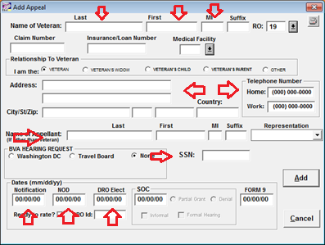
3 | On the SPECIAL INTEREST screen, identify special contentions or indicate no special contentions.  Example:  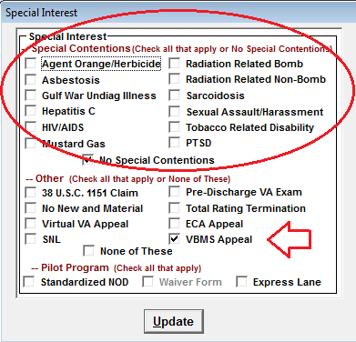
4 | On the ADD ISSUE screen, add claimed contentions and relevant details by populating fields, including  - PROGRAM AREA  - ISSUE  - SUBSIDIARY QUESTIONS OR OTHER TRACKING IDENTIFIERS, and  - NOTES.  Example:  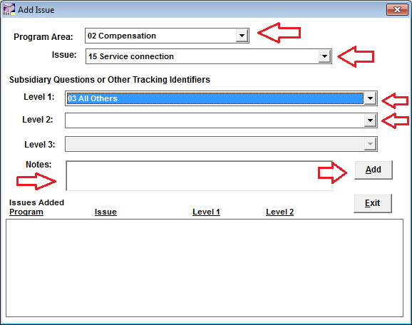  Note: Select ADD for each contention until all have been added, then select EXIT.
5 | On the VACOLS main screen, enter the claimant’s identification (ID) number and select the DIARY tab to ADD the information listed below on the DIARY DETAIL screen.  - ASSIGNED TO (VSR)  - DIARY CODE (NOD received)  - DAYS (in compliance with local guidance).  Example:  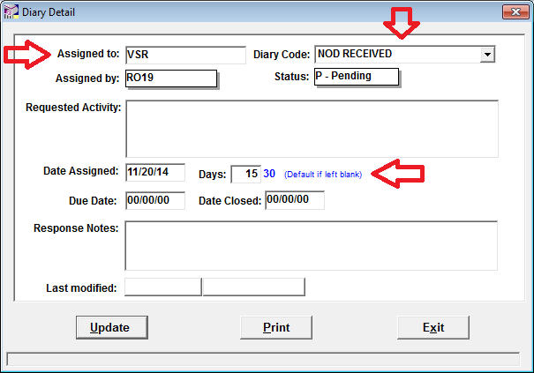
6 | Select UPDATE to save the information.

Notes:
- VACOLS allows the tracking of fiduciary appeals. The following are the user names for the Fiduciary Hubs:
- Columbia Fiduciary Hub RO64
- Indianapolis Fiduciary Hub RO65
- Lincoln Fiduciary Hub RO66
- Louisville Fiduciary Hub RO67
- Milwaukee Fiduciary Hub RO68
- Western Area Fiduciary Hub RO69, and
- The Manila Regional Office (RO) fiduciary activity will continue to use the RO's user name.
- VACOLS allows the tracking of pension related appeals. The following are the user names for the PMCs:
- Philadelphia PMC RO81
- Milwaukee PMC 082, and
- St. Paul RO83.

References: For more information on
- Fiduciary Hub jurisdictions, see M21-1 III.ii.1.E.6.c, and
- jurisdiction over fiduciary appeals, see M21-1, I.5.D.1.c.

d. Establishing an NOD in VBMS | Follow the steps in the table below to establish a claimant’s NOD in VBMS.

Step | Action
1 | Open the claimant’s profile and select NEW CLAIM from the ACTIONS drop down menu.
2 | Review and update the following fields, including  - ADDRESS  - TELEPHONE NUMBER, and  - POWER OF ATTORNEY (POA).
3 | Select 170NOD – NOTICE OF DISAGREEMENT in the EP & CLAIM LABEL field. The EP 170 will be shown as the default EP in the MODIFIER field.
4 | Enter the date of receipt of the NOD in the DATE OF CLAIM.
5 | Assign the EP 170 to Appeals (National) in the SEGMENTED LANE field.  Example:  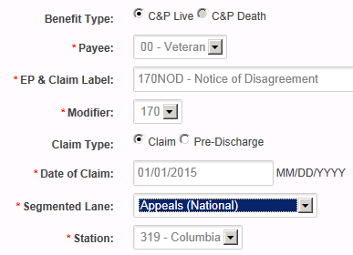
6 | Select SUBMIT to save the information.
7 | From the CONTENTIONS tab, add each contention specified by the claimant.  Note: If the VA Form 21-0958 is received after March 24, 2015, treat any contentions without a previous decision as a request for application in accordance with M21-1, Part III, Subpart ii, 2.C.2.
8 | From the PROFILE screen, select MANAGE EVIDENCE from the ACTIONS drop down menu.  - Select ADD UNSOLICITED and populate the following fields  - RECEIPT DATE  - DOCUMENT TYPE, and  - EVIDENCE NAME.  Example:  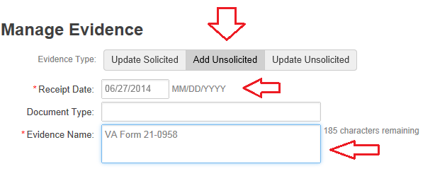  - Select COMPLETE on the right panel of the screen to update and save the information.

Exception: Establish non-Veteran appeals in Share.

References: For more information on establishing claims in
- VBMS, see M21-1, Part III, Subpart ii, 3.D.2.c, and
- Share, see M21-1, Part III, Subpart ii, 3.D.2.e.

e. Jurisdiction for Control of an Appellate Record | The following divisions will establish the appeal record for their respective NODs.  - Veterans Service Center (VSC)  - PMC  - Fiduciary Hub  - Education Division  - Philadelphia Insurance Center  - Vocational Rehabilitation and Employment (VR&E) Division, and  - Veterans Health Administration (VHA)  Program Offices other than those listed above will refer an NOD to the VSC to establish and maintain the appeal record in VACOLS. The VSC is entitled to EP credit for those appeals tracked for other program offices.  Note: Effective April 1, 2002, VHA’s Administration Service assumed responsibility for establishing appeal records in VACOLS and managing the VHA appellate workload.

2. Controlling a Perfected Appeal

Introduction | This topic contains information pertaining to controlling an appellate claim perfected by the submission of a VA Form 9, Appeal to Board of Veterans’ Appeals, including  - controlling a perfected appeal in VBMS, and  - updating VACOLS for tracking of a perfected appeal.

Change Date | October 9, 2015

a. Controlling a Perfected Appeal in VBMS | After receiving a decision on an NOD, the claimant may choose to submit a VA Form 9, Appeal to Board of Veterans’ Appeals to show his/her disagreement with the NOD decision and certify an appeal to the Board of Veterans’ Appeals (BVA).  Follow the steps in the table below to establish control of a perfected appeal.

Step | Action
1 | Open the appellant’s VBMS profile and select NEW CLAIM.
2 | Review the following information and update fields as necessary  - ADDRESS  - TELEPHONE NUMBER, and  - POWER OF ATTORNEY (POA).
3 | Enter 170FRM9 – FORM 9 in the EP & CLAIM LEVEL field.
4 | Enter the date the VA received the VA Form 9 in the DATE OF CLAIM field.
5 | Assign the 170FRM9 to APPEALS (NATIONAL) as the SEGMENTED LANE  Example:  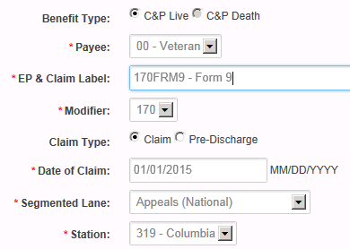
6 | Select SUBMIT to save the information.
7 | Use the table below to complete the contentions screen in VBMS.  If on the VA Form 9 the claimant checks ... Then ...  box 8A enter the issues indicated by the claimant as contentions.  box 8b enter the issues listed under the ISSUES tab in VACOLS.  Important: If there is any ambiguity as to what the claimant is appealing or if the claimant adds a new contention, the Intake Processing Center (IPC)  - enters “miscellaneous” as the contention  - forwards the EP to an appeals Veterans Service Representative (VSR) VBMS work queue, and  - leaves a system note regarding the ambiguity.  Notes:  - The issue(s) indicated on the VA Form 9 must be listed on the ISSUES tab in VACOLS.  - Ensure issues reviewed in VACOLS are from the correct appeals record, as there may be multiple appeals records.  - If the VA Form 9 is received after March 24, 2015, treat any new contentions received on the form as a request for application, in accordance with M21-1, Part III, Subpart ii, 2.C.2.
8 | Return to the claimant’s PROFILE screen and select MANAGE EVIDENCE from the ACTIONS drop down menu.  - Select ADD UNSOLICITED and populate the following fields.  - RECEIPT DATE  - DOCUMENT TYPE, and  - EVIDENCE NAME.  Example:  - Select COMPLETE on the right panel of the screen to update and save the information.

Exception: Establish non-Veteran appeals in Share.

References: For more information on
- establishing claims in VBMS, see M21-1, Part III, Subpart ii, 3.D.2.c
- establishing claims in Share, see M21-1, Part III, Subpart ii, 3.D.2.e, and
- managing evidence in VBMS, see the VBMS Job Instruction Sheet Manage Evidence.

b. Updating VACOLS for Tracking of a Perfected Appeal | In addition to establishing an EP 170 in VBMS for a perfected appeal, VACOLS must also be updated for tracking purposes.  Follow the steps in the table below to update VACOLS for perfected appeals.

Step | Action
1 | On the VACOLS main screen, enter the claimant’s ID number and select the DIARY tab to ADD the following information on the DIARY DETAIL screen.  - ASSIGNED TO (in compliance with local guidance)  - DIARY CODE (VA Form 9 RECEIVED)  - DAYS (in compliance with local guidance).  Note: Refer to local RO guidance regarding assignment of a perfected appeal. In many cases, a Decision Review Officer (DRO), the appeals rating activity, or other designee will be assigned the perfected appeal in order to expeditiously certify it to BVA.
2 | Select UPDATE to save the information.

3. Lost NODs

Introduction | This topic contains information pertaining to lost NODs, including  - identifying lost NODs, and  - handling a lost NOD.

Change Date | January 22, 2016

a. Identifying Lost NODs | Identify lost NODs through review of diaries in  - VACOLS  - Share  - Modern Award Processing – Development (MAP-D), and  - VBMS notes.  Consider an NOD lost if there is an electronic record of a pending NOD but the claims folder contains no documents related to the NOD.

b. Handling a Lost NOD | Follow the steps in the table below upon identification of a lost NOD.

Step | Action
1 | Establish EP 400.
2 | Review all available systems (such as VACOLS, MAP-D, Share, and VBMS) and records for the following information regarding the NOD:  - date received, and  - issue(s) identified.
3 | Prepare a Lost NOD Memorandum, including the following information, as applicable:  - which electronic system(s) were checked for lost NOD information, including, but not limited to  - MAP-D  - VBMS  - VACOLS  - Share  - Virtual VA  - if the claims file was reviewed for the NOD  - if the duly appointed representative, including a VSO, was contacted regarding information on the lost NOD, and  - if the lost NOD can be re-established from the record  - the date the NOD was re-established  - which system(s) were used to re-establish the NOD, and  - the specific issue(s) identified for the NOD.  Note: The employee’s supervisor must sign the memorandum.  References: For a sample of  - a completed Lost NOD Memorandum, see M21-1, Part III, Subpart ii, 3.E.4.a, and  - a Lost NOD Memorandum, see M21-1, Part III, Subpart ii, 3.E.4.b.
4 | Does the review of records  - establish the date the NOD was received, and  - identify at least one issue on the NOD?  - If yes, go to Step 5.  - If no, go to Step 6.
5 | - Send the Lost NOD – Some Issues Identified letter to the appellant. The letter should include the following information:  - the date the lost NOD was received by VA  - the issue(s) identified on the NOD  - a request that the appellant inform VA of any additional issues or corrections by submitting  - a copy of the previously submitted NOD, if available, or  - a new VA Form 21-0958, and  - notification that VA will continue to process the appeal for the issue(s) listed in the letter if no corrections or additional issues are received within  - 60 days of the date of the Lost NOD – Some Issues Identified letter, or  - one year after the date of the decision notice for the decision(s) being appealed, whichever is later.  - Proceed to Step 7.  References: For more information on  - the time to respond to a request for clarification of an NOD, see 38 CFR 19.26(c), and  - the Lost NOD – Some Issues Identified letter, see M21-1, Part III, Subpart ii, 3.E.3.4.c.
6 | Send the Lost NOD – No Issues Identified letter to the appellant. The letter should include the following information:  - the date the lost NOD was received by VA  - a request that the appellant inform VA of the issue(s) he/she wishes to appeal by submitting  - a copy of the previously submitted NOD, if available, or  - a new VA Form 21-0958, and  - notification that VA will consider the attempt to appeal abandoned if the appellant does not re-submit the NOD within  - 60 days of the date of the Lost NOD – No Issues Identified letter, or  - one year after the date of the decision notice for the decision(s) being appealed, whichever is later.  References: For more information on  - the time to respond to a request for clarification of an NOD, see 38 CFR 19.26(c), and  - the Lost NOD – No Issues Identified letter, see M21-1, Part III, Subpart ii, 3.E.4.d.
7 | Clear (PCLR) the EP 400 after sending the letter.

Note: If the appellant resubmits an NOD within the specified time limits, use the date of receipt of the initial (lost) NOD as the date of claim when reestablishing EP control. Otherwise, use the date of receipt of the resubmitted NOD.

4. Exhibits: Lost NODs

Introduction | This topic contains exhibits, including  - exhibit: completed Lost NOD Memorandum  - exhibit: Lost NOD Memorandum  - exhibit: Lost NOD – Some Issues Identified letter, and  - exhibit: Lost NOD – No Issues Identified letter.

Change Date | January 22, 2016

a. Exhibit: Completed Lost NOD Memorandum | A sample of a completed Lost NOD Memorandum is shown below.  Reference: For more information on the Lost NOD Memorandum , see M21-1, Part III, Subpart ii, 3.E.4.b.

Department of Memorandum
Veterans Affairs

Date: 11/23/2015

Subj: Lost Notice of Disagreement

File Number: 999999999

Name of Veteran/claimant: G. I. Joe

The following steps were taken when trying to locate evidence associated with:

EP: 170 Date of NOD: 10/27/2015

For Completion by VSR

- Checked VACOLS
- Checked Map-D/VBMS notes
- Checked eFolder/VVA/paper claims file (if applicable)
- Checked Share to see if claim established at HRO
- Checked VBMS to see if there are any documents pending with the scanning vendors
- Checked with VSO (if applicable)

VSR signature: __V. S. Representative___ Date: _11/21/2015

For Completion by Supervisor

Have you cancelled above EP due to lost NOD? √ YES NO

If so, please note date of PCAN: __11/25/2015__

Was lost NOD letter released? YES √ NO

If so, on what date: ______________

Update Lost NOD Log (upload copy of memo to eFolder/VVA/c-file)

__Ima D. Coach___
Coach Signature

b. Exhibit: Lost NOD Memorandum | A sample of the Lost NOD Memorandum is shown below.

Department of Memorandum
Veterans Affairs

Date: [MM/DD/YYYY]

Subj: Lost Notice of Disagreement

File Number: [Claim Number]

Name of Veteran/claimant: [Veteran/claimant’s name]

The following steps were taken when trying to locate evidence associated with:

EP: [EP number] Date of NOD: [MM/DD/YYYY]

For Completion by VSR

- Checked VACOLS
- Checked Map-D/VBMS notes
- Checked eFolder/VVA/paper claims file (if applicable)
- Checked Share to see if claim established at HRO
- Checked VBMS to see if there are any documents pending with the scanning vendors
- Checked with VSO (if applicable)

VSR signature: ___________________ Date: [MM/DD/YYYY]

For Completion by Supervisor

Have you cancelled above EP due to lost NOD? YES NO

If so, please note date of PCAN: [MM/DD/YYYY]

Was lost NOD letter released? YES NO

If so, on what date: [MM/DD/YYYY]

Update Lost NOD Log (upload copy of memo to eFolder/VVA/c-file)

____________________
Coach Signature

c. Exhibit: Lost NOD – Some Issues Identified Letter | A sample of the Lost NOD – Some Issues Identified letter is shown below.

Department Of Veterans Affairs

[MM/DD/YYYY]

[APPELLANT NAME]  [ADDRESS LINE 1]  [ADDRESS LINE 2]  [ADDRESS LINE 3]  [CITY] [STATE] [POSTAL] | In reply, refer to: [VSR INITIALS]  File Number: [XXXXXXXXX]

Dear [Insert appellant’s name.]:

Our records show that you filed a notice of disagreement on [MM/DD/YYYY]. Unfortunately, we have not been able to locate the original paperwork submitted.

Our records indicate that your notice of disagreement was in reference to the following issue(s)
- [INSERT DISABILITY/ISSUE(S) HERE]

If your notice of disagreement included additional issue(s), please provide a copy of the notice of disagreement that you previously submitted. If you do not have a copy of your previously submitted notice of disagreement, please complete and return the enclosed VA Form 21-0958, Notice of Disagreement.

You have 60 days from the date of this letter, or one year from the date of the decision notice associated with the issue(s) you are attempting to appeal, whichever is later, to submit your notice of disagreement for additional issue(s). If we do not receive your notice of disagreement within this timeframe, we will continue to process your appeal for the issue(s) listed above, however, any additional issue(s) will not be considered as part of your appeal.

Please accept our apologies for this inconvenience.

If You Have Questions or Need Assistance

[If the claimant’s address is Domestic-US/Puerto Rico/Alaska/Hawaii use the following text:]
If you have any questions or need assistance with this claim, you may contact us by telephone, e-mail, or letter.

If you | Here is what to do.
Telephone | Call us at [Insert the appropriate number: 1-800-827-1000 for compensation or 1-877-294-6380 for pension]. If you use a Telecommunications Device for the Deaf (TDD), the Federal number is 711.
Use the Internet | Send electronic inquiries through the Internet at https://iris.va.gov.
Write | VA now uses a centralized mail system. For all written communications, put your full name and VA file number on the letter. Please mail or fax all written correspondence to the appropriate address listed on the attached Where to Send Your Written Correspondence chart.

In all cases, be sure to refer to your VA file number [Insert file number.].

If you are looking for general information about benefits and eligibility, you should visit our web site at http://www.va.gov or search the Frequently Asked Questions (FAQs) at http://iris.va.gov.

[If the claimant’s address is outside the US use the following text:]

If you have any questions or need assistance with this claim, you may contact us by telephone, e-mail, or letter.

If you | Here is what to do.
Telephone | Call or visit the nearest American Embassy or Consulate for assistance. In Canada, call or visit the local office of Veterans Affairs Canada. From Guam, call us by dialing toll free, 475-8387.  From American Samoa and N. Marianas, call us at 1-800-844-7928. If you use a Telecommunications Device for the Deaf (TDD), the number is 1-800-829-4833.
Use the Internet | Send electronic inquiries through the Internet at https://iris.va.gov.
Write | VA now uses a centralized mail system. For all written communications, put your full name and VA file number on the letter. Please mail or fax all written correspondence to the appropriate address listed on the attached Where to Send Your Written Correspondence chart.

In all cases, be sure to refer to your VA file number [Insert file number.].

If you are looking for general information about benefits and eligibility, you should visit our web site at http://www.va.gov or search the Frequently Asked Questions (FAQs) at http://iris.va.gov.

[If the Veteran has a VSO use the following text:]

We sent a copy of this letter to [Enter name of Service Organization/POA.], who you have appointed as your representative. If you have questions or need assistance, you can also contact your representative.

[If the Veteran does not have a VSO use the following text:]

We have no record of you appointing a service organization or representative to assist you with your claim. You can contact us for a listing of the recognized Veterans’ Service Organizations and/or representatives. Veterans’ Service Organizations, which are recognized or approved to provide services to the veteran community, can also help you with any questions.

Thank you,

Regional Office Director

Enclosure(s): Where to Send Your Written Correspondence
VA Form 21-0958

cc: [Insert POA if applicable.]

d. Exhibit: Lost NOD – No Issues Identified Letter | A sample of the Lost NOD – No Issues Identified letter is shown below.

Department Of Veterans Affairs

[MM/DD/YYYY]

[APPELLANT NAME]  [ADDRESS LINE 1]  [ADDRESS LINE 2]  [ADDRESS LINE 3]  [CITY] [STATE] [POSTAL] | In reply, refer to: [VSR INITIALS]  File Number: [XXXXXXXXX]

Dear [Insert appellant’s name.]:

Our records show that you filed a notice of disagreement on [MM/DD/YYYY]. Unfortunately, we have not been able to locate the original paperwork submitted.

Please provide a copy of the notice of disagreement that you previously submitted. If you do not have a copy of your previously submitted notice of disagreement, please complete and return the enclosed VA Form 21-0958, Notice of Disagreement, indicating all the issues with which you disagree.

You have 60 days from the date of this letter, or one year from the date of the decision notice associated with the issue(s) you are attempting to appeal, whichever is later, to submit your notice of disagreement. If we do not receive your notice of disagreement within this timeframe, we will consider your attempt to appeal abandoned.

Please accept our apologies for this inconvenience.

If You Have Questions or Need Assistance

[If the claimant’s address is Domestic-US/Puerto Rico/Alaska/Hawaii use the following text:]
If you have any questions or need assistance with this claim, you may contact us by telephone, e-mail, or letter.

If you | Here is what to do.
Telephone | Call us at [Insert the appropriate number: 1-800-827-1000 for compensation or 1-877-294-6380 for pension]. If you use a Telecommunications Device for the Deaf (TDD), the Federal number is 711.
Use the Internet | Send electronic inquiries through the Internet at https://iris.va.gov.
Write | VA now uses a centralized mail system. For all written communications, put your full name and VA file number on the letter. Please mail or fax all written correspondence to the appropriate address listed on the attached Where to Send Your Written Correspondence chart.

In all cases, be sure to refer to your VA file number [Insert file number.].

If you are looking for general information about benefits and eligibility, you should visit our web site at http://www.va.gov or search the Frequently Asked Questions (FAQs) at http://iris.va.gov.

[If the claimant’s address is outside the US use the following text:]

If you have any questions or need assistance with this claim, you may contact us by telephone, e-mail, or letter.

If you | Here is what to do.
Telephone | Call or visit the nearest American Embassy or Consulate for assistance. In Canada, call or visit the local office of Veterans Affairs Canada. From Guam, call us by dialing toll free, 475-8387.  From American Samoa and N. Marianas, call us at 1-800-844-7928. If you use a Telecommunications Device for the Deaf (TDD), the number is 1-800-829-4833.
Use the Internet | Send electronic inquiries through the Internet at https://iris.va.gov.
Write | VA now uses a centralized mail system. For all written communications, put your full name and VA file number on the letter. Please mail or fax all written correspondence to the appropriate address listed on the attached Where to Send Your Written Correspondence chart.

In all cases, be sure to refer to your VA file number [Insert file number.].

If you are looking for general information about benefits and eligibility, you should visit our web site at http://www.va.gov or search the Frequently Asked Questions (FAQs) at http://iris.va.gov.

[If the Veteran has a VSO use the following text:]

We sent a copy of this letter to [Enter name of Service Organization/POA.], who you have appointed as your representative. If you have questions or need assistance, you can also contact your representative.

[If the Veteran does not have a VSO use the following text:]

We have no record of you appointing a service organization or representative to assist you with your claim. You can contact us for a listing of the recognized Veterans’ Service Organizations and/or representatives. Veterans’ Service Organizations, which are recognized or approved to provide services to the veteran community, can also help you with any questions.

Thank you,

Regional Office Director

Enclosure(s): Where to Send Your Written Correspondence
VA Form 21-0958

cc: [Insert POA if applicable.]

