Section D. Claims Establishment

Overview

In This Section | This section contains the following topics:

Topic | Topic Name
1 | Veterans Benefits Management Systems (VBMS) Claim Establishment Exclusions
2 | Establishing Claims in VBMS and Share
3 | Establishing Apportionment Claims
4 | Establishing a Request for a Hearing
5 | Procedures for VBMS Claims Establishment
6 | Procedures for Share Claims Establishment
7 | Exhibit: Segmented Lane Assignment Criteria

1. VBMS Claim Establishment Exclusions

Introduction | This topic contains information about the establishment of claims excluded from VBMS, including  - types of claims excluded from VBMS, and  - processing appeals and paper claims in VBMS.

Change Date | June 30, 2015

a. Types of Claims Excluded From VBMS | Use the Veterans Benefits Management System (VBMS) to establish all  - original and subsequent claims for compensation, and  - all claim types for which a VBMS record already exists.  Note: If there is no VBMS record, establish the following claim types using Share (legacy systems)  - pension claim  - the claimant is not the Veteran, including survivor benefits claims, such as  - Dependency and Indemnity Compensation (DIC)  - Survivors Pension  - accrued benefits, and  - burial claim  - dual (compensation and pension) claim  - pending paper claim, including any new claim filed while a paper claim is pending  - all Sensitive 8 level cases, including  - witness protection cases, and  - classified claims, and  - a claim or Work Item for which the claimant has a Department of Veterans Affairs (VA) appointed fiduciary.  Important: Review both the VBMS and Virtual VA electronic claims folder (eFolder) for Paperless Claims Processing (PLCP) claims until historical evidence in Virtual VA is migrated into VBMS.  Reference: For more information on uploading to the VBMS eFolder, see M21-1, Part III, Subpart ii, 4.G.2.

b. Processing Appeals and Paper Claims in VBMS | Pending paper claims are excluded from VBMS processing. Appeals are not excluded from VBMS processing. Unlike pending paper claims, appeals have not been previously controlled with end products (EPs), therefore a pending appeal can be scanned into VBMS.  Use the table below to determine whether an appeal or paper claim should be controlled in VBMS.

If there is… | And the RO receives… | Then…
no claim pending | a paper appeal | - send the appeal for scanning, and  - control the appeal in VBMS.
a claim pending in VBMS | a paper appeal | - send the appeal for scanning, and  - control both the claim and the appeal in VBMS.
a paper appeal pending | - a paper claim, or  - a new notice of disagreement (NOD) | - send the folder for scanning, and  - control both the claim and the appeal(s) in VBMS.  Reference: For more information on establishing appeals, see M21-1, Part III, Subpart ii, 3.E.
- a paper claims folder, and  - a Court of Appeals for Veterans Claims (CAVC) hold due to an appealable BVA decision | - a paper claim, or  - a new NOD | - control the claim or appeal in VBMS but  - do not send the appeal and claim for scanning for 180 days (the CAVC hold period).  Exception: If establishing the claim under a payee code other than 00, use Share to control the claim or appeal.  Reference: For more information on special handling of BVA decision files, see M21-1, Part III, Subpart ii, 4.I.1.

Important: Appeals must also be controlled in Veterans Appeal Control and Locator System (VACOLS) regardless of whether the claims folder is paper or electronic.

2. Establishing Claims

Introduction | This topic contains information about establishing claims, including  - preparing for claims establishment  - determining the end product (EP) for original and supplemental claims  - establishing claims in VBMS  - description of claim information fields in VBMS, and  - establishing claims in Share.

Change Date | September 25, 2015

a. Preparing for Claims Establishment | The table below describes the stages of claims establishment and the references for guidance on these actions.

Step | Action | Reference
1 | Review the VBMS exclusions to determine the system in which to place the claim under control. | M21-1, Part III, Subpart ii, 3.D.1.a.
2 | Check for a previously established claims folder number. | M21-1, Part III, Subpart ii, 3.A.1.d.
3 | Determine the current claims folder format and request scanning of paper claims folders. | - M21-1, Part III, Subpart ii, 3.B.1.f, and  - M21-1, Part II, Subpart ii, 3.B.1.h.
4 | Establish a claims folder in VA systems (if necessary). | M21-1, Part III, Subpart ii, 3.B.2.

Important: Establish EP control only upon receipt of a substantially completed form.

Reference: For more information on processing an Intent to File (ITF) and Incomplete ITFs, see M21-1, Part III, Subpart ii, 2.C.

b. Determining the EP for Original and Supplemental Claims | To administer proper EP control for rating-related claims, determine if the claimant  - previously filed for benefits (making the current claim supplemental), or  - is filing an initial (original) claim.  Follow the steps in the table below to determine if a claim should be controlled with an original or supplemental EP.

Step | Action
1 | Open Share.
2 | - Select the CORPORATE INQUIRY command.  - Enter the claimant’s Social Security number (SSN) or claims folder number into the FILE NUMBER OR SSN field.  - Select SUBMIT.
3 | - Select AWARDS/RATING from the MENU bar.  - Select the RATING INFORMATION tab.  Has the claimant already received any rating determinations?  - If yes, use a supplemental rating EP from the 020 series.  - If no, go to Step 4.  Note: For more information on establishing a request for reconsideration, see M21-1, Part III, Subpart ii, 2.F.1.b.
4 | - Select READY.  - Select the Beneficiary Identification & Records Locator Subsystem (BIRLS) INQUIRY command, and  - Select the INACTIVE COMP & PEN tab.  Are there any entries in the  - DIAGNOSTIC table  - ENTITLEMENT CODE field, or  - Reason for Termination or Disallowance field?  Illustration:  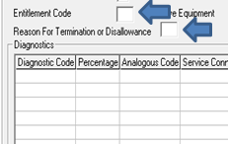  - If yes, use a supplemental rating EP from the 020 series.  - If no, use an original rating EP from the  - 110 series, if there are seven or fewer claimed contentions, or  - 010 series, if there are eight or more claimed contentions.

Note: For full guidance on proper EP control, see M21-4, Appendix B.

c. Establishing Claims in VBMS | Follow the steps in the table below to establish a claim in VBMS.

Step | Action
1 | Search for the Veteran in VBMS by  - logging into VBMS  - entering the claimant’s claims folder number in the Global search bar, and  - selecting OPEN PROFILE.
2 | Begin claims establishment by choosing NEW CLAIM from the ACTIONS drop down menu.  Illustration:  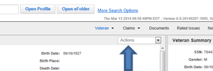
3 | On the NEW CLAIM screen verify the following  - the claimant’s first and last names are correct  - the CONTACT INFORMATION field is current (update as needed), including the  - address  - telephone number, and  - e-mail, and  - check for open claims in the EXISTING CLAIMS field.  Note: If a rating claim is already pending  - update the contentions, and  - manage evidence.  References: For more information on  - managing evidence in VBMS, see the VBMS Job Instruction Sheet - Manage Evidence  - processing name changes, see M21-1, Part III, Subpart ii, 3.C.2, and  - receiving notice of a change of address or direct deposit, see  - M21-1, Part III, Subpart ii, 3.C.1.a  - M21-1, Part III, Subpart ii, 3.C.1.b, and  - M27-1, Part I, 3.12.
4 | Using the table below, complete the CLAIM INFORMATION field.  Required Fields Optional  EP & CLAIM LABEL ALLOW POA ACCESS TO DOCUMENTS  MODIFIER BENEFIT TYPE  PAYEE CLAIM TYPE  POA CODE DATE OF CLAIM  SEGMENTED LANE GULF WAR REGISTRY PERMIT  STATION INTAKE SITE  --- POA  --- SUPPRESS ACKNOWLEDGEMENT LETTER  --- SUSPENSE DATE  --- SUSPENSE REASON  Reference For a complete description of the CLAIM INFORMATION field options, see M21-1, Part III, Subpart ii, 3.D.2.d.
5 | Select SUBMIT.
6 | VBMS will ask if the claim was submitted on a VA Form 21-526EZ, Application for Disability Compensation and Related Compensation Benefits, dated August 2011 or later.  - If no is selected, a Section 5103 notice will generate. Print this letter and send it to the claimant.  - If yes is selected, VBMS will transition to the CONTENTIONS screen.
7 | Enter the claimant’s contentions.  - Select add contention.  - Type the claimed condition into the CONTENTION field.  - Using the drop down menu, populate the CLASSIFICATION field.  - Enter the date of contention.  - In the TYPE field, use the drop down menu to indicate if the claimed contention is  - new  - increase  - reopen, or  - secondary.  - Select any appropriate special issues, to include the  - segmented lane, or  - Fully Developed Claims (FDCs) election.  - Select  - Save and add to add more contentions, or  - Save when all contentions have been entered.
8 | Use the table below to document the claims establishment process.  If processing the mail in... Then...  a paper format annotate the claim document with the - EP - establishment date, and - initials of the individual establishing the EP.  an electronic format an annotation is not required, but the creation of a VBMS note documenting the EP established is recommended.
9 | Return to the VETERAN PROFILE screen, and select MANAGE EVIDENCE in the drop down actions box.  Illustration:  Select update unsolicited to add each piece of mail or mail packet received.  Reference: For more information on updating unsolicited mail, see the VBMS Job Instruction Sheet - Manage Evidence.

Note: A BIRLS record exists for each Veteran or other beneficiary for whom one of the following types of files has been established
- CLAIMS
- NOD
- CH 35
- VR&E, and
- CH 30.

References:
- For a flowchart illustrating the VBMS establishment process, see M21-1, Part III, Subpart ii, 3.D.5.b.
- For more information on
- claims folder establishment in VA systems, see M21-1, Part III, Subpart ii, 3.B.2
- confirming a BIRLS record exists and BIRLS ADD, see
- M21-1, Part III, Subpart ii, 3.B.2
- M21-1, Part III, Subpart ii, 3.A.1.d, and
- the Share User’s Guide
- validating in the Control of Veterans Records System (COVERS) and requesting folders, see M21-1, Part III, Subpart ii, 3.B.1
- controlling appeals and determining if claimed contentions are controlled under an Active NOD, see M21-1, Part III, Subpart ii, 3.E, and
- establishing a request for reconsideration, see M21-1, Part III, Subpart ii, 2.F.1.b.

d. Description of Claim Information Fields in VBMS | See the table below for a description of each available section for the CLAIM INFORMATION field in VBMS.

Field Name | Description
ALLOW POA ACCESS TO DOCUMENTS | Check the box in this field if there is a valid  - VA Form 21-22, Appointment of Veterans Service Organization as Claimant’s Representative, or  - VA Form 21-22a, Appointment of Individual as Claimant’s Representative.  References: For more information on  - processing power of attorney (POA) appointments, see M21-1, Part III, Subpart ii, 3.C.4, and  - updating electronic systems for POA, see M21-1, Subpart ii, 3.C.6.
BENEFIT TYPE | Select the appropriate radio button for either  - C&P LIVE, or  - C&P DEATH.  Note: Currently, processing of compensation and pension claims for survivors benefit(s) is a VBMS exclusion.  Reference: For more information on VBMS exclusions, see M21-1, Part III, Subpart ii, 3.D.1.a.
CLAIM TYPE | Select the appropriate radio button for either  - CLAIM, or  - PRE-DISCHARGE.  Reference: For more information on establishing pre-discharge claims, see M21-1, Part III, Subpart i, 2.A.2.
DATE OF CLAIM | For claims establishment purposes, the date of claim is the earliest date of receipt in any VA facility, to include eBenefits and scanning vendor sites. Identify this date from the earliest VA date stamp or equivalent.  References: For more information on date of claim regarding  - ITF and informal claims, see M21-1, Part III, Subpart ii, 2.C.1  - original claims, see M21-1, Part III, Subpart ii, 2.B.3.f  - correct date of claim, see M21-4, Appendix B  - definition of date of receipt, see 38 CFR 3.1  - identifying date of receipt, to include documents received in the Centralized Mail (CM) Portal, see M21-1, Part III, Subpart ii, 1.C.1, and  - pre-discharge claim date of claim, see M21-1, Part III, Subpart i, 2.A.2.
EP & CLAIM LABEL | Select the appropriate EP and claim label based on the correspondence being processed.  Note: Choose the claim label that best describes the claim including  - special missions (e.g. Pension, Pre-Discharge, etc.)  - claim characteristics (dual, reopen, increase, secondary, new herbicide presumptive, child incapable of self-support, etc.), and  - number of contentions.  Reference: For more information on EPs, see M21-4, Appendix B.
GULF WAR REGISTRY PERMIT | Check the box in the GULF WAR REGISTRY PERMIT field when claimants indicate they were included in the Veterans Heath Administration (VHA) Persian Gulf Health Registry.
INTAKE SITE | This is a required field if pre-discharge is selected in the CLAIM TYPE field. Choose the proper intake site.  Reference: For more information on intake sites, see M21-1, Part III, Subpart I, 2.B.1.a
MODIFIER | The default third digit modifier is zero.  Select a third digit modifier other than zero if the claim corresponds to any special missions listed on the table in M21-4, Appendix B.
PAYEE | Select the appropriate payee code.  Note: Currently, processing claims for which the payee is not the Veteran is a VBMS exclusion. Establishing a claim for a non-Veteran in VBMS with Payee Code 00 will erroneously replace the Veteran’s name in the corporate record.  Reference: For more information on VBMS exclusions, see M21-1, Part III, Subpart ii, 3.D.1.a.
POA | Select the proper radio button, including  - NONE  - VSO, or  - PRIVATE.
POA CODE | If VSO or PRIVATE is selected in the POWER OF ATTORNEY (POA) field, entry of a POA code becomes mandatory.  References: For more information on  - processing POA appointments, see M21-1, Part III, Subpart ii, 3.C.4  - updating electronic systems for POA, see M21-1, Subpart ii, 3.C.5, and  - POA codes, see M21-1, Part III, Subpart ii, 3.C.6.
SEGMENTED LANE | Assign claims to the proper segmented lane using the lane criteria in M21-1, Part III, Subpart ii, 3.D.7.a.
STATION | Station will default to the VBMS user’s sign in station.
SUPPRESS ACKNOWLEDGEMENT LETTER | The SUPRESS ACKNOWLEDGEMENT LETTER field is selected by default.
SUSPENSE DATE | Suspense date is an optional field automatically set by VBMS in accordance with business rules if left blank.
SUSPENSE REASON | Suspense reason is an optional field automatically set by VBMS in accordance with business rules if left blank.

e. Establishing Claims in Share | Follow the steps in the table below to establish a claim in Share.

Step | Action
1 | Does a BIRLS record exists?  - If yes, go to Step 2.  - If no  - create a record using the BIRLS ADD command, and  - go to Step 2.  Important: To prevent the establishment of a duplicate claims (DUPC) folder, follow the guidance in M21-1, Part III, Subpart ii, 3.A.1.d.
2 | Has the record been validated in COVERS?  - If yes, go to Step 3.  - If no  - request the claims folder, and  - go to Step 3.
3 | Select the CLAIMS ESTABLISHMENT C+P command on the Share READY screen and using the table below, submit the information needed to start the claims establishment process in Share.  Required Fields Optional  File Number Middle Name and Suffix  Benefit Type Date of Birth  Payee Number Service Number  Claim Type Branch of Service  First Name EOD and RAD  Last Name Regional Office  Illustration:  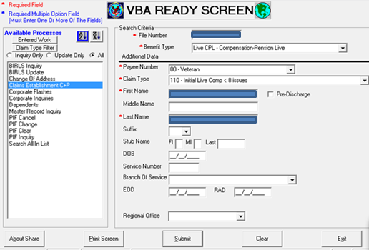  Note: The command establishes a pending issue file (PIF) control for a pending claim or appeal.
4 | On the Veteran’s identification data (VID) screen complete the following as appropriate  - review the data for accuracy and completeness  - correct any erroneous data and enter any missing data, and  - select Continue Establishment.  Illustration:  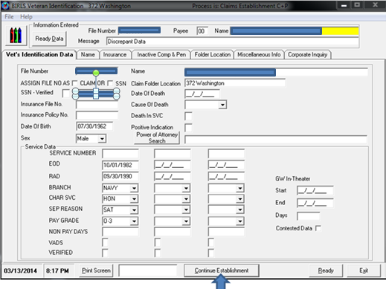
5 | Use the table below to complete the PENDING ISSUE/CORPORATE CONTROL ESTABLISHMENT screen.  Field Name Description  Incremental The default third digit incremental (also called a modifier) is zero. Select a third digit incremental/modifier other than zero, if the claim corresponds to any special missions listed on the table in M21-4, Appendix B.  - Address - Telephone, and - email Update based on current correspondence (as necessary).  Date of Claim For claims establishment purposes, the date of claim is the earliest date of receipt in any VA facility, to include eBenefits and scanning vendor sites. Identify this date from the earliest VA date stamp or equivalent. References: For more information on date of claim regarding - ITF and informal claims, see M21-1, Part III, Subpart ii, 2.C. - original claims, see M21-1, Part III, Subpart ii, 2.B.3.f - correct date of claim, see M21-4, Appendix B - definition of date of receipt, see 38 CFR 3.1 - identifying date of receipt, to include documents received in the Centralized Mail (CM) Portal, see M21-1, Part III, Subpart ii, 1.C.1, and - pre-discharge claim date of claim, see M21-1, Part III, Subpart i, 2.A.2.  SUSPENSE Date Set suspense date to 15 days from the current date.  section/unit Enter 21 for compensation and pension claims.  - Power of Attorney search - Authorized POA Access, and - CADD Auth’d Update POA information (if applicable). References: For more information on - processing POA appointments, see M21-1, Part III, Subpart ii, 3.C.4 - updating electronic systems for POA, see M21-1, Part III, Subpart ii, 3.C.5, and - POA codes, see M21-1, Part III, Subpart ii, 3.C.6.  suppress acknowledgemEnt letter Was the claim submitted on VA Form 21-526EZ dated August 2011 or later? - If yes - select SUPPRESS ACK LETTER, and - go to Step 6. - If no - do not select SUPPRESS ACK LETTER - print and send to the claimant the Section 5103 notice letter that the system automatically generates, and - go to Step 6.
6 | Select CREATE ESTABLISHMENT.
7 | Update any appropriate corporate flashes, as necessary.  Reference: For more information on updating corporate flashes, see the Share User’s Guide.
8 | Open the Veteran’s record in VBMS and from the CLAIMS drop down menu select CLAIM ESTABLISHED IN SHARE.
9 | Enter the Veteran’s claimed contentions. For each contention  - select ADD CONTENTION and type the contention into the first box  - select the classification  - enter the date of contention, which will be the date the claim for the contention was received  - select NEW for original claims  - select any appropriate special issues and corresponding lane by selecting the plus sign on the far right  - select FULLY DEVELOPED CLAIMS (FDCs), if applicable  - select SAVE AND ADD to add more contentions, and  - select SAVE when all contentions have been entered.
10 | - Return to the VETERAN Profile screen.  - Select MANAGE EVIDENCE in the drop down actions box.  Illustration:
11 | Select UPDATE unsolicited to add each piece of mail or mail packet received.  Illustration:  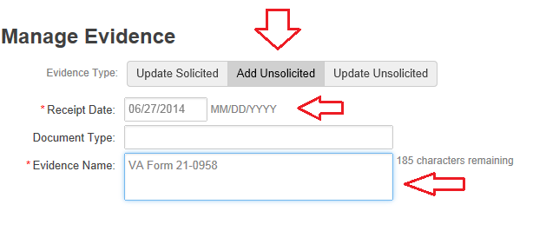  Reference: For more information on unsolicited mail, see the VBMS Job Instruction Sheet - Manage Evidence.
12 | Use the table below to document the claims establishment process.  If processing the mail in a ... Then ...  paper format annotate the claim document with the - EP - establishment date, and - initials of the individual establishing the EP.  electronic format an annotation is not required, but the creation of a VBMS note documenting the EP established is recommended.
13 | Route for scanning or to appropriate location.  Reference: For more information on scanning and claim routing, see M21-1, Part III, Subpart ii, 3.B.1.

Important:
- Establish EP control only upon receipt of a fully completed claim.
- VACOLS must be checked to determine if the contentions claimed, if applicable, are controlled under an active appeal.

Note: A BIRLS record exists for each Veteran or other beneficiary for whom one of the following types of files has been established
- CLAIMS
- NOD
- CH 35
- VR&E, and
- CH 30.

References: For more information on
- processing an ITF and incomplete ITFs, see M21-1, Part III, Subpart ii, 2.C.1
- the Share establishment mail process, see M21-1, Part III, Subpart ii, 3.D.7
- claims folder establishment in VA systems, see M21-1, Part III, Subpart ii, 3.B.2
- confirming a BIRLS record exists and BIRLS ADD, see
- M21-1, Part III, Subpart ii, 3.B.2
- M21-1, Part III, Subpart ii, 3.A.1.d, and
- the Share User’s Guide
- validating in COVERS and requesting folders, see M21-1, Part III, Subpart ii, 3.B.1
- controlling appeals and determining if claimed contentions are controlled under an active appeal, see M21-1, Part III, Subpart ii, 3.E, and
- establishing a request for reconsideration, see M21-1, Part III, Subpart ii, 2.F.

3. Establishing Apportionment Claims

Change Date | August 24, 2015

a. Establishing Apportionment Claims in Share | An apportionment claim can be filed against the Veteran’s benefit.  Follow the steps in the table below to establish an apportionment claim in Share.

Step | Action
1 | Enter the Veteran’s file number in Share.
2 | Access the Corporate Record.
3 | Select the All Relationships tab.  Is the spouse making the apportionment claim listed under the ALL RELATIONSHIPS tab?  - If yes  - make note of the spouse’s  - full name  - date of birth (DOB)  - SSN, and  - go to Step 4.  - If no  - select READY, and  - go to Step 5 to establish an EP 130 for the Veteran under payee code 00.
4 | Select READY.
5 | Select Claims Establishment C&P from the left column, then  - select LIVE CPL for Benefit Type  - select PAYEE 10 for Payee Number, unless different as noted above in Step 3  - select 130 – APPORTIONMENT for Claim Type  - enter the first and last names of the claimant (spouse)  - for Stub name, enter first initial, middle initial and first five letters of the last name of the Veteran, and  - select Submit.  Reference: For more information on appropriate EPs, see M21-4, Appendix B.
6 | Select Continue Establishment on the next screen.
7 | Enter the following on the Pending Issue/Corporate Control Establishment screen  - address of the claimant  - phone number, if one is listed  - date of claim, and section number 21, and  - SSN and DOB of the claimant.  Select CREATE ESTABLISHMENT.  Important: If the apportionment claim is for a child, with the custodian as requestor, enter the child as the claimant. For the address, change the first line to read C/O [CUSTODIAN’S NAME].
8 | - Open VBMS.  - Enter the Veteran’s SSN or file number in the GLOBAL SEARCH bar.  - Select OPEN PROFILE.
9 | Select MANAGE EVIDENCE in the drop down actions box.  Illustration:
10 | Select update unsolicited to add each piece of mail or mail packet received.  Illustration:  Reference: For more information on unsolicited mail, see the VBMS Job Instruction Sheet - Manage Evidence.
11 | Go to CONTENTIONS, and enter Apportionment Claim with a Miscellaneous classification.
12 | Select Save.

Reference: For more information on establishing claims in Share, see
- the Share User’s Guide, and
- M21-1, Part III, Subpart ii, 3.D.2.e.

4. Establishing a Request for a Hearing

Change Date | August 24, 2015

a. Establishing –Requests for a Hearing | Upon request, a claimant is entitled to a hearing at any time, on any issue involving a claim.  Follow the steps below to control a request for a hearing in VBMS.

Step | Action
1 | - Open the claimant’s profile in VBMS, and  - select New Claim from the ACTIONS drop down menu.
2 | When necessary, update the claimant’s information, including  - ADDRESS  - TELEPHONE NUMBER, and  - POWER OF ATTORNEY (POA).
3 | Is there an active appeal pending?  If … Then …  yes go to the next step.  no - select 173FHODRO-FORMAL HEARING BY OTHER THAN DRO as the EP & CLAIM LABEL, and - go to Step 5.
4 | Did the claimant request a hearing with a DRO?  If … Then select …  yes 174IHDRO-Informal Hearing by DRO as the EP & CLAIM LABEL.  no 173FHODRO-Formal Hearing by Other Than DRO as the EP & CLAIM LABEL.
5 | Enter the earliest date of receipt of the request for a hearing in the DATE OF CLAIM field.
6 | Use the table below to determine the proper segmented lane.  If establishing an ... Then assign the claim to the ...  EP 173 segmented lane established by local policy.  EP 174 Appeals segmented lane.
7 | Select SUBMIT.
8 | From the PROFILE screen, select MANAGE EVIDENCE in the ACTIONS drop down menu.  Illustration:
9 | Select ADD unsolicited to add each piece of mail or mail packet received.  Illustration:  Reference: For more information on unsolicited mail, see the VBMS Job Instruction Sheet - Manage Evidence.

5. Procedures for VBMS Claims Establishment

Introduction | This topic contains information on the procedures for VBMS claims establishment, including a  - table providing the procedures for VBMS claims establishment, and  - flowchart providing the procedures for VBMS claims establishment.

Change Date | August 24, 2015

a. Table Providing the Procedures for VBMS Claims Establishment | Follow the steps in the table below when establishing a claim in VBMS.

Step | Action
1 | Is the claim on the VBMS exclusion list?  - If yes  - establish the claim in SHARE, and  - proceed no further.  - If no, go to Step 2.  References: For more information on  - the VBMS exclusion list, see M21-1, Part III, Subpart ii, 3.D.1.a, and  - establishing a claim in Share, see M21-1, Part III, Subpart ii, 3.D.2.e.
2 | Is there a previously established claims folder number?  - If yes, go to Step 3.  - If no  - assign a claim number, and  - go to Step 3.  References: For more information on  - previously established claims folder numbers, see M21-1, Part III, Subpart ii, 3.A.1.d, and  - assigning a claim number, see M21-1, Part III, Subpart ii, 3.A.1.f.
3 | Does a claims folder need establishment in VA systems?  - If yes  - manually establish the claims folder in VA systems, and  - go to Step 5.  - If no, go to Step 4.  References: For more information on  - when to establish a claims folder in VA systems, see M21-1, Part III, Subpart ii, 3.B.2.a, and  - manually establishing a claims folder in VA systems, see M21-1, Part III, Subpart ii, 3.B.2.c.
4 | Determine the current claims folder format and request scanning (if necessary).  Reference: For more information on determining the current claims folder format, see M21-1, Part III, Subpart ii, 3.B.1.f and h.
5 | Establish the claim in VBMS, in accordance with M21-1, Part III, Subpart ii, 3.D.2.c.

b. Flowchart Providing the Procedures for VBMS Claims Establishment | Follow the procedures contained in the flowchart below when establishing claims in VBMS.

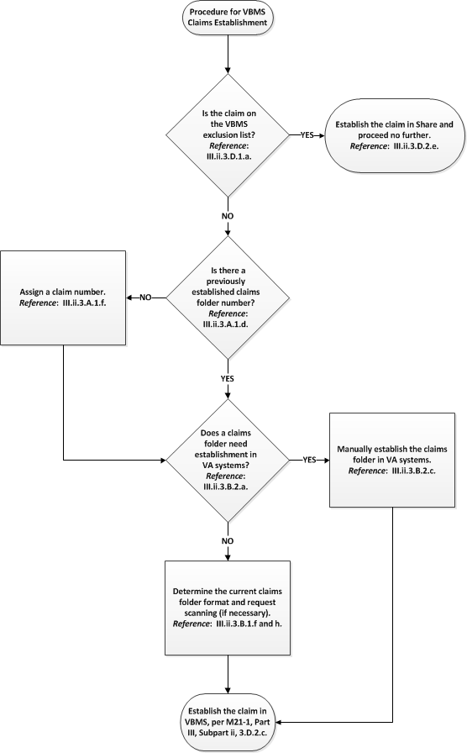

6. Procedures for Share Claims Establishment

Introduction | This topic contains information on the procedures for Share claims establishment, including a  - table providing the procedures for Share claims establishment, and  - flowchart providing the procedures for Share claims establishment.

Change Date | August 24, 2015

a. Table Providing the Procedures for Share Claims Establishment | Follow the steps in the table below when establishing claims in Share.

Step | Action
1 | Is the claim on the VBMS exclusion list?  - If yes, go to Step 2.  - If no  - establish the claim in VBMS, and  - proceed no further.  References: For more information on  - the VBMS exclusion list, see M21-1, Part III, Subpart ii, 3.D.1.a, and  - establishing a claim in VBMS, see M21-1, Part III, Subpart ii, 3.D.2.c.
2 | Is there a previously established claims folder number?  - If yes, go to Step 3.  - If no  - assign a claim number, and  - go to Step 3.  References: For more information on  - previously established claims folder numbers, see M21-1, Part III, Subpart ii, 3.A.1.d, and  - assigning a claim number, see M21-1, Part III, Subpart ii, 3.A.1.f.
3 | Does a claims folder need establishment in VA systems?  - If yes  - manually establish a claims folder in VA systems, and  - go to Step 5.  - If no, go to Step 4.  References: For more information on  - when to establish a claims folder in VA systems, see M21-1, Part III, Subpart ii, 3.B.2.a, and  - manually establishing a claims folder in VA systems, see M21-1, Part III, Subpart ii, 3.B.2.c.
4 | Determine the current claims folder format and request scanning (if necessary).  Reference: For more information on determining the current claims folder format, see M21-1, Part III, Subpart ii, 3.B.1.f and h.
5 | Establish the claim in Share, in accordance with M21-1, Part III, Subpart ii, 3.D.2.e.

b. Flowchart Providing the Procedures for Share Claims Establishment | Follow the procedures contained in the flowchart below when establishing claims in Share.

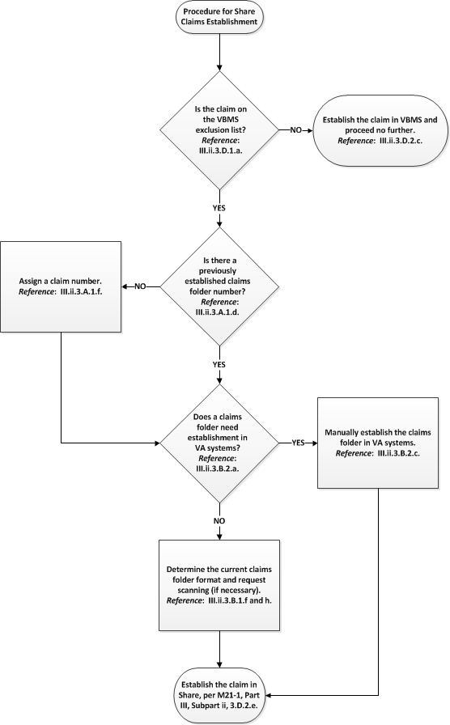

7. Exhibit: Segmented Lane Assignment Criteria

Change Date | June 30, 2015

a. Segmented Lane Criteria | Below is a graphic representation of the segmented lane assignment criteria.

