Section E. Centralized Mail (CM) Intake

Overview

In This Section | This section contains the following topics:

Topic | Topic Name
1 | Overview of the CM Process
2 | Receipt, Separation, and Routing of Physical Mail in the Mailroom
3 | Use of CM Vendor Fax Lines
4 | Freedom of Information Act (FOIA) and Privacy Act (PA) Request Process
5 | Intake Processing Center (IPC) CM Screening and Processing Functions
6 | Routing Mail to Other Business Lines

1. Overview of CM Process

Introduction | This topic provides an overview of the Department of Veterans Affairs (VA) CM processing, including  - intent of CM  - roles and responsibilities in the CM process, and  - definitions of CM terms.

Change Date | July 14, 2015

a. Intent of CM | Centralizing conversion of incoming paper to an electronic medium in the centralized mail (CM) process is intended to  - eliminate paper handling by the Department of Veterans Affairs (VA) personnel at regional offices (ROs)  - reduce the number of times mail is handled in any medium  - expedite uploading of claims, evidence, and other mail to electronic claims folders in the Veterans Benefits Management System (VBMS)  - improve customer service and claims processing timeliness through improved mail control processes, and  - implement first in, first out (FIFO) workflow for all mail received.

b. Roles and Responsibilities in the CM Process | The Intake Processing Center (IPC) is responsible for initial screening, control and uploading to VBMS of mail received in the CM portals.  Reference: For more information on individual IPC responsibilities, see M21-1, Part III, Subpart i, 1.2.b.

c. Definitions of CM Terms | For definitions of terms related to CM processing, see the below table.

Item | Definition
- Receipt Date (CACI)  - Received Date (SMS) | The date the mail is received at the scanning vendor is displayed in the CM portals as the  - receipt date in CACI, or  - received date in SMS.  The table below outlines what date is displayed in the CM portals.  If ... Then ...  - mail is received by the RO, and - sent to the vendor the receipt/received date is the date stamped by the RO  mail is received directly at the vendor the receipt/received date is the date stamped by the vendor when received at the scanning site (equivalent to a VA date stamp)  Note: If an earlier date of receipt is discovered, VBMS allows the user to edit this data field.  Reference: For more information on editing document properties in VBMS, see the VBMS Job Aid – Editing Document Properties.
FIFO | FIFO (first in, first out) refers to processing documents according to oldest date received rather than by type of document.
- Packet, or  - Package | A packet or package pertains to a mail bundle for a single claimant and may contain one or more documents.
Document | Documents are single files of one or more pages/images and are part of a packet or package.
Image | The optical reproduction of the document/page contained in a packet or package.
United States Postal Service (USPS) Priority Mail Box | A standard box normally used for shipping mail to scanning vendors in the CM process.
Bankers Box | A standard white Bankers Box normally used to ship paper claims folders and service treatment records (STRs).

Reference: For more information on earliest date of receipt, see M21-1, Part III, Subpart ii, 1.C.1.d.

2. Receipt, Separation, and Routing of Physical Mail in the Mailroom

Introduction | This topic provides an overview of processing physical mail received at the RO mailroom, including  - sources of physical mail received at the RO  - separating and shipping physical mail, and  - shipping mail to scanning vendors.

Change Date | July 14, 2015

a. Sources of Physical Mail Received at the RO | The USPS automatically sends mail to the scanning vendor when the claimant uses the centralized mail address provided in all development letters.  Physical mail received by the ROs may come from various sources, including, but not limited to  - Veterans Service Organizations (VSOs)  - walk-in via Public Contact Team (PCT)  - other courier services, including  - United Parcel Service (UPS)  - Federal Express (FedEx)  - Dalsey, Hillblom, and Lynn (DHL), and  - other private messenger services.  - VA satellite offices, including  - Out-based offices  - Benefits Delivery at Discharge (BDD), and  - Integrated Disability Evaluation System (IDES) Intake Centers  - USPS mail addressed to the previously published RO address, prior to the establishment of CM.

b. Separating and Shipping Physical Mail | When physical mail is received by the RO, the mail clerk opens, date stamps and separates the mail by VA business lines and/or addresses including  - Compensation  - Pension  - Fiduciary  - Education  - Insurance  - Loan Guaranty  - Veterans Health Administration (VHA)  - Vocational Rehabilitation & Education (VR&E)  - National Cemetery Administration (NCA)  - Human Resources (HR) Management  - Director’s Office, and  - Co-located VSOs.  Once separated, use the table below to route the physical mail.

If mail is ... | Then ...
- compensation, or  - pension. | ship to the appropriate scanning vendor.  Note: Ship Freedom of Information Act (FOIA) and Privacy Act (PA) requests to the scanning vendor for processing in the CM portal.  References: For more information on  - processing compensation mail in the CM portal, see M21-1, Part III, Subpart ii, 1.E.5, and  - RO processing of FOIA/PA requests in the CM portals, see M21-1, Part III, Subpart ii, 1.E.4.
related to all other business lines | mail or forward (if interoffice) the documents to the appropriate business line.

Note: Printing a document or otherwise creating a physical copy of an electronic document to facilitate scanning or upload into an electronic records repository (e.g. VBMS or Virtual VA) is not permitted.

Reference: For more information on date stamping mail, see M21-1, Part III, Subpart ii, 1.C.1.

c. Shipping Mail to Scanning Vendors | Once the mail is separated, follow the steps in the table below to forward the compensation and pension mail to the scanning vendor.

Step | Action
1 | Return the mail to the original envelope or staple envelope to the front of the mail.
2 | Securely bundle mail prior to placing it in the shipping box.  Note: Only use rubber bands for packages too large for clips or staples.
3 | To indicate separation for the vendors of packets for multiple claimants use a  - sheet of paper between packets, or  - place each packet in a manila folder.
4 | Place bundled mail into a USPS Priority Mail Medium Flat Rate Box (11’’ x 8 ½” x 5 ½” USPS box).
5 | Fill the box to approximately 90 percent capacity and add filler material. Ensure there is enough cushioning and items do not shift.  Notes:  - Use the standard white Bankers Box when the volume of mail exceeds the capacity of three USPS Priority Mail Medium Flat Rate boxes.  - Do not ship claims folders and/or STRs via USPS or in USPS boxes. Claim folders and STRs are to be shipped via the Records Management Number/ Document Control Sheet (RMN/DCS) shipping process in approved Bankers Boxes.
6 | Use clear plastic shipping tape with United States Postal Service Mailing writing to seal the  - box top  - bottom seam, and  - reinforce the edges.  Do not use  - cord  - string  - twine  - masking tape, or  - cellophane tape.
7 | Label the top of the box CM for centralized mail.  Important: All mail shipped to the vendors needs to contain a VA Directive 6609 Notice sheet inserted into the shipping container. This notice provides the penalties for violation of Privacy and Health Insurance Portability and Accountability Acts.
8 | Use the table below to determine the appropriate address to forward centralized mail to for scanning.  If the sending facility is … Forward centralized mail to …  an Eastern or Southern Area VSC Department of Veterans Affairs Claims Intake Center PO Box 5235 Newnan, GA 30271-0020  a Central or Western Area VSC Department of Veterans Affairs Claims Intake Center PO Box 5235 Janesville, WI 53547-5235  the Philadelphia Pension Management Center (PMC) Department of Veterans Affairs Claims Intake Center Attention: Philadelphia Pension Center PO Box 5206 Janesville, WI 53547  Note: Place the address label inside a sealable clear jacket provided by USPS.
9 | Use priority mail tracking services from the USPS for shipping.  Notes:  - Mailroom must maintain a log of tracking numbers for future reference.  - A DCS is not required for mail sent under the CM program.

3. Use of CM Vendor Fax Lines

Introduction | This topic provides an overview of the use of vendor fax lines in the CM process, including  - use of CM vendor fax lines, and  - fax confirmation.

Change Date | July 14, 2015

a. Use of CM Vendor Fax Lines | Dedicated facsimile (fax) lines are available for transmitting documents directly to the scanning vendors.  The fax numbers listed below for both CACI and SMS can be used by  - PCT personnel  - VSOs  - VHA personnel, and  - claimants.  CACI: Eastern and Southern Areas  Toll Free – (844) 531-7818  Direct inward dial (DID) – (248) 524-4260 (utilized for foreign claimants)  SMS: Central and Western Areas  Toll Free – (844) 822-5246 (844VACLAIM)  DID – (608) 373-6690 (utilized for foreign claimants)  Important:  - Once a claim is faxed, do not mail the paper as this will create duplicates in the portals and claims folder.  - Always utilize a fax coversheet. Use a locally devised coversheets or those provided by the Veterans Claim Intake Program (VCIP) listed below.  - CACI Fax Coversheet  - SMS Fax Coversheet  - Send only one claimants information per fax transmission. Sending more than one claimant’s information in a single fax risks  - release of personally identifiable information (PII), and  - missing evidence when a decision is made on the claim.  - There is a 999 page limit on faxes; therefore, larger packets should be mailed rather than faxed to the scanning vendor. Multiple fax transmissions will cause the packet to be broken into multiple packets in the portal.

b. Fax Confirmation | When faxing documents to the CM portals, senders must  - ensure that prior to submission they understand their fax settings and whether a “1” or “9” is needed for dialing. Adding a “1” or “9” when it isn’t necessary may change the fax number and inadvertently transmit mail to a non-VA organization or private business  - always review the fax confirmation sheet to ensure the correct number of pages were transmitted to the correct fax number, and  - verify vendors provide a faxed confirmation of receipt of faxes received by the scanning facility.  The example below contains the information the sender will receive in a fax confirmation receipt from CACI.

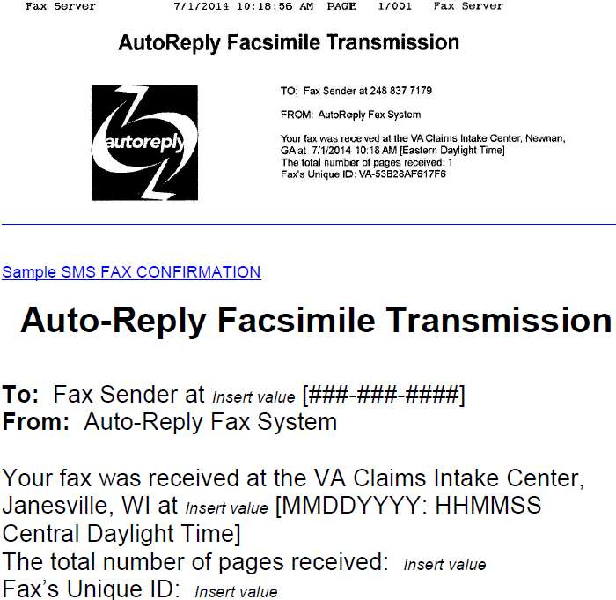

4. Freedom of Information Act (FOIA) and Privacy Act (PA) Request Process

Change Date | July 14, 2015

a. Processing FOIA and PA Requests | Routing of FOIA and PA requests to the Records Management Center (RMC) is required when received through the CM portals. Follow the steps in the table below for RO FOIA/PA procedures.

Step | Action
1 | During initial screening, the IPC user routes FOIA/PA requests through the CM portals to the RMC’s mail queue without taking any system actions, unless  - a FOIA/PA request is received in the same mail packet as other mail requiring RO action, or  - a Congressional FOIA/PA request is received.  Use the table below for instruction on FOIA/PA request forwarding exceptions.  If a ... Then ...  FOIA/PA request is received in the same mail packet as other mail requiring RO action - Establish end product (EP) 510 Privacy Act Request or EP 511 FOIA, leave the suspense reason as Initial Review Pending, and immediately broker the work item to the RMC in VBMS only Notes: - The user’s permanent note under the broker work items should indicate a FOIA/PA request was received with other RO action mail. - After establishing the 510 series EP, the RO user should proceed with processing the action mail and uploading the mail packet to VBMS. Reference: For more information on establishing EPs in VBMS, see M21-1, Part III, Subpart ii, 3.D.2.c.  Congressional FOIA/PA request is received through the CM portal - download the request from the portal to a PDF - e-mail the document to VAVBASTL/RMC/CONGRESSIONAL, and - upload to VBMS. Note: The CM portal would not normally contain Congressional FOIA/PA requests. RO Congressional Liaisons may refer Congressional staff to the RMC for qualifying requests.
2 | If paper records exist at another facility, to include RMC, RMC will utilize the Control of Veterans Records System (COVERS) under the guise of Newark (309) to request the folder be sent to the scanning vendor. RMC will document the folder request as a tracked item in VBMS.  Within 48 hours of receiving a COVERS request from 309, ROs must  - send the requested folders to the scanning vendor, and  - assign the appropriate COVERS location for the scanning vendor (e.g. DCSS1).  Note: Do not permanently transfer the claims folder to 309 in COVERS.  Reference: For more information on claims folder request in COVERS, see the COVERS User Guide.

5. Intake Processing Center (IPC) CM Screening and Processing Functions

Introduction | This topic provides an overview of IPC screening and processing functions in the CM portals, including  - Super User mail processing in the CM portals  - Basic User mail processing in the CM portals  - processing CM packages, and  - processing solicited and unsolicited mail.

Change Date | July 14, 2015

a. Super User Mail Role in the CM Portals | The IPC Super User  - reviews and distributes all mail in the CM portals on a daily basis  - routes mail to work queues based on a FIFO received date  - mentors Basic Users  - provides guidance to Basic Users on processing complex mail, and  - if applicable, processes the more complex cases.  Important: Super Users do not prescreen mail before distributing it to work queues. All users process mail based on FIFO principles.  Notes:  - In the SMS portal only Super Users can transfer mail packages to another RO’s CM queue. In CACI both Super Users and Basic Users may transfer mail packages to another RO’s CM queue.  - The IPC supervisor provides direction to non-supervisory Super Users on the amount of mail distributed to basic users.

b. Basic User Mail Role in the CM Portals | The Basic User  - screens mail assigned to his/her work queue  - establishes new claims or appeals, including  - entering contentions  - sending Section 5103 notices (when applicable)  - assigning claims to the appropriate segmented lane, and  - routing paper claims folders to scanning vendors for conversion (when necessary)  - updates currently pending claims, including  - claim level suspense, and  - managing evidence/tracked items  - updates claimant information in all applicable VA systems, and  - uploads the mail to VBMS or sends to the appropriate business line.  References: For more information on  - establishing claims in VBMS or Share, see M21-1, Part III, Subpart ii, 3.D.2  - routing claims to the appropriate segmented lane, see M21-1, Part III, Subpart ii, 3.D.7  - managing evidence, see the VBMS Job Instruction Sheet – Manage Evidence, and  - updating claimant information in VA systems, see M21-1, Part III, Subpart ii, 3.C.

c. Processing CM Packages | Follow the steps in the table below when processing CM packages

Step | Action
1 | Check the VBMS and Veterans Appeals Control and Location System (VACOLS) for a previously established EP or appeal.  Is there a previously established EP or appeal related to the content of the mail package?  - If yes, follow the guidance found in M21-1, Part III, Subpart ii, 1.E.5.d.  - If no, proceed to the next step.
2 | Does the mail involve a claim for a Veteran employee, a relative of an employee, an employee or relative of a VSO, or other claimant as defined in M21-1, Part III, Subpart ii, 4.A.3 and 4?  - If yes,  - transfer the packet to the appropriate RACC queue (St. Paul RACC, Milwaukee RACC, or Philadelphia RACC), and  - take no further action.  - If no, go to the next step.  Notes:  - System access settings prevent RO users from viewing the claimant’s information. Therefore, system updates cannot be completed on RACC related materials and must be forwarded immediately.  - RACC development letters contain the RACC Coversheet for placement on top of subsequent mail submitted. The RACC Coversheet automatically routes the packet to the appropriate RACC queue.  - To avoid improper routing in the CM portals, PCT personnel accepting mail from Veteran employees must use the RACC Coversheets listed below.  - Philadelphia RACC Coversheet  - Milwaukee RACC Coversheet  - St. Paul RACC Coversheet  References: For more information on  - RACC coversheets, see M21-1, Part III, Subpart ii, 1.E.8, and  - determining the proper RACC jurisdiction, see M21-1, Part III, Subpart ii, 4.A.4.
3 | Does the mail represent material for a pension related claim?  - If yes,  - use the map below to determine the PMC with jurisdiction  - transfer the claim to the appropriate PMC queue, and  - take no further action.  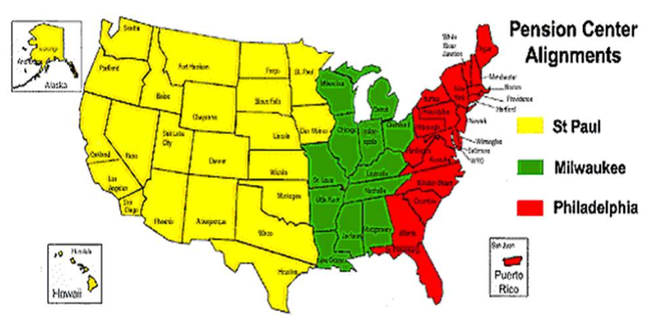  - If no, proceed to the next step.
4 | Does the mail represent a new compensation related claim, VA Form 21-0958, Notice of Disagreement, or VA Form 9?  - If yes, go to the next step.  - If no, go to Step 6.
5 | ROs will not transfer claims (rating, non-rating, appeals, or work items, to include mail received in the CM portal) to another RO’s jurisdiction based on solely where the Veteran resides.  Unless otherwise directed by the Office of Field Operations (OFO), ROs receiving claims (rating, non-rating, appeals, or work items, to include mail received in the CM portal) will not transfer claims to another RO unless the claim  - requires a personal hearing  - pertains to a homeless Veteran, or  - involves special mission claims worked by specific RO’s.  Important: If an RO receives a claim and will retain jurisdiction, but the physical claims folder is located at another RO, immediately notify the RO in possession of the folder to ship the folder to the appropriate scanning vendor.  Based on the information above, will the RO receiving the CM package retain jurisdiction?  - If yes,  - place the correspondence under control in VA systems using the table below  For guidance on establishing a new … See …  claim M21-1, Part III, Subpart ii, 3.D.2  NOD M21-1, Part III, Subpart ii, 3.E.1  perfected appeal M21-1, Part III, Subpart ii, 3.E.2  - upload the package to VBMS, and  - take no further action.  - If no, use the table below to determine the RO of jurisdiction.  If the claim, NOD, VA Form 9, or work item… Then…  - requires a personal hearing - pertains to a homeless Veteran - transfer the mail package to the proper RO’s queue based on where the Veteran resides, and - take no further action.  - involves special mission issues with exclusive jurisdiction, or - exceptions to general policy for claims folder jurisdiction - determine jurisdiction by following the guidance found in - M21-1, Part III, Subpart ii, 5.A.2.a, or - M21-1, Part III, Subpart ii, 5.A.1.b - transfer the mail package to the proper RO’s queue, and - take no further action.
6 | Is the mail for a business line other than compensation or pension?  - If yes,  - reroute the mail to the appropriate business line following the guidance in M21-1, Part III, Subpart ii, 1.E.6, and  - take no further action.  - If no, proceed to the next step.
7 | Check COVERS to determine whether a claims folder exists.  Does a claims folder exist?  - If yes, go to the next step.  - If no,  - check for a previously established claims folder using the guidance found in M21-1, Part III, Subpart ii, 3.A.1.d  - establish a claims folder (if necessary), and  - go to the next step.  Note: If there is not enough information to establish a claims folder, see the military mail procedures in M21-1, Part III, Subpart ii, 4.H.  References: For more information on  - using COVERS, see the COVERS User Guide, and  - establishing a claims folder, see M21-1, Part III, Subpart ii, 3.B.2.
8 | Does a review of the mail determine that no action is needed?  - If yes,  - the package is considered file or drop mail  - upload to VBMS, and  - take no further action.  - If no,  - take all necessary actions (e.g. intent to file (ITF), change of address, power of attorney (POA) update, etc.), and  - upload to VBMS.  Note: On or after March 24, 2015, new claims/appeals must be filed on a fully completed, prescribed VA application form. See ITF reference below for more information.  Reference: For more information about ITF and VA Form 21-0966, Intent to File a Claim for Compensation and/or Pension, or Survivors Pension and/or DIC, see M21-1, Part III, Subpart ii, 2.B.

d. Processing Solicited and Unsolicited Mail | When processing solicited or unsolicited mail, the Basic User updates VBMS according to instructions in the following table.

Step | Action
1 | Does the mail pertain to a pending EP?  - If yes, go to the next step.  - If no, go to Step 6.
2 | Does the mail represent evidence requested and documented by a tracked item?  - If yes,  - the package is considered solicited  - go to the next step.  - If no,  - the package is considered unsolicited  - go to Step 4.
3 | - Update the tracked item RECEIVED field with the date of receipt of the evidence  - select the SAVE button  - upload the packet to VBMS, and  - take no further action.  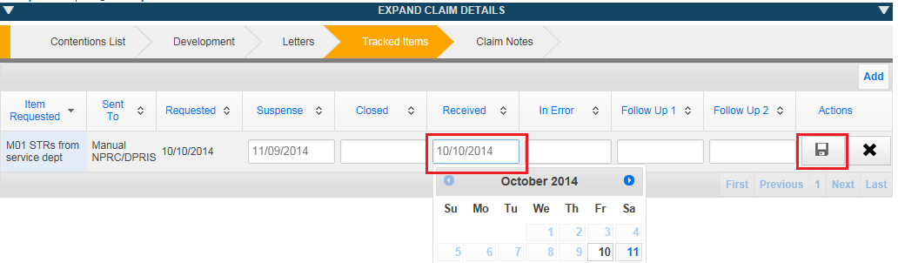
4 | - Update the MANAGING EVIDENCE screen with the evidence received under the ADD UNSOLICITED tab, and  - go to the next step.  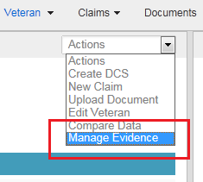  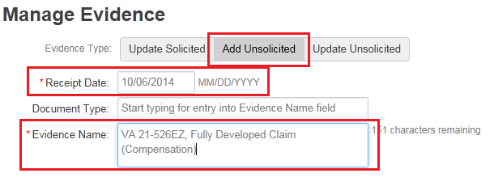
5 | - Add any new contentions by selecting ADD CONTENTIONS on the contentions screen  - upload the packet to VBMS, and  - take no further action.  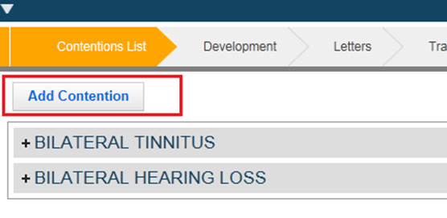  Notes:  - Remember to include the date of claim (date of receipt of new contention) for each contention.  - Do not change the lane already assigned unless there is a new special issue or Special Operations contention.
6 | If the evidence does not pertain to any pending claim, check VACOLS.  Does the mail pertain to a pending appeal?  - If yes,  - manage evidence in VBMS to show that the evidence was received as outlined in Step 4  - upload packet to VBMS, and  - go to Step 8.  - If no, go to the next step.  Reference: For more information on using VACOLS, see the VACOLS User Guide.
7 | Review the mail for a possible EP 930.  Is an EP 930 warranted (the mail relates to a previous claim and was received prior to a previous claim being closed)?  - If yes, establish an EP 930 and go back to Step 4.  - If no, contact the Super User for guidance, and no further action is necessary.  Note: Use the appropriate claim label to differentiate between rating and non-rating EP 930s.  Reference: For more information on EP 930s, see M21-4, Appendix B.
8 | Is the appeal under the jurisdiction of the Board of Veterans’ Appeals (BVA)?  - If yes, go to the next step.  - If no, take no further action.
9 | Record in an Excel spreadsheet the name and claims folder number of the appellant’s record to which the mail was associated.  Note: At the end of each week, the IPC supervisor will send the completed spreadsheet, via encrypted email to BVA at: BVA VBMS Mail (BVAVBMSMAIL@va.gov). In the email, state Attached is a list of records in the jurisdiction of BVA for which mail was uploaded to VBMS. Title the email Records with Received Mail for Week of [insert date of first day in week].

6. Routing Mail to Other Business Lines

Introduction | This topic provides an overview on routing mail to other business lines, including  - rerouting mail by e-mail to other business lines  - VR&E e-mail contact list  - Fiduciary Hub jurisdiction list, and  - Support Services Division (SSD)/finance activity e-mail contact list.

Change Date | July 14, 2015

a. Rerouting Mail by E-Mail to Other Business Lines | If the Basic User identifies mail for business lines not in CM, he/she  - uses the functionality within the portals to download the mail image(s) to PDF format, and  - sends the document(s), via encrypted e-mail, to the appropriate business line mailbox per the below table.

Business Line | Document E-Mail Address
Education | 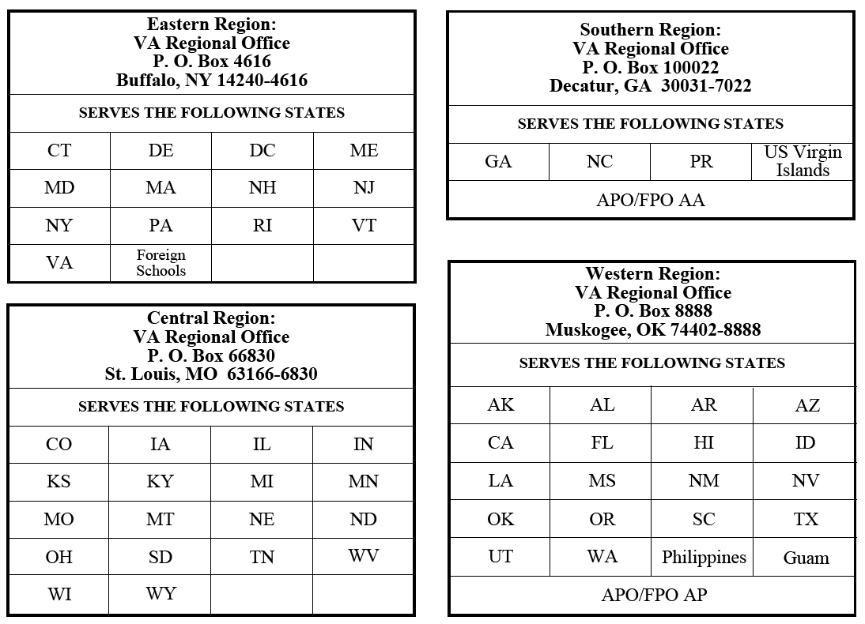  - Atlanta Regional Processing Office VAVBAATL/RO/EDU  - Buffalo Regional Processing Office  VAVBABUF/RO/EDU  - Muskogee Regional Processing Office  VAVBAMUS/RO/EDU  - St. Louis Regional Processing Office VAVBASTL/RO/EDU
Insurance | VAVBAPHI/IC/IPCMAIL
Loan Guaranty | VAVBAWAS/CO/LGY ADMIN CORRESPOND
VR&E | VR&E mail must be routed to the correct VR&E office. The e-mail subject line should be VR&E Misdirected Mail – RO #.  Reference: For more information on VR&E offices’ e-mail addresses, see M21-1, Part III, Subpart ii, 1.E.6.b.
Fiduciary Hub | The e-mail subject line should be Fiduciary Misdirected Mail – RO #.  Reference: For more information on Fiduciary Hub jurisdictions and e-mail addresses, see M21-1, Part III, Subpart ii, 1.E.6.c.
Support Services Division (SSD)/finance activity | SSD/finance activity mail must be routed to the correct SSD/finance activity office. The email subject line should be SSD/Finance Activity Misdirected Mail – RO #.  Reference: For more information on SSD/finance activity e-mail addresses, see M21-1, Part III, Subpart ii, 1.E.6.d.
VHA | Handle mail received for a VHA facility in accordance with local policy.

b. VR&E E-Mail Contact List | The table below contains the e-mail addresses for sending documents to RO’s VR&E division.

RO Name | VR&E E-Mail Address
Albuquerque | VRC.VBAALB@va.gov
Anchorage | VRE.VBAANC@va.gov
Atlanta | VRC.VBAATG@va.gov
Baltimore | VRE.VBABAL@va.gov
Boise | DIR.VBABOI@va.gov
Boston | VRC.VBABOS@va.gov
Buffalo | VRC.VBABUF@va.gov
Chicago | VAVBACHI.VRE@va.gov
Cleveland | VRE.VBACLE@va.gov
Columbia | VRC.VBACMS@va.gov
Denver | VRE.VBADEN@va.gov
Des Moines | VRE.VBADES@va.gov
Detroit | VRE.VBADET@va.gov
Fargo | VRC.VBAFAR@va.gov
Ft. Harrison | VRC.VBAFHM@va.gov
Hartford | VRE.VBAHAR@va.gov
Honolulu | VRC.VBAHON@va.gov
Houston | VRE.VBAHOU@va.gov
Huntington | VRE.VBAHUN@va.gov
Indianapolis | VRE.VBAIND@va.gov
Jackson | VRE.VBAJAC@va.gov
Lincoln | VRE.VBALIN@va.gov
Little Rock | VRE.VBALIT@va.gov
Los Angeles | ROVRC.VBALAN@va.gov
Louisville | VRE.VBALOU@va.gov
Manchester | VRE.VBAMAN@va.gov
Manila | VRE.VBAMPI@va.gov
Milwaukee | VRC.VBAMIW@va.gov
Montgomery | VRE.VBAMGY@va.gov
Muskogee | VRE.VBAMUS@va.gov
Nashville | VRE.VBANAS@va.gov
New Orleans | VRC.VBANOL@va.gov
New York | DIR.VBANYN@va.gov
Newark | VRE.VBANEW@va.gov
Oakland | VRC.VBAOAK@va.gov
Philadelphia | VRC.VBAPHI@va.gov
Phoenix | VRE.VBAPHO@va.gov
Pittsburgh | VRE.VBAPIT@va.gov
Portland | VRE.VBAPOR@va.gov
Providence | VRE.VBAPRO@va.gov
Reno | VRE.VBAREN@va.gov
Roanoke | VRE.VBAROA@va.gov
Salt Lake | VRE.VBASLC@va.gov
San Diego | VRE.VBASDC@va.gov
San Juan | MBVRE.VBASAJ@va.gov
Seattle | VRE.VBASEA@va.gov
Sioux Falls | VRC.VBAFAR@va.gov
St. Louis | VRC.VBASTL@va.gov
St. Paul | VRC.VBASPL@va.gov
St. Petersburg | VRC.VBASPT@va.gov
Togus | VRE.VBATOG@va.gov
Waco | VRC.VBAWAC@va.gov
Washington | VRE.VBAWAS@va.gov
White River | DIR.VBABOS@va.gov
Wichita | VRE.VBAWIC@va.gov
Wilmington | VRC.VBAPHI@va.gov
Winston Salem | VRC.VBAWIN@va.gov

c. Fiduciary Hub Jurisdiction List | Refer to the following table to determine which Fiduciary Hub jurisdiction the mail falls under and the corresponding address to e-mail documents.

Fiduciary Hub | Jurisdiction
Salt Lake City Fiduciary Hub  PO Box 58086  Salt Lake City, UT 84158  1-888-407-0144, #6  VA e-mail: VAVBASLC/RO/FIDHUB | - Alaska  - Arizona  - California  - Colorado  - Hawaii  - Idaho  - Montana  - Nevada  - New Mexico  - Oregon  - Utah  - Washington  - Wyoming
Lincoln Fiduciary Hub  PO Box 5444  Lincoln, NE 68505-5444  1-888-407-0144, #3  VA e-mail: VAVBALIN/RO/FIDHUB | - Central and South America  - Kansas  - Mexico  - Nebraska  - North Dakota  - Oklahoma  - South Dakota  - Texas
Milwaukee Fiduciary Hub  PO Box 14975  Milwaukee, WI 53214-0975  1-888-407-0144, #5  VA e-mail: VAVBAMIW/RO/FIDHUB | - Arkansas  - Illinois  - Iowa  - Louisiana  - Minnesota  - Missouri  - Wisconsin
Columbia Fiduciary Hub  PO Box 9367  Columbia, SC 29209-9998  1-888-407-0144, #1  VA e-mail: VAVBACMS/RO/FIDHUB | - Florida  - Georgia  - North Carolina  - South Carolina
Louisville Fiduciary Hub  PO Box 3487  Louisville, KY 40201  1-888-407-0144, #4  VA e-mail: VAVBALOU/RO/FIDHUB | - Alabama  - Kentucky  - Mississippi  - Puerto Rico  - Tennessee  - Virginia  - West Virginia
Indianapolis Fiduciary Hub  PO Box 441480  Indianapolis, IN 46244  1-888-407-0144, #2  VA e-mail: VAVBAIND/RO/FIDHUB | - Asia  - Australia  - Canada  - Connecticut  - Delaware  - Europe  - Indiana  - Maine  - Maryland  - Massachusetts  - Michigan  - New Hampshire  - New Jersey  - New York  - Ohio  - Pennsylvania  - Rhode Island  - Vermont
Manila Fiduciary Activity 1501 Roxas Boulevard  Pasay City, PI 1302  VA e-mail: VAVBAMPI/RO/F&FE | Republic of the Philippines

d. SSD/Finance Activity E-Mail Contact List | The table below contains the e-mail addresses for sending documents to RO’s SSD/finance activity division.

RO Name | SSD/Finance Activity E-Mail Address
Albuquerque | OPS.VBAPHO@va.gov
Anchorage | SSD.VBASLC@va.gov
Atlanta | SSD.VBAATG@va.gov
Baltimore | FINANCE.VBABAL@va.gov
Boise | SSD.VBABOI@va.gov
Boston | SSD.VBABOS@va.gov
Buffalo | SSD.VBABUF@va.gov
Chicago | VAVBACHI.SSD@va.gov
Cleveland | SSD.VBACLE@va.gov
Columbia | SSD.VBACMS@va.gov
Denver | SSD.VBADENROSSD@va.gov
Des Moines | SSD.VBADES@va.gov
Detroit | SSD.VBADET@va.gov
Fargo | FIN.VBASPL@va.gov
Ft. Harrison | SSD.VBASLC@va.gov
Hartford | SSD.VBAHAR@va.gov
Honolulu | SSD.VBASLC@va.gov
Houston | SSD24.VBAHOU@va.gov
Huntington | SSD.VBAHUN@va.gov
Indianapolis | MC.VBAIND@va.gov
Jackson | SSD.VBAJAC@va.gov
Lincoln | SSD.VBALIN@va.gov
Little Rock | SSD.VBALIT@va.gov
Los Angeles | ROFIN.VBALAN@va.gov
Louisville | SSD.VBALOU@va.gov
Manchester | SSD.VBAMAN@va.gov
Manila | SSD.VBAMAN@va.gov
Milwaukee | SSD.VBAMIW@va.gov
Montgomery | SSD.VBAMGY@va.gov
Muskogee | SSD.VBAMUS@va.gov
Nashville | SSD.VBANAS@va.gov
New Orleans | SUP.VBANOL@va.gov
New York | SSD.VBANYN@va.gov
Newark | SSDVBANEW@va.gov
Oakland | FIN.VBAOAK@va.gov
Philadelphia | FIN.VBAPHI@va.gov
Phoenix | OPS.VBAPHO@va.gov
Pittsburgh | SSD.VBAPIT@va.gov
Portland | SSD.VBAPOR@va.gov
Providence | SSD.VBAPRO@va.gov
Reno | SSD.VBASLC@va.gov
Roanoke | SSD.VBAROA@va.gov
Salt Lake | SSD.VBASLC@va.gov
San Diego | SSD.VBASDC@va.gov
San Juan | SSD.VBASAJ@va.gov
Seattle | SSD.VBASEA@va.gov
Sioux Falls | FIN.VBASPL@va.gov
St. Louis | SSD.VBASTL@va.gov
St. Paul | FIN.VBASPL@va.gov
St. Petersburg | SSD.VBASPT@va.gov
Togus | SSD.VBATOG@va.gov
Waco | SSD.VBAWAC@va.gov
Washington | AMCDIRMAILBOX@va.gov
White River | SSD.VBAMAN@va.gov
Wichita | SSD.VBAMUS@va.gov
Wilmington | FIN.VBAPHI@va.gov
Winston Salem | VAVBAWINSSDFACILITIE@va.gov

