Section F. Veterans Claims Intake Program (VCIP) Shipping

Overview

In This Section | This section contains the following topics:

Topic | Topic Name
1 | Overview of VCIP Shipping Procedures for Claims Folders, Service Treatment Records (STRs), and Personnel Records
2 | Record Management Number (RMN)/Document Control Sheet (DCS) Shipping Process
3 | Shipping Exceptions and Upload Failure Guidance

1. Overview of VCIP Shipping Procedures for Claims Folders, Service Treatment Records (STRs), and Personnel Records

Introduction | This topic provides an overview of the VCIP processing, including  - purpose of VCIP, and  - shipping requirements.

Change Date | June 25, 2015

a. Purpose of VCIP | The Veterans Claims Intake Program’s (VCIP) mission is to  - provide direct support to the Veterans Benefits Administration (VBA) claims process by providing procedures for intake of  - source material  - documentation  - electronic records, and  - data  - work collaboratively with all stakeholders to manage VBA’s digital operating environment, and  - provide procedures relating to intake capabilities and the execution/management of document conversion services contracts.  References:  - For more information on VCIP, see the VCIP SOP.  - For the most recent information on the following topics and other material related to Centralized Mail, see the Office of Business Process Integration (OBPI) Centralized Mail resource page  - using the CACI Portal, see the CACI Portal User Guide, and  - using the SMS Portal, see the SMS Portal User Guide.

b. Shipping Requirements | Using the Record Management Number (RMN)/Document Control Sheet (DCS) shipping process, a regional office’s (RO’s) Intake Processing Center (IPC) or mailroom personnel ship source materials for document conversion, including  - claims folders  - service treatment records (STRs), and  - personnel records.  Important:  - Claims excluded from the Veterans Benefits Management System (VBMS) cannot be shipped to scanning vendors.  - ROs should verify the authenticity of any DD Form 214, Certificate of Release or Discharge from Active Duty, contained in the claims folder in accordance with procedures outlined in M21-1, Part III, Subpart ii, 6.6.a and M21-1, Part III, Subpart iii, 1.B.6.b prior to shipping the folder to the vendor for scanning.  Notes:  - Loose mail may be shipped to the scanning vendors without the use of the RMN/DCS process.  - When the evidence of record is insufficient to award individual unemployability (IU) and evidence indicates the Veteran was seen by the Vocational Rehabilitation and Employment Service (VR&E), ROs may request to have VR&E records sent to the scanning vendor.  Reference: For information on  - shipping loose mail received in the mailroom, see M21-1, Part III, Subpart ii, 1.E.2  - requesting and shipping VR&E records for scanning, see M21-1, Part IV, Subpart ii, 2.F.2.i  - the RMN/DCS shipping process, see M21-1, Part III, Subpart ii, 1.F.2, and  - claims excluded from VBMS, see M21-1, Part III, Subpart ii, 3.D.1.

2. Record Management Number (RMN)/Document Control Sheet (DCS) Shipping Process

Introduction | This topic provides an overview of the RMN/DCS shipping process, including  - required shipping resources  - gaining access to the tracking portal  - creating a DCS in VBMS  - submitting CDs, DVDs, or other portable electronic media  - preparing source materials for shipping  - preparing a box shipping label and a DCS  - creating a manifest and packaging boxes for shipping  - scanning vendor shipping addresses, and  - shipping container validation checklist.

Change Date | June 25, 2015

a. Required Shipping Resources | At a minimum, the following resources are required for shipping source materials  - workstation with computer and document printer  - United Parcel Service (UPS) shipping label printer  - UPS scale  - permanent, black-ink markers  - barcode scanner wand or gun  - manila folders  - approved shipping containers, and  - local shared folder for saving generated shipping documents and manifests.  Note: If the RO does not have a UPS scale on-site, one may be obtained from UPS typically free of charge, based upon shipping volume. For those ROs with small shipping volumes, the scales are available for purchase from UPS.

b. Gaining Access to the Tracking Portal | To obtain new user access to the assigned contractor tracking portal, new users must submit a Vendor Portal Access Request Form as shown below.  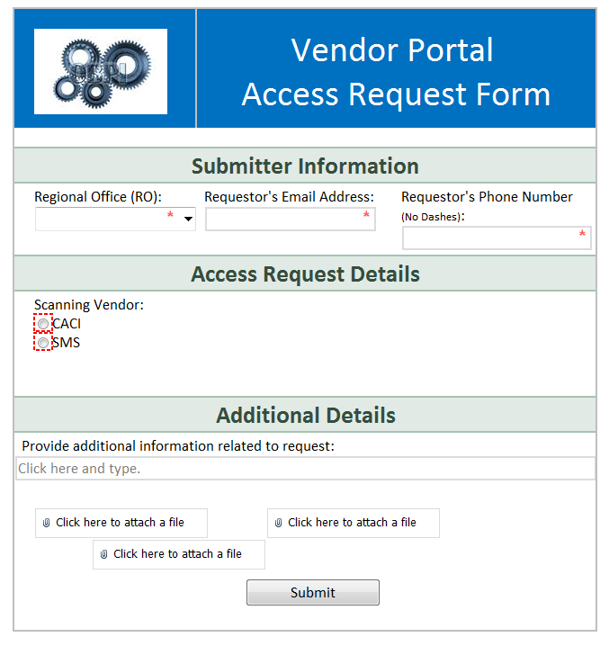  CACI access requirements also include  - each new user in CACI will need to complete and return a CACI Portal Rules of Behavior acknowledgment form provided by VCIP, and  - a token that will be issued to each employee with their username and password for access to the CACI portal.  Note: Because portal access is limited, notify the VCIP mailbox if a user no longer requires access.

c. Creating a DCS in VBMS | The table below describes the process of creating a DCS in VBMS.

Stage | Description
1 | Log into VBMS.
2 | Type the claims folder number into the GLOBAL SEARCH bar and select OPEN PROFILE.
3 | On the PROFILE screen and use the ACTIONS dropdown menu to select Create DCS.  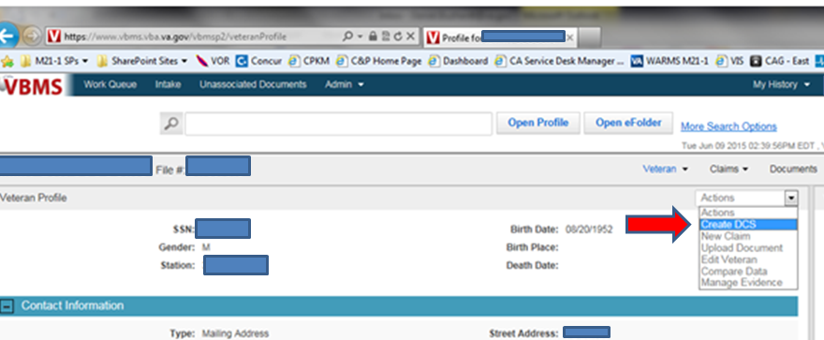
4 | Complete the required fields as shown in the below example, including  - Station  - Intake Site  - Final Destination, and  - Box Number.  Note: Use the last four digits of the UPS tracking number for box number.  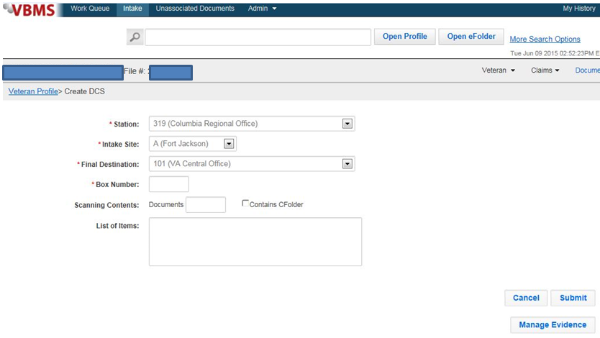
5 | Non-required fields that provide assistance with document tracking during the conversion process, include  - SCANNING CONTENTS: Documents (numeric entry)  - Scanning Contents: Contains CFolder (check-box), and  - List of Items (free text field).
6 | Select SUBMIT at the bottom right corner of the screen to generate DCS.
7 | When the FILE DOWNLOAD screen appears, Select Open.
8 | Save the DCS to a locally designated location.
9 | Print the DCS.

Notes:
- Provide a complete return address on the box of pre-discharge claims if shipping from an intake site to the scanning contractor.
- Use white paper only when printing manifests and DCSs.
- Verify that barcodes are not blurry (e.g., if printer is low on toner).
- Do not enlarge or otherwise distort images.
- Use scan guns/wands for all data-entry shipping tasks to avoid manual key stroke errors.
- Ship all pre-discharge claims and pending post-discharge claims in separate shipping containers. Annotate pre-discharge on the outside of the box as appropriate.
- Pending post-discharge claims do not need an annotation. Do not place other annotations or labels on the box except as specifically directed in the shipping steps below.

d. Submitting CDs, DVDs, or Other Portable Electronic Media | File CDs, DVDs, or other portable electronic media in the claimant’s claims folder or manila folder. Follow the steps below for submitting media  - remove/separate the password from the media  - write the password on a sticky note or piece of paper  - insert the sticky note or piece of paper with the password into an envelope  - seal the envelope, and  - write Simon on the envelope (do not write password, as it will violate Department of Veterans Affairs (VA) Privacy Directives).  Notes:  - Do not print the files or upload them to the efolder.  - The scanning contractors will process any type of source material sent including DVDs, CDs, microfiche, microfilm, microdot, etc. The contractor will extract data from the media and upload it into the electronic claims folder.  - The Social Security Administration (SSA) started encrypting CDs issued to VA claimants, appointed representatives, and VA. SSA places a cover letter with the decryption instructions on every CD they mail. Ensure the decryption instructions and all documentation associated with the CD are included when shipping the CD to the scanning contractor.

e. Preparing Source Materials for Shipping | Follow the steps in the table below to prepare materials for shipping.

Step | Action
1 | Only ship source material in approved shipping containers that can withstand the shipping process and safely and securely deliver claimant’s records to the contractors.  The image below represents the approved shipping container. It is made of corrugated fiberboard, measures 12” X 14-3/4” x 9-1/2”, and has lapped joints secured by wire stitching, as well as locked bottoms with hand holes.  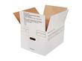
2 | Acquire VBMS-eligible claims folders and secure all loose materials within it. Ensure all STRs are inside the STR jacket(s).  Note: Do not place non-STR materials in STR jackets for shipment, as this will result in all material therein being scanned and indexed together as STRs.
3 | Assess amount of source material (claims folders and manila folders with loose mail) to fit and be shipped in a single container with the following  - box weight (box not to exceed 50 pounds; ‘hand rule’ applies (see Step 5) - approximately 30 pounds of paper will fit in a standard-sized shipping container)  - count (number of claims)  - height (number of inches), and  - availability (such as Only five pre-discharge claims received today).
4 | Use the Control of Veterans Records System (COVERS) to scan claims folders to the internal locations for the scanning contractor including  - DCSS1 for SMS in Janesville, WI (all locations)  - DCSC1 for CACI in Newnan, GA, or  - DCSC2 for CACI in Mt. Vernon, KY.
5 | Place source material in an approved shipping container.  Notes:  - When packing containers, leave enough room in each to easily insert your hand into the front of the box and touch the bottom of the box (hand rule).  - If a box is not completely full, insert packing material in the box to prevent the source material from shifting and becoming damaged during shipment.

f. Preparing a Box Shipping Label and a DCS | Follow steps in the below table to prepare a shipping label for each box and a DCS for each claims folder.

Step | Action
1 | On the day the box is to be shipped, generate a UPS shipping label and tracking number for each shipping container. Use one UPS tracking number per box.  Note: The last four digits of the UPS tracking number must be used when creating an RMN and DCS as described below.
2 | Create a DCS for each claim folder number being shipped. To avoid creating duplicate RMNs that result in shipping exceptions. Use the following format for creating the RMN  - RO code (3 digits)  - VB (2 digits)  - date (6 digits), and  - last four digits of UPS tracking number.  Notes:  - ROs may assign an alpha character in VBMS at the end of the RMN.  - Pre-discharge intake sites must use the associated RO code when creating RMNs in VBMS, not the Rating Activity Site (RAS) station code (first three digits of RMN).  Example: The RMN for a box shipped from Baltimore (313) on February 12, 2015, (021215) using UPS tracking number 1Z1X3V730396160883 is 313VB0212150883.
3 | Secure the DCS to the top of each claimant’s claims folder (or bundle of volumes) and/or to the top of each claimant’s manila folder (or bundle of manila folders) in the box using a rubber band or paper clip.  Notes:  - If there are multiple volumes for one claimant that will not fit into a single container, do not overstuff the box to keep the claims folder together. The shipper should place the overflow portion of the record into a separate box.  - That box will require its own UPS tracking label and its own RMN, and the overflow volumes of the claims folder will require a new DCS, linked to that new box. (Other Veterans’ materials may be placed in this new box as well to fill it.)

g. Creating a Manifest and Packaging Boxes for Shipping | Follow the steps in the below table to create a shipping manifest in VBMS.

Step | Action
1 | Create a manifest for the shipping container. VBMS generates the manifest using the RMN that was created through the prior DCS process and will be used in subsequent steps.
2 | In VBMS follow the steps in the below table to create a shipping manifest from the VBMS PROFILE, ACTIONS dropdown.  Stage Description  1 Select INTAKE at the top of the screen.  2 Select the Box # (as identified above) and the MANIFEST DETAIL screen appears.  3 Scan the UPS tracking number into the VBMS manifest.  4 Use the Actions drop down in the upper right to choose Generate Manifest and generate VBMS Intake Manifest for each box sent to the scanning facility.  5 Print the VBMS manifest on white paper only.  6 Write Pre-discharge on the printed manifest, if applicable.  7 Save an electronic copy of the VBMS manifest in a locally designated shared folder.  Notes:  - Ensure there are no extra DCSs on the VBMS manifest (also known as ‘ghost’ entries).  - Electronically delete any ghost or duplicate entries on the VBMS manifest before printing.  - Once you select Generate Manifest in VBMS, you may delete items off the VBMS manifest and reselect the Generate Manifest action to create the manifest without those entries.  - Once Generate Manifest is selected, the shipper will not be able to associate additional material with that RMN.  - If ghost entries appear on the printed manifest, completely cover the entries with stickers prior to initialing the manifest.  - The associated RMN and UPS tracking number must be entered into the tracking portal; otherwise, a shipping exception will occur and processing of the box will be delayed.
3 | Scan/wand each RMN and UPS tracking number into the appropriate contractor’s tracking portal.
4 | Write the RMN in permanent, black ink on the outside front of the shipping container.
5 | Verify and validate the contents of the box against the VBMS manifest and initial the manifest before sealing the box.
6 | Package boxes for shipping.  Important:  - Ensure that no Personally Identifiable Information (PII) is visible through the handle openings in the box and seal the shipping container.  - Ensure that the tape used to seal the shipping container does not stick to any paper behind the box handles – if the manifest or DCS sheet is the last sheet of paper before the box handle and is damaged upon removal, it will be rendered unscannable and result in a shipping exception.  - Place the correct UPS shipping label on the flap of the associated box. Do not place the label in the center of the box or cover the RMN.  - Ensure that there are no old barcode labels on the shipping container.
8 | Transfer boxes to mailroom for pick up by UPS.

h. Scanning Vendor Shipping Addresses | Use the table below to determine the correct address for each scanning vendor.

Contractor | Location | Address
CACI | Newnan, GA (DCSC1) | SourceHOV Services  216-A Bullsboro Drive  Newnan, GA 30263
CACI | Mt. Vernon, KY  (DCSC2) | SourceHOV Services  618 Progress Dr.  Mt. Vernon, KY 40456
SMS | Janesville, WI (DCSS1) | Data Dimensions  432 Midland Road  Mail Stop 195601  C/O Kathy Miller  Janesville, WI 53547
SMS | Janesville, WI (DCSS1) | Data Dimensions  432 Midland Road  Mail Stop 195601  C/O Kathy Miller  Janesville, WI 53547
SMS | Clinton, IA (DCSS1) | Data Dimensions  1315 19th Avenue NW  Mail Stop BAY R-1  C/O VBA DCS SCANNING DD2 CLI  Clinton, IA 52732

i. Shipping Container Validation Checklist | The following checklist can be used to ensure the container was properly documented and packed for shipping.

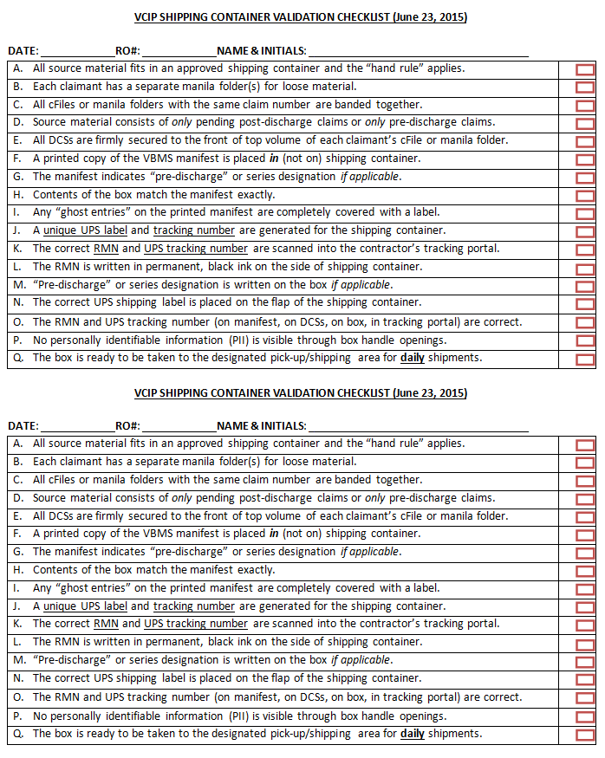

3. Shipping Exceptions and Upload Failure Guidance

Introduction | This topic provides an overview of the VCIP exemptions and upload failures, including  - resolution for common exemptions, and  - upload failure procedures.

Change Date | June 25, 2015

a. Resolution for Common Exceptions | Use the table below to resolve shipping exceptions for source material sent to the scanning vendors.

Exception Type | VA Action (CACI) | VA Action (SMS)
RMN or UPS Tracking Keying Error/Numbers Not Found in Vendor Portal | In the CACI (Omega) portal  - search for the record on the Reconciliation tab, and  - if the record does not exist under the RMN or tracking number, then create a new entry, or  - if the record is keyed in incorrectly, then  - click Shipping then Search and enter either the RMN or tracking number as it is currently in the system  - click Search then SELECT next to the entry, and  - edit the tracking number and RMN fields on the right side as necessary and click Update Record. | In the Data Dimensions (dd) Tracker  - search for the record using the Search feature, and  - if the record does not exist under the RMN or tracking number, then  - use the Create function to enter it as a new shipment  - be sure to save the new entry once all the information is entered, and  - once entered and saved, use the Search function to confirm that the manifest entry was successfully created, or if a record exists but is entered incorrectly, such as the wrong UPS tracking number being associated with an RMN, ROs should  - use the Search function to look up existing entries with the relevant RMN and UPS tracking number  - double-click on the search result  - update the entry to reflect the information provided in the exception description, and  - do not use Create to try to add a new manifest entry, as it will result in a duplicate keying error.
Extra Folder Not on Manifest or Folder does not have DCS. | - Determine if the Veteran's documents should have been sent for conversion. If the Veteran falls within the parameters of the VBMS exclusions list, request the folder be returned to the RO.  - If there is no VBMS exclusion and there is an existing DCS sheet for the Veteran that was mistakenly not included in the box, then forward the PDF to VCIP for correction.  - If there is no VBMS exclusion and there is no record of a DCS sheet for the Veteran in that shipment, then  - generate a new DCS and manifest for the Veteran using a ‘dummy’ box number  - enter the shipment into the Omega portal using a dummy tracking number, and  - send the PDFs to VCIP when complete. | ROs should not request the return of extra claims folder exceptions except as a last resort. The preferred method of resolution is  - use VBMS to create a new DCS sheet(s) for the extra record(s)  - use the ddTracker exceptions tool to open the EXCEPTION ID by double-clicking on it  - scroll within the exception entry to the file upload area (bottom of page) and click ADD to upload the new DCS sheet(s)  - once the new DCS sheet(s) is/are added, use the RESOLUTION pull-down menu to select the appropriate resolution, and  - hit SAVE once all these steps are taken.  Notes:  - If the issue is a missing DCS sheet and the RO has a saved local copy of the sheet, and it has the correct DCS ID on it, that sheet may be uploaded in an attempt to clear the exception. If the DCS sheet provided does not match the Veteran's record or the manifest, SMS will reject the proposed resolution.  - If the extra claims folder should not be uploaded into VBMS, before requesting the claims folder's return in ddTracker, the RO should e-mail the VCIP mailbox noting the exception ID number, RMN, DCS ID, and a brief description of the circumstances necessitating the claims folder's return.
Missing Folder/DCS Listed on Manifest | - Attempt to locate folder. If the folder is still on-site at the RO, let VCIP know to proceed as a ghost DCS. Delete the DCS from VBMS.  - If you are not able to locate the folder on station, you can request a re-check of the box by providing the Veteran's name and claims folder number to VCIP. | Attempt to locate folder.  - If the folder is still on-site at the RO, choose Confirm DCS Can Be Removed from Manifest as the exception resolution in the ddTracker Exception Tool.  - If the folder is not on station, use the Exception Detail report in ddTracker to see if another exception exists for that RMN in either the OPEN or CLOSED exception tabs. Use this information to see if the claims folder was sent with an incorrect DCS ID.  - If there is both an extra claims folder and a missing claims folder exception applying to the same folder in a particular RMN, the RO should confirm that the DCS ID associated with the missing DCS can be removed from the manifest and follow the above instructions for handling the extra claims folder exception to create usable shipping documentation.  - If you are not able to locate the folder on station and believe that the claims folder is in the box, you can request the scanning vendor recheck the box. To do this, add a comment to the exception entry in ddTracker. Recheck requests should note the Veteran's last name and claims folder number. Once all the needed information is entered, ROs must reassign the Current Owner of the exception to Data Dimensions to alert them to the pending request.  Note: ROs should delete the DCS IDs of claims folders confirmed not to be in the box from the corresponding VBMS manifest to prevent any confusion.
RMN on DCS Does Not Match RMN on Manifest | - Generate new DCS sheets and manifest for the entire box.  - Enter the shipment into the Omega portal using a dummy tracking number.  - Send the PDFs to VCIP when complete. | Follow instructions for extra file exceptions above.
Folder does not match DCS | - Attempt to locate both folders listed at the RO.  - Generate a new DCS sheet and manifest for the mismatched folder.  - Enter the shipment into the Omega portal using a dummy tracking number.  - Send the PDFs to VCIP when complete.  - Delete the old DCS from VBMS. | - Attempt to locate both folders listed at the RO.  - Follow instructions for extra claims folder exceptions above as needed.
Misfiled Documents | - When received, drop-file the misfiled documents into the appropriate folder(s) if they were not already sent for scanning.  - If the folders were already scanned, generate a new DCS for the correct Veteran and send the misfiled documents in accordance with the shipping SOP instructions for documents not part of a claims folder. | Follow instructions for extra file exceptions above.  Note: You may request the return of misfiled documents if the affected documents pertain to a record that should not be uploaded in VBMS. Please e-mail the VCIP mailbox a description of the issue necessitating the documents' return prior to submitting the request via ddTracker.
Missing Manifest | Send a PDF of the manifest to VCIP. | - Upload the missing manifest to the appropriate EXCEPTION ID via the ddTracker Exceptions Tool. Manifests can be regenerated out of VBMS by looking up the box number and selecting Action then Generate Manifest.  - If the manifest provided does not clear the exception, contact the VCIP mailbox to request an inventory of the actual box contents.  - A VCIP staff member will provide the aforementioned inventory. ROs should use that information to generate a new manifest and DCS sheets for all claims folders from that box.
Unscannable Manifest and/or DCS Sheets | Send PDFs of the manifest/DCS sheets to VCIP.  Note: Prior to shipping, ensure the barcodes are scannable and are not faded due to low printer ink cartridge. | Upload PDFs of the manifest/DCS sheets directly to the appropriate EXCEPTION ID in the ddTracker Exceptions Tool.  Note: Prior to shipping, ensure the barcodes on all VBMS shipping documentation are scannable and are not faded due to low printer ink cartridge.

Note: Contact the vcip.vbaco@va.gov mailbox to resolve shipping questions or issues.

References:
- For more information on VCIP, see the VCIP SOP.
- For the most recent information on the following topics and other material related to Centralized Mail, see the Office of Business Process Integration (OBPI) Centralized Mail resource page
- using the CACI Portal, see the CACI Portal User Guide, and
- using the SMS Portal, see the SMS Portal User Guide.

b. Upload Failure Procedures | The table below describes the procedures to follow when upload failures occur.

Stage | Description
1 | Open VBMS, input the Veteran’s claims folder number into the search bar, and select OPEN PROFILE.  - If the Veteran’s profile has a valid address  - establish an End Product (EP) 400 Correspondence using the address present, and  - make sure that the Suppress Acknowledgement Letter is checked when establishing the EP, or  - if the Veteran’s profile does not have a valid address or has a partial address  - use your RO’s address as a placeholder to establish the EP 400 Correspondence  - use Address Placeholder for Address Line 2, and  - make sure that the Suppress Acknowledgement Letter is checked when establishing the EP.  Important: When establishing the EP 400, users should set a suspense date and reason of seven days and Image Review, respectively.
2 | Submit upload failure responses to your Area office.
3 | After the EP 400 suspense date expires  - check the Veteran’s claims folder to make sure upload succeeded, and  - if the upload did not succeed, contact the VCIP mailbox for further assistance.
4 | If a placeholder address was used to establish the EP 400  - use the uploaded documents to find the Veteran’s address and overwrite the placeholder address in the Veteran’s VBMS profile, or  - if the upload documents do not contain an address, leave the placeholder address until such time as new evidence arrives for that Veteran, at which point you should verify and correct the placeholder address.
5 | Establish appropriate EPs in VBMS, as needed, based on the Veteran’s uploaded record.  Note: The RO should change the EP 400 from Stage 1 to the appropriate EP, or cancel the EP 400 if the upload is loose/late flowing mail.

