Section B. Division of Responsibilities for Processing Benefits Delivery at Discharge (BDD) and Quick Start Claims

Overview

In This Section | This section contains the following topics:

Topic | Topic Name | See Page
3 | Regional Office (RO) and Intake Site Responsibilities | 2-B-2
4 | Intake Site Responsibilities Unique to BDD Claims | 2-B-16
5 | Intake Site Responsibilities Unique to Quick Start Claims | 2-B-21
6 | BDD Rating Activity Site (RAS) Responsibilities | 2-B-24
7 | Quick Start Consolidated Processing Site (CPS) Responsibilities | 2-B-35

3. Regional Office (RO) and Intake Site Responsibilities

Introduction | This topic contains information about the responsibilities of intake sites and regional offices in handling pre-discharge claims, including  - definition of an intake site  - pre-discharge claim coordinators  - pre-discharge outreach  - initial actions upon receipt of a pre-discharge claim  - circumstances requiring additional/alternative intake site action(s)  - claims filed more than 180 days prior to discharge  - claims filed with no known date of discharge  - intake site responsibilities to update Modern Award Processing Development (MAP-D)  - pre-discharge claims without service treatment records (STRs)  - handling pre-discharge claims folders  - pre-discharge claims with existing paperless claims folders, and  - folder flash for Benefits Delivery at Discharge (BDD) and Quick Start claims.

Change Date | July 14, 2014

a. Definition: Intake Site | An intake site is any location where the Department of Veterans Affairs (VA) accepts claims. This includes  - all regional offices (ROs)  - demobilization sites with a VA presence  - military installations with a VA presence, and  - VA health care facilities.  Note: Not all intake sites have the staffing or capability to perform the actions described in this topic. Under such circumstances, the parent RO of these sites bears the responsibility for taking these actions.
Continued on next page

3. Regional Office (RO) and Intake Site Responsibilities, Continued

b. Pre-Discharge Claim Coordinators | Each RO must assign a coordinator to monitor the pre-discharge claims it receives. The coordinator is responsible for ensuring the RO (and any of its remote intake sites) is  - proactive in soliciting and accepting claims from service members prior to their release from active duty  - timely in following up on development actions, and  - timely in transferring claims to designated processing sites.

c. Pre-Discharge Outreach | It is important for service members to understand they may file a claim for VA benefits prior to discharge. ROs and intake sites should make every effort to inform service members of this opportunity through  - claims workshops that, where feasible, should be scheduled in conjunction with  - Transition Goals, Plan, Success (GPS) VA Benefits I and II briefings  - benefit briefings for service members who are separating or retiring from service  - benefit briefings for demobilizing Reserve or National Guard members, as part of the three- to five-day pre-separation process, and  - Reserve or National Guard “Welcome Home” activities and events  - outreach to severely injured service members who are patients at military treatment facilities or VA Medical Centers (VAMCs), and  - outreach activities jointly sponsored with local VAMCs, National Guard units, and State Directors of Veterans Affairs.  Note: ROs and intake sites should invite and encourage veterans service organizations to participate in claims workshops.

d. Initial Actions Upon Receipt of a Pre-Discharge Claim | Upon receipt of a pre-discharge claim, intake sites are initially responsible for taking the steps described in the table below.

Step | Action
1 | Review the application to ensure it is complete.
Continued on next page

3. Regional Office (RO) and Intake Site Responsibilities, Continued

d. Initial Actions Upon Receipt of a Pre-Discharge Claim (continued)

Step | Action
2 | Date-stamp the application with the date of receipt.
3 | Ensure the service member’s cell phone number and e-mail address are of record (to expedite development activities).
4 | Obtain original (preferred) or photocopies of the service member’s service treatment records (STRs) for all periods of service (if not already in VA custody).
5 | Did the service member file his/her claim on VA Form 21-526EZ, Application for Disability Compensation and Related Compensation Benefits?  - If yes, proceed to the next step.  - If no,  - provide the service member with the Section 5103 notice VA specifically designed for service members that file a claim for disability compensation prior to discharge, and  - proceed to the next step.
6 | Undertake any development that is necessary to determine whether the service member is entitled to additional benefits for his/her dependents.
7 | Attempt to obtain the Section 5103 Notice Response (not required).
8 | Establish a Beneficiary Identification and Records Locator Subsystem (BIRLS) record (if one does not already exist).
9 | Build a red-rope claims folder (if one does not already exist).
10 | File down in the service member’s claims folder  - a dated copy of the Section 5103 notice, and  - the Section 5103 Notice Response (only if signed by the service member).
11 | Place the claim under end product (EP) control in Share.
12 | Request examination(s) of all claimed disabilities within five days of receipt of the claim.
Continued on next page

3. Regional Office (RO) and Intake Site Responsibilities, Continued

d. Initial Actions Upon Receipt of a Pre-Discharge Claim (continued)

Step | Action
13 | Update Modern Award Processing Development (MAP-D), according to instructions in M21-1MR, Part III, Subpart i, 2.B.3.h.

Notes: Intake sites
- must place the date stamp on the front page of documents they receive in connection with a BDD claim
- must send the claims folder to the examining facility under the circumstances described in M21-1MR, Part III, Subpart iv, 3.A.1.l, and
- are entitled to credit for an interview if they conduct one in connection with a pre-discharge claim.

Reference: For more information on placing pre-discharge claims under EP control, see M21-1MR, Part III, Subpart i, 2.A.2.

e. Circumstances Requiring Additional/Alternative Intake Site Action(s) | Under certain circumstances, intake sites must take additional and/or alternative action(s) upon receipt of a pre-discharge claim. The table below describes these circumstances and the corresponding action(s):

If a(n) ... | Then the ...
VA employee accepts a pre-discharge claim but has no access to a date stamp | VA employee must annotate the application with  - his/her initials  - his/her title  - the date of receipt, and  - the location where the employee received the claim.
service member claims entitlement to pension | intake site must provide the Section 5103 notice that is unique to claims for pension.
Continued on next page

3. Regional Office (RO) and Intake Site Responsibilities, Continued

e. Circumstances Requiring Additional/Alternative Intake Site Action(s) (continued)

If a(n) ... | Then the ...
service member files a claim more than 180 days prior to discharge | intake site must follow the instructions in M21-1MR, Part III, Subpart i, 2.B.3.f.
service member files a claim with no known date of discharge | intake site must follow the instructions in M21-1MR, Part III, Subpart i, 2.B.3.g.
intake site  - receives a Quick Start claim ten or fewer days before a service member’s discharge date, or  - does not have the capability to place claims under EP control | intake site must follow the instructions in M21-1MR, Part III, Subpart i, 2.B.5.a.
service member with a Quick Start claim will be unable to attend local examinations because he/she is relocating | intake site must follow the instructions in M21-1MR, Part III, Subpart i, 2.B.5.b.
intake site receives a Quick Start claim through VA Online Application (VONAPP) | intake site must  - disregard the instructions in M21-1MR, Part III, Subpart i, 2.B.3.d, and  - route the claim to the appropriate Quick Start consolidated processing site (CPS).
Continued on next page

3. Regional Office (RO) and Intake Site Responsibilities, Continued

e. Circumstances Requiring Additional/Alternative Intake Site Action(s) (continued)

If a(n) ... | Then the ...
intake site receives a BDD claim through VONAPP | intake site must  - disregard the instructions in M21-1MR, Part III, Subpart i, 2.B.3.d, and  - route the claim to the regional office of jurisdiction (ROJ).  Note: The ROJ may later treat the claim as a BDD or Quick Start claim (whichever is appropriate) as long as it completes all the actions in M21-1MR, Part III, Subpart i, 2.B.3.d prior to the service member’s discharge.
intake site receives a pre-discharge claim without a complete copy of STRs for the current period of service | intake site must follow the instructions in M21-1MR, Part III, Subpart i, 2.B.3.i.
intake site receives a claim that BDD rating activity sites (RASs) and Quick Start CPSs do not process, under M21-1MR, Part III, Subpart i, 2.A.1.e | intake site must  - disregard steps 8 through 13 of the instructions in M21-1MR, Part III, Subpart i, 2.B.3.d  - enter a note in MAP-D that explains why the claim cannot be processed as a BDD or Quick Start claim, and  - route the claim to the ROJ.  Exception: If the service member has a paperless claims folder, do not route the claim to the ROJ. Instead, follow the instructions in M21-1MR, Part III, Subpart i, 2.B.3.k.
Continued on next page

3. Regional Office (RO) and Intake Site Responsibilities, Continued

f. Claims Filed More Than 180 Days Prior to Discharge | If a service member files a claim more than 180 days prior to discharge, the intake site is responsible for  - taking only those actions described in steps 2, 8, and 9 of the instructions in M21-1MR, Part III, Subpart i, 2.B.3.d  - establishing a non-BDD/Quick Start EP  - denying the service member’s claim under reason code 19, ON ACTIVE DUTY/RETIRED PAY, and  - notifying the service member of the reason for the denial.  Reference: For information on non-BDD/Quick Start EPs, see M21-1MR, Part III, Subpart i, 2.A.2.b.
Continued on next page

3. Regional Office (RO) and Intake Site Responsibilities, Continued

g. Claims Filed With No Known Date of Discharge | If a service member files a claim with no known date of discharge, the intake site must  - disregard the instructions in M21-1MR, Part III, Subpart i, 2.B.3.d  - explain to the service member that VA cannot pay compensation or pension to a person who is still on active duty, and  - encourage the service member to  - file a claim within 180 days of discharge, or  - submit a DD Form 214, Certificate of Release or Discharge From Active Duty, upon discharge from active duty.  Exception: If the service member is not present when the intake site discovers he/she has no known discharge date, the intake site must  - take only the actions described in steps 2, 8, and 9 of the instructions in M21-1MR, Part III, Subpart i, 2.B.3.d, and  - follow the instructions provided above through contact with the service member by  - telephone  - e-mail, or (if unsuccessful using these two means)  - letter.  Notes:  - If the intake site contacts the service member by letter, it may clear an EP 400.  - By failing to provide his/her date of discharge, the service member did not submit a “substantially complete application” under 38 CFR 3.159(a)(3). For this reason, the intake site would not  - establish EP control, or (if it sends a letter to the service member)  - provide appeal rights.
Continued on next page

3. Regional Office (RO) and Intake Site Responsibilities, Continued

h. Intake Site Responsibilities to Update MAP-D | Upon receipt of a pre-discharge claim and throughout the time an intake site has custody of it, the intake site is responsible for updating MAP-D to show  - all claimed contentions  - the appropriate special-issue indicator: BDD or Quick Start (or an explanation why the claim does not qualify for processing as a BDD or Quick Start claim), and  - any development actions taken, to include the  - location(s) where the service member will be examined, and  - date the intake site  - requested the examination(s), and  - received a corresponding examination report.

i. Pre-Discharge Claims Without STRs | Upon receipt of a pre-discharge claim without STRs for the current period of service, intake sites must  - establish a non-BDD/Quick Start EP, and  - take the actions described in the table below:

If ... | Then the intake site must ...
- the service member is able to attend local examinations prior to discharge, and  - STRs for the current period of service are not required for the examination | - request the examination(s), and  - follow up with the service member for his/her STRs.
the service member is unable to attend local examinations prior to discharge | forward the claim to the ROJ, which then assumes responsibility for  - requesting the examination(s), and  - following up with the service member for his/her STRs.
Continued on next page

3. Regional Office (RO) and Intake Site Responsibilities, Continued

i. Pre-Discharge Claims Without STRs (continued)

If ... | Then the intake site must ...
- the intake site later obtains STRs through follow-up with the service member  - at least 60 days remain before his/her date of discharge, and  - the service member is still able to attend local examinations | - change the EP it initially established to the appropriate BDD EP, and  - process the claim as a BDD claim.
the intake site later obtains STRs through follow-up with the service member, but  - less than 60 days remain before his/her discharge date, or  - the service member is no longer able to attend local examinations | - change the EP it initially established to the appropriate Quick Start EP, and  - process the claim as a Quick Start claim.
the intake site does not receive the service member’s STRs before his/her discharge date | forward the claim to the ROJ for processing.

Exception: VA does not require members of the National Guard or Reserves who file a Quick Start claim during demobilization briefings to concurrently provide their STRs. Under these circumstances, Quick Start CPSs assume responsibility for obtaining the STRs through coordination with
- the appropriate unit of the National Guard or Reserves, and
- RO Global War on Terrorism (GWOT) Coordinators.

Note: Defer examinations that require the service member’s STRs if the STRs are unavailable.

Reference: For information on EPs for pre-discharge claims, see M21-1MR, Part III, Subpart i, 2.A.2.b.
Continued on next page

3. Regional Office (RO) and Intake Site Responsibilities, Continued

j. Handling Pre-Discharge Claims Folders | Intake sites must establish a separate Control of Veterans Records System (COVERS) location for all claims folders associated with a pre-discharge claim.  The table below shows the actions intake sites must take if a claims folder already exists for a service member who submits a pre-discharge claim:

If the service member submits a ... | And the claims folder is ... | Then the intake site  must ...
BDD claim | located at another RO or records storage facility | - request the claims folder from its current custodian, and  - attach a paper flash to the folder that identifies it as a BDD claim.
 | paperless | follow the instructions in M21-1MR, Part III, Subpart i, 2.B.3.k.
Continued on next page

3. Regional Office (RO) and Intake Site Responsibilities, Continued

j. Handling Pre-Discharge Claims Folders (continued)

If the service member submits a ... | And the claims folder is ... | Then the intake site  must ...
Quick Start claim | located at another RO or records storage facility | not request the claims folder unless it is required for a local examination.
 | required for an examination | - request the claims folder from its current custodian, and  - attach a paper flash to the folder that instructs the examining facility to forward the claims folder to the appropriate Quick Start CPS as soon as the examiner completes his/her review.  The flash must also include  - a point of contact at the CPS, and  - the address of the CPS.
 | paperless | follow the instructions in M21-1MR, Part III, Subpart i, 2.B.3.k.

Note: The existence of an electronic claims folder (eFolder) does not always denote a Veteran’s claims folder is paperless; eFolders exist for many Veterans whose claims folders are not paperless. COVERS is the best source for determining whether a Veteran’s claims folder is paperless. It alerts users a claims folder is paperless by displaying the following in the bottom, right-hand corner of the FOLDER DATA tab on the COVERS – DISPLAY FOLDER DATA screen:

PLCP Case
A Virtual Folder EXISTS

Reference: For more information on COVERS, see the COVERS User Guide.
Continued on next page

3. Regional Office (RO) and Intake Site Responsibilities, Continued

k. Pre-Discharge Claims With Existing Paperless Claims Folders | In addition to the other actions described in this topic, intake sites must do the following upon receipt of a pre-discharge claim for which a paperless claims folder already exists:  - update MAP-D (NOTES) and Virtual VA (JOURNAL) with  - detailed information about the nature of the claim  - the actions taken to date, and  - the date of shipment for scanning  - change the SUSPENSE REASON to Paperless Claims Processing Case, awaiting: Scan, and  - forward the application, STRs, and a copy of the examination request to:  St. Paul PMC  Attn: Capture Unit, PLCP Documents  1 Federal Drive  St. Paul, MN 55111-4050  Important: The BDD RAS with jurisdiction over the pre-discharge claim is responsible for  - obtaining examination results, and  - canceling and reestablishing the EP the intake site used to control the pre-discharge claim, if necessary (to transfer jurisdiction to the RAS).
Continued on next page

3. Regional Office (RO) and Intake Site Responsibilities, Continued

l. Folder Flash for BDD and Quick Start Claims | Intake sites must attach the paper flash below to claims folders associated with a  - BDD claim, or  - Quick Start claim.  Intake sites must identify the specific type of pre-discharge claim by placing an X in the appropriate box.  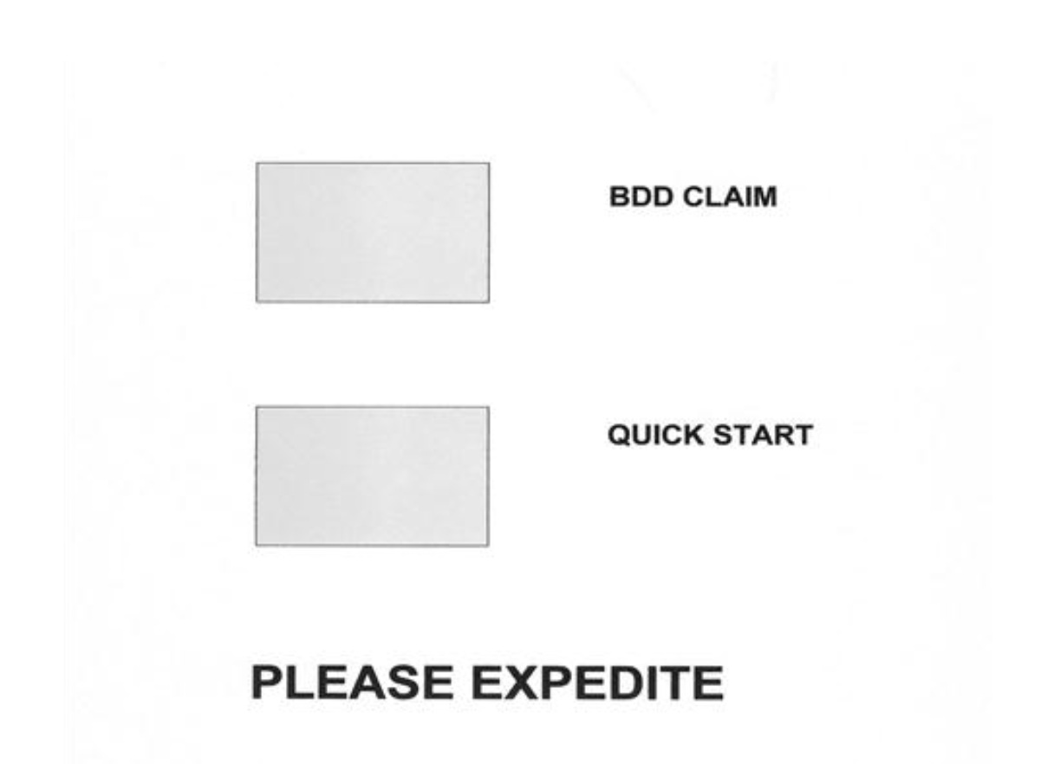

4. Intake Site Responsibilities Unique to BDD Claims

Introduction | This topic contains information about intake site responsibilities unique to BDD claims, including  - determining which RAS has jurisdiction over a BDD claim  - special claims-handling procedures for BDD claims, and  - handling documents received after shipping a claims folder for scanning.

Change Date | October 26, 2011

a. Determining Which RAS Has Jurisdiction Over a BDD Claim | BDD RASs are located at the following two ROs:  - Salt Lake City, and  - Winston-Salem  The jurisdiction of each RAS is determined geographically, as shown in the table below:

If the intake site that received the claim is located in ... | Then jurisdiction lies with the ...
- the Western Area  - the Central Area, or  - Korea | Salt Lake City RAS.
- the Eastern Area  - the Southern Area, or  - Germany | Winston-Salem RAS.
Continued on next page

4. Intake Site Responsibilities Unique to BDD Claims, Continued

b. Special Claims-Handling Procedures for BDD Claims | In addition to the responsibilities described in the previous topic (M21-1MR, Part III, Subpart i, 2.B.3), intake sites are responsible for following the steps in the table below when handling a BDD claim for which no paperless claims folder exists:

Step | Action
1 | Access Virtual VA to  - establish an eFolder, and  - assign the RAS with jurisdiction over the BDD claim as the CURRENT RO.
2 | After requesting examinations, access MAP-D to  - change the suspense reason to Paperless Claims Processing Case, Awaiting VAE (or QTC), and  - update the suspense date.
3 | As soon as all documentation required to decide the claim (except examination reports and evidence of discharge) is of record, and the claims folder is available, access MAP-D to  - change the suspense reason to Paperless Claims Processing Case, Scan, and  - extend the suspense date 40 days from the current date.
4 | Prepare the claims folder for scanning by  - removing  - documents with no record value, such as  - blank forms  - routing slips, and  - screen prints  - locally generated forms, and  - duplicate documents, and  - filing down all remaining documents in  - chronological order, and  - the correct location in the claims folder.
Continued on next page

4. Intake Site Responsibilities Unique to BDD Claims, Continued

b. Special Claims-Handling Procedures for BDD Claims (continued)

Step | Action
5 | Access COVERS to  - generate a shipping manifest (and convert it to an Excel spreadsheet), and  - record temporary transfer of the claims folder to 951 Contract Scanning Site Other.
6 | - Create a records management number (RMN)  - obtain a tracking number, and  - add both numbers to the spreadsheet referenced in Step 5.  Note: Prepare an RMN by adding the following to the intake site’s station number in a continuous string of characters:  - SC  - two-digit month of shipment  - two digit day of shipment  - two-digit year of shipment  - four-digit box number (starting with 0001), and  - station suffix (modifier).  Example: The RMN for the second of two boxes sent from Ft. Bragg on May 14, 2008, would be 318SC0514080002C.
7 | Place the claims folder(s) and a copy of the spreadsheet in a box suitable for shipping.
8 | Write the RMN on the outside of the box.
Continued on next page

4. Intake Site Responsibilities Unique to BDD Claims, Continued

b. Special Claims-Handling Procedures for BDD Claims (continued)

Step | Action
9 | Ship the box (one-to-five-day ground) to the scanning site, which is currently  Hands On Venture Services  216 Bullsboro Drive  Suite A  Newnan, GA 30263

Notes:
- If the service member already has a paperless claims folder, intake sites must follow the instructions in M21-1MR, Part III, Subpart i, 2.B.3.k.
- Intake sites should make every effort to ship claims folders for scanning at least 35 days before the service member’s discharge date. If an intake site misses this target, however, it must still ship the claims folder for scanning.
- The minimum frequency for shipping claims folders for scanning is weekly.
Continued on next page

4. Intake Site Responsibilities Unique to BDD Claims, Continued

c. Handling Documents Received After Shipping a Claims Folder for Scanning | If an intake site receives documents that belong in a claims folder it has already sent for scanning, the intake site must  - update MAP-D (NOTES) with  - a description of the documents  - the date of shipment for scanning, and  - any other information of importance to the RAS, such as new contentions  - attach a flash to the documents that identify them as INACTIVE  - follow the instructions in steps 6, 7, and 8 of the procedure described in M21-1MR, Part III, Subpart i, 2.B.4.b, and  - ship the documents to:  St. Paul PMC  Attn: Triage Unit (Loose Documents)  1 Federal Drive  St. Paul, MN 55111-4050  Exception: Intake sites do not need to include a shipping manifest/spreadsheet with a box containing inactive documents it sends to St. Paul for scanning. They should, however, retain the tracking number for future reference, in case the box becomes misplaced during shipment.  Note: Marking the mail/evidence INACTIVE alerts scanning personnel that the creation of a work item in Virtual VA is not necessary.

5. Intake Site Responsibilities Unique to Quick Start Claims

Introduction | This topic contains information about intake site responsibilities that are unique to Quick Start claims, including  - Quick Start claims intake sites do not place under EP control  - examination requests intake sites do not initiate  - checklist for Quick Start claims  - transferring Quick Start claims to a CPS, and  - CPS addresses.

Change Date | July 14, 2014

a. Quick Start Claims Intake Sites Do Not Place Under EP Control | If an intake site receives a Quick Start claim ten or fewer days before the discharge date, it should not place the claim under EP control. Under these circumstances, or if the intake site does not have the capability to place a claim under EP control, it must take the following actions before forwarding the claim to the appropriate CPS:  - attach a paper flash to the application materials that reads NO EP OR DIARY EXISTS-ESTABLISH CONTROL IMMEDIATELY, and  - provide an explanation (on the paper flash) for not placing the claim under EP control.

b. Examination Requests Intake Sites Do Not Initiate | An intake site should not schedule a service member for examination(s), if the service member will be unable to attend them due to relocation. Under these circumstances, the intake site must  - complete the Compensation and Pension Examination Request Worksheet  - associate the worksheet with the other application materials  - attach a paper flash to the application materials that reads NO EXAMINATION SCHEDULED, and  - provide an explanation (on the paper flash) for not scheduling the examination(s).
Continued on next page

5. Intake Site Responsibilities Unique to Quick Start Claims, Continued

c. Checklist for Quick Start Claims | Intake sites are responsible for  - completing the checklist below, and  - including the checklist with each Quick Start claim package it sends to a CPS.  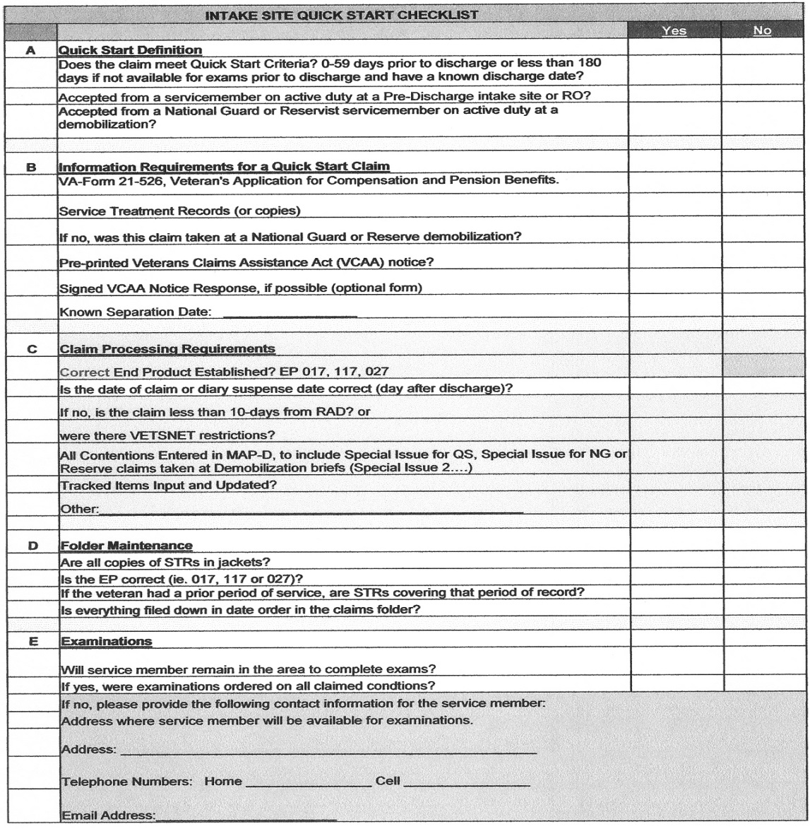
Continued on next page

5. Intake Site Responsibilities Unique to Quick Start Claims, Continued

d. Transferring Quick Start Claims to a CPS | Intake sites must transfer Quick Start claims (with their corresponding claims folders and documentation) to the appropriate CPS within five days of receipt.  Quick Start CPSs are located at the following two ROs:  - Winston-Salem, and  - San Diego.  The jurisdiction of each CPS is determined geographically, as shown in the table below:

If the intake site that received the claim is located in ... | Then jurisdiction lies with the ...
- the Western Area  - the Central Area, or  - Korea | San Diego CPS.
- the Eastern Area  - the Southern Area, or  - Germany | Winston-Salem CPS.

Important:
- Intake sites must ensure they process folder transfers through COVERS.
- After transferring a Quick Start claim to a CPS, intake sites must immediately forward to that CPS any documents it subsequently receives in connection with the claim.

e. CPS Addresses | The table below shows the addresses of the Winston-Salem and San Diego CPSs:

Winston-Salem CPS | San Diego CPS
VA Regional Office (318)  Attn: Winston-Salem Quick Start CPS  100 North Main Street, Suite 1900  Winston-Salem, NC 27101 | VA Regional Office (377)  8880 Rio San Diego Drive  Attn: Quick Start Team  San Diego, CA 92108

6. BDD Rating Activity Site (RAS) Responsibilities

Introduction | This topic contains information about BDD RAS responsibilities. It includes information about  - pre-discharge claims for both compensation and pension  - work items in Virtual VA  - initial RAS actions upon receipt of a work item  - verifying service information  - handling claims for which no evidence of discharge exists  - handling claims from service members who remain on active duty  - inadequate examination results  - preparing a rating decision  - promulgating a rating decision  - authorizing an award action  - handling claims folders from scanning sites  - document scanning at the RAS, and  - transfer of jurisdiction after a RAS decides a BDD claim.

Change Date | July 14, 2014

a. Pre-Discharge Claims for Both Compensation and Pension | If a service member files a BDD claim for both compensation and pension, the RAS with jurisdiction over the claim is responsible for determining entitlement to both benefits.

b. Work Items in Virtual VA | After a scanning site scans documents contained in a service member’s claims folder, it uploads them into Virtual VA. This action triggers the creation of a “work item” in Virtual VA for the RAS with jurisdiction over the BDD claim. This work item serves as notification to the RAS that the contents of a claims folder (created for a BDD claim) are now viewable in Virtual VA.  Note: The scanning of documents by the St. Paul PMC under the circumstances described in M21-1MR, Part III, Subpart i, 2.B.3.k similarly triggers the creation of a work item in Virtual VA.  Reference: For more information on work items, see the Work Items User Guide.
Continued on next page

6. BDD Rating Activity Site (RAS) Responsibilities, Continued

c. Initial RAS Actions Upon Receipt of a Work Item | Once a work item representing a pre-discharge claim appears in Virtual VA, the RAS to which it is assigned must initially take the actions described in the table below:

Step | Action
1 | Review the paperless claims folder to determine whether it is ready for a rating decision. If it is, proceed to Step 3.
2 | Follow up on any outstanding examination reports or missing evidence/documentation.
3 | Once all evidence required to decide the claim (except evidence of discharge) is of record in Virtual VA, update MAP-D to reflect  - a suspense reason of Paperless Claims Processing Case, Awaiting RD, and  - a suspense date that is 30 days after the anticipated date of discharge.
4 | Route the work item to rating activity.
Continued on next page

6. BDD Rating Activity Site (RAS) Responsibilities, Continued

d. Verifying Service Information | Before a BDD RAS or Quick Start CPS may grant benefits, it must verify the Veteran’s  - discharge date, and  - character of discharge (must be under conditions other than dishonorable).  A variety of means for verifying service information exists, including  - Veterans Information Solution (VIS)  - Defense Personnel Records Information System (DPRIS), and  - DD Form 214, Certificate of Release or Discharge from Active Duty.  Note: Service departments normally issue a DD Form 214 to service members at the time of their release from active duty. Under certain circumstances, however, service departments may issue the form prior to separation. VA considers such forms valid for the purpose of verifying service information.  References: For more information on  - VIS, see the VIS User Guide, and  - DPRIS, access the HELP tab on the DPRIS web site. (Registration is required.)
Continued on next page

6. BDD Rating Activity Site (RAS) Responsibilities, Continued

e. Handling Claims for Which No Evidence of Discharge Exists | If no evidence of discharge is of record on or after a claimant’s anticipated discharge date, the BDD RAS or Quick Start CPS with jurisdiction over the affected claim must take one or more of the following actions until the evidence is obtained:  - check VIS  - ask the claimant to provide VA with his/her DD Form 214  - contact the appropriate separation site or transition facility to determine the claimant’s  - duty status, and  - anticipated release date, and/or  - submit a request for service verification through DPRIS.  Note: A RAS or CPS should assume a claimant will remain on active duty for at least 60 more days and deny his/her claim accordingly if  - at least 60 days have passed since the anticipated discharge date, and  - attempts to obtain evidence of discharge through the actions described above have been unsuccessful.  Reference: For more information on denying pre-discharge claims from service members who remain on active duty, see M21-1MR, Part III, Subpart i, 2.B.6.f.
Continued on next page

6. BDD Rating Activity Site (RAS) Responsibilities, Continued

f. Handling Claims From Service Members Who Remain on Active Duty | If a service member remains on active duty beyond his/her anticipated discharge date, the RAS or CPS must  - attempt to contact the service member to obtain a new discharge date, and  - follow the instructions in the table below.  Exception: If a service member remains on active duty because his/her service department referred the service member into the Integrated Disability Evaluation System (IDES), follow the instructions in M21-1MR, Part III, Subpart i, 2.D.27.c.

If the service member ... | Then the RAS or CPS must ...
- plans to remain on active duty more than 60 days from the current date, or  - the RAS or CPS is unsuccessful in its attempts to contact the service member | - dispose of any hard-copy, unpromulgated rating decisions under RCS VB-1, Part I, Item number 13-052.200  - delete unpromulgated rating decisions from  - Virtual VA, and  - Rating Board Automation (RBA) 2000  - retain all other accumulated documentation in the claims folder  - deny the claim under reason code 19, ON ACTIVE DUTY/RETIRED PAY, and  - notify the service member of the reason for denial.  Notes:  - Only users with the Virtual VA role of “Supervisor” or “System Administrator” may delete rating decisions from Virtual VA.  - To remove an unpromulgated rating decision from RBA 2000, the Rating Veterans Service Representative (RVSR) who prepared the decision must first pull it back into RBA 2000 and then delete it.
Continued on next page

6. BDD Rating Activity Site (RAS) Responsibilities, Continued

f. Handling Claims From Service Members Who Remain on Active Duty (continued)

If the service member ... | Then the RAS or CPS must ...
provides a discharge date that is 60 days or fewer from the current date | determine whether the suspense date of the pending EP has expired.  - If the suspense date has not expired, the RAS or CPS must extend the suspense date 30 days beyond the new discharge date.  - If the suspense date has expired, the RAS or CPS must  - change the pending EP to an EP 400  - cancel the EP 400, and  - establish a new EP, with a suspense date that is 30 days beyond the new discharge date.

g. Inadequate Examination Results | BDD RASs and Quick Start CPSs are responsible for determining the adequacy of examinations conducted in connection with pre-discharge claims over which they have jurisdiction. If a RAS or CPS determines examination results are inadequate for rating purposes, it is responsible for  - returning the examination report to the VA medical facility or contractor that conducted the examination for appropriate action, and/or  - scheduling any additional examination(s) it deems necessary to decide the pre-discharge claim.  Note: Under the circumstances described above, RASs and CPSs should  - decide every issue for which sufficient evidence exists to grant a benefit, including service connection at a noncompensable level, and  - defer a decision on the remaining issues for which insufficient evidence exists.  Reference: For more information about intermediate rating decisions and deferred issues, see M21-1MR, Part III, Subpart iv, 6.A.
Continued on next page

6. BDD Rating Activity Site (RAS) Responsibilities, Continued

h. Preparing a Rating Decision | The table below describes the steps an RVSR must follow when preparing a rating decision in a paperless environment.

Step | Action
1 | Access the queue of unassigned work items in Virtual VA.
2 | Select a claim number or the name of a claimant.
3 | - Click ASSIGN TO ME to route a work item to MY WORK ITEMS, and  - click OK to accept the change.
4 | Select the claim number to review the contents of the corresponding eFolder.
5 | Prepare a rating decision in RBA 2000.
6 | Place a paper copy of the rating decision in a designated area for retrieval by a Senior Veterans Service Representative (SVSR).
7 | Use the INSERT DOC feature in Virtual VA to upload the rating decision into Virtual VA.  Note: The indexing value for the rating decision is Rating – Under Review (VSO, Second Signature).
8 | Update MAP-D to reflect  - a suspense reason of Paperless Claims Processing Case, Awaiting Promg, and  - a suspense date that is five days from the current date.
9 | Route the corresponding work item to authorization activity.

i. Promulgating a Rating Decision | The table below describes the steps a Veterans Service Representative (VSR) must follow when promulgating a completed rating decision in a paperless environment.

Step | Action
1 | Select the claim number of a completed rating decision from the MY WORK ITEMS screen in Virtual VA.
Continued on next page

6. BDD Rating Activity Site (RAS) Responsibilities, Continued

i. Promulgating a Rating Decision (continued)

Step | Action
2 | If the claimant selected a veterans service organization as his/her power of attorney,  - notify the appropriate Veterans Service Officer (VSO) by email that a completed rating decision is available for his/her review, and  - allow the VSO at least two days to complete his/her review.
3 | Review the contents of the eFolder to ensure it includes  - an application for benefits that is complete and accurate, and  - evidence of discharge  - under conditions other than dishonorable, and  - one day prior to the effective date of the corresponding rating action.
4 | - Promulgate the rating decision in Veterans Service Network (VETSNET) Awards, and  - place the corresponding award print in a designated area for retrieval by an SVSR.
5 | Save the decision notice to a local shared drive.
6 | Change the MAP-D suspense reason to Paperless Claims Processing, Awaiting Auth.
7 | Route the corresponding work item to the appropriate SVSR.

j. Authorizing an Award Action | The table below describes the steps an SVSR must follow when authorizing an award action in a paperless environment.

Step | Action
1 | Retrieve the corresponding award print from the location referenced in Step 4 of M21-1MR, Part III, Subpart i, 2.B.6.i.
2 | Select the corresponding claim number from the MY WORK ITEMS screen in Virtual VA.
3 | Review the award and decision notice for accuracy.
Continued on next page

6. BDD Rating Activity Site (RAS) Responsibilities, Continued

j. Authorizing an Award Action (continued)

Step | Action
4 | Are the award and decision notice accurate?  - If yes, proceed to Step 5.  - If no,  - disapprove the award  - dispose of the award print under RCS VB-1, Part I, Item number 13-052.200  - route the corresponding work item to the VSR who committed the error  - clearly explain the error the VSR committed in the REMARKS section of the WORK ITEM ACTIONS – WEBPAGE DIALOGUE screen, and  - take no further action.
5 | Authorize/approve the award.
6 | Place the corresponding award print in a location designated for the collection of documents that require scanning and uploading into Virtual VA.
7 | Prepare a notification package for the Veteran by  - printing the decision notice  - scanning the barcode on the decision notice with a handheld barcode scanner  - retrieving a paper copy of the corresponding rating decision from the location referenced in Step 6 of M21-1MR, Part III, Subpart i, 2.B.6.h, and  - attaching the rating decision to the decision notice.
8 | Mail the notification package to the Veteran.
9 | Close the work item.
Continued on next page

6. BDD Rating Activity Site (RAS) Responsibilities, Continued

k. Handling Claims Folders From Scanning Sites | When a scanning site finishes scanning and uploading documents within a claims folder into Virtual VA, it ships the claims folder to the RAS with jurisdiction over the corresponding BDD claim.  The RAS is responsible for creating a special COVERS location for claims folders it receives from scanning sites. It is also responsible for  - comparing the claims folders in the shipment from the scanning site against the shipping manifest that accompanied them, and  - updating COVERS to reflect receipt of the claims folders. (This also transfers jurisdiction for the pending EP to the receiving RAS.)

l. Document Scanning at the RAS | After an intake site sends a claims folder for scanning, the RAS with jurisdiction over the corresponding pre-discharge claim assumes responsibility for scanning and uploading into Virtual VA any documents the RAS subsequently receives or creates.  RASs may use high-speed scanners or desktop scanners to accomplish this task. The table below contains instructions for scanning and uploading a small number of documents into Virtual VA, using a desktop scanner.

Step | Action
1 | Retrieve documents that require scanning and uploading into Virtual VA from the location referenced in Step 6 of M21-1MR, Part III, Subpart i, 2.B.6.j.
2 | Scan the document(s) and save an electronic copy on the employee’s desktop, hard drive, or other location.
3 | From within Virtual VA, click on INSERT DOCUMENT.
4 | Complete all required fields.
5 | Click FIND.
6 | - Enter the claim number of the corresponding eFolder, and  - click SEARCH.
7 | Select the appropriate claim number.
8 | Click INSERT. (If successful, the system will confirm insertion of the scanned document(s).)
Continued on next page

6. BDD Rating Activity Site (RAS) Responsibilities, Continued

m. Transfer of Jurisdiction After a RAS Decides a BDD Claim | After a RAS decides a BDD claim, it transfers jurisdiction over the corresponding eFolder to the ROJ (based on the geographical area in which the claimant resides). The ROJ is responsible for processing  - subsequent claims, and/or  - an appeal of the RAS decision.  Exception: If the BDD claimant is one of the following, the RAS transfers jurisdiction over the eFolder to the appropriate Restricted Access Claim Center (RACC), according to the instructions in Office of Field Operations Letter 20F-13-04:  - former (within the last three years) or current Veterans Benefits Administration (VBA) employee  - relative of a VBA employee  - VSO employee, or  - high-level government official.  Notes: To transfer jurisdiction over an eFolder in  - Virtual VA, edit the eFolder’s attributes in Virtual VA to reflect the ROJ (or RACC) in the CURRENT RO folder, or  - the Veterans Benefits Management System (VBMS), follow the instructions in the TIP Sheet titled Transferring Out VBMS Claims.

7. Quick Start Consolidated Processing Site (CPS) Responsibilities

Introduction | This topic contains information about Quick Start CPS responsibilities, including  - claims processing at CPSs  - inadequate examination results  - handling claims from service members who remain on active duty  - Quick Start claims for both compensation and pension  - discovery of claims that CPSs do not process, and  - jurisdiction over appeals and subsequent claims

Change Date | October 26, 2011

a. Claims Processing at CPSs | The table below describes the process for handling Quick Start claims after their arrival at a CPS:

Step | Action
1 | Remove the paper flash from the claims folder that identifies it as a Quick Start claim.
2 | Update COVERS to show receipt of the claims folder at the CPS.
3 | Place the claim under EP control if the intake site did not establish an EP.
4 | Request all necessary examinations within five days if  - the intake site did not request them, or  - the service member submitted his/her claim through VONAPP.
5 | Undertake any other development necessary to make a decision on the claim. This might include development to obtain the service member’s  - STRs, and/or  - military personnel records.
6 | Obtain completed examination reports.
7 | Update MAP-D to show the claim is ready for a decision.
Continued on next page

7. Quick Start Consolidated Processing Site (CPS) Responsibilities, Continued

a. Claims Processing at CPSs (continued)

Step | Action
8 | Verify the Veteran’s  - discharge date, and  - character of discharge (must be other than dishonorable).
9 | Prepare a rating decision.
10 | If the Veteran selected a veterans service organization as his/her power of attorney, make the completed rating decision available for review by the appropriate VSO for a minimum of two days.
11 | - Promulgate the rating decision, and  - authorize the corresponding award action.
12 | Send decision notice to the Veteran.
13 | Permanently transfer the claims folder to the ROJ.

Note: CPSs should create a special COVERS location for Quick Start claims.

References: For more information about
- placing Quick Start claims under EP control, see M21-1MR, Part III, Subpart i, 2.A.2
- verifying a Veteran’s discharge date and character of discharge, see M21-1MR, Part III, Subpart i, 2.B.6.d and e, and
- VSO review of completed rating decisions, see M21-1MR, Part I, 3.B.12.

b. Inadequate Examination Results | If the rating activity determines examination results are inadequate for rating purposes, the CPS must following the instructions in M21-1MR, Part III, Subpart i, 2.B.6.g.  Note: The CPS is responsible for rating all issues it defers, unless the basis for the deferral is incorrect jurisdiction.
Continued on next page

7. Quick Start Consolidated Processing Site (CPS) Responsibilities, Continued

c. Handling Claims From Service Members Who Remain on Active Duty | If a service member remains on active duty beyond his/her anticipated discharge date, the CPS must follow the instructions in M21-1MR, Part III, Subpart i, 2.B.6.f.

d. Quick Start Claims for Both Compensation and Pension | If a service member files a Quick Start claim for both compensation and pension, the CPS with jurisdiction over the claim is responsible for determining entitlement to both benefits.

e. Discovery of Claims That CPSs Do Not Process | If a Quick Start CPS discovers a claim in its inventory that VA policy specifically excludes from the Quick Start program under M21-1MR, Part III, Subpart i, 2.A.1.e, the CPS must  - change the pending EP to a non-Quick Start EP, and  - transfer the corresponding claims folder to the ROJ.  Reference: For information on non-Quick Start EPs, see M21-1MR, Part III, Subpart i, 2.A.2.b.

f. Jurisdiction Over Appeals and Subsequent Claims | Once a Quick Start CPS decides a Veteran’s claim, the ROJ has jurisdiction over  - an appeal of the CPS decision, and/or  - subsequent claims.

