
Business Partner Solutions - VALERI



VA Loan Electronic Reporting Interface (VALERI)
Claims Bulk Upload Guide
June 2009

1 Summary 3
2 Download the Template 3
3 Complete the Template 5
4 Upload the Template into VALERI 10
5 Confirm Upload was Successful 15

1 Summary
One of the tools available to Servicers for uploading multiple Claim Events at once is called the ‘Claim bulk-upload template’. This process is very similar to the Bulk Upload function, except the ‘Claim bulk-upload template’ is used strictly for reporting Claim events. If you have any questions about VALERI or are unsure if your bulk-upload template is working properly, your assigned technician or RLC of jurisdiction can help. If you have any questions regarding how to contact your assigned technician or RLC of jurisdiction, please reference the VALERI website at http://www.homeloans.va.gov/valeri.asp.

2 Download the Template
The first step in using the Claim bulk-upload feature is acquiring a copy of the template. This can be saved to your computer and used every time you want to submit multiple Claim events in VALERI. To download the template, visit http://www.homeloans.va.gov/valeri.asp. Here you should see links for many helpful documents. The Claim Bulk Upload document can be found by clicking on the link entitled Claims Bulk Upload Template.

When you click on the link for the Claim Bulk Upload template on the VALERI website, a Microsoft Excel document will open on your Computer. You will need to save the template on your computer.

Instructions:
- Click File, Save As.
- The Save As window will open allowing you to rename the file and save it to your computer. Rename the template.
  - Rename the file something you can remember. You may want to include today’s date.
  - Click save. Remember where you saved the file so that you can retrieve it and fill it out.

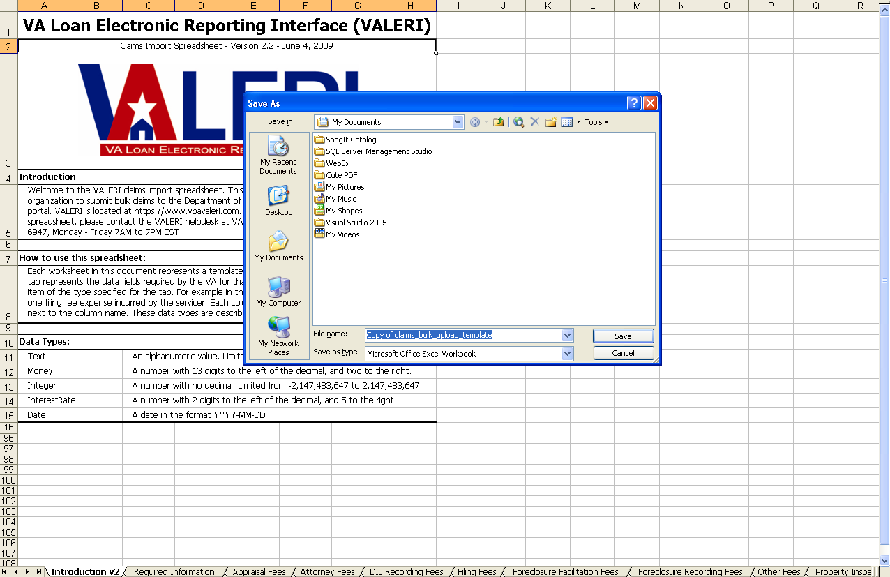

3 Complete the Template
Now that you have a copy of the template you will want to fill it out depending on the Claim events you need to report to VALERI. Open the copy of the template that is saved on your computer. It should look like the figure shown below
Understand the Template.
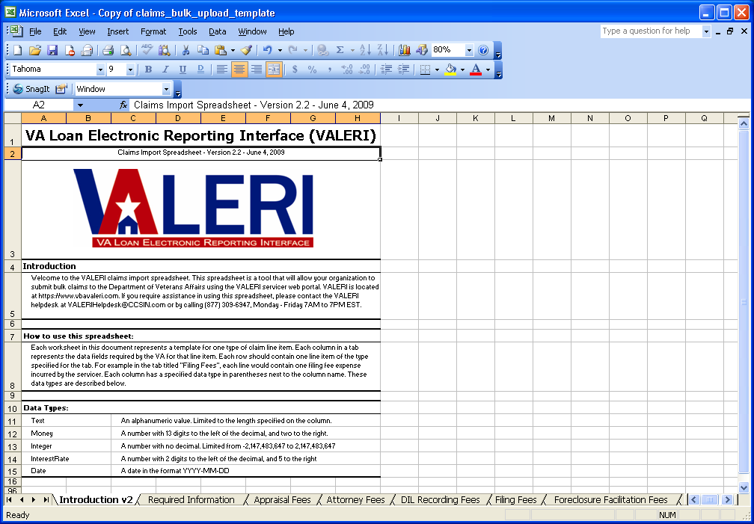
Introduction tab
Introduction
How to section
Data Types
Instructions:
1. The file should open automatically to the Introduction tab. You will notice there is a separate tab along the bottom of the
screen for each piece of the Claim that is reported to VALERI.
2. The introduction section of the spreadsheet provides the link to the VALERI site and explains that this is a tool you can use
for reporting.
3. The ‘how to’ section of the spreadsheet explains how to fill out each spreadsheet. We will also go into that with more detail in
this next section.
4. The data types section lists the five types of data you might need to report a Claim. This helps you format your numbers
and text correctly so that the file transmits successfully.
5. To begin completing your spreadsheet, click the Required Information tab.

This will take you to the screen shown below.
Each column in the Required Information Tab must be populated. Your file will not process unless this tab has been completed in its entirety. For amount fields where there is no amount to report, populate the cell with zeros.
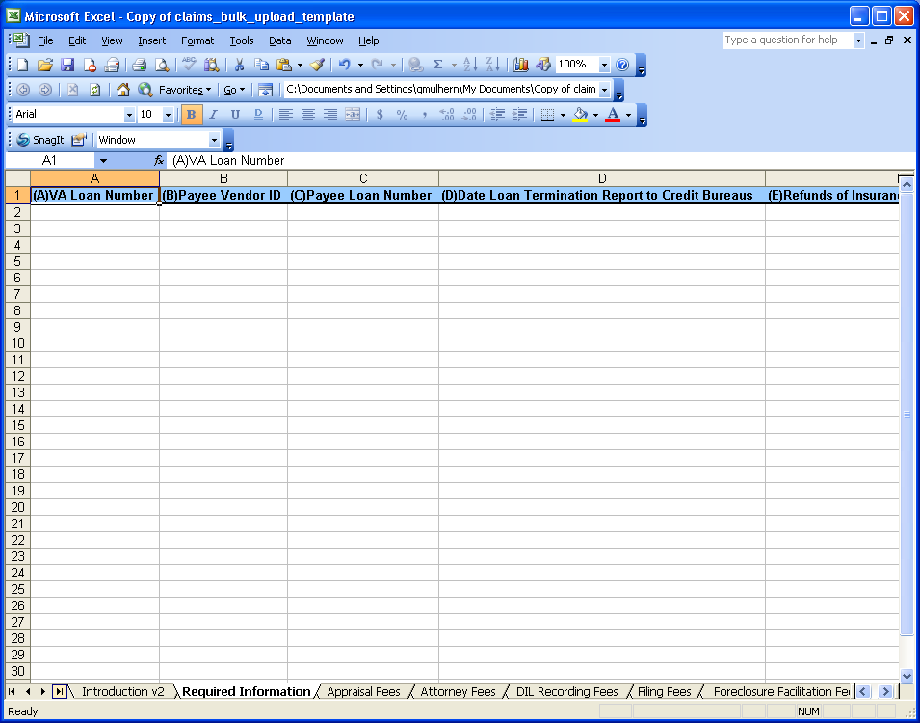
All columns under the Required Information tab must be populated according to the Data type for the column.
Zeros must be entered for amount fields if there is no value for the row.

Enter Claim Data

Detailed Claim items can be entered under the appropriate tab in the worksheet for uploading to VALERI.

If the Column title is listed as “Type” a pull down menu will be displayed for the user to select a valid Type available. The user must select one of these options available in the pull down menu.
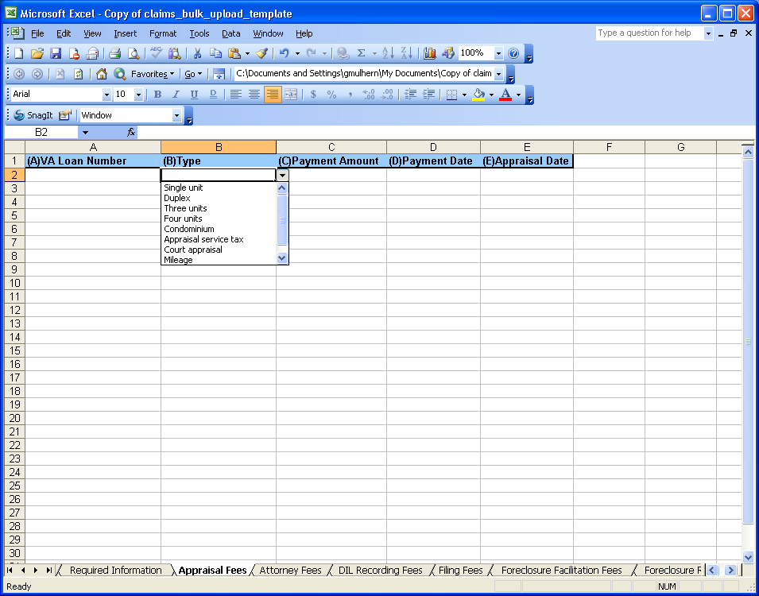
The “Type” value must match exactly the values in the pull down menu. If the value in the Type column is populated incorrectly the file will not process.
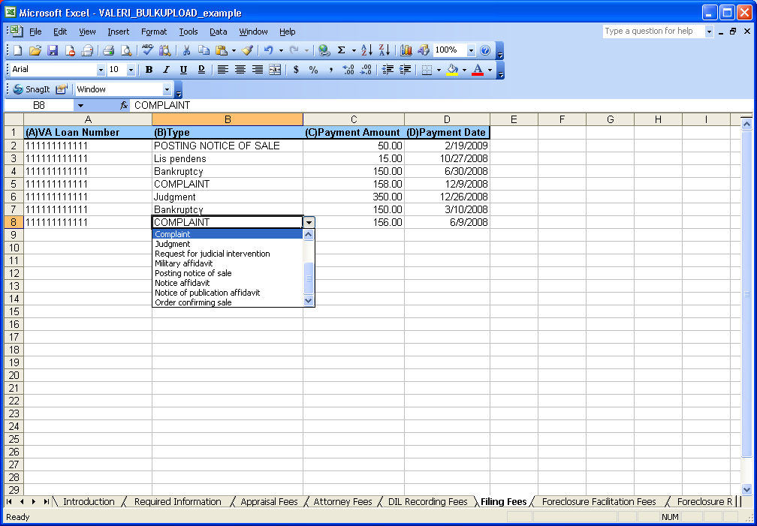
In this example cell B8 is populated in CAPS, COMPLAINT instead of Compliant.

4 Upload the Template into VALERI
Once you have completed the spreadsheet you can upload it into VALERI in the same manner as the Bulk Upload template is uploaded.

First make sure the file is saved and closed. Your file cannot be uploaded while it is still open on your computer. To upload the template, log into VALERI using your username and password.

To log into the SWP, access https://www.vbavaleri.com and enter your username, password, and company name in the fields shown
below.

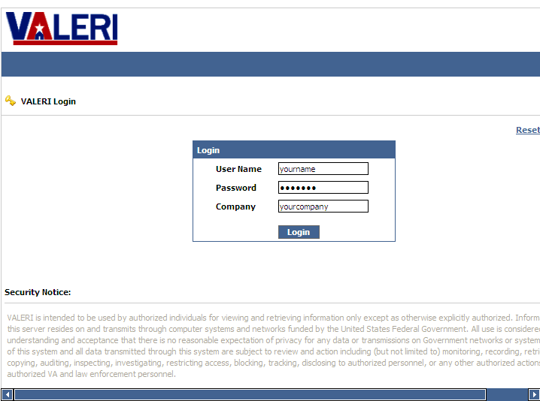
Once you are logged in, VALERI takes you to the Applications screen. From there, you can choose either the Servicer Web Portal application, or the Reports application.

Access the Servicer Web Portal homepage. From this page you will want to search for any 12-digit VA loan number in your portfolio to access the Bulk upload feature.

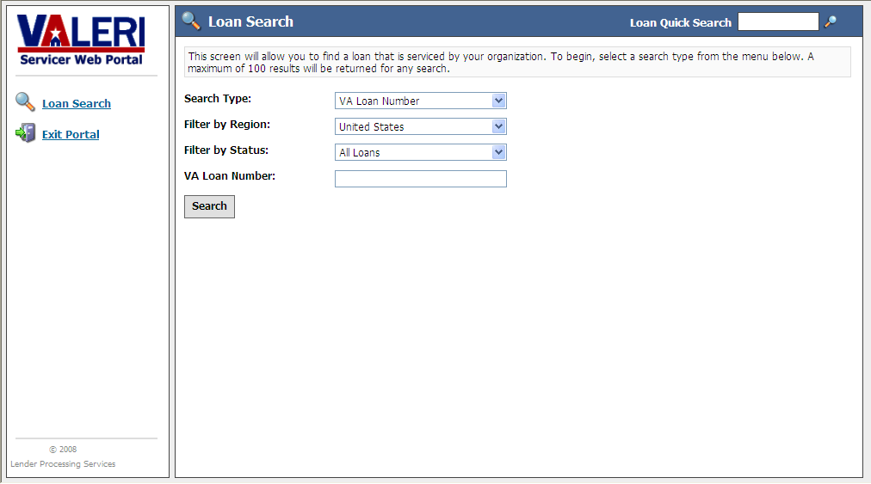
Enter any VA loan number.

Click
Search.

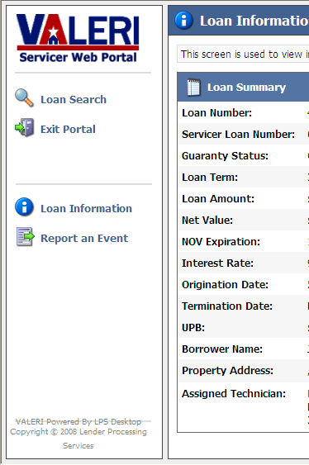
Click Report
an Event

- Click on Report an Event.
- Click Bulk Event Upload.

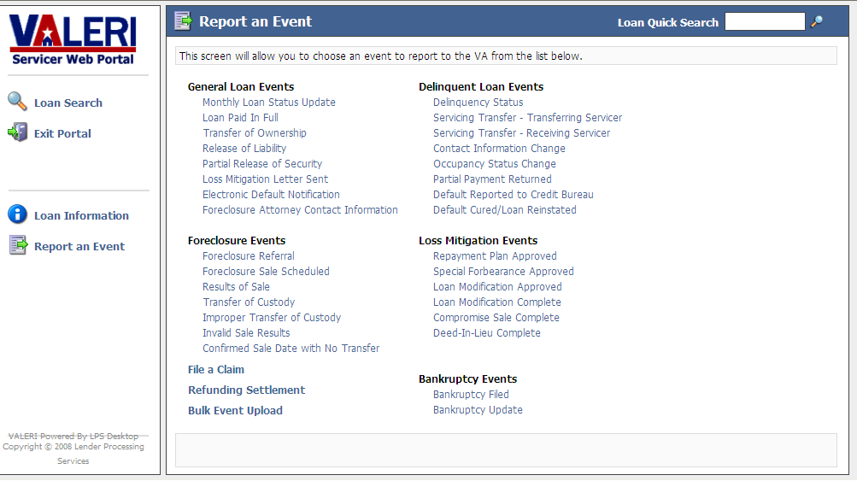
Click Bulk
Event Upload

- Browse for your Claim Bulk upload file.
- Select Upload Claim Events.
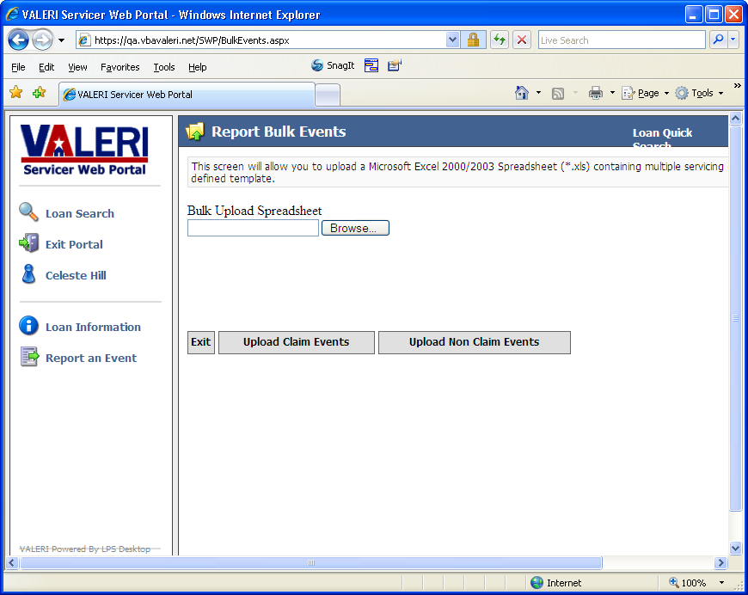
Browse for your file and select the Upload Claims events

5 Confirm Upload was Successful
Once the file is done uploading you should see the message ‘File uploaded successfully’.

Your file has been uploaded and you can exit the Servicer Web Portal. Within one business day you should receive an email
indicating whether or not your bulk upload file was successful. If there were problems with your bulk upload file, they will be
indicated in the email, and you will need to correct the issue and upload a new file. If you get an error message on the screen when submitting a bulk upload file, please contact your assigned technician or RLC of jurisdiction for assistance.

